"NUCLEAR FISSION"
Safety of Existing Nuclear Installations

Contract 605001

Report 2: Guidance document on practices
to model and implement external FLOODING hazards in extended PSA

- This version of the report will be submitted to a peer review
- The conclusions of the review will be discussed during the
ASAMPSA_E workshop with PSA End-Users (12-14th Sept. 2016)
- The report will then be improved before the end of the project (31st Dec. 2016)

Reference ASAMPSA_E
Technical report ASAMPSA_E / WP21&22 / D21.3&D22.2 report2/ 2016-20
Reference IRSN PSN/RES/SAG/2016-00263

V. Rebour (IRSN), G. Georgescu (IRSN), D. Leteinturier (IRSN), E. Raimond (IRSN), S. La Rovere (NIER), P. Bernadara (EDF), D. Vasseur (EDF), H. Brinkman (NRG), P. Groudev (INRNE), I. Ivanov (TUS), M. Turschmann (GRS), S. Sperbeck (GRS), S. Potempski (NCBJ), K. Hirata (JANSI), M. Kumar (LRC)

Period covered: from 01/07/2013 to 31/12/2016 |  | Actual submission date: 13/07/2016
Start date of ASAMPSA_E: 01/07/2013 |  | Duration: 42 months
WP No: 21/22 | Lead topical coordinator : V. Rebour, S. La Rovere |  | His organization name : IRSN, NIER

Project co-funded by the European Commission Within the Seventh Framework Programme (2013-2016)
Dissemination Level
PU | Public | No
RE | Restricted to a group specified by the partners of the ASAMPSA_E project | Yes
CO | Confidential, only for partners of the ASAMPSA_E project | No

ASAMPSA_E Quality Assurance page

Partners responsible of the document : IRSN, NIER, LRC
Nature of document | Technical report
Reference(s) | Technical report ASAMPSA_E/ WP21&22 / D21.3&D22.2 report2/ 2016-20  Rapport IRSN PSN/RES/SAG/2016-00263
Title | Report 2: Guidance document on practices to model and implement external FLOODING hazards in extended PSA
Author(s) | V. Rebour (IRSN), G. Georgescu (IRSN), D. Leteinturier (IRSN), E. Raimond (IRSN), S. La Rovere (NIER), P. Bernadara (EDF), D. Vasseur (EDF), H. Brinkman (NRG), P. Groudev (INRNE), I. Ivanov (TUS), M. Turschmann (GRS), S. Sperbeck (GRS), S. Potempski (NCBJ), K. Hirata (JANSI), M. Kumar (LRC)
Delivery date | 13 July 2016
Topical area | Probabilistic safety assessment, external hazards, external flooding
For Journal & Conf. papers | No
Summary :
The goal of this report is to provide guidance on practices to model EXTERNAL FLOODING hazards and its implementation in extended level 1 PSA. This report is a joint deliverable of work package 21 (WP21) and 22 (WP22) of the ASAMPSA_E project.
The report addresses mainly external flooding events, but other correlated/associated hazards are considered. The report refers to existing guidance as far as possible.

Visa grid
 | Main author(s) : | Verification | Approval (Coordinator)
Name (s) | V. Rebour (IRSN), S. La Rovere (NIER) | M. Kumar (LRC) | E. Raimond
Date | 22.06.2016 | 11.07.2016 | 12.07.2016
Signature

Modifications of the document

Version | Date | Authors | Pages or paragraphs modified | Description or comments
V1 | 03.07. 2015 | V. Rebour, G. Georgescu, D. Leteinturier, E. Raimond (IRSN) | All | The initial structure of the document takes into account the LRC and UNIVIE preliminary proposals, the ASAMPSA_E phone meeting 2015-04-28 and the IRSN views.
V2 | 18.11.2015 | V. Rebour, S. La Rovere | All | Draft version discussed during ASAMPSA_E workshop in Paris in November 2015.
V3 | 22.06.2016 | V. Rebour | All | Incorporated review comments and input from LRC, NRG, EDF, IRSN, INRNE and NIER.
V4 | 11.07.2016 | M. Kumar | Section 6 | Technical review of the report with additional contribution in section 6.
V5 | 12-07-2016 | E. Raimond | All | Editorial improvement during “approval review”. Ch. 3.7.2 to be checked later.

List of diffusion
European Commission (scientific officer)

Name | First name | Organization
Passalacqua | Roberto | EC

ASAMPSA_E Project management group (PMG)

Name | First name | Organization
Raimond | Emmanuel | IRSN | Project coordinator
Guigueno | Yves | IRSN | WP10 coordinator
Decker | Kurt | UNIVIE | WP21 coordinator
Klug | Joakim | LRC | WP22 coordinator until 2015-10-31
Kumar | Manorma | LRC | WP22 coordinator from 2015-11-01
Wielenberg | Andreas | GRS | WP30 coordinator until 2016-03-31
Löffler | Horst | GRS | WP40 coordinator  WP30 coordinator from 2016-04-01

REPRESENTATIVES OF ASAMPSA_E PARTNERS

Name | First name | Organization
Mustoe | Julian | AMEC NNC
Grindon | Liz | AMEC NNC
Pierre | Cecile | AREVA
Godefroy | Florian | AREVA
Dirksen | Gerben | AREVA
Kollasko | Heiko | AREVA
Pellisseti | Manuel | AREVA
Bruneliere | Hervé | AREVA
Hasnaoui | Chiheb | AREXIS
Hurel | François | AREXIS
Schirrer | Raphael | AREXIS
Gryffroy | Dries | Bel V
De Gelder | Pieter | Bel V
Van Rompuy | Thibaut | Bel V
Jacques | Véronique | Bel V
Cazzoli | Errico | CCA
Vitázková | Jirina | CCA
Passalacqua | Roberto | EC
Bonnevialle | Anne-Marie | EDF
Bordes | Dominique | EDF
Vasseur | Dominique | EDF
Panato | Eddy | EDF
Romanet | François | EDF
Lopez | Julien | EDF
Gallois | Marie | EDF
Hibti | Mohamed | EDF
Brac | Pascal | EDF
Jan | Philippe | EDF
Nonclercq | Philippe | EDF
Bernadara | Pietro | EDF
Benzoni | Stéphane | EDF
Parey | Sylvie | EDF
Rychkov | Valentin | EDF
Coulon | Vincent | EDF
Banchieri | Yvonnick | EDF
Burgazzi | Luciano | ENEA
Karlsson | Anders | FKA
Hultqvist | Göran | FKA
Pihl | Joel | FKA
Ljungbjörk | Julia | FKA
KÄHÄRI | Petri | FKA
Wielenberg | Andreas | GRS
Loeffler | Horst | GRS
Tuerschmann | Michael | GRS
Mildenberger | Oliver | GRS
Sperbeck | Silvio | GRS
Serrano | Cesar | IEC
Benitez | Francisco Jose | IEC
Del Barrio | Miguel A. | IEC
Apostol | Minodora | INR
Nitoi | Mirela | INR
Stefanova | Antoaneta | INRNE
Groudev | Pavlin | INRNE
Laurent | Bruno | IRSN
Clement | Christophe | IRSN
Duluc | Claire-Marie | IRSN
Leteinturier | Denis | IRSN
Raimond | Emmanuel | IRSN
Corenwinder | François | IRSN
Pichereau | Frederique | IRSN
Georgescu | Gabriel | IRSN
Bonneville | Hervé | IRSN
Denis | Jean | IRSN
Bonnet | Jean-Michel | IRSN
Lanore | Jeanne-Marie | IRSN
Espargilliere | Julien | IRSN
Mateescu | Julien | IRSN
Guimier | Laurent | IRSN
Bardet | Lise | IRSN
Rahni | Nadia | IRSN
Bertrand | Nathalie | IRSN
Duflot | Nicolas | IRSN
Scotti | Oona | IRSN
Dupuy | Patricia | IRSN
Vinot | Thierry | IRSN
Rebour | Vincent | IRSN
Guigueno | Yves | IRSN
Prošek | Andrej | JSI
Volkanovski | Andrija | JSI
Alzbutas | Robertas | LEI
Olsson | Anders | LRC
Häggström | Anna | LRC
Klug | Joakim | LRC
Kumar | Manorma | LRC
Knochenhauer | Michael | LRC
Kowal | Karol | NCBJ
Borysiewicz | Mieczyslaw | NCBJ
Potempski | Slawomir | NCBJ
Vestrucci | Paolo | NIER
La Rovere | Stephano | NIER
Brinkman | Hans (Johannes L.) | NRG
Zhabin | Oleg | SSTC
Bareith | Attila | NUBIKI
Lajtha | Gabor | NUBIKI
Siklossy | Tamas | NUBIKI
Caracciolo | Eduardo | RSE
Gorpinchenko | Oleg | SSTC
Dybach | Oleksiy | SSTC
Vorontsov | Dmytro | SSTC
Grondal | Corentin | TRACTEBEL
Claus | Etienne | TRACTEBEL
Oury | Laurence | TRACTEBEL
Dejardin | Philippe | TRACTEBEL
Yu | Shizhen | TRACTEBEL
Mitaille | Stanislas | TRACTEBEL
Zeynab | Umidova | TRACTEBEL
Bogdanov | Dimitar | TUS
Ivanov | Ivan | TUS
Kubicek | Jan | UJV
Holy | Jaroslav | UJV
Kolar | Ladislav | UJV
Jaros | Milan | UJV
Hustak | Stanislav | UJV
Decker | Kurt | UNIVIE
Prochaska | Jan | VUJE
Halada | Peter | VUJE
Stojka | Tibor | VUJE

REPRESENTATIVE OF ASSOCIATED PARTNERS
(External Experts Advisory Board (EEAB))

Name | First name | Company
Hirata | Kazuta | JANSI
Hashimoto | Kazunori | JANSI
Inagaki | Masakatsu | JANSI
Yamanana | Yasunori | TEPCO
Coyne | Kevin | US-NRC
González | Michelle M. | US-NRC

EXECUTIVE SUMMARY

This report provides a review of existing practices to model and implement external flooding hazards in existing level 1 PSA. The objective is to identify good practices on the modelling of initiating events (internal and external hazards) with a perspective of development of extended PSA and implementation of external events modelling in extended L1 PSA, its limitations/difficulties as far as possible. The views presented in this report are based on the ASAMPSA_E partners’ experience and available publications.
The report includes discussions on the following issues:
- how to structure a L1 PSA for external flooding events,
- information needed from geosciences in terms of hazards modelling and to build relevant modelling for PSA,
- how to define and model the impact of each flooding event on SSCs with distinction between the flooding protective structures and devices and the effect of protection failures on other SSCs,
- how to identify and model the common cause failures in one reactor or between several reactors,
- how to apply HRA methodology for external flooding events,
- how to credit additional emergency response (post-Fukushima measures like mobile equipment),
- how to address the specific issues of L2 PSA,
- how to perform and present risk quantification.

PARTNERS INVOLVED

The following table provides the list of the ASAMPSA_E partners involved in the development of this report.
1 | Institute for Radiological Protection and Nuclear Safety | IRSN | France
2 | Gesellschaft für Anlagen- und Reaktorsicherheit mbH | GRS | Germany
5 | Lloyd's Register Consulting | LRC | Sweden
10 | Nuclear Research and consultancy Group | NRG | Netherlands
12 | Electricité de France | EDF | France
20 | NIER Ingegneria | NIER | Italy
25 | Institute of nuclear research and nuclear energy – Bulgarian Academia of science | INRNE | Bulgaria
27 | Technical University of Sofia – Research and Development Sector | TUS | Bulgaria

CONTENT

Modifications of the document 3
EXECUTIVE SUMMARY 6
PARTNERS INVOLVED 7
CONTENT 8
PICTURES 11
ABBREVIATIONS 11
DEFINITIONS 12
1 Introduction 15
2 Screening criteria 20
2.1 Screening criteria 20
2.2 Screening process 20
2.2.1 Qualitative Process 21
2.2.1.1 Single hazards 21
2.2.1.2 Combinations of hazards 22
2.2.2 Quantitative process 22
3 Modelling external flooding events for PSA 24
3.1 Introduction 24
3.2 Data for flooding hazards characterisation 24
3.2.1 Generic/regional data 25
3.2.2 Instrumental on site measures 26
3.2.3 Numerical simulation data 26
3.2.4 Data related to plant design 26
3.2.5 Data quality and completeness 27
3.3 Assessment of hazard specific to coastal sites 27
3.3.1 Tide (N18) 27
3.3.2 Tsunami (N7) 28
3.3.3 Storm surge (and associated waves) (N19, N20) 32
3.3.3.1 Sea water level definitions 32
3.3.3.2 Processes to consider 33
3.3.3.3 Example of storm surge hazard assessment including protection failure 35
3.3.4 Seiche (N16) 41
3.4 Assessment of hazard specific to river sites 42
3.4.1 Floods resulting from snow melt and precipitation on large watersheld (N9, N10) 42
3.4.1 Floods resulting from snow melt and precipitation on large watersheld (N9, N10) 42
3.4.2 Floods resulting by failure of water control structures and watercourse containment failure (N15) 43
3.4.3 Floods resulting from bores (N17) 43
3.5 Assessment of hazard that could affect both river and coastal sites 45
3.5.1 Floods resulting from flash flood on small drainage basins and on the site precipitations (N8 and N8’) 45
3.5.2 Floods resulting from high groundwater (N11) 48
3.6 common methods for sinGle hazards characterisation 48
3.7 Hazard combinations 48
3.7.1 Definitions of Hazard Combinations 49
3.7.2 Treatment of Combinations of Independent Hazards 50
3.8 Methods for the assessment of hazard combinations 51
4 Modelling the site protection reliability against flooding 53
5 Modelling the water propagation 56
6 Structure and solutions of External Flooding PSA 58
6.1 Available indications from IAEA and WENRA 58
6.2 Initiating events for a single unit 59
6.3 Modelling safety functions and SSC failures 60
6.4 Assessment of accident sequences 62
6.5 Modelling human failures 63
6.6 Emergency response modelling 67
6.6.1 Post Fukushima measures 67
6.6.2 Mobile equipment and Emergency Measures 67
6.7 Multi-units initiating events modelling 68
6.8 Importance of plant specific data and walkdown 70
6.9 Risk quantification and reporting 71
7 Conclusion 71
8 List of open issues 73
List of References 74
list of tables 76
List of figures 76
9 APPENDIX 1: Interface between L1 and L2 PSA 77
9.1 Forword 77
9.2 Definition of Plant Damage States (PDS) for external flooding initiating events 77
10 ANNEX A: Past experiences of external flooding 79
11 Annex B: extreme value theory 88
12 Annex C: Human Reliability Analysis 92

PICTURES
Can be completed, for example by protection against flooding recently upgraded.

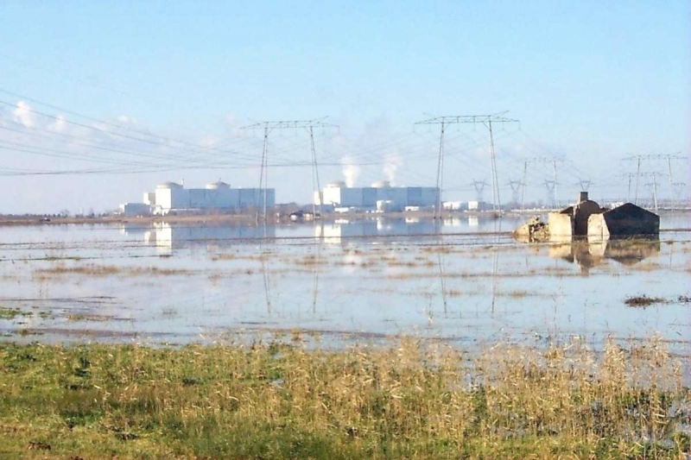
Le Blayais NPP, Gironde river flood, 1999,

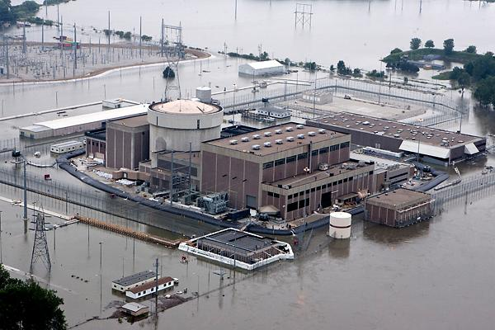
Fort Calhoon NPP, 2011, Missouri river floods, volumetric protection

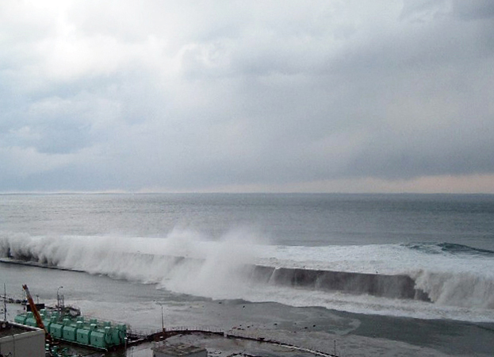
Fukushima NPP, 2011, a tsunami exceeds the site protection

ABBREVIATIONS
This will be updated in the final version of the report.
AEP | Annual Exceedance Probability
ARP | Alarm Response Procedure
CCF | Common Cause Failure
CDF | Core Damage Frequency
DG | Diesel Generator
DPD | Discrete Probability Distributions
DSG | Design Safety Guide
EOP | Emergency Operating Procedure
EPRI | Electric Power Research Institute
EPZ | Emergency Planning Zones
ETL | Event Tree Linking
FDF | Fuel Damage Frequency
FTL | Fault Tree Linking
HCLPF | High Confidence of Low Probability of Failure
HEP | Human Error Probability
HFE | Human Failure Events
HRA | Human Reliability Analysis
IPEEE | Individual Plant Examination of External Events
ISRS | In Structure Response Spectra
LERF | Large Early Release Frequency
LOCA | Loss of Coolant Accidents
LOOP | Loss of Off-Site Power
MCS | Monte Carlo Simulation
PDF | Probability Density Functions
POS | Plant Operational State
PSA | Probabilistic Safety Assessment
PSF | Performance Shaping Factor
PSR | Periodic Safety Review
NDC | NPH Design Category
NPH | Natural Phenomena Hazards
NPP | Nuclear Power Plant
SAM | Severe Accident Management
SAR | Safety Analysis Report
SBO | Station Black Out
SFP | Spent fuel Pool
SSC | Structure System and Component

DEFINITIONS
These definitions come from IAEA and US NRC safety glossaries. Some harmonization will be done between all ASAMPSA_E reports in final versions.
This will be updated in the final version of the report.

Accident Sequence Analysis | The process to determine the combinations of initiating events, safety functions, and system failures and successes that may lead to core damage or large early release.
Bounding Analysis | Analysis that uses assumptions such that assessed outcome will meet or exceed the maximum severity of all credible outcomes.
Event Tree Analysis | An inductive technique that starts by hypothesizing the occurrence of basic initiating events and proceeds through their logical propagation to system failure events.  - The event tree is the diagrammatic illustration of alternative outcomes of specified initiating events.  - Fault tree analysis considers similar chains of events, but starts at the other end (i.e. with the ‘results’ rather than the ‘causes’). The completed event trees and fault trees for a given set of events would be similar to one another.
Fault Tree Analysis | A deductive technique that starts by hypothesizing and defining failure events and systematically deduces the events or combinations of events that caused the failure events to occur.  - The fault tree is the diagrammatic illustration of the events.  - Event tree analysis considers similar chains of events, but starts at the other end (i.e. with the ‘causes’ rather than the ‘results’). The completed event trees and fault trees for a given set of events would be similar to one another.
Cliff Edge Effect | In a nuclear power plant, an instance of severely abnormal plant behaviour caused by an abrupt transition from one plant status to another following a small deviation in a plant parameter, and thus a sudden large variation in plant conditions in response to a small variation in an input.
Design Basis | The range of conditions and events taken explicitly into account in the design of a facility, according to established criteria, such that the facility can withstand them without exceeding authorized limits by the planned operation of safety systems.
Design Basis External Events | The external event(s) or combination(s) of external events considered in the design basis of all or any part of a facility.
External Event | An event originated outside a nuclear power plant that directly or indirectly causes an initiating event and may cause safety system failures or operator errors that may lead to core damage or large early release. Events such as earthquakes, tornadoes, and floods from sources outside the plant and fires from sources inside or outside the plant are considered external events. By historical convention, LOOP not caused by another external event is considered to be an internal event.  According to NUREG 2122, the term external event is no longer used and has been replaced by the term external hazard.
External Hazard | External hazards originating from the sources located outside the site of the nuclear power plant. Examples of external hazards are seismic hazards, external fires (e.g. fires affecting the site and originating from nearby forest fires), external floods, high winds and wind induced missiles, off-site transportation accidents, releases of toxic substances from off-site storage facilities and severe weather conditions
External Hazard Analysis | The objective is to evaluate the frequency of occurrence of different severities or intensities of external events or natural phenomena (e.g., external floods or high winds).
External flood | A flood initiated outside the plant boundary that can affect the operability of the plant.  In a PRA, external floods are a specific hazard group in which the flood occurs outside the plant boundary. The PRA considers floods because they have the potential to cause equipment failure by the intrusion of water into plant equipment through submergence, spray, dripping, or splashing or by the loss of buildings.
External Flood Analysis | A process used to assess potential risk from external floods.  In a PRA, an external flood analysis quantifies the risk contribution (e.g., core damage frequency and large release frequency) as a result of an external flood. The analysis models the potential failures of plant systems and components from external floods, as well as random failures. Floods have the potential to cause equipment failure by the intrusion of water into plant equipment through submergence, spray, dripping, or splashing. The likelihood of an external flood is determined through an external flood hazard analysis, which evaluates the frequency of occurrence of different external flood severities. The frequency of the external flood is used as input to the model used to assess external flood risk.
External Flood Hazard Analysis | The objective is to evaluate the frequency of occurrence of different external flood severities.
Fragility | The fragility of a structure, system or component (SSC) is the conditional probability of its failure at a given hazard input level. The input could be earthquake motion, wind speed, or flood level.
Fragility Analysis | Estimation of the likelihood that a given component, system, or structure will cease to function given the occurrence of a hazard event of a certain intensity.  - In a PRA, fragility analysis identifies the components, systems, and structures susceptible to the effects of an external hazard and estimates their fragility parameters. Those parameters are then used to calculate fragility (conditional probability of failure) of the component, system, or structure at a certain intensity level of the hazard event.  - Fragility analysis considers all failure mechanisms due to the occurrence of an external hazard event and calculates fragility parameters for each mechanism. This is true whether the fragility analysis is used for an external flood hazard, fire hazard, high wind hazard, seismic hazard, or other external hazards. For example, for seismic events, anchor failure, structural failure, and systems interactions are some of the failure mechanisms that would be considered.
Fragility Curve | A graph that plots the likelihood that a component, system, or structure will fail versus the increasing intensity of a hazard event.  - In a PRA, fragility curves generally are used in seismic analyses and provide the conditional frequency of failure for structures, systems, or components as a function of an earthquake-intensity parameter, such as peak ground acceleration.  - Fragility curves also can be used in PRAs examining other hazards, such as high winds or external floods.
Hazard | The ASME/ANS PRA Standard defines a hazard as “an event or a natural phenomenon that poses some risk to a facility”.  - Internal hazards include events such as equipment failures, human failures, and flooding and fires internal to the plant.  - External hazards include events such as flooding and fires external to the plant, tornadoes, earthquakes, and aircraft crashes.”
Hazard Analysis | The process to determine an estimate of the expected frequency of exceedance (over some specified time interval) of various levels of some characteristic measure of the intensity of a hazard (e.g., peak ground acceleration to characterize ground shaking from an earthquake). The time period of interest is often taken as 1 year, in which case the estimate is called the annual frequency of exceedance.
Human Reliability Analysis | A structured approach used to identify potential human failure events and to systematically estimate the probability of those events using data, models, or expert judgment.
Individual plant examination for external events (IPEEE) | While the “individual plant examination” takes into account events that could challenge the design from things that could go awry internally (in the sense that equipment might fail because components do not work as expected), the “individual plant examination for external events” considers challenges such as earthquakes, internal fires, and high winds.
Initiating Event | An identified event that leads to anticipated operational occurrences or accident conditions.  - This term (often shortened to initiator) is used in relation to event reporting and analysis, i.e. when such events have occurred. For the consideration of hypothetical events considered at the design stage, the term postulated initiating event is used.
Large early release | The rapid, unmitigated release of air-borne fission products from the containment to the environment occurring before the effective implementation of off-site emergency response and protective actions such that there is a potential for early health effects.
Large early release frequency (LERF) | Expected number of large early releases per unit of time.
Loss of coolant accident (LOCA) | Those postulated accidents that result in a loss of reactor coolant at a rate in excess of the capability of the reactor makeup system from breaks in the reactor coolant pressure boundary, up to and including a break equivalent in size to the double-ended rupture of the largest pipe of the reactor coolant system.
Loss of Offsite Power (LOOP) | The loss of all power from the electrical grid to the plant.  In a PSA/PRA, loss of offsite power (LOOP) is referred to as both an initiating event and an accident sequence class. As an initiating event, LOOP to the plant can be a result of a weather-related fault, a grid-centered fault, or a plant-centered fault. During an accident sequence, LOOP can be a random failure. Generally, LOOP is considered to be a transient initiating event.
Postulated Initiating Event (PIE) | An event identified during design as capable of leading to anticipated operational occurrences or accident conditions.  - The primary causes of postulated initiating events may be credible equipmentfailures and operator errors (both within and external to the facility) or human induced or natural events.
Structures, Systems And Components (SSCs) | A general term encompassing all of the elements (items) of a facility or activity that contributes to protection and safety, except human factors.  - Structures are the passive elements: buildings, vessels, shielding, etc.  - A system comprises several components, assembled in such a way as to perform a specific (active) function.  - A component is a discrete element of a system. Examples of components are wires, transistors, integrated circuits, motors, relays, solenoids, pipes, fittings, pumps, tanks and valves.
Severe accident | A type of accident that may challenge safety systems at a level much higher than expected.
Screening | A process that distinguishes items that should be included or excluded from an analysis based on defined criteria.
Screening criteria | The values and conditions used to determine whether an item is a negligible contributor to the probability of an accident sequence or its consequences.
Sensitivity Analysis | A quantitative examination of how the behaviour of a system varies with change, usually in the values of the governing parameters.  - A common approach is parameter variation, in which the variation of results is investigated for changes in the value of one or more input parameters within a reasonable range around selected reference or mean values, and perturbation analysis, in which the variations of results with respect to changes in the values of all the input
Uncertainty | A representation of the confidence in the state of knowledge about the parameter values and models used in constructing the PRA.  OR  Variability in an estimate because of the randomness of the data or the lack of knowledge.
Uncertainty Analysis | An analysis to estimate the uncertainties and error bounds of the quantities involved in, and the results from, the solution of a problem.

Introduction
The operation experience of nuclear industry has shown how significant a large flooding event can be for a nuclear site; see for instance the events at Le Blayais in 1999, Fort Cahloun in 2011, and Fukushima Dai-ichi in 2011. Ideally, flooding events should have been appropriately taken into account in the design basis of each NPP and efficient protection against flooding hazards should be in place. Moreover, some design extension conditions have to be considered as reasonably practical as possible.
For many NPPs however, the site protections are not sufficient to exclude the possibility of extensive damage in case of high amplitude rare flooding events. Some NPPs sites have developed additional protections against such rare but high amplitude flooding events. These reinforcements are today associated to the “design extension conditions” approach, described for example in (WENRA 2014, issue F [3]).
The development of an external flooding PSA should make it possible to verify or demonstrate that the design measures against the flooding hazard are sufficient. The present report discusses good practices to develop and use such external flooding PSA, from the flooding hazards probabilistic assessment to the risk quantification. It introduces also some views on the modelling of the correlated hazards to be associated with the flooding events.
A general framework to analyse internal and external hazards provided by IAEA has shown in below .

Figure 1-1: IAEA (SSG-3) suggested overall approach to analyse external events in Level 1 PSA
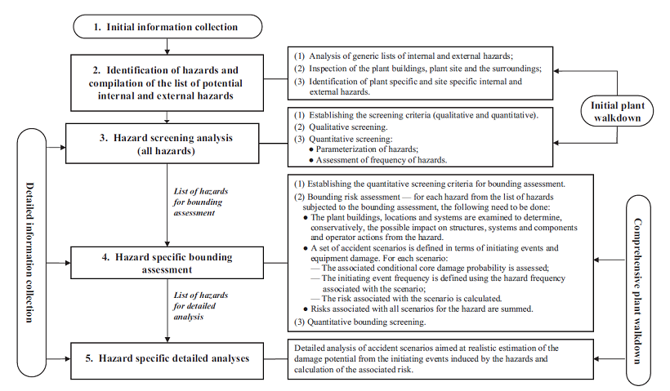
Flood hazard can be from “internal” or “external” origins. There are different approaches and criteria to define the limit between “internal” and “external” flooding hazards. A clear separation between the two types of flooding hazard does not exist. For example, IAEA SSG-18 indicates, “external events are events unconnected with the operation of a facility or the conduct of an activity that could have an effect on the safety of the facility or activity. The concept of ‘external to the installation’ is intended to include more than the external zone, since in addition to the area immediately surrounding the site area, the site area itself may contain features that pose a hazard to the installation, such as a water reservoir”.
In the framework of ASAMPSA_E project, it appears that participants use mainly two approaches to define what is “internal” flooding (and by the way, “external” flooding as the others):
- internal flooding concerns one reactor and its auxiliary buildings (for example, this is the choice used by IRSN L1 PSA team),
- internal flooding concerns all water capacities, which are under the control of the management of plant (within the site boundaries).
In the second case, the internal flooding PSA is highly more complex because it could be a multi-unit PSA. Nevertheless, it appears that the second case corresponds to the practice for a majority of participants. This report endorses this definition, and it focuses on “external” flooding related to water sources/capacities, which are not under the control of the management of plant. Whatever the dividing line between “internal” and “external” flooding, the key point in the safety assessment is to identify all the possible sources for flooding that could be defined as “internal” or “external” and to ensure that no gap exists between the two.

The report addresses all the types of external flooding events identified in (D21.2 List of external hazards [6]) (failures of large water capacity on the site are excluded, as it is assumed as an internal event). The modelling of these events in a PSA can be different depending on followings:
- the sources of water for flooding which can be:
  - “off-site”: the site main water body which is generally used for the heat sink (sea or river with several floods causes : storm, rainfall, snow melt, tsunami, tide, dam rupture, …);
  - “on-site”: local precipitation or groundwater.
In the first case, flood protection will mainly rely on the site protection (grade level of the NPP platform, dikes…). In the second case, flood protection cannot rely on site protection but mainly on the drainage capabilities of the NPP platform and the building protection against water entering the safety relevant buildings and rooms.
- the predictability of the events, which allow (or not) the site to install additional protections,
- the kinetics (rapid or gradual),
- the duration of the flooding (from minutes to days),
- the failure modes of Structure, System and Components (SSCs) (Section 6.2).
The combinations of external flooding with other hazards, its correlation, various hazard phenomena’s and possible dependencies are to be considered.

The flooding events considered in this report are presented in the Table 1.

The potential impacts of flooding on the plants are diverse:
- the action of the water during a flood event can be static, dynamic or both. Dynamic effects include, for example, the erosion of embankments, banks and dykes, sediment deposition, changes in the turbidity of the water, debris jams and floating bodies that can also cause fouling and blockage of intakes. This can affect the availability of equipment.
- floods can have impact on several or even all installations on a site. It can also affect several lines of defence simultaneously.
- flood can also affect the site's environment. Depending on the extent and duration of the phenomena that causing it, flood can lead to the isolation of the site and loss of support functions (off-site electrical power supplies, telecommunications, off-site emergency resources, discharge facilities, etc.).
- moreover, floods can be accompanied with other phenomena (lightning, wind, etc.).
Nevertheless, depending on the causal phenomena, floods can sometimes be predicted by implementing warning systems and the site and installation configuration can be adapted accordingly in a preventive manner.
In the PSA context, some assumptions might be needed to build a model with a reasonable complexity. Some “hazards parameters” are needed at the interface between the flooding hazards assessment and the L1-L2 PSAs i.e. the transition from hazard to initiating event(s).

Typical “hazards parameters” for flooding are:
- frequency of occurrence,
- water level,
- wave height and associated run-up,
- event duration,
- potential for static and dynamic pressures (including hydrostatic uplifting forces),
- additional loads due to debris.

A PSA can be modified for each hazard parameters (as listed above) range with the associated annual frequency (initiating event of the particular PSA) for the main parameter for probabilistic characterization of the hazard and the derivation of secondary parameters, e.g. water height, water velocity and duration etc.
Some additional interfaces can be defined (to make the link with the L1 PSA initiating events, or interface between L1 PSA to L2 PSA). Table 1-1 represents the list of flooding events.
Table 1-1 : List of flooding events
Code | Hazard | Duration | P&P | Site |  | Hazard definition and hazard impact | Interfaces and comments
N8’ | Flooding due to local rainfall on the site | m-h | P/R | S | C  I | The hazard is defined in terms of damage to the plant due to flooding by extreme rain. | See explanation [N8]. Damage due to rain load on structures is treated separately (N25). Note links to other meteorological phenomena.
N11 | High groundwater | d-l | P/G | S | C  I | The hazard is defined in terms of damage to the plant due to flooding by high ground water.
N7 | Tsunami (seismic, volcanic, submarine land sliding, meteorite impact) | m-h | U/R | O | C | The hazard is defined by flooding by a series of water waves and the drawdown during the wave troughs. | See explanation [N7]. Earthquake (N1), landslide (N60, N61), and volcanic hazards (N68, N69) are treated separately.
N14 | Flood resulting from large waves in inland waters induced by volcanoes, landslides, avalanches or aircraft crash in water basins | m-h | U/R | O | I | The hazard is defined by flooding due to large waves in inland waters. | Flooding by wind induced waves is treated separately (N19).
N15 | Flood and waves caused by failure of water control structures and watercourse containment failure (dam, dike, or levee failure) | m-h | U/R | O | C  I | The hazard is defined by flooding due to the failure of dams, dikes, or other water containments, e.g., due to hydrological or seismic effects.
N16 | Seiche | h-d | U/G | O | C  I | The hazard is defined by flooding due to fluctuations of water level due to standing waves in enclosed or partly enclosed bodies of water. | See explanation [N16]. The effect of seiches may aggreviate other hazard phenomena such as tsunami or tides.
N12 | Flooding due to obstruction of a river channel (downstream or upstream) by landslide, ice, jams caused by logs or debris, or volcanic activity | d-l | U/G | O | I | The hazard is defined by flooding due to downstream river impoundment or by the breach of upstream river damming.
N17 | Bore | s-m | P/R | O | C | The hazard is defined by flooding due to bore (waves travelling up a river induced by flood tide or water management). | See explanation [N17].
N8 | Flash flood: flooding due to local extreme rainfall | m-h | P/R | O | C  I | The hazard is defined in terms of damage to the plant due to flooding by extreme rain. | See explanation [N8]. Damage due to rain load on structures is treated separately (N25). Note links to other meteorological phenomena.
N18 | Seawater level: high tide, spring tide | m-h | P/G | O | C | The hazard is defined by flooding due to high tide or spring tide.
N19 | Seawater level, lake level or river: wind generated waves | h-d | P/G | O | C  I | The hazard is defined by flooding due to wind generated waves including long-period, short-period, and rogue waves (freak waves). | See explanation [19] for rough waves. Such waves are not predictable and progress rapidly.
N20 | Seawater level: storm surge | h-d | P/G | O | C | The hazard is defined by flooding due to storm surge. | See explanation [N20].
N9 | Floods resulting from snow melt | d-l | P/G | O | C  I | The hazard is defined by flooding caused by seasonal or rapid snow melt. | Rapid snow melt due to volcanic phenomena is treated separately (N68).
N10 | Flooding due to off-site precipitation with waters routed to the site (including river floods) | d-l | P/G | O | C  I | The hazard is defined in terms of damage to the plant due to flooding by waters routed to the site.
Following are additional effects that should be considered during the assessment of other flooding event/hazards: i.e. erosion is primarily caused by strong currents that can be associated with river or coastal flooding event).
N24 | Underwater debris | h-d | U/R | A | C  I | The hazard is defined in terms of the damage or clogging of cooling water intake or outlet affecting the availability of the UHS. It may result from sediment load swept in by water. | The effects of ice on water intake structures is treated separately (N48).
N13 | Floods resulting from changes in a river channel due to erosion or sedimentation, river diversion | d-l | U/G | A | I | The hazard is defined by flooding due to changes of a river channel. | Instability of the coastal area due to erosion is treated separately (N23).
N23 | Instability of the coastal area due to erosion by strong water currents or sedimentation (sea and river) | d-l | U/G | A | C | The hazard is defined in terms of damage to plant structures due to erosion or sedimentation by strong water currents.
N21 | Seawater level, lake level or river: impact of man-made structures such as wave/tide breaks and jetties | h-d | P/G | A | C  I | The hazard is defined by flooding caused or amplified by the hydrological effects of man-made structures.
N22 | Corrosion from salt water | d-l | P/G | A | C | The hazard is defined in terms of impact on the plant of corrosion by salt water.
Notes:
Duration: minutes, hours, days
U : unpredictable, P : predictable. Predictable= protection can be put in place before the event.
R : progressing rapidly, G : gradually. Gradually = protection can be put in place during the event.
S : onsite, O : offsite, A : additional effects, C : coastal site, I : inland water site

Table 1-1 : List of flooding events distinguishes between coastal (C) and inland (I) water sites of NPP. Sites at tidal rivers are assigned to coastal sites. Inland water sites are river sites (without any tidal influence) and sites at inland lakes. Depending on the site the following flooding and hydrological hazards could be applicable and should be considered (see Table 1-2).

Table 1-2 : Selected “Flooding and hydrological hazards” that have to be analysed
NPP site | Flooding and hydrological hazards
coastal site | N7, N8, N8’, N9, N10, N11, N15, N16, N17, N18, N19, N20, N21, N22, N23, N24
inland water site | N8, N8’, N9, N10, N11, N12, N13, N14, N15, N16, N19, N21, N24

Screening criteria
A general flow chart Figure 2-2 for extended external flooding hazards is proposed below, similar to other hazards flow chart developed in WP22 reports [8]. It consists of nine steps plus reporting and documentation. The step 4 (Walk downs) is repeated several times during the analysis adding more and more details. Hence, it can be regarded as a kind of control part.

Figure 2-2: Flow chart for extended external flooding Level 1 PSA
1. Review Plant Safety
2. Developing PSA external flooding SSC List
(Including Containment Systems)
3. External flooding Hazard Analysis
(Initiating event analysis)
6. (External flooding) fragility analysis
(Plant response analysis)
5. Screening Analysis
(Deterministic and Probabilistic)
4. Walkdowns
7. PSA modelling (Developing an interface, flooding area event and fault trees)

8. Flooding risk quantification
9. Reporting and documentation

Screening criteria
A successive screening process is normally followed to minimize the emphasis on internal and external hazards whose contribution to risk is low and to focus the analysis on hazards that are risk significant. The screening criteria have been specified in a manner that ensures that none of the significant risk contributors from any external hazard relevant to the plant and the site are omitted. The screening criteria are extensively discussed in WP30/D30-3 [10] and are summarised below.

Screening process
The screening analysis can be split in two main processes: a qualitative process and a quantitative process.

Qualitative Process

Single hazards
The step in the qualitative process is where items can be screened out (removed from the analysis) or screened in (retained in the analysis). For this first step, items are normally screened out, where the hazards are not physically possible, e.g. Sea water level increase for an inland facility.
Screening Criteria (SC1) | The event cannot occur at the site or close enough to the site to affect the plant.
Hazards screened out by this criterion can also be disregarded in the analysis of combinations of hazards.
Another reason to screen out hazards is by consequence:
SC2 | The hazard does not result in a plant trip (manual or automatic) or a controlled manual shutdown and does not impact any SSCs that are required for accident mitigation from at-power transients or accidents. If credit is taken for operator actions to correct the condition to avoid a plant trip or controlled shutdown, then ENSURE the credited operator actions and associated equipment have an exceedingly low probability of failure (i.e., collectively less than or equal to 1×10⁻⁵).
SC3 | The consequences to the plant do not require the actuation of front-line systems.
When screened out on one of the above criteria is not sufficient to eliminate the hazard from the combined hazards analysis.
The second step is where the hazard is grouped with or bounded by another hazard, i.e. the characteristics are less severe than or equal to the bounding hazard.
SC4 | The event is of equal or less damage potential than similar events for which the plant has been designed.
SC5 | The hazard has a significantly lower mean frequency of occurrence than another hazard, taking into account the uncertainties in the estimates of both frequencies, and the hazard could not result in worse consequences than the consequences from the other hazard. The phrase “significantly lower “implies that the screened hazard has a mean frequency of occurrence that is at least two orders of magnitude less than (that is, 1% or less of) the mean frequency of occurrence of the other event.
SC6 | The hazard is included in the definition of another hazard. Application of any screening criterion must take into account the range of magnitudes of the hazard for the recurrence frequencies of interest.

With respect to screening criteria (SC4) the following is important to consider: proper usage includes that all relevant data (e.g. operating experience) are transferred to the enveloping event. The frequency of the enveloping event has to be bounding (i.e. include all frequency contributions) as well. Moreover, the bounding event should have the same or at least similar characteristics with regard to the risk measures of interest for the PSA, i.e. at least the set of risk measures used for screening and for PSA results presentation, preferably also with regard to relevant Level 1/Level 2 interface risk measures.
The hazards are not screened out but treated as one single hazard. The frequencies of all the constituting hazards should be summed. For the combined hazards analysis the hazard groups can be used instead of the individual hazards. This will limited to number of combinations to be considered.
The single hazards not screened out are carried forward to be assessed in more detail in the quantitative screening process.

Combinations of hazards
For combinations of hazards the following screening criteria can be applied. Criterion 7 is not fully qualitative as it needs some notion on what joint probability is sufficiently low. For examples, values for risk and core damage frequency are necessary as well as the time window that should be taken into account when assessing this joint probability. This duration would depend on the recovery time required to address the consequences of the first hazard or the time needed to bring the plant in a stable and safe state.
SC7 | The events occur independently of each other in time  AND  the probability of simultaneous occurrence is low.
SC8 | The events do not occur independently in time  AND  multiple events are included in the definition of a single event, which has already been evaluated or considered.
SC9 | The events do not occur independently in time  AND  the events affect the same plant safety function  AND  the combined effect on the safety function is not greater that the effect from most severe of the single events involved.

Quantitative process
In WP30/D30-3 [10] the use of explicit quantitative criteria above semi-qualitative criteria is strongly advocated, when practicable. The basic reasoning behind this generic recommendation is that current PSA models claim results (significantly) below 10⁻⁵ /year for L1 PSA results and below 10⁻⁶ /year e.g. for large early release frequencies. Any screening that is commensurate with these results has to guarantee that screened out contributions amount only to a fraction of these end results. Thus, screening values of (significantly) below 10⁻⁷ /year should be applied. Providing justified claims on these low frequency levels requires careful consideration by PSA analysts. Having claims and supporting arguments significantly improves the traceability of the screening process and thus contributes to the review of the PSA, both internally as well as by regulatory bodies.
So, to screen quantitatively, the criteria are needed. These quantitative screening criteria (the risk measures and their quantitative values) are discussed in WP30/D30-3 [10].
To define those quantitative values, the L1 PSA results of the internal events PSA should be available and preferably also the results of the L2 PSA and L3 PSA. Next, a mapping of systems on buildings is necessary. Additional information on cable routing, and equipment that is normally no part of the internal events PSA (e.g. (location of) cabinets, bus bars, splices and connector boxes) is needed.
Combinations and singles can be treated with same criteria, as a combination of hazards can be seen as a new hazard with its own frequency and consequences.

Modelling external flooding events for PSA

Introduction
Flooding can result from several phenomena that could act separately or in combinations. The identification of the phenomena that are relevant for a specified site of an NPP is based on the identification of water sources that could cause or contribute to the site flooding. Potential sources that are usually considered are the following:
- sea or ocean;
- water courses (streams, rivers and canals);
- natural reservoirs such as lakes, snow and glaciers;
- man-made reservoirs such as artificial lakes and tanks (off-site);
- clouds (as source of precipitation);
- groundwater.
A detailed list of phenomena (more than 15) was established in (WP21-D21_2) [6]. This list is reproduced in the introduction.
Due to the diversity of phenomena and sources, a pragmatic way to identify the phenomena that can cause or contribute to flood hazard is to split them into three categories:
- phenomena that could affect only coastal sites (ocean, sea, lake),
- phenomena that could affect only river sites,
- phenomena that could affect both types of site.
The categorisation is indicated in the fifth column of the table 2 above.
Data necessary for flood hazard characterisation are hydrological, meteorological, geophysical, geological, topographical, bathymetrical and on anthropogenic activities data. This basics knowledge is necessary for all the phenomena categories mentioned above. The topic is presented in subsection 3.2.
Methods to assess each phenomena categories as listed above is presented in subsections 3.3, 3.4 and 3.5. Subsection 3.7 is dedicated to the assessment of the phenomena for the combination of the hazards.

Data for flooding hazards characterisation
Data collection is a crucial step for the characterisation of natural hazards. The overall quality of the natural hazard characterisation will strongly depend on the quality and the quantity of the collected database. It is important, in this framework to investigate all the potential data sources. This section is particularly relevant for floods generated by meteorological causes (local extreme precipitation, run off from precipitation or snowmelt and the combination of storm surge, wind waves).
Among the potential data source it is important to investigate:
- Instrumental on-site measure (rainfall time series from rainfall gauges or tip-gauges, waves time series from buoy, extreme sea level time series). These data are crucial because they are often the more precise in term of data quality and the more reliable for the characterisation of the phenomena occurring on-site. It is important to assess the data quality, in particular on the extreme values records and to double check that the data series cover periods with extreme events. Unfortunately, the duration of the available series is often short. For the characterisation of the extreme events it is important to have time series spanning duration larger than several years (5-10 years minimum) to be sure to have a least some extreme event in the dataset.
- Non-conventional observations might be investigated as well. This may be data reconstructed form the analysis of historical information (media, newspapers, archives) or relevant scientific data (geological survey, flood marks).
- Numerical simulations hind-cast and forecast or Data re-analysis. Rainfall, extreme sea level and waves, surges or meteorological conditions has been widely simulated in the past and dataset of simulated past events are often available (hind-cast dataset or reanalysis). This information, even though less precise than direct observation contains a huge amount of information, filling spatial gap in the phenomena observations and being able to going back in the past for reconstructing past events.
- Regional data. An important recommendation is to collect data from the site surrounding region and not to limit the collection to the single site. Relevant information usually comes from the analysis of neighbourhood sites time series or spatial observation for the region (i.e. satellite maps). The advantage is that the potential amount of information collected dramatically increases if looking at the regional scale. However, the homogeneity of the information collected at the regional scale compared to the specific phenomena expected at the single site must be checked using techniques such as the ‘Regional Frequency Analysis’ or the data imputation.
Special attention should also be paid on the reference level (datum) definition for bathymetry and topography. As far as possible avoid the use of several reference levels (datum). If it is not practicable, each used datum should be clearly identified when elevation values are provided, and relationships between datum’s should be clearly fixed. In addition, reference levels should be accurately defined, accessible, and stable along time.
An extensive literature review on previous studies on extreme values characterisation in the area should be conducted. Often an analysis of the existing study may give more information than a time consuming single study.
Data necessary for flood hazard evaluation are presented in details in IAEA SSG 18 [13], e.g. hydrological data; geophysical, geological and seismological data; topographic and bathymetric data; data on anthropogenic activities.

Generic/regional data
Data on the topography, the geology, the morphology along the coast and the river networks and groundwater networks shall be collected for a complete picture of the region surrounding the site. These include possible changes of river channel due to erosion or sedimentation, river diversion and obstruction. The extensions needed depend on the use and may vary from tenth of kilometre for a detailed morphology description to thousands of kilometre for a rough topography illustration.
Data on extreme river discharge, extreme rainfall, extreme sea level, extreme surges, extreme waves, has to be collected not only at the single site of interest but in a wider region around the site. The actual extent of this region depends on the nature of the phenomenon and on the specificity of the region, but it is usually of the order of thousands of kilometres around the site. Generic data on extreme phenomena at the planetary scale should be collected, even though they may be not relevant for the specific site of interest.
Data on the spatial description of the meteorological phenomena such has windstorm, waves storm and rainfall event shall be collected. A single site description of an extreme meteorological event is often poor and misleading, while an aerial description may help to understand the physics and the dynamics of the event.
The failure cause of water control structures can be malfunction or mismanagement or structural failure of the dam, dike, or levee. The structural failure can be caused by design or construction errors or it can be caused by loads above the design limit of the structure. The design criteria of the water control structure are an essential input for the flooding analysis and depending on the type of structure and its location, specific meteorological data and statistical data on water levels could be needed to assess the failure frequency or fragility of the structure.

Instrumental on site measures
Rainfall. Rainfall can be measure on site by rain gauges, radar and at a regional scale by rain gauges networks, radar networks, and satellite images. Data are available in France from Meteo France, in the UK from the Met Office.
River Discharge. River Discharge are estimated from level observations. The functions linking observed water level are called rating curves and they vary from one site to another. River discharge observations are collected in France on the “banque Hydro” web site.
Waves. Waves can be measured on site by buoys and at a regional scale by buoys networks. Waves paths at the regional scales can be observed from satellite. Waves are observed in France by SHOM (Service hydrographique et océanographique de la marine – Service of Hydrographic and Oceanographic of the Marine) and in the UK by several institutions (BOCD, CEFAS).
Extreme Sea Level. Extreme sea level are observed on-site by sea level gauges and by gauges networks at the regional scale. Dataset are available in France by SHOM and in the UK on the BOCD website
Astronomic Tide predictions. In order to distinguish the Astronomical tide from the Meteorological surge from a sea level observation, a prediction of astronomic tide is need. Prediction of time series of astronomic tide are estimated using harmonic equation often embedded in simple software. “Predit” software by SHOM may be used for French costs predictions.
Some operational event database of plants are available, which are very plant-specific connected to external events and their root cause analysis leading to the events causing core damage or reactor shutdown.

Numerical simulation data
Hydrological modelling and 1-D or 2-D hydraulic modelling (i.e. Mascaret, TELEMAC, MIKE) may be used to simulate river discharges from rainfall, temperature and morphology data. Hydrodynamic modelling may be used for estimated extreme sea level, currents (TELEMAC, MIKE) and waves (TOMAWAC, ARTEMIS, etc.). Meteorological model are used for simulating storms including wind, rainfall and atmospheric pressure. Global climate models, coupling atmospheric and oceanic model are used for simulating climate change scenarios (ARPEGE in France, UKPC09 in the UK). These models might be used for producing hind-cast data, which are very rich in quantity and often in quality as well.
Rainfall, wind, atmospheric pressure and storm. Re-analysis dataset of rainfall are available, covering usually the last 30 years with daily or hourly resolution on quite fine grid over Europe. Some examples of available re-analysis are the Ensemble project re-analysis, the NCAR re-analysis or ERA-40 re-analysis.
Waves. Re-analysis dataset for waves are also available over the Atlantic Ocean, the North Sea and the Mediterranean sea. They are produced using hydrodynamic modelling and they cover usually the last 30 years. The ANEMOC dataset is an example of wave hind-cast dataset produced by EDF R&D and CEREMA.

Data related to plant design
To be able to evaluate real effects of the flooding hazard to the NPP, data on NPP design are needed. More specific, data shall be collected on flood protection measures such as flood defences around the site (levees, dikes, dunes, etc.), strength and stability of buildings, water tightness of buildings, critical water levels outside as well as inside buildings, and the vulnerability of components to flooding.
In case of precipitation, the roofs of safety related structures and the site drainage systems at the plant are designed with conservative criteria to withstand the local intense precipitation (rainfall). The impact of this hazard depends on the site-specific features (i.e., and layout of the plant buildings), the design of roof systems (i.e., presence of parapets) and maintenance of site drains.

Data quality and completeness
An important issue is data completeness and quality assessment. This pertains to the following problems:
- assessing data completeness via statistical methods and/or expert judgement: in a number of cases there are mathematical rules when and how to apply statistical methods. However, in the considered case, typical situation is the lack of data, then missing or censoring techniques can be applied, but in any case this should be supported by expert judgement.
- accuracy or uncertainty of the measurement and numerical simulation data: in the most cases, observations or simulated numerical data should include information on their accuracy. If not they should be treated carefully and additional analysis of their uncertainty could be performed.

Assessment of hazard specific to coastal sites

Tide (N18)
The tide (or theoretical tide) corresponds to the predictable part of the variations in sea level. Its main component is the astronomical tide, due to the gravitational action of the Moon and the Sun, but it also includes the radiational tide which is the predictable part of the sea level variations of atmospheric origin. The radiational tide is associated with the thermal action of solar radiation on the atmosphere and the ocean. It is lower compared with the astronomical tide, but not negligible. By way of example, the amplitude of the radiational tide at Calais (France) is 8.5 cm. The theoretical tide wave at a given point can be broken down into a sum of waves. Knowing the characteristic harmonic constants of these waves makes it possible to predict the height of the theoretical tide brought down to the mean sea level at any given moment at the point in question. Thus it is possible to derive empirical densities of the theoretical tides, as shown in the Figure 3-3 below:

Figure 3-3: Probability densities of the predicted high tide level
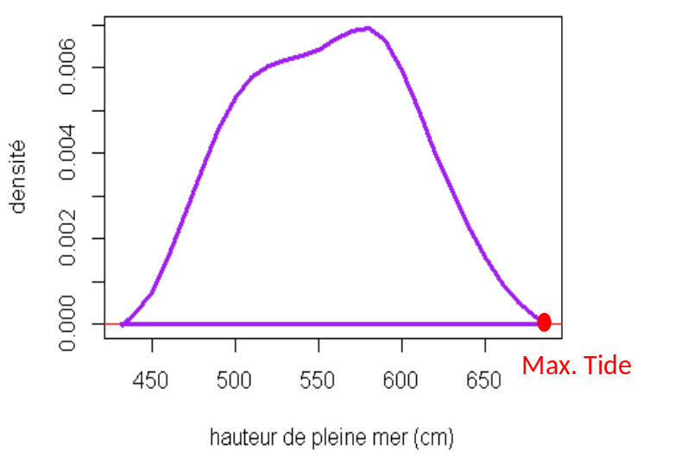

The theoretical tide is currently determined by national organisations on the basis of series of measurements at tidal gauges, mainly installed in harbours. For a site distant to the reference harbour correction can be needed to allow for the difference in the theoretical tide between the site and the reference harbour.
As frequently occurring phenomena, high tide or springtide should not pose threats to a nuclear installation by themselves. However, given their more frequent occurrence, they may well contribute to the overall level of a hazard by being coincident with extremes of other phenomena such as storm-surge or tsunami. High tide should be addressed in all combinations defining extreme sea conditions (water level, tsunami, wind-wave etc.).
The change in mean sea water level should be accounted of when analyzing sea level time series, and when defining future sea level. It can be extrapolated on the basis of Panel on Climate Change reports, supplemented by regional study to addressed regional trends, and by statistical analysis on local observations.

Tsunami (N7)
The hazard is defined by flooding by a series of water waves caused by the displacement of a large volume of a body of water typically by earthquake, landslide, or volcanic sources. All oceanic regions and sea basins of the world and even fjords and large lakes can be affected by tsunamis.
Three general types of geologic events capable of generating tsunamis are generally investigated: earthquakes, submarine and subaerial landslides, and a variety of mechanisms associated with volcanism. For each of these tsunami sources, there are different subtypes. Other less common tsunami sources are asteroids and atmospheric disturbances (meteotsunami [14]).
Earthquakes are most common source of tsunamis, where dip-slip earthquakes (with vertical movement) are more often tsunamigenic, than strike-slip earthquakes (with horizontal movement). Only large magnitude earthquakes (M>6.5) will typically generate observable tsunamis. The typical tectonic environment is a subduction zone, and, occasionally, other oceanic (not classified as subduction zones) convergence boundaries.
Submarine and subaerial landslides occur as many types, depending on geologic composition, slope steepness, triggering mechanism and pore pressure [15]. Style and time-history of slope movement needs to be tracking. Subaerial landslides tsunamis occur in more geographically restrictive area (like fjords). However, the impact velocity of subaerial landslides can be greater than for submarine landslides in deeper water. Tsunamigenic subaerial landslides can be triggered by earthquakes or active volcanism.
A variety of mechanisms associated with volcanoes have been known to generate tsunami historically. Any volcano located near or in the world’s oceans can induce a tsunami. General source types are: pyroclastic flows into the ocean, submarine caldera collapse, submarine explosion, debris avalanches and flank failures, and some others. Their combination is also possible, like Krakatau or Santorini.

Key input parameters are related to the tsunami source, the wave propagation from the source up-to the site, and effects at the coast. They are the following:
- source: location, geometry, cinematic (for instance for earthquake: active faults are classically characterized with their 3D geometry, sense of slip, chronology of past earthquakes, and slip-rate data);
- propagation: bathymetry (should be more detailed for shallow-water);
- effects at the coast: bathymetry, topography.
Output of the hazard assessment
- Run-up (maximum height above ambient sea level to which the tsunami wave rises onshore);
- inundation (maximum horizontal distance from the shoreline where tsunami penetrates);
- drawdown (minimum water level at the shoreline) and the duration of the drawdown below the intake.
Other tsunami associated phenomena should be considered regarding site specific conditions: seiche in the harbour and/or the intake passage, movement of sediment, and ground uplift and/or subsidence due to the movement of a fault.
Methods commonly applied
Tsunami hazard can be analyzed from the deterministic and probabilistic points of view. The first case consists of taking the worst credible tsunami case, which is usually derived from the historical tsunami data in the study zone. In the second case, the probabilistic point of view, a selected series of tsunami events are combined using empirical or computational methods. The selection of each approach greatly depends on the completeness of data, the scale and the objectives of hazard analysis. The probabilistic approach allows the hazard assessment for the regions or sites with scarce tsunami data. The probabilistic assessment applied for region-wide analysis can be followed by deterministic specific-site assessment. The objectives can be summarized as follows:
(1) to condense the complexity and the variability of tsunamis into a manageable set of parameters, and
(2) to provide a synopsis of the tsunami hazard along entire coastlines in order to help identify vulnerable locations along the coast and specific tsunami source regions to which these vulnerable locations on the coastline are sensitive [16].
Deterministic assessment methods were dominant up through the early twenty-first century [17]. More of these methods entailed determining the worst-case or maximum credible tsunami for a particular region. Seismogenic sources were defined by estimating the largest possible earthquake rupture for seismic zones that have the potential to affect a target site by a tsunami. Landslide sources have also been used in deterministic analysis, and often are the worst-case sources in non-subduction zone regions [18].
Probabilistic Tsunami Hazard Analysis (PTHA) aggregates all possible sources to determine an exceedance run-up for a particular design probability. Early studies are based on different assumptions (e.g. [19] and [20]). A surge of PTHA studies started in the early 2000s up to present (e.g. [16], [21], [22], [23] and [24]).
PTHA methodology was born directly from PSHA (Probabilistic Seismic Hazard Analysis). Development of PSHA methodology paved a way for a new multidisciplinary field of catastrophe risk modeling in the late 1980s to early 1990s, with building of computer –based models for quantifying probabilistic catastrophe risk.
PSHA is started by Cornell in 1968 [25]. More, the PTHA generally follows the PSHA. There are the three main steps in the probabilistic seismic analysis:
(1) specification of the earthquake source parameters and associated uncertainties,
(2) specification of attenuation relationships (involve empirical analysis of existing data of ground motions),
(3) probabilistic calculations giving the outputs of analysis.
Most of the recent PTHA studies are based solely on seismogenic sources. Most recently, non-seismogenic sources have also been included in PTHA.
From the beginning, the probabilistic assessment methods have handled uncertainties. Evaluating uncertainties help to focus research on the parameters that really matter. Evaluation of model uncertainty is a key component of any hazard assessment. Because small errors in estimated model parameters and/or minor deviations from model assumptions could result in large errors when using the model to extrapolate beyond the range of recorded events, the degree of uncertainty in the model, and the effect of such uncertainty on evaluating the potential hazard, must be quantified [26]. Sensitivity analysis is an important tool in evaluating how limits on model inputs impact the model output. If the estimated hazard is not sensitive to uncertainties in the inputs, the model is robust and further data refinement is not required. However, if the estimated hazard is found to be particularly sensitive to uncertainties in certain inputs, this can be used to help focus additional research efforts.
PTHA are also complex and computationally intensive, cause a number of source parameters. The main difference between the different computational PTHA relies on the fact that some of them are used to analyze the tsunami hazard in a specific zone of coastal region [19], [27]. However, other methods, like the Monte-Carlo based methods [28] [29] [30] or logic-tree approaches [21], [31], [32] are used to analyze the hazard in a whole coastal region.
Two types of analysis can be applied: empirical or computational. Empirical analysis is based on historical records and catalog completeness. No a priori knowledge of source type location is needed to calculate probabilities [33]. The probabilistic empirical analysis is carried out, in general, in a particular location where historical records of tsunami run-up and amplitude data are available. Computational PTHA relies on knowledge of source parameters, recurrence rates and their uncertainties. This approach is valuable with a few historical data or many possible sources, and should be preferred to assess very low probability hazards. Because in most places around the world historical tsunami run-up records are scarce, computational based PTHA is usually applied. The computational methods can be applied in regions with scant historical records and can include parameter sensitivity estimates in the analysis.
The end product of PTHA is a tsunami hazard curve that plots the exceedance probability as a function of tsunami amplitude or run-up at a particular site. The tsunami hazard curves are calculated by combining the tsunami source model giving the tsunami generation probabilities trough the source frequencies and the tsunami height estimation trough tsunami propagation (see Figure 13 [21]).
Figure 13 of [21] as shown below: Process for obtaining fractile hazard curves (Figure 3-4).
(a) Distribution of 72 tsunami hazard curves obtained for one tsunami source by the logic-tree. The vertical broken line indicates a tsunami height of 3 m, along which the cumulative weight curve in (b) is calculated.
(b) Relationship between annual probability and cumulative weights at a tsunami height of 3.0 m. Dashed horizontal lines indicate five fractile levels (0.05, 0.16, 0.50, 0.84 and 0.95) that will be used to draw curves in (c).
(c) Fractile hazard curves obtained by connecting the probabilities with the same fractile values for different tsunami heights. Five fractile values from 0.05 to 0.95 shown here are usually used.
Figure 3-4: Process for obtaining fractile hazard curves [21]
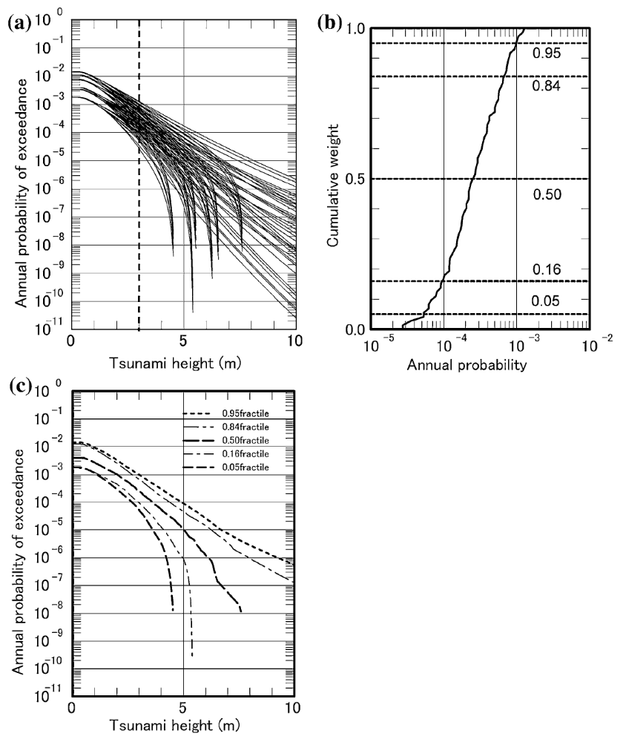

Storm surge (and associated waves) (N19, N20)

Sea water level definitions
A storm surge is the abnormal rise in the mean seawater level during a storm. It is measured as the height of the water above the normal predicted astronomical tide. The surge is caused primarily by meteorological factors a storm’s winds pushing water onshore and depending on the type of storm, especially in case of a hurricane or the low atmospheric pressure. The amplitude of the storm surge at any given location depends on the orientation of the coast line with the storm track, the intensity, size, and speed of the storm; and the local the depths and shapes of the underwater terrain (bathymetry or “submarine topography”).
The storm tide is the total observed seawater level during a storm, resulting from the combination of storm surge and the astronomical tide. Astronomical tides are caused by the gravitational pull of the sun and the moon and have their greatest effects on seawater level during new and full moons—when the sun, the moon, and the Earth are in alignment: the so called spring-tide. As a result, the highest storm tides are often observed during storms that coincide with these spring-tides.
A storm can alter the timing of high tide as is illustrated in figure above. Skew surges are defined as the difference between the maximum sea level and the maximum astronomical tides around a tide cycle maximum. Note that instantaneous surges might be affected by errors due to the potential shift in time of the two series. The instantaneous surges might be depending on the astronomic tide level at which they are observed, while this correlation is lower for skew surges, since they are always observed at the maximum tide. Instantaneous surges are defined as surges estimated as the difference between sea level and astronomical tides at a given time, t, as illustrated by the residuals.
Figure 3-5: Strom Surge
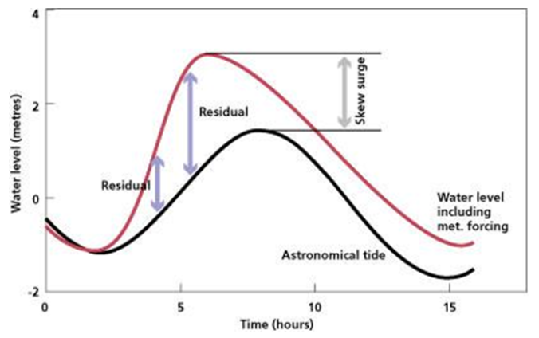
Good practices exist for the extraction of instantaneous and skew storm surges. In particular, eustatism shall be taken into account.
Characterisation of the extreme surges
Methods commonly applied. Extreme Value Analysis of surges (Coles, 2001 [34]), Regional Frequency Analysis of surges (see Hosking and Wallis [34], 1997, Weiss, phd, 2014 [35])
Event modelling. Ex. Telemac modelling of storms surges
Extreme Value Analysis of surges and the regional Frequency Analysis of surges allow the estimation of a surge intensity frequency curve. Note that the curve will be site dependent even in the framework of the Regional Frequency Analysis
The extreme still sea level is the sum of tide and surge, without wave action (wave height).
The sum of tide and surge may be estimated by (1) convolution through a Joint Probability Model (Dixon and Tawn, 1994 [36]) or (2) Simple addition of extreme tide and extreme surge (RFS, 1984 [38]).
The extreme sea level might also be directly estimated via an EVA application to the extreme sea level data (3) (direct approach). This approach is not recommended if the tidal range is not negligible compared to the surge magnitude.
In the cases (1) and (3) the outcome will be the estimation of the intensity frequency curve, while in the case (2) one value of extreme sea level will be estimated but it will not be associated to a given probability of occurrence.
These data (series) form the basis for the flooding frequency analysis. However, for the water level at the site other phenomena and processes have also to be taken into account.

Processes to consider
Several processes can be involved in altering tide levels during storms. In the first place, the earlier mentioned two meteorological factors: the pressure effect, and the direct wind effect. Secondly, there are the effect of the Earth's rotation, the effect of waves (wave height and wave run-up), the rainfall effect [15], bathymetry, and the effect of nearby storm surge barriers. In the third place, long time effects as 1) rise of the mean sea water level, and changing frequencies and magnitudes of storms as result of the global climate change, and 2) fall of the land should be considered.
The pressure effects
The pressure effects of a storm will cause the water level in the open ocean to rise in regions of low atmospheric pressure and fall in regions of high atmospheric pressure. The rising water level will counteract the low atmospheric pressure such that the total pressure at some plane beneath the water surface remains constant. This effect is estimated at a 10 mm increase in sea level for every hPa (i.e. hectopascal, 1hPa = 100 Pa) drop in atmospheric pressure [40].
Wind set-up
Wind stresses cause a phenomenon referred to as "wind set-up", which is the tendency for water levels to increase at the downwind shore, and to decrease at the upwind shore. Intuitively, this is caused by the storm simply blowing the water towards one side of the basin in the direction of its winds. Strong winds (wind stresses) along the surface cause surface currents at a 45 degree angle to the wind direction, by an effect known as the Ekman Spiral. Because the Ekman Spiral effects spread vertically through the water, the effect is inversely proportional to depth. The pressure effect and the wind set-up on an open coast will be driven into bays in the same way as the astronomical tide [40].
Coriolis effect
The Earth's rotation causes the so called Coriolis effect, which bends currents to the right in the Northern Hemisphere and to the left in the Southern Hemisphere. When this bending brings the wind generated currents into more perpendicular contact with the shore it can amplify the surge, and when it bends the current away from the shore it has the effect of lessening the surge [40].
Wave set-up
Next to the general set-up of the water level, strong wind whips up large, strong waves in the direction of its movement, which increases the maximum water level to consider [40].
Wave height
Waves may be classified in short and long fetch waves. The fetch being defined as the horizontal distance over which wave-generating winds blow. Short fetch waves are waves generated by the wind when a short fetch is available for the wave generation. This is the case in closed harbours or on rivers. Long fetch waves are waves generated by the wind when a long fetch is available for the wave generation. This is the case for open shoreline facing the ocean. Long fetch waves are characterised by the significant wave height (SWH or Hs) and 1% wave height. The significant wave height is the mean wave height (trough to crest) of the highest third of the waves (H1/3) for a given sea state. The 1% height is the average height of the upper 1% of the wave heights in a wave record.
Short fetch waves are estimated using coastal engineering equations linking wind and water level with short fetch waves [41].
Long Fetch waves may be estimated using EVA or Regional Frequency Analysis directly applied to buoy data or to big reanalysis dataset. The outcome of the estimation will be a full intensity frequency curves both for EVA and RFA.
Wave run-up
Although these surface waves are responsible for very little water transport in open water, they may be responsible for significant transport near the shore. When waves are breaking on a line more or less parallel to the beach, they carry considerable water shoreward. As they break, the water particles moving toward the shore have considerable momentum and may run up a sloping beach to an elevation above the mean water line which may exceed twice the wave height before breaking [40]. If they are breaking into a vertical construction as for instance a water intake structure or a levee the height the waves can reach will be much larger.
The amount of wave run-up is influenced by the wave height, the wave period and the slope.
Rainfall
Storms may dump large amounts of rainfall in 24 hours over large areas, and higher rainfall densities in localized areas. As a result, watersheds can quickly surge water into the rivers that drain them. This can increase the water level near the head of tidal estuaries as storm-driven waters surging in from the ocean meet rainfall flowing from the estuary [40].
Bathymetry/topography
Surge and wave heights on shore are affected by the configuration and bathymetry of the ocean or sea bottom. A narrow shelf or one that has a steep drop from the shoreline and subsequently produces deep water in proximity to the shoreline tends to produce a lower surge, but a higher and more powerful wave.
Conversely, coastlines such as the Dutch North Sea coast, the Gulf of Mexico Asian coasts such as the Bay of Bengal, have long, gently sloping shelves and shallow water depths. These areas are subject to higher storm surges, but smaller waves.
This difference is because in deeper water, a surge can be dispersed down and away from the hurricane. However, upon entering a shallow, gently sloping shelf, the surge cannot be dispersed, but is driven ashore by the wind stresses of the hurricane.
In addition, the topography of the land surface is another important element in storm surge extent. Areas, where the land lies less than a few meters above sea level are at particular risk from storm surge inundation [40].
Another issue to consider is the fact that for a given topography and bathymetry the surge height is not solely affected by peak wind speed. The size of the storm also affects the peak surge. With any storm, the piled up water has an exit path to the sides and this escape mechanism is reduced in proportion to the surge force (for the same peak wind speed) as the storm covers more area [42].
Climatological effects
Given the usually long life time of a NPP long term effects from the global climate change should be taken into account. These effects are the rise of the mean sea water level, and changing frequencies and magnitudes of storms as result of the global climate change. The magnitude of the impact is very site dependent. Although climate change is a generally accepted phenomenon, the speed and magnitude of change and its impact on storm frequency, rainfall and seawater rise is still under debate.
Land fall
Land fall or subsidence can be result from several causes: 1) by a tilting movement of tectonic plates, as is the case in northern Europe where as a result of the last ice age Scandinavia was pushed down by the enormous mass of ice and the area south of Denmark pushed up. Since the ice in Scandinavia is gone this process reversed; 2) gas and salt exploration and 3) lowering the ground water level. Depending on the soil type this can cause significant settlement effects over a long period of time
In the northern part of the Netherlands, there are areas that have experienced a settlement of 30 cm, with a maximum of about 1 cm per year. The cause is gas exploration. Ground water control in peat rich areas have resulted in a settlement through an oxidation process of 30 cm per decennium.

Example of storm surge hazard assessment including protection failure
The starting point of assessment of the storm surge hazards are data relating water levels (including wave action) with frequencies. These hazard curves) are site dependant. Especially in estuaries, the water levels with the same return frequency can differ significantly within kilometres. Generally, less straight forward than the initial flood levels, is determining the initiating event frequencies for floods that should be taken into account in the PSA model. This requires some sort of translation/transition from the water levels off-site to the critical water levels on site and inside the buildings. A number issues influence this translation:
- The presence or absence of external flood defences, as dikes, dunes, levees; an important aspect is the conditional failure probability of the external flood defence;
- The way the flood defence fails;
- The duration of the flood in combination with the flood height;
- The site characteristics:
  - the height of the site as compared to the sea and to its surrounding area, and;
  - the area that can flooded.
The issues 2, 3 and 4 determine the water level that is reached behind the failed flood defence. All issues lead to a reduction of the initiating frequency. The first issue results in a reduction factor on the initiating frequency at a given water level. The remaining issues make that a higher water level (with a lower frequency) is needed off-site to obtain a certain water level on site. The next paragraphs will elaborate this.
Failure of external flood defences
External flood defences can fail in different ways. Although it looks like the most obvious mechanism, overtopping is not the only and not per definition the dominant failure mechanism of a flooding defence. External Flood defences can be divided is different types, each with specific failure mechanisms. Distinction can be made between dikes, dunes and engineered structures as locks, sluices, and levees.
Failure of dikes
The main failure mechanisms of dikes are illustrated in Figure 3-6. They are overtopping, macro-stability, water-side erosion and piping.
Figure 3-6: Main failure mechanisms of dikes
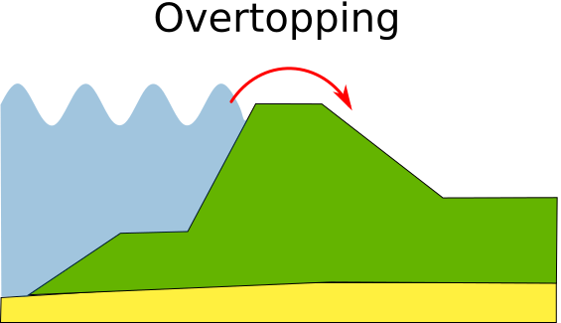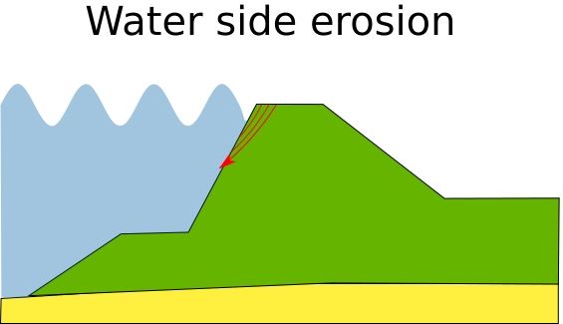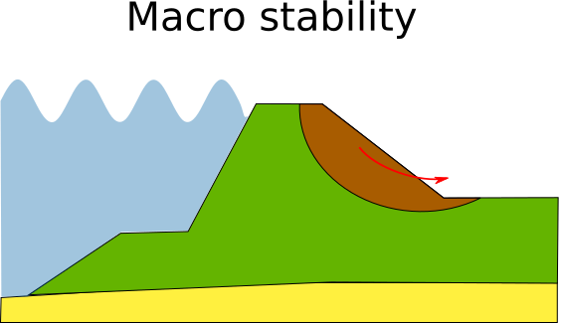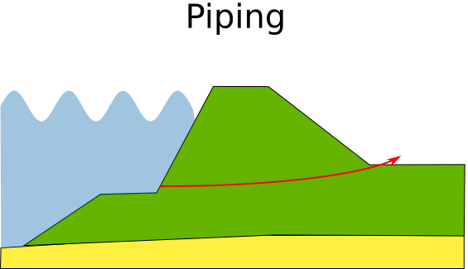

Overtopping: in this case, the dike fails because large amounts of water overrun the dike; the dike is simply not high enough;
Macro-stability: the dike becomes unstable by water penetrating and saturating the core of the dike. As a consequence the inside slope of the dike starts sliding under the sea or riverside water pressure;
Waterside erosion: the top layer (grass plus clay, stone, tarmac) is damaged by wave attack. Once this protective top layer is gone, the main dike structures are eroded away.
Piping: the water pressure forces water under the clay layer that covers the main structure of the dike or under the clay layer that forms its foundation. So called pipes form and the sand in or under the dike is washed away causing the dike to collapse. Piping also plays a major role where for instance the pipework of the ultimate heat sink penetrates the dike and no design precautions e.g. in the form of addition screens, are taken to counteract this mechanism.
Failure of dunes
The main failure mechanism of dunes is illustrated in Figure 3-7: seaside erosion and piping.
Figure 3-7: Failure mechanism of dunes Erosion of dunes

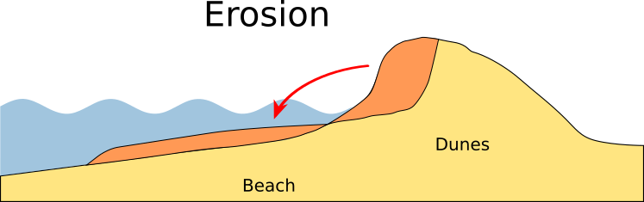

Dunes fail in general simply by the wave action of the sea. Every wave reaching the dune row erodes the dune by removing sand. The erosion speed is influenced by the length and slope of the beach in front of the dunes.

Failure of engineering structures
The main failure mechanism of engineering structures are illustrated in Figure 3-8: overtopping, strength and stability, closure reliability, and piping.

Figure 3-8: main failure mechanisms of engineering structures
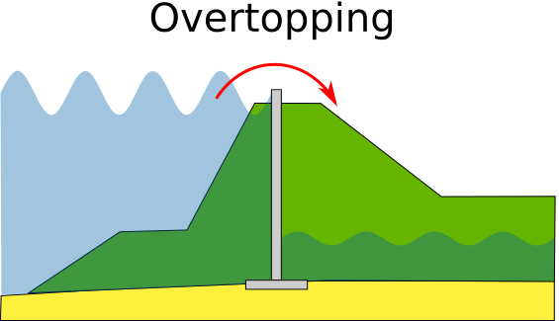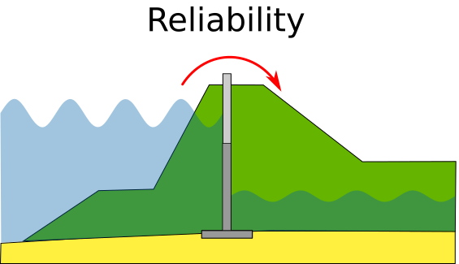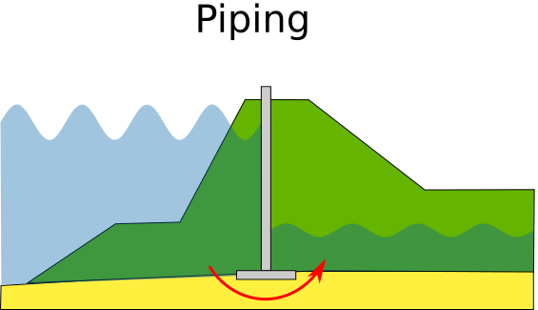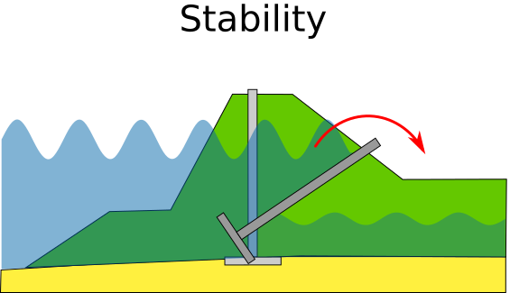

Overtopping: in case of this failure mechanism the moment of failure is reached when a certain amount of water per unit of time overruns the construction. The allowable amount is governed by strength of the underground protection against erosion and the amount of water that can be accommodated behind the structure.
Closure reliability: engineered structures such as locks have to close. Failure is simply defined as failure to close in time, with a resulting flow rate that is to large. The allowable amount is governed by strength of the underground protection against erosion and the amount of water that can be accommodated behind the structure. A standard reliability analysis of the systems needed to close the structures; including support systems like those, that electricity is needed.
Piping: the water pressure forces water under the foundation and its protective ground cover. The stability of the structure is threated by sand and clay washed away. This failure mechanism describes the situation that the strength of the construction is insufficient to cope with the forces as result of the difference in water height on both sides of it. Three different failure modes scan be distinguished: Failure of the retaining means (doors etc.), failure of the complete abutment, and ship collision. Piping also plays a major role where for instance the pipework of the ultimate heat sink penetrates the dike and no design precautions e.g. in the form of additional screens, are taken to counteract this mechanism, see Figure 3-9.

Figure 3-9: Piping failure mechanism for dikes and dunes

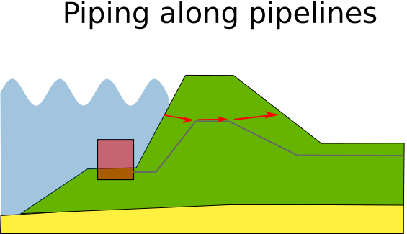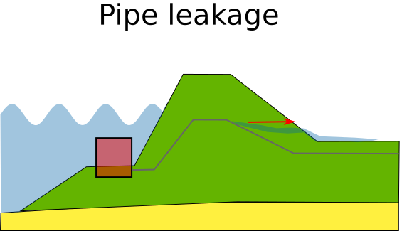

From the description of the possible failure mechanisms it will be clear that flood defences can and will fail at water levels below their maximum height; e.g. before overtopping becomes the dominant failure mechanism.

Definition of failure of a flood defence
When trying to quantify the probability of failure a definition of what is a failed defence, is necessary. In all cases, failure is defined as the condition that the amount of water passing the flood defence exceeds a predefined amount. Before this amount is reached the water that passes the flood defence will not lead to problems behind the defence. For a dike for instance it signifies the starting point of the development of a breach. From this point on it will take time to develop a full size breach.
To obtain the (conditional) failure probability the structural reliability of the flood defence is calculated by evaluating the resistance of the flooding defence against the possible failure mechanisms (being the strength of the flood defence) initiated by the high tide (being the stress on the flood defence). Interactions between the different failure modes are taken into account. Parameters influencing the strength of the flooding defence are the dimensions (e.g. width, height, the inside and outside slope of dike), the material used for the underground, the core, and top layer (clay) and cover (grass, tarmac, cobbles, stone), density and grain size distribution of the sand and clay, permeability, subsoil type etc. For dunes and sea dikes the slope of the sea bottom and the width of the beach play an important role. Mean water level, wave height, wave frequency and wave direction are factors that determine the stress.
In Table 3-3 an example of the output of the calculation for a section of a sea dike at a given storm surge level is presented. It shows that erosion of the outer slope at the locations with a grass cover dominate the probability of failure. Overtopping is not a major concern. Which of the mechanisms is dominant, changes with the water level. It will be clear that overtopping will become more and more dominant when the water level comes nearer to the height of the dike. Also, the type of flooding influences the dominant failure mechanism. In case of river dikes the stability of the dikes is a major concern, piping and macro-instability are in general the dominating failure mechanisms. There will in general be less dynamic attack by waves, but the much longer time water will stand against the dike, as compared to high water levels at sea, can cause saturation of the core of the dike and thus instability and the one sided water pressure promotes piping.
Table 3-3 : Example of a conditional failure probability, total and per failure mechanism,
for a flooding height of 2.9 m.
Failure mechanism | Failure Prob. | Combined  Failure Prob.
Overtopping | 2.9E-08 | 9.9E-07
Sea side erosion: stone cover | 8.6E-10 | 9.9E-07
Sea side erosion: grass cover | 9.4E-07 | 9.9E-07
Piping | 1.2E-08 | 9.9E-07
Macro stability | 1.3E-08 | 9.9E-07

Based on the failure mechanism of interest a fragility curve has to constructed for the flood defence under consideration. Figure 3-10 gives a result of a complete set of stress strength evaluations of a dike section over a range of water levels for an example river dike. A s expected the conditional failure probability is very low for normal water levels between 0 and 2m above the local reference level. It approaches unity when the water level tends towards the maximum height of the dike (6.3m).

Figure 3-10 : Conditional failure probability of a dike as function of flood level
[m above reference level]
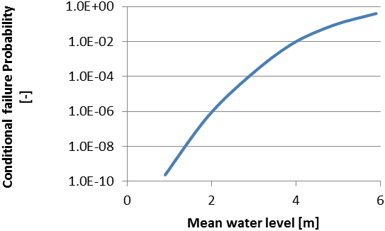
Water level on site
Given a failure of the flood defence, the water level on site is determined by two factors: the amount of water that can enter the site through the failed location and the amount of water that is needed to reach a certain water level on site.
- Breach calculations
The amount of water that can enter the site is depending on the duration of the high water level, and the size of the breach. High water levels in a river caused by for instance melting snow or heavy or prolonged rain can last for a long time (several days to over a week), while high flood levels on sea are mostly limited by the duration of the storm and the normal tide (12 - 48 hours). Also, the breach size and thus the amount of water that can enter the site is a function of time. Time is needed for the process of developing a breach and for the growth process of a breach.
Erosion starts - for instance, depending on the dominant failure mechanism - at the inner slope by the small amounts of water that are flowing down. The inner slope will erode until the crown of the dike is reached. The amount of water entering the site will remain small and constant until the crown of the dike is completely eroded away and the height of the dike starts dropping and the breach starts growing in width. This growth will stop when the flow rate of water through the breach is so low that no further erosion is possible.
As this process takes time and the speed it develops increases with increasing water level, it is imaginable that - certainly at lower flood levels at sea - the breach has no time to develop fully before the flooding level at sea drops. This means that although the flooding defence has failed no water will enter the site.

- Basin calculations
If a full breach develops, the next step is to evaluate the resulting water level on site taking into account the surroundings of the site. Factors to consider are the size of the area that is open to flooding, its elevation with respect to the normal mean sea level, secondary flood defences, and the height differences within the flood threatened area. Also, in this case it is possible that flooding levels will be very limited, as the amount of water available could limited in relation to the available area.
An example result of such an evaluation (from breach and basin calculations) is given in Figure 3-11. For instance, a flood level outside of the flood defences (blue line) of 4 m corresponds with a water level on site of approximately 2.8 m (red line). The corresponding conditional probability of the flood defence failing at these levels is 1E-4. Outside flood levels below approximately 2.1 m do not result in significant amounts of water on site, because although the flood defence fails, this relatively low water level has no potential to form a breach of any significance.

Figure 3-11 : Relation between water level on site (red line), and the flood level (blue line)
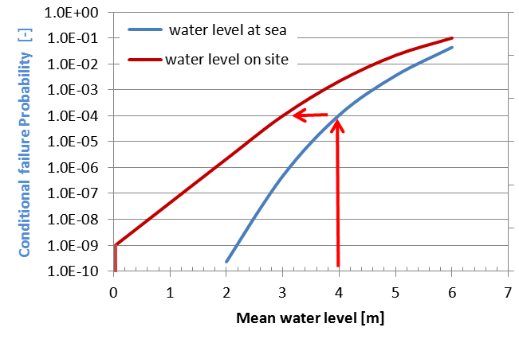
Initiating event calculation
The last step in the process is to obtain the initiating event frequencies for identified threatening water levels on site (plant flooding scenarios). This is done by combining the conditional failure probability given a certain water level on site from figure 5 with the exceedance frequency from figure 2.
The process is illustrated in the two figures below. Suppose the following flooding scenario: off-site power is lost at a water level of 3m on-site (red arrows in figure 6) and that additional systems fail at 4.4m on-site (green arrows in Figure 3-12). The loss off-site power situation then exists between off site water levels of 4 and 5.1 m with a conditional probability of failure of the dike varying between approximately 1E-4 and 7E-3. The accompanying exceedance frequencies lie roughly between 5E-2 and 5E-4 (red and green arrows in Figure 3-13).
Figure 3-12 : Relation water level on site and the flood level:
red arrows: start of flooding scenario, green arrows end of scenario

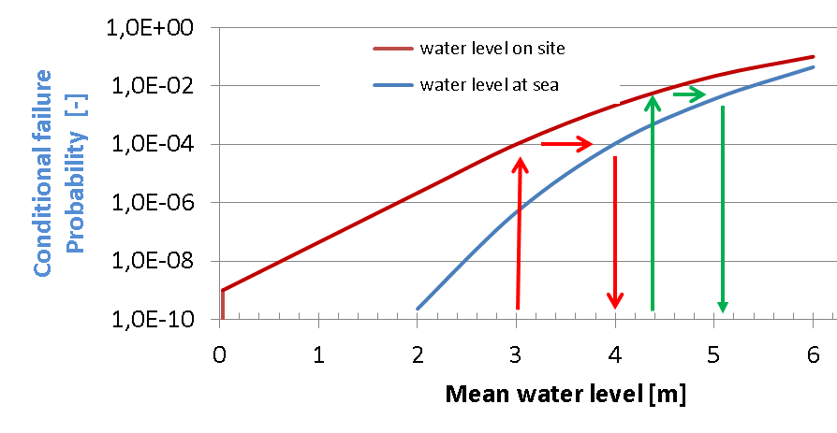
Figure 3-13 : Exceedance frequency: red arrows:
start of scenario, green arrows end of scenario
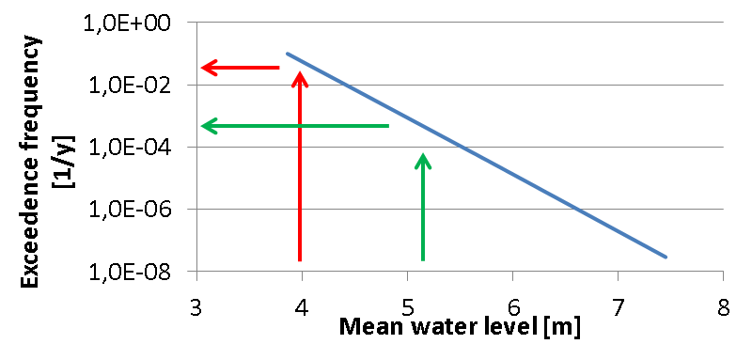
The resulting initiating frequency for loss of off-site power due to flooding is approximately 2.3E-5 per year. This value is calculated by discretising the exceedance curve between 4m and 4.8m resulting in an approximated frequency per water level, multiplying these frequencies with their the corresponding conditional failure probabilities and summing the results. This process is illustrated in Table 3-4.
Table 3-4 : Initiating frequency of LOSP scenario caused by external flooding
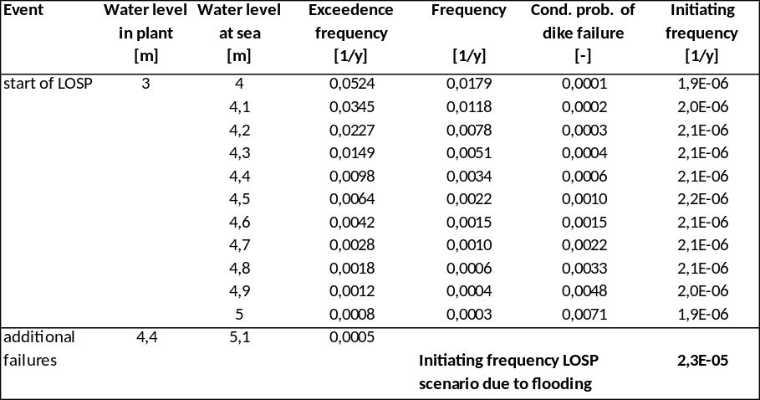

Seiche (N16)
A seiche (or meteo-tsunami) is a standing wave in which the largest vertical oscillations are at each end of a body of water with very small oscillations at the "node," or center point, of the wave. Seiches and seiche-related phenomena have been observed on lakes, reservoirs, swimming pools, bays, harbours and seas. The key requirement for formation of a seiche is that the body of water be at least partially bounded, allowing the formation of the standing wave.
Seiches, are typically caused when strong winds and rapid changes in atmospheric pressure push water from one end of a body of water to the other. When the wind stops, the water rebounds to the other side of the enclosed area. The water then continues to oscillate back and forth for hours or even days. In a similar fashion, earthquakes, tsunamis, or severe storm fronts may also cause seiches along ocean shelves and ocean harbours.
The appearance of a seiche requires next to a small scale jump in atmospheric pressure caused by a local depression or a frontal system of heavy showers, a shallow body of water, and a perpendicular direction towards an (semi) enclosed body of water. The atmospheric disturbance causes long waves. These waves can grow depending on the fact if their frequency corresponds to the resonance period or the length of the sea basin. To create a standing wave, the frequency of those long waves should correspond to the resonance period of the (semi-) enclosed water body.
How often seiches occur and what is their magnitude, is very site dependent and local data should be used to assess the hazard.
Regarding N14 flooding hazards i.e. flood resulting from large waves in lakes induced by volcanoes, landslides, avalanches or aircraft crash in water basins; the project participants have no experience in the domain.

Assessment of hazard specific to river sites

Floods resulting from snow melt and precipitation on large watersheld (N9, N10)

Floods resulting from snow melt and precipitation on large watersheld (N9, N10)
Large watersheds (>5000km²), with consequently large rivers, are very complex system, where floods are driven by manifold different phenomena. Precipitation is a first obvious triggering phenomena, but unlike for the small watershed (<5000km²) where flash floods are a direct and almost instantaneous consequence of precipitation, on large watersheds, the floods may occur several day after the rainfall (this lag is known as time of concentration). Moreover, the antecedent soil moisture, the river network geometry, the presence of lakes or reservoirs, the hydraulic phenomena such as the flooding plains or the presence of dikes, may impact the time and the magnitude of the flood. Temperature plays an important role as well, because floods may be triggered (or amplified) by snow melting.
Hydrological model has been widely used in the past for modelling the rainfall runoff transformation. Several classes of hydrological models exist nowadays (lumped vs distributed) including the modelling of a very large range of phenomena among those depicted below. A proper modelling for a large watershed shall also include the hydraulic (1D or 2D) modelling of the branch of river of interest in order to take into account the hydraulic phenomena that might change the flood magnitude at the site of interest.
A single extreme event modelling could thus be used for simulate a flood scenarios based on some extreme hypothesis on the amount of rainfall over the catchment, snow melting, antecedent soil moisture. The Probable Maximum Flood methods are based on this approach. In this case the scenario is not associated to a given probability of occurrence or frequency but it is supposed to be the maximum scenario.
More sophisticated approached based on Monte Carlo simulations of full numerical modelling of the watershed has been suggested recently (i.e. SCHADEX approach by EDF or the Stochastic Event Flood Modelling, SFEM), which allow to provide full intensity duration frequency curves for the river discharges. We suggest here to carefully double check the hypothesis of application of these approaches before using, in particular on the maximum size of the watershed that can be reasonably modelled in this framework.
Obviously, for a quick estimation of extreme discharge, avoiding the analysis of the complexity of phenomena involved, an extreme values analysis on the annual maxima or peak over a threshold of the discharge observed at the site of interest may be suggested and was widely applied in the past. The extrapolation toward the rare frequency, in this case, shall be carefully commented and validated in order to avoid predicting discharge values which are not in line with the physical understanding of the phenomena. In particular, specific care shall be put in the estimation of the shape parameter and on the evaluation of an eventual upper physical limit of the discharge to be considered. This approach allows providing full intensity duration frequency curves for the river discharges.
In the probabilistic framework, the estimation may be made more robust by the use of regional data, through a RFA (Regional Frequency Analysis). This technique consists in using data for several rivers within a homogeneous region to improve the estimation of the site of interest discharge. It has been applied since the 1960 and a wide list of reference can be found in the scientific literature.

Floods resulting by failure of water control structures and watercourse containment failure (N15)
Methods commonly applied. Hydraulic modelling of dam breaking.
The simulation of the collapse of the larger dam upstream the NPP might be done to model the floods resulting from failure of containment failure. Important parameter for the simulation are: the dam volume, the morphology description of the river downstream the dam and upstream the NPP. Hydraulic 1-D and 2-D models (TELEMAC, MASCARET) might be used. Few examples in the world of case studies for dam breaking exist. The most famous in France is the collapse of the Malpasset dam.
Due to the nature of the exercise, it will be impossible to describe a full intensity frequency curve of the flood discharges or water level. Only one simulation will be available and the probability to be associated to this simulation will be challenging to estimate.

Floods resulting from bores (N17)
Tidal bores are waves travelling up a river induced by flood tide. These waves move upstream over the entire width of the river and opposite to the normal direction of river flow. This phenomenon is characteristic of funnel-shaped estuaries with shallow depths at low water. In general a large tidal range is required (typically more than 6 metres) and incoming tides are funneled into a shallow, narrowing river or lake. The funnel-like shape not only increases the tidal range, but it can also decrease the duration of the flood tide, down to a point where the flood appears as a sudden increase in the water level. A tidal bore takes place during the flood tide and never during the ebb tide. However, in many estuaries and rivers, works have been performed for river regulation and shape of the estuaries has been modified in order to prevent bore development. Then, in general, tidal bore is not a concern for existing NPP sites (it’s in particular the case for German and French estuary sites), and is no more addressed in the following.
Mechanically induced hydraulic waves can form in a channel or a reservoir in the vicinity of a dam or a discharge control structure, such as a hydroelectric plant. Waves are induced when a discharge passing through the structure is suddenly stopped (e.g. due to a load rejection at a hydroelectric power plant). The waves likewise move upstream through the channel or reservoir and opposite to the normal direction of river flow. The wave height can be amplified by a reduction of the channel cross-section and by reflection from structures and shorelines. When a positive wave travels against a current, the wave front tends to steepen. Beyond certain steepness, a series of undulations superimposed on the main wave is observed. These undulations are known as "Favre waves", or undular bores, or secondary waves (as shown in Figure 3-14 and Figure 3-15).
It should be also considered that malfunctions of hydraulic structures (upstream and downstream) can lead to a difference between inflow and outflow of the channel and cause a rise in the water level at the site due to water storage in the channel.

Figure 3-14 : Wave generation by partial closure of a gate

Figure 3-15: Wave generation by total closure of a gate
V
c
h
H

Key input parameters
The possible “sources” of mechanically induced hydraulic waves should be identified, both downstream and upstream of the site. In this process, it should be considered that malfunctions of hydraulic structures (upstream and downstream) can lead to a difference between inflow and outflow of the channel and cause a rise in the water level at the site. The pumping station of the NPP is also a possible source for such waves, but should be addressed in the framework of internal flooding analysis.
Mechanically induced wave scenario(s) that could affect the site should be defined considering the hydraulic structure operating instructions. The maximum level reached as a result of the mechanically induced wave is closely related to the initial water levels and discharge rate (just before sudden change) and depends on the channel geometry.
Output of the hazard assessment
- maximum wave height above ambient water level in the channel along the site,
- duration: fast dynamic for secondary waves, slower for principal wave and water storage.
Methods commonly applied
For channels with simple rectangular geometry, the following formula (Ven Te Chow, 1981 [43]) is sufficient to quantify the mechanically induced wave:
h=c.V/g
Where (see figure above):
- h is the height of the mechanically induced wave (m);
- c is the speed of propagation of the mechanically induced wave (m/s), with c = (g.H)^{1/2}, if h<<H;
- V is the average speed of flow before flow cutoff (m/s).
In more complex cases it may be necessary to use mathematical models (1D, 2D or 3D), or even a physical model. It may be necessary to take into account phenomena such as Favre waves, or the edge effects accompanying the main wave.
In a deterministic approach that is the currently used one, the hazard is characterized considering the initial water level and flow rate conditions (i.e. discharge change due to malfunctions of hydraulic structures, taking into account the structure operating instructions) leading to the worst-case mechanically induced wave situation.
In a probabilistic approach, the hazard should be characterized considering the same parameters with associated frequencies of occurrence. As the structure operating instructions are based on water level and flow rate conditions, these frequencies are not independents. Moreover, human actions may affect operating instructions effective results.

Assessment of hazard that could affect both river and coastal sites

Floods resulting from flash flood on small drainage basins and on the site precipitations (N8 and N8’)
Run-off from precipitation is the most common flood hazard, wherever the site is located. Many methods are developed to assess this hazard. They differ particularly in the size of considered drainage basins. As a general trend, it could be observed that small drainage basins are the domain of methods based primarily on precipitation characterisation when studies of large drainage basins benefit from discharge observations. Precipitation falling on the site and on the upstream drainage basins require also different flood protection measures (typically site grading design to control flow direction and drainage system for local precipitation, and elevation of the site, for flood due to precipitation in rivers or nearby drainage basins), and then different hazard parameters for the design.
In order to characterise the flood resulting from onsite precipitation and precipitation on small drainage basins (1) estimations of the extreme precipitations at various time resolutions are needed together with (2) hydraulic modelling of the site and buildings. Various time resolutions should be investigated as flood condition depends on both the amount on water and the duration of the event. Critical durations usually span from 5 minutes for closed platform areas to several hours for small natural watershed.

Key input parameters

Precipitation data are currently available at national meteorological organisations that collect long historical series of measurements. Some of these organisations provide also evaluations of extreme precipitations, which can be relevant for nuclear installations. Rainfall events are characterised by a height of precipitation totalled over a given period of time. As an example, the Figure 3-16 bellow presents an overview of highest amount of precipitation observed over the world for various event durations (based on US-NOAA data).
Figure 3-16: World’s observed precipitation for various event durations
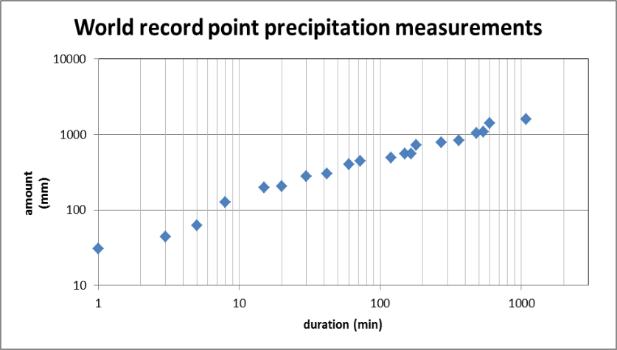

Discharge measurements may be available for some streams, and should be collected as they are a key information for model calibration. They are usually assumed by various operators, in accordance to their specific purposes (hydro-electrical production, flood risk assessment or forecast etc.). It should be recognized that discharge measurement involves some uncertainties in the assessment of a relationship linking water depth and discharge, and needs special attention.
Main data necessary for drainage basin description and modelling are topography, roughness in the flooded area, “loss of water” by infiltration and vegetal interception, exchanges with groundwater flows, and hydraulic controlling structures. In particular, this includes the site layout and drainage system for onsite precipitation. These data are available at national organisations and at local operators, but are generally insufficient and should be supplemented by specific surveys (for example: local detailed topography). Moreover, roughness and infiltration parameters result not from direct measurements but from calculations (hydraulic model calibration) or expert judgements.

Output of the hazard assessment
For on the site precipitation, expected outputs are water heights in front of entrances of buildings that host SSC and water loads on these building roofs, including roof drainage systems.
For small upstream of the site drainage basins, expected output are flood hydrograph along the site boundaries.
For both types of output, the current practice associates probabilities to the causal phenomenon (rainfall or discharge) and not to the resulting flooding parameters.

Methods commonly applied
In order to characterise the flood resulting from onsite precipitation and precipitation on small drainage basins (1) estimations of the extreme precipitations at various time resolutions are needed together with (2) hydraulic modelling of the site and buildings or the drainage basin.
Extreme precipitation could be derived from deterministic or statistical approaches. Typical deterministic approaches are based on the concept of a “probable maximum event”. The probable maximum precipitation, which is determined by accounting for the postulated physical limits of the natural phenomenon, is the greatest height of precipitation for a given duration over a given area at the location of interest (World Meteorological Organisation (WMO), “Manual on estimation of probable maximum precipitation (PMP)”, WMO No 1045, 2009). One key limit to this approach is that the extreme event is not associated with any annual frequency of exceedance, as upper bounds that can’t be exceeded. Statistical approaches are also widely used.
Extreme Value Analysis and the regional Frequency Analysis of rainfall allow the estimation of a precipitation intensity frequency curve for given durations. Several formula link the average intensity ‘i’, the duration ‘t’ and the annual frequency of exceedance ‘F’ of a rainfall event. A classical one is the Montana formula, with two parameters ‘a’ and ‘b’ that depend on the annual frequency of exceedance ‘F’ considered.
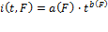
This model is to be used with caution because a particular pair of parameters a and b does not give a satisfactory fit if the range of rainfall event durations is too great.
The flood parameters are quantified using a rainfall-runoff transformation method and run-off modelling in the area of interest (site, drainage basin). The rainfall events can be modelled by design rainfall events (for example Keiffer or double-triangle rainfall patterns), or derived from a rainfall model. Rainfall-runoff transformation aims to derive the amount of water which flow on the area of interest, as part of the water coming from precipitation could be “lost” for example by infiltration in the soil. In some simple cases, methods such as the rational method can be used to derive the discharge rate at the outlet of a drainage basin. In this method, rainfall and drainage basin are described using only three parameters (the uniform rate of rainfall intensity, the drainage area and the runoff coefficient). It is preferable to perform detailed numerical modelling of water flow on the area of interest. This hydraulic model should also integrate the water drainage system to cover the interactions between both surface and drainage system flows. Modelling of the water drainage system should consider: (1) friction coefficients representative of the wear and state of maintenance of the pipes, (2) continuous flow rate discharged into the water drainage system in normal operation, (3) potential for obstruction or malfunctions of the drainage system, (4) level at the outlet of drainage system when influencing drainage capability.
In particular, for small drainage basin rainfall-based statistical approaches have been developed for better consideration on meteorological and hydrological simulation of extreme floods, to derive the discharge rate at the outlet of a drainage basin. Such approaches offer also more possibilities to integrate regional information. These methods aim at stochastically simulating huge number of floods, using rainfall models coupled with hydrological models. These approaches are limited to catchment area smaller than 5000 km², in the present state of the art. For example “Stochastic Event Flood Model” (SEFM) (Schaefer et Barker, 2009 [44]) and “Semi-continuous Rainfall-runoff Simulation for Extreme Flood Estimation” The SCHADEX method [45] are used by dam operators. The output of these methods are discharge rates with associated annual frequency of exceedance at the outlet of a drainage basin. These data are in-put of hydraulic modelling necessary to derive water heights and flood hydrographs at the point of interest.
Hydraulic modelling has to cope with many sources of uncertainties. Moreover, some of them are geographically distributed (for example, topography and roughness). Development of methods to cope with these uncertainties, such as sensitivity analysis, is necessary for probabilistic flood hazard assessment. Sensitivity analysis methods are useful tools as they allow robustness of model predictions to be checked and help to identify input parameters influences. Most commonly, Monte-Carlo approach is performed to propagate uncertainties. Various methods are then available to rank parameters regarding their impact on result variability. The whole process constitutes a Global Sensitivity Analysis (GSA), whose steps are: i) to identify the hydraulic code input parameters of interest and to assign them a probability density function, ii) to propagate uncertainties within the model, and (iii) to rank the effects of input parameters variability on the output of interest variance. In practice, such type of approach is of a great interest, but is still at an exploratory level in applied river flood studies.

Floods resulting from high groundwater (N11)
Ground water level control is a geotechnical issue and should be partly covered in the design. The issue has two sides: the first issue is the stability of the buildings and the second is (area) flooding. Groundwater control is a requirement of the civil engineering design process because high water table levels can cause foundation stability problems for deeply founded structures, and increase forces on structures (tanks, piping and basements) embedded in the ground, which could give rise to floatation and breakage of cables, tanks and piping, and leakage through basement walls and floors into buildings. This aspect of ground water should have been designed out, as the maximum ground water level that is possible is known as ground level. If the ground water level hazards is not adequately addressed in the design a structural assessment of vulnerable buildings, underground piping and tanks will be needed.
Groundwater under the site is primarily controlled by the height of the water table around and under the site, which in turn is driven mainly by rainfall onto the areas surrounding the site, or in case of river site by the water level in the river and by the ground water drainage flows and /or installed drainage pump capacity and sewer systems.
Knowledge of the local hydrogeology shall be based on the acquisition of descriptive data relative to the site and its surroundings (geology, groundwater levels, hydrodynamic data, etc.). The data collected from public organisations shall be supplemented by the results of in-situ measurements. More specifically, piezometric measurements shall be taken over a continuous period that shall never be less than 1 year and shall preferably exceed 3 years, with a sufficiently small time step to characterise the amplitude and speed of fluctuations in groundwater level. The number and location of the piezometers shall enable the local functioning of the groundwater table to be analysed by covering a sufficiently large area, generally extending beyond the site boundaries.
If the conditions at the boundaries of the hydrogeological system are linked to a body of water (sea, lake, etc.) or a watercourse, it is recommended to monitor the change in the corresponding water levels at the same time.
An analysis of the groundwater level fluctuations shall be carried out to identify the behavioural particularities of the groundwater table and to characterise water level rise and fall times.
A high ground water table can cause area flooding by itself or hamper the removal of rain water again resulting in area flooding. In both cases, the capacity of the sewer system in relation to the water influx is a decisive factor. The issue cannot be seen separately from the “on the site precipitation” analysis although a wider area needs to be considered, and possibly the “river flooding” analysis.

common methods for sinGle hazards characterisation
- EVA, Coles (2001) (application to waves, surges, extreme sea level, discharge and rainfall)
- RFA, Hosking and Wallis (1997) (application to waves, surges, discharge and rainfall)
- MEWP, Garavaglia et al. (2011) (application to rainfall)
- JPM, Dixon and Tawn, 1990 (application to extreme sea level and surges)

Hazard combinations
The impact of combinations of hazards on safety functions is assessed as they may affect different safety functions simultaneously or the same function in a more severe manner than from a single hazard. During screening, it should be justified that hazards whose combined impact can result in significant consequences are not excluded from further consideration, even though each of them, considered independently, would make a negligible contribution to risk. The possible combinations of hazards are therefore, identified based on the entire list of individual hazards before any screening analysis is carried out.
The general approach used for the identification of a realistic set of combinations of hazards is based on a systematic check of the dependencies between all external hazards. In principle, the following causes for combinations of hazards are generally considered (see IAEA SSG-3 [46]):
- hazards have the potential to occur under the same conditions and at the same time (e.g. high winds and (snow) precipitation, high wind and ship accidents): correlated hazards;
- external hazards can induce other external hazards (e.g. seismically induced tsunami, high wind and ship accidents): consequential hazards;
- external hazards can induce internal hazards (e.g. seismically induced internal fires or floods): consequential hazards;
- one internal hazard can induce other internal hazards (e.g. internal floods induced by internal missiles): consequential hazards;
- internal hazards can induce external hazards: consequential hazards;
- hazards coincide by chance: independent hazards.

Definitions of Hazard Combinations

There are three distinct mechanisms in which multiple design basis external hazards may occur in combination with each other:
- Consequential External Hazards
An event causing a primary hazard may give rise to one or more consequential, secondary hazards due to a direct causal relationship between the primary and secondary hazard(s). For example, a seismic event could result in a tsunami and the superimposed loads or plant impacts are to be considered.
- Correlated External Hazards
Multiple external hazards could occur as a consequence of a single underlying cause, in which case they can be assumed to be correlated. The underlying cause could be either internal or external. For example, a high wind event could result in LOOP and could also cause transportation accidents. The level of correlation may range from weak to strong and must be identified on a case by case basis.
- Independent External Hazards
External hazards are considered to be independent if they could only be expected to occur together by random coincidence, due to there being no causal association between the initiating events.
Following the occurrence of an external hazard event, the state of the plant may be compromised due to potential unavailability of SSCs providing Fundamental Safety Functions and this must be taken into account in any combined hazards assessment. In the case of consequential or correlated external hazards, the primary and secondary hazards will, by definition, occur simultaneously or within a relatively short period of time.
In a number of cases the effect of the potential consequences for a given hazard are already included in the hazard definition i.e. for high wind scenarios the potential impact of wind-borne missiles will be structural damage.
For correlated hazards (high wind and transportation accidents for instance), the potential impacts that are required to be considered will be based on the potential to result in multiple failures of structures / buildings due to different hazards that could occur due to the base or initiating hazard. The safety functions that could primarily be impacted by hazards are for instance Loss of Offsite Power (LOOP) (long term) and Loss of Ultimate Heat Sink (LUHS). The combinations of the loss of these two functions can be difficult to assess qualitatively and may not be considered in the design basis.
In external hazards PSAs performed in the nuclear industry so far, hazard combinations have not been identified and evaluated because the problem is complex and concerted research has not been conducted to confirm the need and risk impact of hazard combinations. Generic statements calling for care in identifying and treating hazard combinations can be found in various reports and standards e.g., [46] or [47]. In the nuclear plant design, hazard combinations are typically considered in the design and the assessment of design basis events (e.g., design basis external flood includes the coincident wave action due to wind, and tornado load includes the wind pressure, negative pressure and missile impact). Induced load combinations (e.g., seismic induced fire and seismic induced flooding) are expected to be avoided through proper layout and design.
Independent combinations (e.g., earthquake and tornado) have generally been screened out in external hazards PSA on the basis of low frequencies of joint occurrence as explained below. Consequential internal hazards such as seismically induced fire and flooding in existing plants have been addressed in the plant walk down. Much research is underway to fully assess these induced loads in the external hazards PSA of existing plants.
Correlated load combinations are dependent on the site characteristics (e.g., presence of upstream dam for a possible combination of seismic hazard and external flooding).
There is very little guidance on how to assess combinations of hazards for PSA – the most detailed reference found to date is SKI Report 02:27 [47]. The following screening criteria (Table 3-5) are used in the SKI report:
Table 3-5 : Screening Criteria [47]
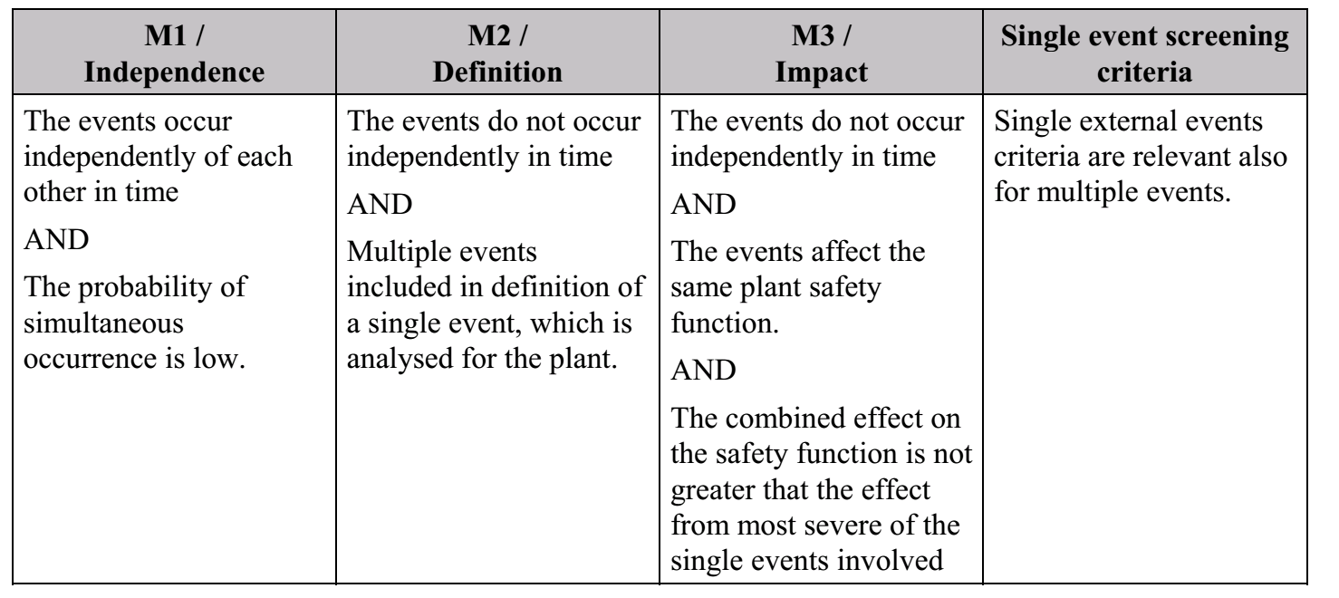

Treatment of Combinations of Independent Hazards
/the formula may be modified in the final version/
The number of combinations of independent hazards would be too high to be evaluated, and therefore in order to focus effort on identifying relevant combinations, quantitative rational can be used.
For independent combinations of hazards, the time period in which both hazards could have an impact on the plant needs to be considered, i.e. the plant may still be affected by the consequences of the first hazard when the second hazard occurs. Given a mission time of 24 hours that is normally used in a PSA to demonstrate that the plant has achieved a stable end state, the product of the frequencies of the two coinciding hazards should be lower than:
when a screening value of 10⁻⁸ pa for any initiating event is used. In case of a mission time of 72 hours (assuming longer term impacts arise from the first hazard and it is required to demonstrate a safe stable end state for this longer period) the frequency becomes:
Depending on the design a selection of or all combinations of hazards can be screened. In general, combinations of independent hazards are judged to be below the screening criterion, and do not need to be considered further.
Combinations of hazards are treated in the same way as single hazards. This is the case for all three types of combinations:
- causally connected hazards: the first hazards may cause the second or third etc.; the probability of their joint occurrence varies between 0 and 1;
- associated hazards: the hazards have a common root cause; the probability of their occurrence at the same time varies between 0 and 1;
- hazardous combinations of independent phenomena.

The hazard combination can be seen as a separate single hazard with its own hazard curve or frequency and severity. If the severity of the combination is the same as for one of the single hazard, the combination can be screened out from further analysis.
Hazard combination is an emerging topics and a common methodology for their screening characterisation is lacked.
Some recommendations may be given: (1) one may want to check if a knowledge on the causality between two hazards exists (it can take the form of an equation, a numerical model). (2) If (a) there is no knowledge available on the causality between two hazards, (b) a sufficient long series of observations on site is available for both the hazards, a multivariate statistics analysis might be used. When using (2) the recommendation is to double check the coherence of the estimated asymptotic correlation compared to the expert understanding and regional results
Flooding and hydrological events can be initiated by other hazards (see Table 3-6).

Table 3-6 : Hazard groups and possible consequences in the hazard group
Nr. | Hazard group | Consequences in N7 – N24
N1 – N6 | Seismotectonic hazards | N7, N11, N12, N13, N15, N16, N18
N25 – N52 | Meteorological events | N8, N9, N10, N12, N13, N14, N16, N19, N20, N22, N23
N53 – N59 | Biological infestation | N12
N60 – N72 | Geological hazards | N7, N9, N12, N13, N14
M1 – M24 | External man-made hazards | N10, N11, N17

Methods for the assessment of hazard combinations
In terms of hazard combination frequency evaluation, the nature of combination has to be taken into account. As it was derived in [6]: "Hazard correlations discriminate between: (1) Causally connected hazards (cause-effect relation) where one hazard may cause another hazard; or where one hazard is a prerequisite for a correlated hazard. (2) Associated hazards which are probable to occur at the same time due to a common root cause" and in additional, hazard combinations of independent phenomena have been denoted.

IAEA Fault Sequence Analysis (FSA) Methodology
IAEA developed a complementary safety analysis FSA methodology and supporting tool to assist in evaluation of the impact of extreme events on NPPs [49] or [50]. This method utilised both probabilistic and deterministic safety assessment methods to gain the insights of robustness of plant protection including impact on SSCs against the extreme external hazards and its combinations. The method also considers combined load conditions resulting from the simultaneous occurrence of these hazards. Fundamentally, the FSA method incorporates ‘stress test’ principles that have been performed in Europe after Fukushima accident. The method considers sufficiency of defence-in-depth provisions, including various dependencies, safety margins, application of specific design features, cliff edge effects, multiple failures, prolonged loss of support systems and the capability of safety important systems for long term operation [50].
The application of FSA method and supporting tools are implemented at Goesgen-Daeniken NPP, Switzerland and Medzamor NPP, Armenia. The methodology is described in detail in IAEA paper [50].
Extreme Event Analyzer (EEA) Methodology
Lloyd’s Register Consulting (LRC), in cooperation with IAEA, has further developed the FSA method [51]. LRC developed a value added tool (ExtremeEventAnalyzer (EEA)) to systematically analyze the accident scenarios not explicitly addressed in the design extension conditions using integrated deterministic and probabilistic approaches. The tool has incorporated lesson learned from FSA methodology developed by IAEA, which has been verified by application on Goesgen-Daeniken NPP (Switzerland) and Medzamor NPP (Armenia).
This method utilise an internal initiating events PSA model for assessing the impact of extreme events, including the consideration of hazard susceptibility limits of SSCs and impact of extreme external hazards. In EEA method, a number of extreme events (including credible combinations) can be postulated, for example seismic, water levels, extreme temperature, weather conditions etc. The extreme event analysis is linked directly to the PSA model (in RiskSpectrum) to ensure that the whole PSA model is included in the evaluation of the impact of the event or combinations of events. The EEA perform re-quantification of the PSA model including the hazard susceptibility limits of the SSCs. The outcome of the analysis is to [51][52]:
- Identify sensitive scenarios for extreme events;
- Analyse simultaneous extreme events;
- Prove robustness of plant design, for individual components and for buildings.
Below is a list of sequential steps to perform while using the EEA method to identify scenarios sensitive for extreme events [51]:
- Determine what hazards to include. This will be site specific and screening criteria may be applied.
- Determine the components, buildings that can be susceptible to the hazards. Plant data collection and plant walkdowns are important inputs.
- Determine initiating events which can be triggered by the hazard.
- Determine the magnitudes of hazards that will fail the components, the buildings and trigger the initiators.
- Generate the minimal combinations of events given the occurrence of a hazard or combinations of hazards.

EEA method and tool is utilised in a benchmarking study “Extreme Event Analysis – an application of RiskSpectrum EEA at Armenian NPP” is performed under co-operation project between LRC, Nuclear and Radiation Safety Center (NRSC) and Armenian Nuclear Power Plant (ANPP). The purpose of the study was to perform a comprehensive and systematic assessment of robustness and vulnerability of NPPs against the impact of extreme events using EEA method and tool.

Modelling the site protection reliability against flooding
According to the previous chapters, extreme events – and specifically external floods - are defined in terms of:
- intensity, which is characterized by physical parameters depending on phenomena (e.g. water level, water volume, water flow rate, rainfall intensity);
- dynamic, which can deal with the minimal duration of the rise from a value of normal intensity to an extreme value and / or with the duration during which an extreme intensity is maintained;
- frequency, typically in terms of probability that a given intensity is exceeded, derived from a statistical analysis of the phenomenon or of the initiating cause.
Hazards should be characterised as having either:
- a continuous frequency-severity relation; these “non-discrete hazards” are those that can occur across a continuous range of frequencies and are defined in terms of a hazard curve (a plot of hazard severity against the frequency of this severity being exceeded).
- discrete frequency-severity relation; these “discrete hazards” are those that are realised at a single frequency (or set of discrete frequencies) with associated hazard severity/magnitude(s);

In general, flooding is a non-discrete hazard characterized by a Water Level Exceedance Curve (see Figure 4-17 below).
Figure 4-17: Water Level Exceedance Curve (example data)
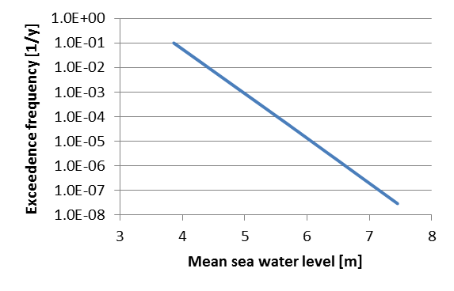
This distinction - discrete and non-discrete hazards - may have some ambiguities. Indeed, in case of flooding the damage could be the loss of a complete building through collapse and thus the loss of all systems within this building or by flooding of one or more floors of the building, causing loss of systems that are not designed to operate under flooding conditions. Although the flood level can be non-discrete, the damage to the plant can be discrete.
Roughly speaking, not necessarily a direct relation between the hazard curve and the initiator frequency exists. Defences against the hazard, the characteristics of the hazard such as duration, possible preventive actions (as shutting down the plant) and the site surrounding can affect this relationship.
Typically, the protection of NPP sites from external flooding is ensured mainly by:
- the shoring of the platform supporting the buildings housing and protecting safety-related SCSCs at a level at least equal to that of the maximum flood level plus a margin of safety (the corresponding level is the maximum design flood level);
- the closure of the potential pathways for water ingress into the chambers sheltering materials related to the maintenance of the installation in a safe condition located below the level of the platform shoring.
As general objective, it shall be assured that the SSCs required for bringing and maintaining the units in a (controlled and then in a) safe state are kept dry or otherwise designed and fully qualified to operate under this accidental conditions (e.g. water immersion, dynamic forces, humidity etc.).
About Defence in Depth, it is possible to identify at least three lines of defense against external flooding events:
- warning system, when possible depending of the specific flooding hazards;
- preventive and protection measures against flooding, aimed at limiting the height of water arriving at the site, through passive protection and/or active system (e.g. pumping);
- providing resistance to the water propagation through the buildings or the chambers housing important safety-related equipment aimed at maintaining a safe emergency shutdown condition.
The performance and reliability of the Warning system should be included in the modelling when essential to trigger actions for site protection and plant safe operation. The following aspects should be considered:
- ability to detect timely the on-going flooding of the plant depending on the nature of the hazards involved (river flood, storm surge, wind-wave on sea, dam rupture, on-site rainfalls);
- principles of implementation of the devices and equipment used for monitoring (tide sensors, wind measurements etc.) and reliability of the parameters monitored;
- successive warning phases e.g. stand-by phase, vigilance phase (carrying out of some early actions), early warning phase (e.g. site protection preparedness), alert phase (plants to be brought to a safe shutdown state);
- activation thresholds, able to assure enough durations of the warning and alert phases to carry out all the actions for site protection and plant safe operation, including safe shutdown.
Preventive measures against flooding include the sealing of the relevant buildings against ground and surface water, the sealing of the relevant buildings or rooms against entering water from other buildings or rooms, the constructional and spatial separation of redundant safety trains, the measures for detection, sealing, or isolation of leakages, the quality assurance during operation and maintenance.
Protections include either passive (e.g. barriers) and active means (e.g. pumps to drain water from rainfall), required to prevent the spreading of water on the site platforms or to limit its height. The estimation of the unit safety level requires evaluating the existing margins in terms of protection against intensity greater than used in sizing in order to avoid "cliff-edge effects".
The above measures allow the implementation of a "watertight area", that includes all the substructures and superstructures (up to the required protection level) of the buildings that house and protect safety-related equipment (i.e. required for bringing and maintaining the units in a safe state) against the different flooding hazards. Two specific provisions should be addressed in the demonstration of the effectiveness of the watertight area: qualification of materials used to plug openings (e.g. pipe or cable penetrations, entrance doors), provisions implemented in case of temporary opening (e.g. for maintenance), prevention of the potential ways of bypassing this area (e.g. discharge lines of the inner draining systems).
For flooding events greater than the flooding design level, protection is usually provided by the sealing of the buildings below the 0 level and beyond (volumetric protection), and by the implementation of flooding masks. Considering Defense in Depth, further provisions should allow coping with a residual leakage of the watertight area, based on the existing draining means and on additional mobile pumps installed during the warning phase.

The fragility analysis should not be limited to on-site SSCs (see §6.2), but should focus also on off-site structures because some off-site structure act as passive barriers for flooding. Failures of structures as power lines and pipework carrying hazardous materials may result in initiating events, such as loss of off-site power or a blast (such failures may be highly correlated if the fragilities are low). Damage to off-site structures may impair the personnel and equipment plant accessibility (from inside or outside) requiring the implementation of additional protection or specific emergency management measures.

The interaction of an external flooding with the site and plan protections can be caused:
- by collapse of building/structure; in this case, the building/structure resistance should be assessed against dynamic forces from water; moreover, depending on the distance between building/structure and the point where the water is entering the plant site – phenomena undermining the foundations need attention;
- by inundation; in the case, the water tightness of building/structure have to be assessed against the static water level outside, to determine the water level inside the building; considerable damage can also be caused to safety related SSCs by the infiltration of water into internal areas of the plant.
In both cases, the plant internal design features against external flooding (e.g. location and elevation of safety relevant equipment, “dry-site” concept, design and qualification of equipment to operate under flooding condition) play a dominant role. Specifically, the knowledge about the location and elevation of SSCs is essential to assess the damage produced by the flooding event. In general, this mapping is not part of the internal events model where location of the equipment plays no role.
In the modelling of the site protection, the following hypotheses can be made about protection effectiveness:
- if they are adequately implemented, passive protection features are reliable if the water level remains under the level they have been designed for;
- for active protection features, such as valve closure or pumps start-up, their reliability is linked to both human action and component reliability (failure to start or to run).
For assessment of human actions reliability, the analysis of the existing operating procedures may be used to construct a flow/resources/actions diagram (see §6.5).

Modelling the water propagation
Before any external flooding scenario (event tree) can be developed, the relationship between water level outside the defences against flooding and the water level, and thus consequences inside the plant, should be investigated by modelling the existing protections and the propagation of water in case of their failure or ineffectiveness.
Having characterized the occurrence of the event in terms of intensity, dynamic and frequency, the process for the evaluation of the water propagation can be articulated in the following steps:
- Identification, localization and characterization (elevation and protection, as applicable) of the off-site buildings and structures and of the safety-relevant SSC;
- modelling of water propagation on the site in case of no / failure of protections and protections bypass;
- modelling of water ingress into the buildings (considering protections fragility and human factor);
- modelling of water propagation inside the buildings and appraisal of the corresponding water level (e.g. calculated with the know flow rate, room volume, and capability of water removal).

The objective is to provide the information on water level (static) and water dynamic behaviour in a given scenario, as required for the estimation of potential damages on SSCs based on their “fragility”.
This allows the identification of the "critical" water levels inside or onsite around the plant, i.e. levels of water impairing the functionality of safety relevant SSCs; e.g. which cause the loss of off-site power or the loss of the ultimate heat sink or the loss of a secondary plant. Then, it is evaluated how these critical levels can be related to initiating events and then to the external flooding hazards (which are not, in general, in one to one relationships).
Conventional approaches or advanced simulation aim at mapping the plant into physically separate “flooding areas” which can be considered as independent of other areas in terms of potential for flood propagation and which can be characterized singularly in terms of expected water level and related effects in a given scenario.
Useful information could come from the L1 PSA for internal flooding, including the identification and characterization of flooding compartments (i.e. location of flood compartment boundaries/barriers, capacity of drainage systems, communications with other compartments, location of flood susceptible equipment) and potential secondary flood sources (e.g. ruptures in service water systems) generated by the dynamic forces produced by the primary flood).
The use of Advanced 3D simulation integrated into computational framework for risk assessment can provide a spatial/visual aspect to the design, improving the realism of results, and their understanding to validate results. This approach can be extended to different levels, e.g.:
- topography level - it focuses on the hydrography, orography and weather modelling on a wide region around the NPP station;
- site level - it focuses in more detail on the modelling of the structures of the NPP and around the plant itself; in case of multi-units site, the set of resources shared among the reactor units should be modelled at this level;
- unit level - it explicitly models the temporal evolution of the key reactor systems (e.g., core, safety systems, reactor pressure vessel) and relevant containment.
Advanced 3D simulation aims to manage external events not as initial condition but as boundary condition for the accident evolution. The status of systems or components of the plant is not set by the user, but evolves in time according to the simulation. This allows accounting for correlations related to timing and sequencing of events, correlations between the spatial location of components and systems, correlations between physical phenomena that might evolve on different spatial and temporal scale and correlations due to information sharing between plant systems, components and humans.

Structure and solutions of External Flooding PSA
Roughly, external floods may have a relatively greater potential to cause an accident with non-negligible consequences being an important cause of multiple dependent failure. An external (flooding) event can be modelled as every other (common cause) initiator. This means that the following steps are taken, once the potential flood hazards (sources) are identified:
- the flooding hazard(s) (e.g., high sea water level) are translated into initiating events (e.g. sea water level exceeding 2 m, but lower than 2.5 m); these initiating events are characterised by frequency and severity/damage level;
- identified external flooding initiating event, the main transient caused by the event is decided; based on these event trees a list of SSC important to bring the plant into a safe, stable state for each of the initiators is composed;
- the effects of the initiator on the plant systems at the given damage level is assessed. Typically, this is a degradation or loss of safety functions, caused by the loss of components, systems or complete buildings. This list from the previous step is used as input;
- initiating event an event tree is created and analysed in the PSA. The way this is done is dependent on the possibilities the software used is offering and the preferences of the analyst or user.
The final results of the external flooding PSA should include information on:
- flood minimal cut-sets and dominant accident sequences initiated by external flooding event;
- plant fragility;
- flood safety margin at component level and plant level;
- relative contribution of the different Initiating events related to external flooding hazards to the plant damage states;
- external flood vulnerabilities based on dominant contributors to risk measure(s).

Available indications from IAEA and WENRA
Generically, it can be considered that the lessons of Fukushima lead in advocating a strengthening of Defense in-Depth with, in particular, an increased balance between, on one side, the prevention of abnormal conditions and, on the other side, the effort for the management of severe accidents and the mitigation of their consequences. The independence between the different levels of Defense in Depth, the practical elimination of certain situations or sequences and the rejection of any risk of cliff-edge effects, are integral part of this goal.
Among the available literature dealing with the post-Fukushima and which translates, in terms of requirements, the indication above, recent documents delivered by IAEA and WENRA are considered in the following.
Regarding the IAEA, it is the updated version of the document IAEA SSR-2/1 [1] that presents exhaustively the requirements applicable for the design of new facilities. These specifications can also guide - as far as feasible - the evolution of the process of analysis applicable to existing facilities and should, as such, be considered for the evolution of the PSA practices to external aggressions. In this report, the requirements are worded in generic way and a number of them relate to internal and external hazards of natural origin. The flooding is obviously covered by these requirements. The updated formulation of requirements translate, in particular, the will of:
- Strengthening the prevention of unacceptable radiological consequences to the public and the environment;
- Strengthening severe accident mitigation measures so that, if an accident occurs, off site contamination is avoided or minimized;
- Preventing severe accident through strengthening the plant design basis, including strengthening the independence of level four of defense-in-depth, consideration of external hazards and sufficient margins
PSA is a part of the response to these requirements. Specifically, the role of PSA is essential for the demonstration of the strengthening of Defense in Depth and for the treatment of external hazards in general and of external flooding hazards in particular, must be part of the response to these new requirements.
Regarding WENRA, it is appropriate to consider the report “Safety Reference Levels for Existing Reactors” [2] as amended in September 2014, a version whose rationale is the integration of the lessons of Fukushima with a particular focus on the integration of external hazards. In this optic, a "Guidance Document - Issue T: Natural Hazards Head Document" [4], still from WENRA, provides technical insights for the specific topic of external hazards. It details the process of identifying "natural hazards", the process for the site specific natural hazards screening and assessment, the definition of design basis events, the approach for the protection against design basis events, the one that relates to "considerations for events more severe than the design basis events" and finally the requirement for periodic reviews of the site specific natural hazards.

Important concepts are defined within the above documents ([2] and [4]). First of all the notion of “protection concept”: “T5.1 Protection shall be provided for design basis events. A protection concept shall be established to provide a basis for the design of suitable protection measures. A protection concept, as meant here, describes the overall strategy followed to cope with natural hazards. It shall encompass the protection against design basis events, events exceeding the design basis and the links into the Emergency Operating Procedures and Severe Accident Management Guidelines.” Addressing the possible role of probabilistic support, “T5.2 The protection concept shall be of sufficient reliability that the fundamental safety functions are conservatively ensured for any direct and credible indirect effects of the design basis event.” Second the notion of “margin to cliff edge effect” as the “difference between a design basis natural event, and a natural event at which the fundamental safety functions can no more be ensured”.

Initiating events for a single unit
The probabilistic assessment of external flooding scenarios is typically based on Event trees-Fault trees linked models. The flooding hazard(s) characterized by intensity, dynamic and severity frequency is translated into initiating events, characterized by frequency and severity/damage level, i.e. the initial conditions that may be generated from external flooding hazard and could challenge the plant’s ability to perform the safety fundamental functions (control of reactivity, removal of (decay) heat, and confinement).
Initiating events should be defined taking into account the intensity and dynamic of the flooding hazard, the involvement of off-site structures, the failure or by-pass of the site protections, and/or other relevant boundary conditions if any.
Per initiating event, an event tree is developed and analyzed. The transient caused by the event is assessed/postulated, by addressing the performance and reliability of site protections (see §4) and the propagation of water through the site and inside buildings (see §5). For each scenario, the frequency of the initiating event reflects the frequency of the external flooding hazard(s) and the (conditional) probability that the specific accidental condition is realized, because of the failure of relevant barriers, and/or specific paths for water propagation, and/or other relevant boundary conditions, if any.
The integration of the external flooding hazards into the external flooding L1 PSA model requires two further main tasks:
- the estimation of damages produced by the initiator on SSCs (or group of SSCs inside the same building), and specifically on those required to bring and to maintain the plant into a controlled and safe state (see §6.2);
- the evaluation of the accident evolution considering the possible degradations of the safety architecture, due to the loss of safety functions (see §6.4).

Modelling safety functions and SSC failures
The consideration of accident sequences initiated by external floods should start from the site specific hazard curves and the fragilities of all SSCs for which damage may lead to a failure event modelled in the L1 PSA. Flooding and hydrological hazards can cause different failure modes of SSCs, according to the following Table 6-7.

Table 6-7 : Failure modes of SSC in case of flooding and hydrological hazards
failure mode (FM) |  | exposure time | remarks, questions, examples
FM | SSC is … | exposure time | remarks, questions, examples
FM1 | Flooded | short- to long-term | - SSC lying in water pool induced by site flooding.  - It is to check if and how a SSC is designed against flooding.  - Are short-term flooding of a SSC possible without failure?  - Assessment of cable and cable connections regarding failure sensitivity against flooding or humidity they are not designed for.
FM2 | exposed  to high humidity | long-term | - SSC in humid atmosphere.  - corrosion (depends on water quality, e.g. saline water by sites near the sea).  - Is an examination of corrosive impacts necessary, also in case of short-term flooding?
FM3 | unstable | short-term | - SSC-design against pressure and forces of waves  (failure of foundation soil in case of long-term impact)
FM4 | clogged | short-term | - The water supply of pumps will be interrupted due to blocking.
FM5 | dry | short- and long-term | - Failure mode in case of low water level, pumps or heat exchanger are mainly concerned.

Table 6-8 specifies which hazards can induce which failure modes.
Table 6-8 : Flooding and hydrological hazards and possible failure modes of SSC
Failure mode (FM) |  | Failure mode is possible as consequence  of the marked flooding and hydrological hazards  N
FM | SSC is …
FM | SSC is … | 7 | 8 | 9 | 10 | 11 | 12 | 13 | 14 | 15 | 16 | 17 | 18 | 19 | 20 | 21 | 22 | 23 | 24
FM1 | flooded | x | x | x | x | x | x | x | x | x | x | x | x | x | x | x |  | x
FM2 | exposed  to high humidity | x |  |  |  |  |  | x |  | x |  | x | x | x | x | x | x
FM3 | unstable | x | x |  |  |  |  |  | x | x | x | x | x | x |  | x |  | x
FM4 | clogged | x | x | x | x |  |  | x |  | x |  | x | x | x | x | x |  |  | x
FM5 | Dry |  |  |  |  |  | x | x | x |  | x

For a given scenario, results obtained by the modelling of water propagation and the knowledge of the location and real elevation of the SSCs allow identifying the ones involved in the accidental scenario. The fragility analysis of SSCs allows identify the ones to be assumed as faulted under the postulated accidental scenario.
The fragility analysis of SSCs should be evaluated through accepted engineering and plant specific information and data, which can be obtained by a review of the available documentation, the knowledge of the plant personnel and extensive walk down. The fragility analysis should include uncertainties in the underlying information, in particular when data other than plant specific data are used (i.e. generic data).
The fragility analysis should refer to all SSCs required to maintain the fundamental safety functions, which are potentially involved in a flooding events because of their localization and elevation and the level of water foreseen for the postulated event (all structures located at low levels, in particular intakes and ultimate heat sinks, should be included in the consideration). Non-safety structures that could fall into or on to safety related SSC, thereby causing damage on SSC, should be considered.
The fundamental analysis to be performed regards the failure mode FM1 – Flooded.
The fragility analysis should include its immersion, dynamic loads from waves and foundation failures / infiltration (when applicable). Generally, the equipment have to be postulated as faulted if it is not design and qualified to operate under flooded condition (water immersion).
The loads due to the design-basis flooding (e.g. static water pressure due to the design water level, dynamic forces due to streaming water, waves) have be combined with loads of normal operation and loads due to potentially correlated external events (e.g. in case of tsunami due to a seismic event).
Specific vulnerabilities concern electrical equipment like instrumentation and control devices, transducers terminal and connection boxes, motors of operated valves and pumps and non-hermetic cable junctions. They are assumed to be affected by flooding if no evidence exists of their appropriate design and qualification to operate under this accidental condition.After the analyses of the failure mode FM1, it should be checked if there are other flooding or hydrological failure modes (Table 6-7) to be considered. In this case, corresponding modifications of the PSA model must be performed. The failure mode FM2 - exposed to high humidity - and FM3 – unstable - refer to specific conditions against which a SSCs can or not be designed and qualified and thus affect the criteria adopted about the SSCs fragility. About FM2, the environmental condition accounted for the design and qualification of SSCs have to be addressed also against the potential exposure to high humidity in case of flooding. About FM3, permissible loads, damage limits and safety margins assumed in the design of SSCs against pressure and forces of waves should be addressed, also accounting for non-short term effect (e.g. failure of foundation soil only in case of long-term exposure to flood).
The failure mode FM4 – clogged – and FM5 - dry refer to failure modes of specific equipment (pumps or heat exchanger a) and thus affect only specific events (to be re-assessed or introduced) into the PSA model.

Assessment of accident sequences
For a given flooding scenario, the assessment of the accident sequence is typically developed through three main activities:
- development of specific Common Cause Failure (CCF) analysis, SSCs fragility analysis and Human Reliability Analysis (HRA);
- development of Event Trees (ET) and Fault Trees (FT) linked models, often as modifications of the existing models;
- quantification of ETs/FTs and relevant Uncertainty, Sensitivity, and Importance analyses.
The activities are based on the results coming from a survey of the configuration, characteristics and status of the site, including the collection and analysis of information acquired through site and plant walk-down.
Practically, the L1 PSA model for internal initiating events is always used, when available, as basis for the L1 PSA model for external hazards. The major aspects of the hazard that could lead to different classes of internal initiating event (e.g. large loss of coolant accident, small loss of coolant accident, transient) or which could lead directly to severe accident should be assessed in the selection of appropriate event tree from the PSA model for internal initiating events (e.g. by use of a hazard event tree).
In general, the event trees for a normal plant trip, loss of off-site power and loss off ultimate heat sink are used. However, depending on site and plant characteristics other internal event initiators can be more appropriate. These existing event trees need in most cases pruning and or modifications to account for (part of) systems lost as result of the flooding level (see §6.2). The way this modification or pruning is performed depends on the possibilities of the software package, the preferences of the analyst or the PSA requirements, e.g. the fault tree gates describing the failure behaviour of a SSCs which can be flooded must be complemented by failure mode FM1.
In addressing the accident evolution, one should be aware that not all components that could cause system loss are part of the L1 PSA for internal events (e.g. electrical cabinets, connector boxes, piping, heat exchangers, tanks etc.). This could also mean that rooms, areas or buildings not safety relevant in the internal events model could be relevant in the external flooding PSA.
If no L1 PSA for internal events is available, the way to proceed is completely comparable to the way an internal events model is developed.
The first step is to assess the vulnerabilities of the plant, by identifying the SSCs to be considered, which are those needed to maintain the fundamental safety functions (control of reactivity, removal of decay heat and confinement), and the ones impacted by the external hazard. The approach generally taken is the “success path” approach. The success path approach relies on establishing success paths to accomplish the three fundamental safety functions, given the initial conditions. A success path is as such a set of systems that can bring and keep the plant in a safe and stable (shutdown) condition. The set comprises of frontline systems as well as support system. After having identified all the possible safe shutdown paths, the scenarios can be developed into event trees.
An alternative approach is based on the preliminary representation of the safety architecture of the plant against external hazards. According to IAEA GSR Part 4 [2], it should include the identification of challenges to the safety functions, the identification of mechanisms (initiating events) and the selection of provisions implementing the different levels of the DiD. The representation and assessment of the global safety architecture could be supported by the Objective Provision Tree (OPT). The OPT method is fully compliant with the safety assessment process defined by the IAEA GSR Part 4. OPT concerns the systematic identification, for a given level of Defence in depth and for a given “safety functions” (SF) and corresponding objectives, of the “challenges” to the SF and for the relevant “mechanisms and phenomena” to be prevented or controlled by a set of “provisions” designed to meet specific acceptance criteria. Based on this representation of the implemented safety architecture, the PSA model is developed through event trees whose branches refer to the failure and success of subsequent DiD levels, and nodes are linked to Fault trees whose basic events represent the failure of the implemented provisions.

Modelling human failures
Human factors are discussed within the IAEA SSR-2/1 [1] through three requirements.
Basically, the priority should be given to the design which, consistently with the IAEA SSR-2/1 [1] should be as far as feasibly organized to satisfy the following requirement, which does not require the operator intervention [1] (Requirement 16): “(2) Following a postulated initiating event, the plant would be rendered safe by means of passive safety features or by the action of systems that are operating continuously in the state necessary to control the postulated initiating event”. The possible operator intervention is considered with the lowest priority: “(4) Following a postulated initiating event, the plant would be rendered safe by following specified procedures”.
Two further requirements specified in the IAEA SSR-2/1 [1] refer to Human factors.
The first one (Requirement 17) considers the human factor among the possible causes of internal and external hazards: “All foreseeable internal hazards and external hazards, including the potential for human induced events directly or indirectly to affect the safety of the nuclear power plant, shall be identified and their effects shall be evaluated. Hazards shall be considered in designing the layout of the plant and in determining the postulated initiating events and generated loadings for use in the design of relevant items important to safety for the plant.”
The second one (Requirement 32) is specific on how to consider the “Design for optimal operator performance”: “Systematic consideration of human factors, including the human– machine interface, shall be included at an early stage in the design process for a nuclear power plant and shall be continued throughout the entire design process.”
Discussing the details of this Requirement 32, the new version of IAEA SSR-2/1 [1] slightly modifies the previous text (modifications are in bold): “5.55. The design shall support operating personnel in the fulfilment of their responsibilities and in the performance of their tasks, and shall limit the likelihood and the effects of operating errors on safety. The design process shall give due consideration pay attention to plant layout and equipment layout, and to procedures, including procedures for maintenance and inspection, to facilitate interaction between the operating personnel and the plant, in all plant states.”
Two key modifications are introduced: first, there is the request to reduce the likelihood of operating errors; second, there is the explicit request for the consideration of the contribution of the operating personnel in “all the plant states” including the ones under/after the occurrence of an external hazard, as for an external flooding. This can have an impact versus the extended PSA and the consideration of Human reliability (besides the fact that – obviously – the quantitative figures for the HRA will change), considering that the need to prove the effectiveness of the reduction of the likelihood of operating errors – also considering the extension of the scope for the operator intervention (i.e. extended to extremely degraded situations) - will likely require the availability of extremely performant methodologies.
The second modification requests to consider all plant states. Therefore, the assessment Human reliability should be extended to extremely degraded situations (i.e. Requirement 20: Design extension conditions. and. accidents that are either more severe than design basis accidents or that involve additional failures [1]) and this introduces significant uncertainties both aleatory and epistemic.
Specific operating procedures dealing with external flooding have to be applied during the warning and alert phases in order to:
- prepare the site protection all along the warning phase: closure of the dykes openings, closure of hoppers and doors of the "watertight area", installation of mobile shutters, installation of mobile pumps in the chambers…,
- anticipate a situation for which the plants will have to be maintained in a safe shutdown state for a long duration or might encounter an accidental situation. In particular, the possible occurrence during a flooding of the "loss of the ultimate heat sink" or/and the "loss of external power supplies" is examined. The corresponding specific actions required during the warning phase, in order to prevent, to delay or to be able to cope in the long term with these situations, are then defined, such as the filling of tanks (fuel for the diesel generators, secondary water inventory) in order to increase the autarchy of the plants,
- bring the plants to a safe state which depends on their initial state.
For the assessment of human actions reliability, the analysis of the existing operating procedures may be used to construct a flow/resources/actions diagram (Table 6-9). This is a timeline which depends on the increasing flood flow, with these different preventive organizational states: Daily flow monitoring (normal situation); Enhanced flow monitoring; Vigilance; Early warning; Alert.
Table 6-9 : HRA
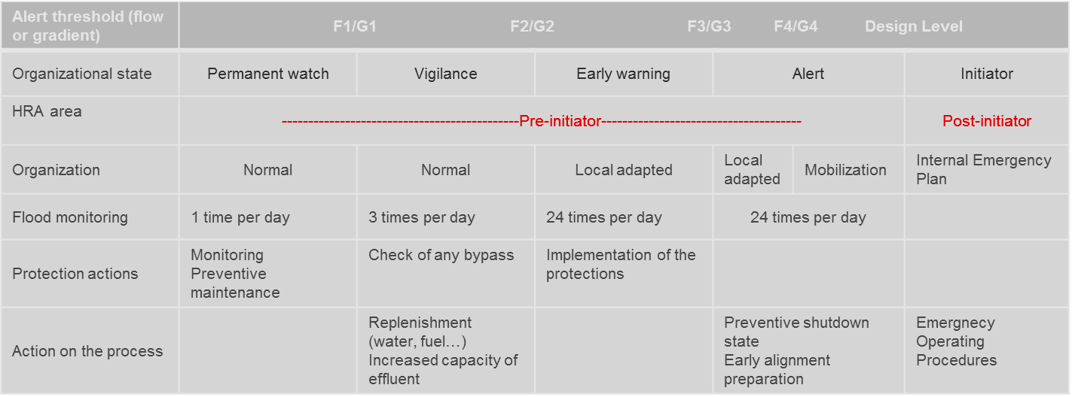
For each of these states, the goal is to obtain the following information:
- how the diagnosis and prognosis of flooding is done, and therefore the ability of the organization to detect the need for a phase change;
- the specific organization for each phase (with an increasing resource mobilization);
- the human resources that are mobilized : operating crews, crisis teams, maintenance staff;
- the key actions for the volumetric protection concerned with organizational phases.
Thus, each key action can be simply and precisely characterized with these items:
- what (which action precisely);
- when (in which phase the action must be requested);
- who (the staff allowed);
- how (the procedures applied, the tools needed);
- where (the location).
Moreover, the use of the flood hydrograph allows the time limit to be estimated for each specific action.
Five types of actions can be analyzed:
- the control of integrity of the opening (which are necessary for the cable entry or pipes);
- the closing of the watertight doors at the periphery of the volumetric protection;
- the installation of specific flood masks in each entrance of the nuclear buildings;
- the closing of specific valves of exhaust water pipes, which bypass the volumetric protection;
- the use of specific mobile pumps.

To complete the analysis, it is important to evaluate the normal operation and control of these materials (e.g. the control of presence and condition of flood masks, the periodic testing of the exhaust valves), and to collect the operational feedback, especially following the crisis exercises.
From these qualitative data, the quantification of human failure can be then achieved with HRA methods.
Human Errors Probabilities (HEP) should be adjusted to account for flood effects on performance shaping factors. A specific process for determining and analysing the HEPs is necessary.
An idea could be to apply a fixed penalty to the HEPs in the PSA, linked to the "additional human and organizational workload" involved in a context of external hazard impacting more than one unit.
First, the analysis of each critical HEPs selected according to the context of hazard, must be carried out. To do this, the actions to be taken within each of the HEPs must be identified according to the following categories:
- management actions in the main control room;
- local management actions (reactor building), using the compendium of local electrical equipment sheets or the compendium of local alignment sheets ;
- additional specific incident management actions related to the context of the hazard (e.g. fuel handling and storage system / fuel building);
- equipment recovery actions required by the instructions, to be carried out by on-call staff, using the compendium of on-call sheets.
Second, organizational and staffing must be determined, as functions that are provided normally for two or more units and presence and/or arrival time on site:
- operations Manager and Supervisor: number of units managed / supervised;
- safety Engineer: on site or on call, arrival time…;
- number of control room operators and field operators by unit;
- time rigging for on-call staff (recovery actions).
Then a fixed penalty for each HEPs could be given on three levels (Figure 6-18 below), according to the different functions to achieve, taking into account the data from the two previous steps:
- permanent supervision, the management strategy "independent checking" function, by the Operations Manager or the Safety Engineer;
- incident/accident management supervision, the management strategy "monitoring & coordination" function, by the Supervisor;
- the "action implementation" function, in the control room and in the area/room involved.

Figure 6-18: Fixed penalty for each HEPs given on three levels
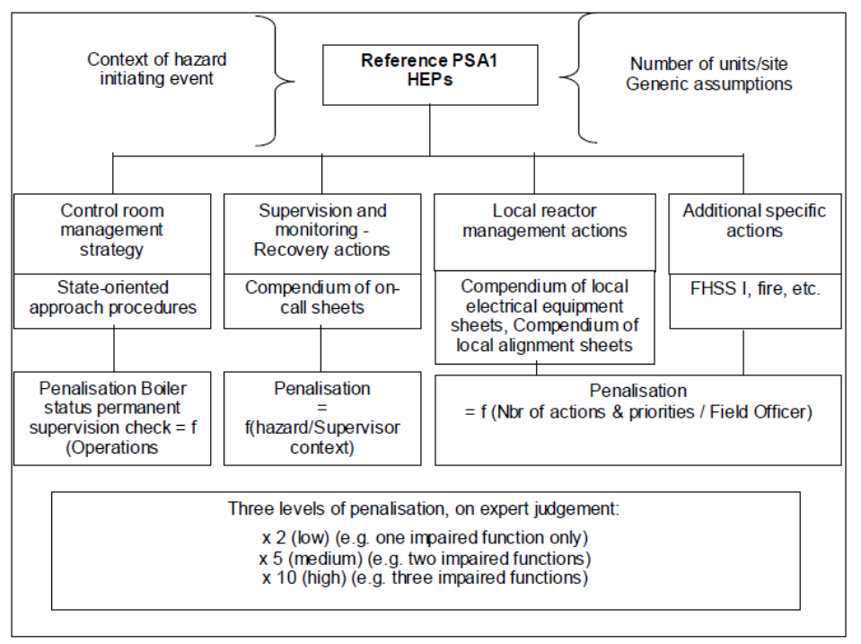
Specifically about human factors and external flooding events, starting from the lessons learnt from the Fukushima Daiichi event, the HRA should:
- consider actions performed by all plant staff (i.e. not only for control room), in the execution of procedures for accidents management (through rule-base actions) and in the solution of problems under unusual extreme conditions (through knowledge-based actions), including internal and external warning, use of mobile barriers / equipment and restoration of structures/ equipment in long term accident sequences;
- identify and assess errors of omission and errors of commission, during normal operation and off-normal scenarios, including dependency among errors in the same incidental/accidental sequence as potentially introduced by extreme external events;
- take account for the potential loss of accessibility for the site, specific area, building, rooms or equipment (e.g. due to damages to structure and equipment that could obstruct the areas),
- take account for the effect on human error probability of
- professional and personal stress induced to the operators during the accident,
- uncertainty in plant response (e.g. due to insufficient or incorrect information on essential safety parameters, up to the unavailability of the main control room),
- insufficient information on the essential parameters about the plant state (e.g. action without guideline) and equipment,
- lack or unavailability of adequate written procedures,
- unavailability or inadequacy of external (e.g. regional) and/or internal (i.e. in site) infrastructures (e.g. for communication, transport),
- constraints during multi-units accidents coming from the sharing of finite resources (e.g. common technical support center).
Annex C provides a brief review of methods for HRA.

Emergency response modelling

Post Fukushima measures
Experience gained from the study of the accident at Fukushima NPP is considered in details in the report D30.2 [9].
If any measures based on lessons learnt from the accident at Fukushima NPP have been implemented at NPP, they should obligatory be considered in the probabilistic model, since they can significantly affect accident sequences related to a complete loss of NPP power supply or loss of ultimate heat sink.

Mobile equipment and Emergency Measures
The use of additional technical means and emergency teams to mitigate consequences of NPP accidents can have an impact on the possibility for occurrence of an initiating event and on accident progression scenarios. Specific attention should be paid to analysis of accident progression scenarios and equipment that potentially can be damaged and secondary effects of hazards.
Since the secondary effects may progress in time and depend on severity of a hazard and its confinement, the following factors should be taken into account to consider additional technical means and external support:
- location of emergency teams (important in term of time needed to deliver equipment and take the required actions);
- type and quantity of available special equipment (important in terms of efficiency, and severity of hazards that shall be overcome);
- presence of blockages and other obstacles on the way (important in terms of time for delivery of equipment and for taking required actions);
- category of hazard consequences severity (important in terms of efficiency in their overcoming or possibility to overcome them in principle).
- preparedness for the particular impact.
Thus, for correct accounting of the above factors, it is necessary to perform analysis of hazard progression scenarios and to explore the possibilities of additional technical means and emergency teams.
The main success criterion to mitigate hazard consequences is the time of “deployment”, which plays one of basic roles in the analysis. For a positive outcome (for example, non-damage of additional equipment), the “deployment” time should be less than time for secondary effects to reach “key” points (should this include access ways of personnel to the required equipment or equipment important to safety). Therefore, the “deployment” time shall be defined taking into account training of emergency teams, time for delivery of special equipment taking into account blockages (for scenarios that envisage presence of blockages or obstacles), available NPP emergency response plan, procedures for obtaining permits from the physical protection, etc.
In addition to the “deployment” time, success criterion includes specific nature of a hazard, category of hazard severity, hazard confinement, training of emergency teams, type and quantity of special equipment. The relevant analysis involves searching of correlation between the list of screened emergency events (scenarios of hazard progression) and the possibility of emergency teams to overcome or mitigate the consequences of a hazard.
In modelling response of external emergency teams, depending on the availability of statistical data on overcoming the consequences of hazards taking into account their specific nature, there are two ways to consider mitigation of accident sequences:
- discrete/Boolean (based on results of deterministic analysis), which postulates a complete success or a complete failure in mitigation of consequences (confinement of equipment, ensuring access for personnel, complete overcoming of hazard consequences without its progression into the initiating event). This approach envisages the decision making related an inclusion of additional scenario ways to the model logics, if action of the emergency teams cannot be successful (e.g., due to time limitations, state of environment). For example, add branches with dependent failure of equipment (which cannot be remained operable due to efforts of the emergency teams), incorporate the whole scenario of hazard consequences progression (since efforts of the emergency teams could not help to prevent occurrence of the initiating event), etc.;
- probabilistic, which considers representative statistics on successful/unsuccessful overcoming of relevant consequences of a hazards, taking into account their specific nature. With availability of sufficient and representative statistics, it is necessary to define probability of successful mitigation of consequences and to supplement the model with the relevant events (for example, top events in the interface event tree), which reflect probability of mitigation of hazard consequences.
Application of any of the two described approaches requires collection of additional information and consultations with experts.

Multi-units initiating events modelling
The paper [54] presented a classification system that utilizes existing single-unit PSAs and combines them into a multi-unit PSA. Two methods which can be used for creating a multi-unit PSA have been identified. One method is to develop an entirely new multi-unit PSA, and the other is to integrate existing single-unit PSAs. It is stated that the prohibitive cost of developing a PSA and the potential technical impediments of creating a state-of-practice multi-unit PSA make the latter method more feasible both practically and economically because of the ability to utilize existing data and models. An example of attempt to construct a comprehensive methodology that would create a simplified multi-unit PSA by integrating multiple single-unit PSAs into a multi-unit PSA is given in ref. [55].
Since this methodology requires the user to create a Level 3 PSA for each unit at the site, it is much more resource intensive than creating a multi-unit L1 PSA, which can be accomplished by combining existing single-unit L1 PSAs to create the risk profile of a multi-unit site. In this case all of the ways in which units could be coupled needs to be understood. The multi-unit methodology proposed [54] defines a unit as a reactor core and it’s front-line and support SSCs). That is, everything inside of the primary containment building and power generation and supporting systems.
There are many types of events that could create a dependency between multiple units from a risk perspective. In order to effectively account for these risks when looking to create a multi-unit PSA, six main commonality classifications have been established (see Figure 6-19): initiating events, shared connections, identical components, proximity dependencies, human dependencies, and organizational dependencies. The first step in the proposed process is to sort the events in the single unit accident sequences into classifications. This allows the dataset to be reduced from typical 100 plant systems to just seven classifications (one independent and six dependent) that need to be analyzed.
Figure 6-19: Commonality classification of dependent events

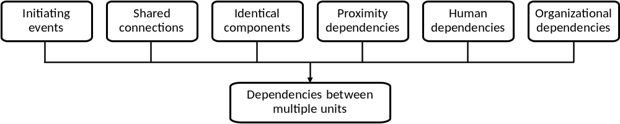

For the purpose of this report, dependencies on initiating events are relevant. The initiating events can be divided into two subclasses: events that will always affect multiple units, referred to as “definite” events, and events that will only affect multiple units under certain circumstances, referred to as “conditional” events. Those events that will always affect multiple units include many external events including external flooding.
In the study [54], the following five different type methodologies have been identified to account for multi-unit dependencies: combination, parametric, causal-based, extension, and external event type methodologies. The definite initiating events that will always affect multiple units would only need to use the combination methodology to be integrated into a multi-unit PSA. Since the single-unit PSAs should contain all of the potential initiating events, they would simply need to be combined. The items (SSCs, initiating events, etc.) that are already common to multiple plants will always be common; they simply need to be represented as one item in the multi-unit PSA so that they are not double counted in the quantification of the site CDF, LERF, LRF, etc. For these items, there will be no effect on the site CDF (i.e., the site CDF is the CDF of one unit multiplied by the number of units on the site); however, the importance of the items may increase in the final risk importance measures.
Shared components and human resources
It is important to note that in some accident scenarios developed in the Internal Events PSA, shared systems or systems with cross ties between units can be credited as mitigating systems. But when a flooding occurs, all the equipment on site may be concerned. Thus, crediting shared equipment or safety systems of a twin unit can only be done on a case by case basis. The analysis of flooding scenarios must be done at the site level and the status of each unit of the site, in terms of components failed due to the flooding propagation at a given instant, must be taken into account.

Develop CCF issues between units
In the case where the same initiating event is induced by the flooding scenario in these units, some systems required to mitigate this initiating event may be subject to inter-unit CCFs. This is the case for identical systems present in each unit which are required for the mitigation of the initiating event. As they are identical, this makes them potentially sensitive to "inter-unit" common-cause failures, in addition to "intra-unit" common-cause failures that are usually modelled for systems with redundancy. The main diesel generators of the units constitute an example of such a type of system. If each unit has two redundant diesel generators, an “intra-unit” CCF (common-cause failure) group of 2 is generally modelled in IE PSA. In the event of a LOOP (loss of offsite power) affecting two units, the potentiality of a CCF affecting the 4 diesel generators should be studied. The same requirement applies for systems with cross ties between units. These systems are identical and present in each unit; interconnections exist and a system on one unit can be backed up by the same system on the other unit. This type of case can be illustrated via the CVCS charging pump system, which under certain circumstances, can be used to backup the twin unit. In this case, the problem of potential inter-unit CCF should be studied, as should the impact of the respective operating mode of both units on the success criteria to be taken into account in the modelling.

Importance of plant specific data and walkdown
The numerical input necessary for quantifying accident sequences consist of reliability data needed to calculate the frequencies/probabilities of basic events included in the PSA model. This information need is dependent on the underlying component (basic event) reliability models applied generally as follows for analysis of:
- Initiating events
Frequency - f (1/y).
- Independent Component (Hardware) Failures
a) time related failure rate - λ (1/h) or
b) demand related failure rate/probability - λ_{d} (1/demand),
c) time data on operational exposure, test and repair, as appropriate (mission time: T_{mi}s (h), repair time: T_{rep} (h), test interval (time between tests): T_{per} (h), test time: T_{test} (h)),
d) extreme weather induced failures, fragilities – P (failure probability).
- Dependent (Common Cause and Correlated) Component Failures
a) data on independent failures for each component involved in a common cause failure (CCF) group,
b) parameter values for the fraction of common cause failures in a CCF group in accordance with the underlying parametric CCF model applied (e.g. β factors, α factors, MGL factors),
c) correlation coefficients for multiple, correlated failures of SSCs: ρ_{ij}.
- Human Errors
Probability of an error: HEP.
The frequency of external flooding initiating events as the only initiators in the external flooding PSA are characterized by a family of continuous hazard curves. The hazard characteristics are obtained from the external flooding hazard assessment as input information for the external flooding PSA (see also Section 3 of this report).
The reliability data for random equipment failures are taken from the PSA for internal events. Additional reliability parameters also need to be estimated for quantifying random failures included in the system fault trees developed newly for the purposes of the external flooding PSA. The method of parameter estimation follows the practice commonly applied in the internal events PSA.
External flooding induced failures of equipment and structures, including transient initiating failures and mitigating system failures, are modelled by different basic events in the logic model for the different flooding events. The probabilities of these failures are determined by fragility analysis (see Section 3 of this report). The fragility analysis quantifies the likelihood that a component or structure fails, as a function of the parameter which represents best the load induced by the external flooding event in question. As the external flooding induced failures are characterized by a family of continuous fragility curves, the fragility analysis explicitly accounts for the effects of randomness in external flooding characteristics and uncertainty in the component response to a particular external flooding event.
With regards to common cause failures of plant equipment, the data available in the internal events PSA is used without modification for the purpose of the external flooding PSA. It is important to note that these are common cause failures of random failure events as opposed to dependent failures due to the effects of a certain external flooding event. The approach applied in the internal events PSA is followed to estimate the common cause failure parameters of the random equipment failures modelled newly for the purposes of the external flooding PSA.
For example, safety system localization (flooding map) could be developed for following purposes:
- Estimate impact of external flooding on System Structure and Component (SSCs)
  - evaluate common pathways : water access in safeguard, fuel, auxiliary and containment buildings and water propagation;
  - take into account qualification of component against flooding, for instance tight doors submerged in water;
  - also consider equipment’s which are not submerged in water but sensitive to humidity/ droplets.
- Estimate impact of a SSC failing on other SSCs;
- Check specific configuration of doors (e.g. open doors maybe due to Human Errors etc.);
- CCF for single unit - modelling of redundant components / different safety trains;
- Several plant walk down could be needed.

Risk quantification and reporting
The aim of this step is to quantify risk (CDF/FDF damage and LERF/LRF) by appropriate integrating of the external flooding hazards, fragility and the systems analyses.
Based on the work in accordance with Sections 3 to 6 and the flow chart (see Figure 1) quantification of external flooding PSA is standard (mainly software based) activity like in PSA for internal events.
Integral part of quantification process is sensitivity (and importance) analysis. Except of obvious evaluation of importance of basic events (components, systems etc.), which is based on Fussel-Vessely and risk achievement worth factors and sensitivity of used parameters, care should be taken reviewing of used simplification assumptions that have a significant level of uncertainty and which are likely to have a significant impact on the results of the external flooding PSA. The sensitivity studies should be carried out by re-quantifying the analysis using alternative assumptions or by using a range of numerical values for the data that reflect the level of uncertainty. An uncertainty analysis should be carried out to determine the uncertainty in the results of the external flooding PSA that arises from the data and significant assumptions. Importance analysis (even if does not evaluate interaction of factors) forms handy tool to estimate contribution of induced events to the overall results.
Another controversial situation can be caused by double counted basic events. Such potential over counting should be checked by detailed analysis of minimal cutsets.
Results of sensitivity studies, importance and uncertainty analysis should be used to interpret the results of the PSA, to assure the robustness of further decision making based on PSA and identification of further fields of PSA model improvement (if applicable)
The corresponding documentation should provide within the report (or by reference to available material) all necessary information to reconstruct the results of the study. All intermediate sub-analyses, calculations, assumptions, simplifications etc., that will not be published in any reports should be retained as notes, working papers or computer outputs.

Conclusion
The existing and state of the art practices are capable for the modelling and assessment of frequencies for external flooding hazard. However, dealing with combination of hazards (including correlated hazards) much more open issues appeared. The list of open issues described before the conclusions present few limitations, but there is no evidence that it is a complete list.
On another hand, in this guidance the sources of hazard data and quality of hazard data as well as elements of hazard assessment methodologies and relevant examples are discussed pointing out how these could be used for hazards assessment and for extended PSA. These discussions, at least partly, provide explanations and solutions how to avoid different issues, which appears in the modelling and assessment.
Taking into account various issues of hazard data still there are suitable methodologies for separate hazard assessment. Of course, the uncertainty analysis (possibly including sensitivity analysis) should be obligatory part of the assessment and this, at least, will help to cope with issues of data and results uncertainty.
Examples of hazard assessment methodologies just demonstrate availability of some practical methods and tools, which are practically used for calculations estimating frequencies of external events and which provide means for analysis of different data and its impact on the uncertain result. In all cases, for external flooding assessment the extreme value theory is used in one or another way. The practical application of it may differ depending on available data and parameters which are considered for the specific hazard.
The issue of hazards combinations is solved by initial classification of dependencies between hazards and criteria, which allows to avoid irrelevant combinations of external events. It is important to note that some individual hazards (phenomena) already are combinations of hazards, so that analysis of such compound already covers analysis of individual hazards. Such analysis may depend on site and NPP design limits and is performed at the stage, when information necessary to assess the frequency and effect of combination is known. In the guidance, as examples, the specific combinations were discussed and then methodologies suitable for the assessment of these hazard combinations were identified.
The start point of external flooding PSA is to identify amount of collected data related to external flooding characterization and SSCs resistance for the external flooding conditions. The type of input data is defined mainly by results of hazards and its combinations screening, and by parameters that correlate with fragilities of SSCs. Preparation of input data for the PSA model includes construction of hazard curves for external flooding hazards and SSC vulnerability curves. An alternative method is to compare parameters of external extreme hazards with design data for SSCs – boundary evaluation. Such a method is simplified and can be used only in case of unavailability of any statistics for hazard occurrence. In this way, application of hazards and fragility curves is recommended for external flooding PSA (if applicable) and the main attention of this guideline is emphasized on this approach.
The main threats have to be analysed during site response studies and ways for analysis of appropriate emergency sequences for flooding hazard is also covered by this guidance. The main idea for modelling these sequences is to make an interface with L1 PSA for internal initiating events. As result of the interface development connection with emergency sequences of internal initiators or with more severe initiating events have to be built. Recommended approach for these purposes can be also different and has an influence on reliability parameters and frequencies implementation into the further PSA model. In light of the above, this guidance covers two possible ways, which depends on data availability and software capabilities:
- discretization of the hazard and the fragility curves using a limited number of hazard intensities;
- usage of continuous hazard and fragility curves for the whole range of hazard intensity of interest.
Both of these variants are described in the guidance. There is proposed a way for modelling of possible additional secondary effects and aggravating/mitigating factors in the corresponding part of guidance. The main idea of this approach is to model the additional factors as top events (headers) in the initial event tree and/or interface event trees.
It can be concluded that there are no difficulties in PSA model's logic and structure building for external flooding hazards. A major limitations and gaps of external flooding PSA are related to the data preparation and its implementation. Main uncertainties appear from the hazard evaluation and NPP response analysis issues (buildings resistance, missile impact, long-term effects, mitigation of human errors, etc.).

List of open issues

- Limitations in modelling and forecasting the physical phenomena and conditions leading to external flooding hazard;
- Uncertainties in estimation of the impact of climate change on external flooding events ;
- Lack of site-specific data and limitations of spatial modelling and downscaling methods;
- Unclear application of complex probabilistic models, like mixed distributions;
- Difficulties in quantification of uncertainties for common-cause failures;
- Difficulties in integrated modelling of hazard internal and external impact assessment;
- Scope of the fragility curves is limited;
- Adequate and practically applicable methodology for assessing the failure probability of indoor SSC’s (taking into account outside temperature and HVAC capacity);
- Correlation among an external flooding event induced failure modes and on the quantification of correlation coefficients;
- Uncertainties in operational strategy under harsh weather conditions causing flooding events;

List of References

References will be completed in final report version

- IAEA Safety Standards Series No. SSR-2/1, Rev. 1: Safety of Nuclear Power Plants: Design; 2016
- IAEA Safety Standards Series No. GSR Part 4, Rev. 1, Safety Assessment for Facilities and Activities, 2016
- WENRA - Safety Reference Levels for Existing Reactors - September 2014
- WENRA - Guidance Document – Issue T : Natural Hazards Head Document - April 2015
- GIF/RSWG/2010/002/Rev.1 – An Integrated Safety Assessment Methodology (ISAM) for Generation IV Nuclear Systems; June 2011.
- List of external hazards to be considered in ASAMPSA_E, Technical report ASAMPSA_E / WP21 / D21.2 / 2014-12
- Summary report of already existing guidance on the implementation of External Hazards in extended Level 1 PSA, Technical report ASAMPSA_E / WP22 / D22.1 / 2014-05
- SEISMIC hazards modelling for extended PSA, Technical report ASAMPSA_E / WP22 / D21.3-1/ 2016-27 - IRSN PSN-RES/SAG/2016-00232
- Lessons of the Fukushima Daiichi accident for PSA, Technical report ASAMPSA_E / WP30 / D30.2 / 2014-08 - Reference IRSN PSN-RES/SAG/2015-00025
- A. Wielenberg et. al., "ASAMPSA_E D30.3, Methodology for Selecting Initiating Events and Hazards for Consideration in an Extended PSA," 11th May 2016.
- Technical report ASAMPSA_E WP10. Minutes and recommendations of the ASAMPSA_E Uppsala End-Users work-shop (26-28/05/2014).
- ASAMPSA_E D10.3 Report on external hazards with high amplitude that have affected NPP in operation (in Europe or in other countries) ASAMPSA_E / WP10 / D10.3 / 2016-13 - Reference IRSN PSN/RES/SAG/ 2016-00031
- IAEA Safety Standards Series SSG-18, Meteorological and hydrological hazards in site evaluation for nuclear installations, Vienna, 2011.
- UNECO, Tsunami Glossary, Intergovernmental Oceanographic Commission, Technical Series 85, 2013.
- Locat, J., Lee, H.J., 2002. Submarine landslides: advances and challenges. Can. Geotech. J. 39, 193–212.
- Geist, E. L. and Parsons, T., 2006. Probabilistic analysis of tsunami hazards. Natural Hazards, 37, 277– 314.
- Zoback et al., Advances in natural hazard science and assessment, 1963-2013. Geological society of America, special papers, 501, pp 81-154. Doi: 10.1130.2501(5), 2013.
- Borrero et al., Tsunami sources in the Southern California Bight: Geophysical Research Letters, v. 31, no. L-13211, 4p, 2004.
- Rikitake, T., and Aida, I., 1988, Tsunami hazard probability in Japan: Bulletin of the Seismological Society of America, v. 78, p. 268-1278.
- Downes L. G. and Stirling W. M., Groundwork for development of a probabilistic tsunami hazard model for New Zealand, 2001.
- Annaka et. al., Logic-tree approach for probabilistic tsunami hazard analysis and its applications to the Japanese coasts Birkhäuser Basel (Ed.), Tsunami and Its Hazards in the Indian and Pacific Oceans (2007), pp. 577–592.
- Geist et al., Tsunami Probability. In: Bernard EN and. Robinson AR (eds), The Sea 15: 93–135. Harvard Univ Press, Cambridge, Mass, 2009.
- González et al., 2009
- Blaser et al., 2012
- Cornell C. A., Engineering seismic risk analysis, Bulletin of the seismological society of America, Vol 58, No. 5, pp. 1583-1606, 1968.
- Vecchia, 2001
- Ward, 2001
- Gonzales et al., Global patterns in the vulnerability of ecosystems to vegetation shifts due to climate change, Global ecology and biogeography, 2010
- Grilli et al., Modelling Tsunami sources and their propagation in the Atlantic ocean for coastal tsunami hazard assessment and inundation mapping along the US east coast, 2009
- Sørensen et al., 2012
- Power et al, Food webs in Mediterranean rivers, Hydrobiologia 719:119-136. Featured in N. Bonada and V. H. Resh, editors. Streams in Mediterranean climate regions: Lesson learned from the last decade. Doi:10.1007/s10750-013-1510-0, 2013
- Basili et al, The European database of seismogenic faults (EDSF) complied in the framework of the project Share, 2013
- Papadopoulos, 2003
- Coles, S.G., 2001. An Introduction to Statistical Modelling of Extreme Values. Springer, London
- Hosking, J. R. M. and J. R. Wallis. 1997. Regional Frequency Analysis. An approach based on Lmoments, Cambridge, Cambridge University Press
- Weiss, J., P. Bernardara, M. Andreewsky and M. Benoit. 2012. Seasonal autoregressive modeling of a skew storm surge series, Ocean Modelling, 47, 41-54.
- Dixon, M.J., and J.A. Tawn. 1994. Extreme sea-levels at the UK a-class sites: site-by-site analyses, Proudman Oceanographic Laboratory, Internal report n°65, Natural Environment Research Council (UK).
- Simple addition of extreme tide and extreme surge, RFS, 1984.
- Harris, D.L. (1963). "Characteristics of the Hurricane Storm Surge". Technical Paper No. 48 (Washington, D.C.: U.S. Dept. of Commerce, Weather Bureau): 1–139
- https://en.wikipedia.org/wiki/Storm_surge#cite_note-Har63-10
- Coastal Engineering Research Centre, Shore protection manual. Vol. Tome 1. 1984
- Irish, Jennifer L., Donald T. Resio, and Jay J. Ratcliff. “The Influence of Storm Size on Hurricane Surge.” Journal of Physical Oceanography 38, no. 9 (September 1, 2008): 2003–13..
- Ven Te Chow, 1981, Open-Channel Hydraulics, Ed McGRAW-HILL international student editions
- “Stochastic Event Flood Model” (SEFM) [Schaefer et Barker, 2009: Schaefer, M.G. et Barker, B.L. (2009). - Stochastic Event Flood Model – User Manual. MGS Engineering Consultants Inc., January]
- “Semi-continuous Rainfall-runoff Simulation for Extreme Flood Estimation” SCHADEX, [Paquet E., Garavaglia, F., Gailhard, J. et Garçon (2013). - The SCHADEX Method: A Semi-continuous Rainfall-runoff Simulation for Extreme Flood Estimation, Journal of Hydrology, 495: 23-37]
- IAEA Specific Safety Guide No.SSG-3 “Development and Application of Level 1 Probabilistic Safety Assessment for Nuclear Power Plants”, 2010
- EPRI “Identification of External Hazards for Analysis in Probabilistic Risk Assessment,” Report 102297, December 2011
- SKI Report 02:27, M. Knochenhauer, P. Louko, „Guidance for External Events Analysis“, SKI Report, February 2003, ISSN 1104-1374.
- Kuzmina I., Lyubarskiy A., El-Shanawany M., An Approach for Systematic Review of the Nuclear Facilities Protection against the Impact of Extreme Events (Proceedings of the Nordic PSA Conference – Castle Meeting 2011, 5-6 September 2011, Stockholm, Sweden).
- Kuzmina I., Lyubarskiy A., Hughes P., Kluegel J., Kozlik T., Serebrjakov V., The Fault Sequence Analysis Method to Assist in Evaluation of the Impact of Extreme Events on NPPs (Proceedings of the Nordic PSA Conference – Castle Meeting 2013, 10-12 April 2013, Stockholm, Sweden)
- Sörman J., Bäckström O, Yang L., Kuzmina I., Lyubarskiy A., El-Shanawany M., Method for analysing extreme events, PSAM 12, June 2014, Honolulu Hawaii.
- Kumar M., Sörman J., Bäckström O., Tool for extreme events analysis, IAEA technical meeting 7-11 July 2014, Vienna.
- Lloyd’s Register Consulting, RiskSpectrum HazardLite, User guide version 1.1.0, 26th February 2015, Sweden.
- Suzanne Schroer, Mohammad Modarres, An event classification schema for evaluating site risk in a multi-unit nuclear power plant probabilistic risk assessment, Reliability Engineering & System Safety, Volume 117, September 2013, Pages 40-51.
- Arndt S. Methods and strategies for future reactor safety goals. PhD thesis; 2010.
- Minutes of the ASAMPSA_E WP10 WP 21 WP22 WP30 technical meetings 8th-12th September 2014
Hosted by Vienna University in Vienna, Austria, WP5/2014-06.
- Best-Practices Guidelines for L2PSA Development and Applications, Volume 1 - General, Reference ASAMPSA2, Technical report ASAMPSA2/ WP2-3-4/D3.3/2013-35, IRSN-PSN/RES/SAG 2013-0177, dated 2013-04-30.
- Best-Practices Guidelines for L2PSA Development and Applications, Volume 2 - Best practices for the Gen II PWR, Gen II BWR L2PSAs, Extension to Gen III reactors, Reference ASAMPSA2, Technical report ASAMPSA2/ WP2-3-4/D3.3/2013-35, IRSN-PSN/RES/SAG 2013-0177, dated 2013-04-30.

list of tables

Table 1-1 : List of flooding events 17
Table 1-2 : Selected “Flooding and hydrological hazards” that have to be analysed 19
Table 3-1 : Example of a conditional failure probability, total and per failure mechanism, for a flooding height of 2.9 m. 39
Table 3-2 : Initiating frequency of LOSP scenario caused by external flooding 41
Table 3-3 : Screening Criteria [47] 50
Table 3-4 : Hazard groups and possible consequences in the hazard group 51
Table 6-1 : Failure modes of SSC in case of flooding and hydrological hazards 60
Table 6-2 : Flooding and hydrological hazards and possible failure modes of SSC 60
Table 6-3 : HRA 64
Table 10-1 : Past flooding events 85
Table 12-1 : Preliminary overview on HRA Methods 98

List of figures

Figure 1-1: IAEA (SSG-3) suggested overall approach to analyse external events in Level 1 PSA 15
Figure 2-1: Flow chart for extended external flooding Level 1 PSA 20
Figure 3-1: Probability densities of the predicted high tide level 27
Figure 3-2: Process for obtaining fractile hazard curves [21] 31
Figure 3-3: Strom Surge 32
Figure 3-4: Main failure mechanisms of dikes 36
Figure 3-5: Failure mechanism of dunes Erosion of dunes 37
Figure 3-6: main failure mechanisms of engineering structures 37
Figure 3-7: Piping failure mechanism for dikes and dunes 38
Figure 3-8 : Conditional failure probability of a dike as function of flood level [m above reference level] 39
Figure 3-9 : Relation between water level on site (red line), and the flood level (blue line) 40
Figure 3-10 : Relation water level on site and the flood level: red arrows: start of flooding scenario, green arrows end of scenario 41
Figure 3-11 : Exceedance frequency: red arrows: start of scenario, green arrows end of scenario 41
Figure 3-12 : Wave generation by partial closure of a gate 44
Figure 3-13: Wave generation by total closure of a gate 44
Figure 3-14: World’s observed precipitation for various event durations 46
Figure 4-1: Water Level Exceedance Curve (example data) 53
Figure 6-1: Fixed penalty for each HEPs given on three levels 66
Figure 6-2: Commonality classification of dependent events 69
Figure 10-1 – Distribution of external hazard related events reported to the IRS 0 79
Figure 10-2 : Sea water intake structure and sea water pump pit [4] 81
Figure 10-3: Flood flow path [5] 83
Figure 12-1– HRA method developments [9] 95

APPENDIX 1: Interface between L1 and L2 PSA

Forword
This appendix provides recommendations regarding the definition of Plant Damage States (PDSs), which are used as boundary conditions in the Level 2 analyses, for the external flooding initiators groups that have been identified to be of most interest by the end-users groups after collection and discussion of results from the ASAMPSA_E end-users survey [56]. The general discussion on definition of PDSs and protocols and recommendations for performing PSA are to be found in the ASAMPSA2 guidelines ([57] and [58]).
Most of the discussion is the same for each of the external events initiator groups, according to experience gained from performing and/or reviewing complete and integrated analyses, and therefore the sections are given for completeness and to make the discussion self-contained for each initiator group and with small variations from each other, according to initiator group expected consequences.

Definition of Plant Damage States (PDS) for external flooding initiating events
Since the definition of, and collection of data for the PDSs are tasks that may fall upon different teams that perform the analyses (Level 1 and Level 2 teams), this section is intended primarily for Level 2 experts.
It must be stressed, as was done for analyses of internal events ([57] and [58]), that this task involves close interaction between the teams performing the analyses. Level 2 personnel has knowledge about what boundary conditions are necessary for characterization of accidents after core damage, and Level 1 personnel knows how accidents progressed up to that point and why core damage occurred. Therefore, this part of the works profits from feedback and potentially iterative work between the two teams in the course of defining the PDSs.
To this point, it is recommended that the Level 2 team in general takes cognizance and understands thoroughly the definition of systems success criteria used in the Level 1 study, and in particular for accidents initiated by external flooding events, what are the potential initiator-dependent systems failures (failure of systems that occurred as a direct impact from the initiator) and –independent failures (failure of systems that may have occurred after accident initiation, at a time that for the most part cannot be specified by Level 1 analyses).
It is also strongly recommended that the Level 2 team familiarizes themselves with the results of Level 1 in terms of individual accident sequences or Minimal CutSets (MCSs) that show the chain of failures (initiator, dependent systems failures, component failures, and operator errors) that ended in core damage. Operator errors in Level 1 are of particular importance for Level 2 analyses if operator interventions that could be considered as part of SAMGs are introduced in Level 1 in conjunction with interventions that are part of EOPs. This is the case for instance for containment venting, initiation of containment sprays, or initiation of firewater (or equivalent emergency system) injection in the RCS prior to core damage in BWR plants. The danger is that these systems may be over-credited in Level 2, if accident progression to the time of core damage is not thoroughly understood by the Level 2 teams.
In addition, it is also strongly recommended that the Level 2 team responsible for the definition of PDSs understand the role of auxiliary systems (such as compressed air, auxiliary and component cooling water systems) in the process of preventing core damage in particular accident scenarios, since these systems may fail as dependent on the initiator, without immediate failure of the primary safety systems.
The definition of PDSs that has been used for the internal events analysis has to be verified for applicability to Level 1 accident sequences that are initiated by external flooding events. The combination of dependent and independent systems failures due to external flooding events-induced sequences may require the definition of additional PDSs that were not considered possible for internal events. Finally, operators may be required to perform actions (such as venting of the containment prior to core damage) that would not be considered under accidents initiated by internal events and that change the status of the containment before the beginning of Level 2 analyses.
Preliminary discussion of this topic within WP40 has led to the conclusion that for the purpose of “presentation of results” and “analysis of results” (especially for importance analysis) it is strongly suggested to include one additional characteristic in the definition of PDSs that describes the group of initiators. Apart from this additional information, the traditional PDS characteristics seem to be suitable also for external flooding events characterization.
Additional characteristics with particular importance for L2 PSA do not seem to be needed. Any example we could think of would be an accident with somehow catastrophic consequences in Level 1 (everything fails), so that any issue impacting Level 2 would be “mute”.
As a preliminary conclusion of the present document it seems that – apart from the initiating event itself – no additional PDS characteristics are needed.

ANNEX A: Past experiences of external flooding
This annex A provides information about some external flooding events that involved NPP in the past.
IRS Database Past Events and Lessons Learnt
At the end of 1978, the OECD Nuclear Energy Agency (NEA) took the initiative to establish an international system for exchanging information on safety related events occurring in operating nuclear power plants. In March 1979, the Three Mile Island accident accelerated this process. In January 1980, the Incident Reporting System (IRS) was launched. Today, IRS for operating Experience is a worldwide system operated jointly by IAEA and OECD/NEA.
The main objective of the IRS is to ensure that feedback of operating experience gained from nuclear power plants worldwide on safety related events is widely shared amongst the international nuclear community to help prevent occurrence or recurrence of serious events. Events are reported on a voluntary basis, and the reporting criteria vary with countries. IRS provides a platform for the collection, processing and effective dissemination of construction, operating and decommissioning experience information among Member States. IRS not only ensures the distribution of the information but also implements measures to make the information useful, understandable and easily retrievable, in order to make users aware of lessons learnt and any corrective actions identified.
A recent report on External hazard related events at NPPs , developed by the European Joint Research Centre, provide results coming from the analysis of the 3700 incident reports recorded in the IRS database at the time of preparation of the study (2013). Figure 10-20 shows the distribution of the external hazard related events, for the IRS database. The group “Flooding” includes any kind of power plant building flooding from external origin (river, dam, tides, tsunamis, ...). It also includes floods caused by system failure / piping breaks whenever their cause is related to the external environment.
Figure 10-20 – Distribution of external hazard related events reported to the IRS
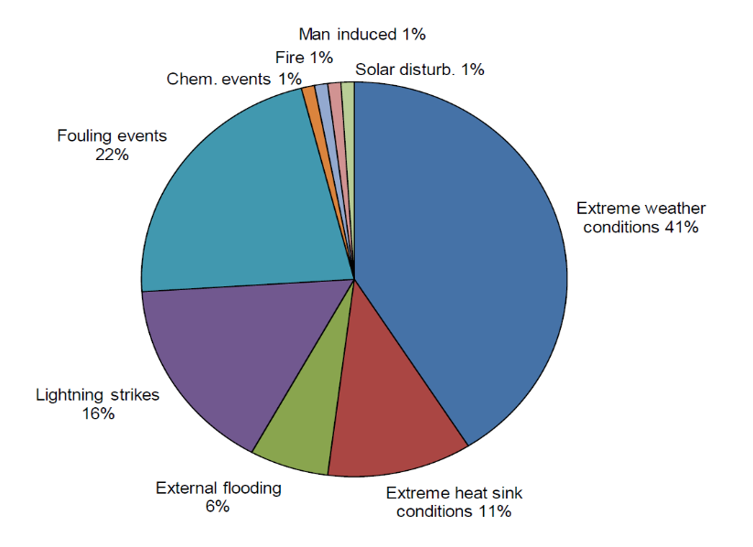

The analysis of the Flooding events reports recorded in the IRS highlights the following “lessons learnt” :
- Room division, which ensures system reliability in case of common cause failure, can be compromised with unblocked passages between rooms supposed to be independent; room division should be restored after working activities (drilling for cable introduction, for example) and periodic controls about room division should be carried out to notice and correct potential non-compliances;
- Consequences of NPP site isolation in case of external flooding should be studied in order to ensure emergency staff arrival;
- Water retention on NPP building roofs combined with the rupture of inter-building sealing joint can be considered as a potential phenomenon of external flooding;
- External events PSA results should be used to understand high seawater level events consequences and to implement adequate surveillance and management procedures;
- It should be ensured that the drainage system is functional and that the water tightness of buildings, penetrations and other openings are checked regularly;
- Adequate measures should be taken to avoid internal flooding caused by pipe break due to different causes (i.e. corrosion, stagnant water sedimentation, freezing and unfreezing, etc.).
A further study developed by IAEA / NEA focuses on flood related vulnerabilities and events in nuclear power plants between 2005-2008 and highlights similar recommendations [2]:
- Sealing of equipment below the flood line, such as electrical conduits;
- Holes or unsealed penetrations in floors and walls between flood areas;
- Adequacy of watertight doors between flood areas;
- Common drain system and sumps, including floor drain piping and check valves where credited for isolation of flood areas within plant buildings;
- Operable sump pumps, level alarms and control circuits, including maintenance and calibrations of flood protection equipment;
- Sources of potential internal flooding that are not analysed or not adequately maintained, for example failure of flexible piping expansion joints, failure of fire protection system sprinklers, roof leaks, rest room backups, and failure of service water lines;
- Condition and availability of temporary or removable flood barriers.
A further work to be mentioned is a report developed by the NEA Committee on Nuclear Regulatory Activities (CNRA) on the Fukushima Daiichi NPP Precursor Event [3], which provides the results coming from queries on the IRS database aimed at identifying events with characteristics similar to Fukushima Daiichi NPP accident. The analysis starts with a description of the Fukushima Daiichi NPP event, focuses on the initiating events and on the main systems unavailable during the accident sequences, and identifies five events that share similarities with the accident at Fukushima Daiichi NPP. One of them is an external flooding event: Blayais, 1999.
The evaluation of each event focusses on two questions: How were severe core damage accidents prevented during these events? What are the main lessons to be learnt from these events? The analysis of the Blayais event revealed weaknesses in the site protection against external flooding related to:
- The extreme meteorological conditions considered in the design of the site protection. For the Le Blayais’ site, high storm-driven waves coincident with high water level in the Gironde estuary had not been initially considered;
- The warning system and its criteria, allowing the anticipation of severe weather (verification of the protection devices, implementation of movable equipment…) and the shutdown of the plants in a timely schedule;
- The site accessibility (blocked roadways), highlighting both the need for additional staff of operating and emergency response personnel prior to the arrival of the severe flooding conditions and the need for an adequate self-sufficiency of the site (water quality and fuel supply…);
- The flooding-related procedures and the on-site emergency organisation, considering all the diverse aspects linked to the flooding conditions including:
- the accessibility of the equipment located outside of the protected buildings,
- the simultaneous impact on several plants, with a potential risk of losing both the external power supplies and the ultimate heat sink,
- the isolation of the site and the difficulties to provide rescue staff and equipment;
- The detection of water in the flooded rooms, allowing a quick response of the operating staff for implementing the necessary action, like the implementation of movable pumping devices;
- The faults in electrical isolation, likely to lead to some electrical busbars loss whereas the external grid may be lost due to the severe weather conditions;
- The management of release of the water collected in the flooded facilities;
- The penetrations and the doors which were built under the platform level and at the periphery of buildings containing safety-classified equipment to ensure reactor shutdown, have to be watertight and sized to resist to water height induced by the external flooding of reference.
Two past events in Japan
Examples of water propagation during an external flooding event are provided in the following with reference to the Great East Japan Earthquake (GEJE) and impacts on Onagawa NPP and Fukushima Daini NPP.
Onagawa NPP [4]
In IAEA report [4] impact of tsunami caused by the GEJE to Onagawa NPP is reviewed as below.
Onagawa NPP was subject to a 13.6 m tsunami wave. The tsunami protection due to the plants chosen elevation of 14.8 m was a key to the performance of the plant during the March-11 event. The first tsunami arrived to the NPP site at 15:21, 35 minutes after the earthquake, flooded the concrete pits containing the traveling screens for all three units see.
The height of the tsunami tide created a positive pressure within the intake canal underneath the floor slab of Unit 2 seawater pump pit, forcing water into the intake canal ultrasonic water level sensor containers. Tsunami also caused inundation of the Unit 3 turbine seawater pump room through the opening of the intake canal. Water contact with the circuitry of the water level sensors automatically tripped the large circulating water pumps for the main condensers.
Details concerning water propagation can be found in the report [4] (see Figure 10-21).

Figure 10-21 : Sea water intake structure and sea water pump pit [4]
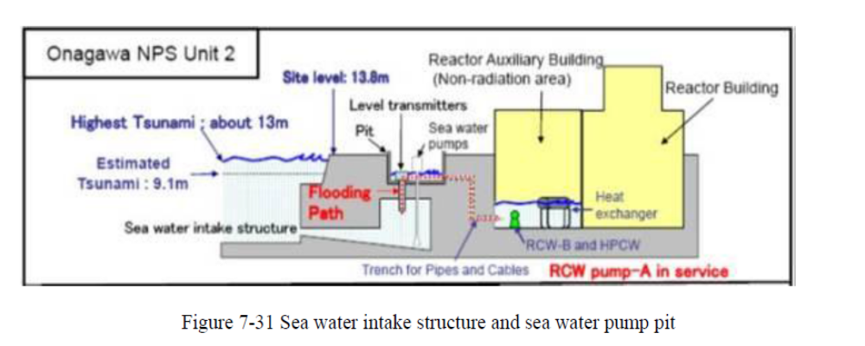
From “https://www.iaea.org/sites/default/files/iaeamissiononagawa.pdf”
Fukushima Daini NPP [5]
- Entry of flood water into main building
Inundation surrounding the main buildings of Fukushima Daini (reactor building and turbine building; Ground Level OP +12 m) was not significantly deep, with the exception of intensive run up on the south side of Unit 1. Intensive tsunami run up entered the Unit 1 building through the openings at ground level located on the south side of the reactor building (air intake louver for the emergency D/G, equipment hatch on the ground level) which flooded the reactor building (annex building) and caused the loss of function of all three units of emergency D/G, emergency power supply (for the C system and high pressure core spray system). The depth of run up around Unit 2 through Unit 4 was not significant, and thus flooding into the reactor buildings or turbine buildings through the openings at ground level was not detected. However, flooding was confirmed in the basement of the reactor building of Unit 3 (Annex) and the basements of turbine buildings Unit 1 through Unit 3. It is thought that tsunami inundation entered the buildings through the cables and pipes leading to the underground trenches and ducts.

- Damage situation of emergency equipment cooling pump
The pumps for the emergency equipment cooling water system at Fukushima Daini were housed in the seawater heat exchanger buildings. The area surrounding the buildings was inundated to a depth of 3 m by the tsunami, and while there was no damage to the building structures, all the seawater heat exchanger buildings were flooded by seawater through the damaged doors and other openings on ground level. As a result, the power panels and the motor of the pumps were submerged underwater and the total of eight emergency equipment cooling water systems lost function except for one system of Unit 3. In addition, the cooling system of the three D/G units, A, B and H installed for each reactor Unit also lost all function except for three systems: B and H of Unit 3 and H of Unit 4.
- Damage situation for power panel
The scale of the tsunami at Fukushima Daini was different from that at Fukushima Daiichi, and inundation of the main building was also different. Accordingly, the situations of power panel damage also differ as a result.
The Reactor building of Unit 1 (Annex), which was flooded by the tsunami, saw inundation on the emergency power panels of the C and H systems, but the D system power panel was not flooded and all the power panels of other reactor Units were free of damage. Due to this situation, it was possible to distribute electric power received from outside sources to various pieces of equipment through these emergency circuits, making it possible to use the necessary facilities to cope with the emergency situation. On the other hand, the power panels in the seawater heat exchanger buildings located in the seaside area were all submerged in the tsunami because of flooding in the buildings, and seven power panels lost function, with the exception of one low voltage power panel (P/C) situated in the seawater heat exchanger building of Unit 3. Therefore, the residual heat removal seawater system lost function except for one system of Unit 3 out of the total of eight.
- Damage situation of Emergency Diesel Generator
In the Fukushima Daini power station, each reactor Unit has three (A, B, H) emergency diesel generators (hereinafter referred to as "emergency D/G"). Unit 1 lost all three emergency D/Gs because the tsunami had entered the reactor building (Annex) through the opening at the ground level. Some of the emergency D/Gs which were able to avoid the flooding still lost function because of the loss of diesel engine cooling due to the flooding of the power panel and the pump motor for the cooling system. The cooling system of the emergency D/G was lost for most of the systems except for three: B and H of Unit 3 and H of Unit 4. As a result, nine D/Gs lost function: A, B and H of Unit 1, A, B and H of Unit 2, A of Unit 3 as well as A and B of Unit 4. However, Fukushima Daini had a continuous supply of electric power from the external sources and there was no need to activate such surviving emergency D/G after all.
- Situation of other outdoor damage
In the Fukushima Daini power station area, no major equipment and/or structure was observed being washed up by the tsunami to the main building area (elevation OP +12 m). However, five cases of openings/holes caused by the tsunami washing away or damaging the lid of the hatch duct in the main building area have been reported (see Figure 10-22).

Figure 10-22: Flood flow path [5]

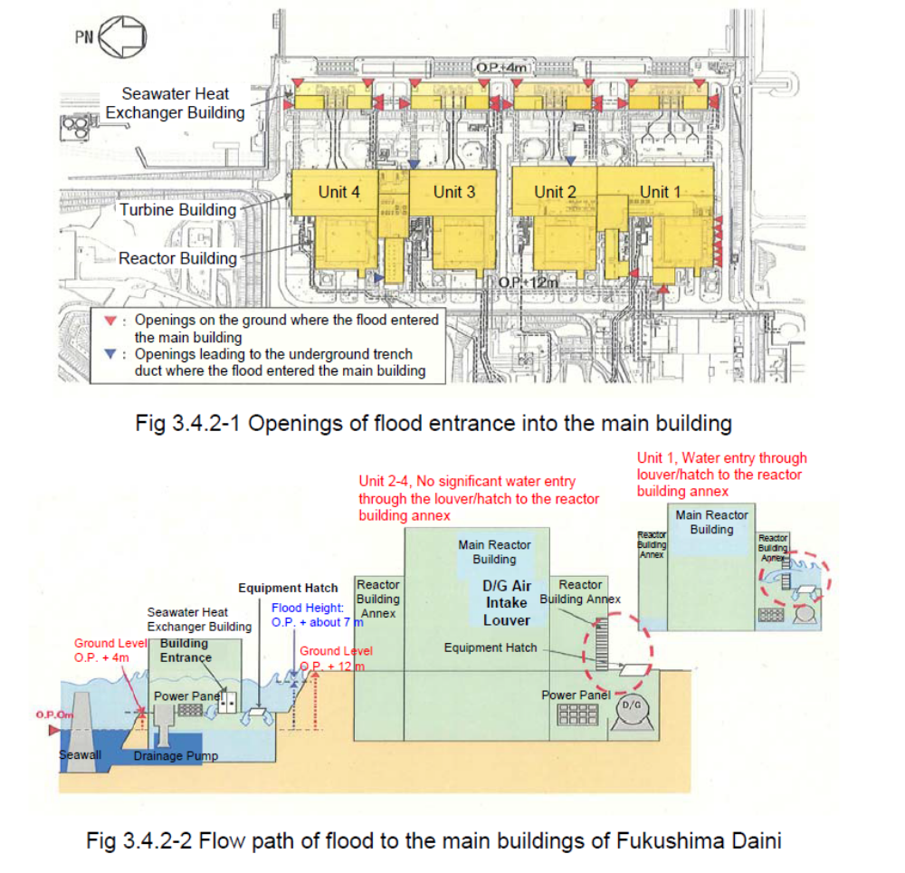
From “http://www.genanshin.jp/english/archive/disastersitereaction/data/F2jiko_Report.pdf”
Other Past Events
The following Table 10-10 provides information on some other past external flooding events involving NPP.
Table 10-10 : Past flooding events
Nr | Date (DD/MM/ YYYY) | Location of the event -name and type of NPP | Type of external event - flooding | Consequences / Impact on safety | Safety significant for NPP (Yes/No) | Lessons learnt (if any)
1 | 21/07/1993 | Cooper Nuclear Station [6] | Missouri River flood | In accordance with plant flood procedures, the licensee for the Cooper Nuclear Station had placed barriers around the entrances to the reactor building, the radwaste building, the turbine building and the diesel generator rooms. On July 21, the licensee began a reactor startup from a scheduled refueling and maintenance outage. At that time, the river level was 273.1 meters and decreasing.  On July 23, it was decided to shut down the reactor and it was declared a Notice Of Unusual Event when the water level in the Missouri River reached 274.0 meters.  The elevated river level caused the closure of several area roads including a portion of Interstate 29 and Route 136 in the State of Missouri which isolated one of the planned emergency evacuation routes. | Subsequent to the reactor shutdown, the licensee noted increased inleakage. The vital area rooms outside of the radiologically controlled areas were relatively dry with only a minor amount of water leaking in through the concrete walls below ground elevation. However, some of the below-grade rooms inside radiologically controlled areas in the turbine building and the reactor building, had extensive inleakage. In some cases, the inleakage significantly challenged the capacity of the floor drains. | This event demonstrates that flooding problems and degradation of equipment may be caused by water inleakage even though flood waters are not above grade elevations. Water leaking through underground walls may impinge on electrical equipment or may enter radiologically controlled areas and spread contamination to other areas. Underground cable and pipe tunnels may become flooded and serve as pathways for water to enter plant buildings.
2 | 27/12/1999 | Blayais NPP [3] [13] | Combination of the incoming tide and exceptionally high winds produced by Storm Martin caused a sudden rise of water in the estuary | The event resulted in the loss of the plant's off-site power supply and knocked out several safety-related backup systems, resulting in a 'level 2' event on the International Nuclear Event Scale | No, the sea walls were raised to 8.0 m above NFG,– up to 3.25 m higher than before – and openings have been sealed to prevent water ingress. | The flooding resulted in fundamental changes to the evaluation of flood risk at nuclear power plants, and in the precautions taken.
3 | 04/05/2006 | Kozloduy NPP vicinity | Danube river flood almost entirely Bulgarian shore. | The government introduces emergency situation in 21 municipalities at the Bulgarian shore of Danube. The level of the river marks the historic records. | No, but on 13/04/2006 and 14/04/2006 were performed draining of sewerage manholes inside of the KNPP site. These sewerage manholes are related to rainwater drainage network. | Additional monitoring and technical activities – for instance only in 1 municipality were performed more than 300 draining in 548 objects.
4 | 06/06/2011 | Fort Calhoun Nuclear Generating Station [9] [10] [11] [12] | Missouri River flood.  The Missouri River was above flood stage and expected to rise further, and to remain above flood stage for several weeks to a month | Contractors installed sandbags and earthen berms to protect the facility from flooding. According to officials, the plant was built to withstand a 500 year flooding event and, though by June 14 much of the facility was surrounded by the swollen Missouri River, Omaha Public Power District officials said they were confident that enough redundancies were in place to ensure adequate safety. It was reported on June 17, 2011 that the plant was in "safe cold shutdown" mode for refueling and the anticipation of flooding, and that four weeks' worth of additional fuel had been brought in to power backup generators, should they be needed. | Omaha Public Power District, as required by Nuclear Regulatory Commission guidelines, declared a Notification of Unusual Event (minimal level on a 4 level taxonomy) due to flooding of the Missouri River. | Before restarting OPPD spent $180 million recommissioning the plant, and cleared a list of 450 corrective items issued by the NRC. After three years in cold shutdown, the plant regained full power again on December 26, 2013.

References in Annex A
- Joint Research Centre, “European Clearinghouse: Report on External Hazard related events at NPPs”, 2013.
- IAEA, AEN NEA, Nuclear Power Plant Operating Experience from the IAEA/NEA, International Reporting System for Operating Experience. 2005–2008
- NEA/CNRA/R, Working Group On Operating Experience [Wgoe], Report On Fukushima Daiichi Npp Precursor Events, 2014
- IAEA MISSION TO ONAGAWA NUCLEAR POWER STATION TO EXAMINE THE PERFORMANCE OF SYSTEMS, STRUCTURES AND COMPONENTS FOLLOWING THE GREAT EAST JAPANESE EARTHQUAKE AND TSUNAMI, Onagawa and Tokyo, Japan 30 July - 11 August 2012, pp. 76 – 83
https://www.iaea.org/sites/default/files/iaeamissiononagawa.pdf
- Japan Nuclear Safety Institute, TEPCO Fukushima Daini Nuclear Power Station Research on the status of response to the Tohoku-Pacific Ocean Earthquake and Tsunami and Lessons learned therefrom (Proposals), October 2012
http://www.genanshin.jp/english/archive/disastersitereaction/data/F2jiko_Report.pdf
- UNITED STATESNUCLEAR REGULATORY COMMISSION,OFFICE OF NUCLEAR REACTOR REGULATION WASHINGTON, D.C. 20555 - March 31, 1994, NRC INFORMATION NOTICE 94-27: FACILITY OPERATING CONCERNS RESULTING FROM LOCAL AREA FLOODING
- Kehoe, Benjamin (Jun 20, 2011). "Unusual event declared due to Missouri river flooding". United States Nuclear Regulatory Commission, NRC. Retrieved 2011-06-23.
- "Flood Facts and Information (June 2011)". Nebraska Public Power District, NPPD. June 2011. Retrieved 2011-06-23.
- "NRC: Event notification report for June 6th, 2011". Nuclear Regulatory Commission. Retrieved 19 June 2011.
- "NRC: Emergency classification". Nuclear Regulatory Commission. Retrieved 19 June 2011.
- "Low-level emergency declared at nuclear power plant". JournalStar.com (Lincoln, Nebraska). June 6, 2011. Retrieved 2011-06-07.
- Smollen, Gary (June 14, 2011). "Fort Calhoun flood defenses". WOWT.com. Retrieved 15 June 2011
- Lessons Learned from 1999 Blayais Flood: Overview of the EDF Flood Risk Management Plan, Eric de Fraguier, EDF, published 2010-03-11, accessed 2011-03-22
- IRS Guidelines Joint IAEA/NEA International Reporting System for Operating Experience, Vienna, March 2010 Services Series No. 19

Annex B: extreme value theory
Estimation of low frequencies of rare natural hazards like extreme values of weather events is an challenging extrapolation exercise. Some selected special mathematical techniques should be applied, but still the main problem is often related to the lack of enough data. These methods are typically based on the extreme value theory, which deals with the analysis of extreme deviation from the median or the mean. In this respect a number of various mathematical tools can be useful, like: the first extreme value theorem of Fisher–Tippett–Gnedenko leading to possible choices of general extreme value distributions, or the second extreme value theorem of Pickands–Balkema–de Haan for tail-fitting, or the methods related to deviation theory. Before applying one or the other method one should answer the following crucial questions: which method to use, how to estimate parameters and how to verify goodness of fit. This paper gives a short overview of statistical techniques that can be useful for a practical approach to these problems.
Annual Maxima/Minima Series (AMS)
The analysis of the data with the annual extreme values (in principle any period can be considered) is based on the first extreme value theorem (known as Fisher–Tippett–Gnedenko theorem). The theorem says that if there exists a non- degenerate distribution function as a limit of probabilities of maxima series then, this limit distribution can be one of the three possible types: Gumbel, Fréchet or Weibull, known as type I, II and III respectively.
Type 1 (Gumbel)

Type 2 (Fréchet)
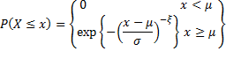
Type 3 (Weibull)
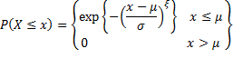

These three families of distributions can be combined in one, known as generalized extreme value (GEV) distribution, leading to the following formula for the cumulative distribution function:
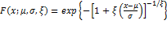
In above formulas μ is known as the location parameter, σ – the scale parameter, and 𝜉 – the shape parameter (𝜉>0 – “long tailed” case, 𝜉=0 – exponential tail, 𝜉<0 – “short tailed” case). In fact, under some assumptions on the positivity of the type II and negativity of type III, they both can be linked to the type I via logarithm function – roughly speaking if X is random variable of the distribution type II or III, then log(X) or log(-X) is of type I.
The theorem is valid for independent random variables and as it has asymptotic character then, in principle, one needs enough statistical data to apply it directly. Therefore some deviations or other distributions are also used in practise. Nevertheless this approach is often applied, for example, for the prediction of extreme weather events, like large floods or surge storms.
Peak Over Threshold (POT)
The POT method is based on the analysis of data exceeding some threshold over defined periods. Two quantities are typically estimated: the number of such events and how big such exceedance is. The first one is usually estimated by Poisson distribution, while the second one is characterized by the generalized Pareto distribution. The cumulative Pareto distribution function is defined by the following formula:
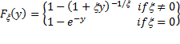

Here 𝜉 is, as above, the shape parameter. One can easily introduce the location and scale parameters μ, σ by utilizing transformation y→ (x-μ)/σ.
A kind of hierarchy is introduced for the class of the Pareto distributions. They are known being as of type I, II, III, IV and the Feller-Pareto. The type IV contains three previous as special cases, while the Feller-Pareto generalizes type IV. These distributions are applied in hydrology for example, in order to model daily maxima of rainfalls and river discharges.
The open question is related to defining the threshold, which should be done carefully, as it has impact on the statistics and not properly set (for example too low) can deteriorate the results.
Survival and hazard functions
The comparison of Pareto type distributions is often made by the survival function, which is simply the complementary of cumulative distribution function (i.e. defined as S(t)=1-F(t), where F is cumulative distribution function). This is strictly connected to such parameters like failure rate or mean time between failures via hazard function which could be determined as follows:
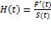 .
The failure rate is a conditional probability of the failure density function. The hazard function is, in fact, a continuous version of failure rate.
There are two estimators, worth mentioning, which could be applied to estimate survival and hazards function, respectively: the Kaplan-Meier and the Nelson-Aalen.
The Kaplan-Meier is a non-parametric estimation of survival function S based on maximum likelihood principle. Assuming that S(t) is the probability that lifetime exceeds time t, and given sample of the form (t₁, n₁, d₁),…,(t_{N}, n_{N}, d_{N}), where t_{i} is observed time, n_{i} is the number at risk prior to time t_{i} and d_{i} number of failures at time t_{i}, the estimator can be defined as follows:
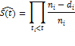
Please note that this formula is given for censored data – in non-censored case n_{i} is the number of elements with no failure just prior to time t_{i}.
Similarly the Nelson-Aalen estimator is also a non-parametric estimation for incomplete or censored data given by the following formula:
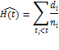
Here d_{i} is the number of failures at time t_{i}, while n_{i} is the number at risk at time t_{i}.
In this respect one can also mention the proportional hazard model introduced by Cox. In this model it is postulated that the parameters affecting hazard can be scaled proportional to time. The model of hazard at time t has the following form:
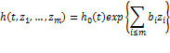
The quantities b_{i} are explanatory variables, z_{i} are model parameters and h₀ is the baseline hazard.
Tail fitting approach
The Pareto distribution is often used for modelling the tail of some other distributions. For this purpose the second extreme value theorem (Pickands–Balkema–de Haan) can be applied. The theorem says that the asymptotic tail distribution of random variable X (where true distribution is unknown) can be approximated by generalized Pareto distribution. By tail it is understood the exceedance of certain threshold. Mathematically it is expressed as follows:
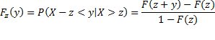

Then the following limit holds:
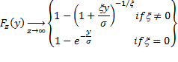

Goodness of fit
Several techniques can be used to verify goodness of fit for extreme value distribution. In this respect one should mention simple plotting methods. Consider for example Gumbel distribution – taking logarithm for the probability P(X≥x) one gets 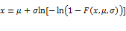 to plot observation data of type I. This should lead to the straight line for sampling of the form (x_{i},ln[-ln(1-p_{i})]) for observed data x_{i} and plotted points p_{i}. Some authors consider different plotting techniques, where p_{i} are defined in various way – for example by median ranks, mean rank, or symmetric distribution ranks. This can be also further combined with the least square method for estimating location and scale parameters μ and σ. Selection of position points p_{i} is an open question and should be somehow motivated.
Another approach is based on Monte Carlo simulations and application of Kolmogorov-Smirnov, Cramer-von Mises, or Anderson-Darling statistics. Assuming that (x₁<x₂<,…,<x_{n}) is ordered statistics of some cumulative distribution function F₀(x;Θ), where Θ is the set of parameters, the tests are based on the verification of the null hypothesis H₀: F(x)=F₀(x;Θ). The following statistics are used:
- Kolmogorov-Smirnov: 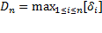, where 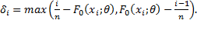
- Cramer-von Mises: 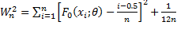.
- Anderson-Darling: 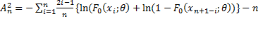.
Basing on these statistics some modifications or other statistics have been also proposed and are used in modelling. Some suggestions have been made in [1] saying that in general the Anderson-Darling statistics coupled with the symmetrical ranks and usage of the estimator based on the least square method can be recommended to use in practice.
For GEV distribution Zempléni test can be used based on the following statistics:
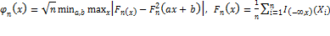.
There exist also tests utilizing the correlation coefficient like the one based on the product-moment correlation between the sample order statistics and their expected values. These tests are relatively simple to perform.
Estimators
A number of methods can be applied for estimation of the distribution parameters. Among them one should mention the following ones [1]:
- moment estimator: explicit formulas are deducted from sample mean and standard deviation;
- simple linear estimator: based on simplification of likelihood equation (which , in principle, can be solved numerically only);
- best linear unbiased or invariant estimator (BLUE/BLIE): based on minimizing generalized variance or mean square error;
- asymptotic best linear unbiased estimation: based on asymptotics of variance or covariance of BLUE;
- maximum likelihood estimator: based on maximum likelihood principle – can lead to numerically solving equations;
- probability-weighted moment (PVM) estimator: based on the moments with the weights which include, for example, cumulative distribution function;
- ranked set estimator: ranked simple mean is used with the optimal weights, leading to ranked set best linear unbiased estimators;
- conditional method: based on determination of marginal conditional densities, which are applied to carry out individual inferences on the parameters;
- minimum distance method: based on finding minimum of Cramer-von Mises distance of the form: 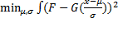, where F is empirical distribution and G the one which parameters are to be estimated;
- bias-robust (B-robust) estimator for GEV: based on utilizing the influence function;
- optimal bias robust (OBRE) estimator for GEV: related to the moment based estimators;
- estimation of tail index of the distribution: different techniques usually utilising some asymptotic behaviour.
Some practical approaches for constructing tolerance limits for extreme value distributions have been also proposed ([1]).
A more general approach can be based on large deviation theory dealing with the asymptotic behaviour of the distribution tails. This theory is based on the results on the convergence of probability measures and hence is difficult to apply directly. There are some relations with thermodynamics via entropy or information system and risk management. As this theory is relatively new one can expect that in the future its role will be slightly increasing.

Censored and incomplete data
As it has been already mentioned lack of required statistical data is one of the main problems in estimating frequencies of extreme natural events. Some improvement can be possibly expected when the techniques for censored or incomplete data are applied. However, typical imputation methods should be used carefully as simply replacing missing data with substitutes usually does not improve statistics in terms of appearance of extreme values. Probably partial imputation with expectation-maximization algorithm could be used in some cases.
Similarly application of asymptotic estimators for censored data could be useful, as asymptoptics reflects behaviour of very large sample, while censoring deals with partially known observations. Some estimators, in this case, like the ones based on likelihood equation can lead to the system of nonlinear equations that can be solved only numerically. As an example of such an approach is to use maximum likelihood principle to the likelihood that can be expressed in the following form [1]:
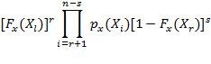

X_{l} and Xr are left and right censoring fixed points with r lowest and s largest data (r and s are random variables), while F_{x} is one of the cumulative extreme value distributions.
Future perspectives
Application of the presented above statistical tools will be always limited by the availability of enough good statistical data. In order to tackle the problem of the lack of data one should step out of the extreme value theory application at the single site and go toward RFA, stochastic modelling, historical data and simulation data. As an example of the latter, one can mention possible application of climate models and ensemble techniques used in weather forecasting. Combination of data coming from different sources will be probably necessary. In this respect statistical techniques similar to the ones used in data assimilation can be useful – in order to apply them information about data uncertainty is needed. Estimation of uncertainties, both for input data and the results, is important at any rate.
References in Annex B
- Kotz S. , Nadarajah S., Extreme value distributions, 2000

Annex C: Human Reliability Analysis
This Annex provides a brief review of methods for HRA.
First and second generation HRA methods
Human Reliability Analysis (HRA) aims at providing an assessment of Human Error Probabilities (HEP), to be introduced into a Probabilistic Safety Analysis (PSA), in the actions performed by the staff of a Nuclear Power Plant (NPP) during normal operation or as a part of the emergency response on a specific initiating event. Many qualitative and quantitative methods have been proposed and used by some high hazard industries to assess the human contribution to risk. Throughout the last thirty years (i.e. since THERP was made available), HRA methods have changed significantly their constitutive structure. For a number of years, a clear distinction between first and second generation HRA methods has existed, even if guidance for their classification was not entirely consistent.
The many right, punctual and pertinent criticisms moved by psychologists towards the “black box approach” implicit in the earlier developed HRA method have pushed human factor engineers to move towards more advanced approaches, which include cognition in their framework, when accounting for the influence of working conditions on human performance. From this point of view, the “first generation” HRA methods refer to precognitive movements in psychology; the “second generation” ones harness findings and insights from the cognitive movement. Differently, the “context” where human actions are performed and human errors can be made is considered the main topic that HRA methods may or not address, allowing the distinction between the first generation methods, which are quite weak in that, and the second generation which try to carefully consider the influence of context on the human errors probability. Other criteria have been drawn based on the consideration of errors of commission in the second generation HRA methods, as opposed to the focus on errors of omission in first generation ones. Currently, the HRA community is prone to classify HRA methods simply considering the oldest one within the first generation and the later developed methods within the second generation. Certainly, the use of cognitive models, the account for the context and the analysis of commissioning errors are major topics to characterize HRA methods.
HRA is a major contributor to the variability in PSA results [12]. Different methods rely on different human performance frameworks and data, and analysts may apply them inconsistently. Due to the significant differences in HRA methods, including their scope, approach, and underlying models, a number of benchmarking studies have been performed in order to investigate their validity and reliability, by comparing HRA methods with each other and against operator performance in simulator studies (empirical validation) ([40], [41]). Variability in HRA results can be highlighted by the application of some methods by one (or more) team/analyst and by the involvement of some team/analysts in the application of the same method. Earlier benchmarking studies on HRA methods highlighted that, even if results obtained from different team / analysts could be significant, the difference can be reduced by a deep familiarization with the system and the scope of the assessment and by the use of structured and high decompositive methods (, [2]). New insights are coming from the ongoing empirical benchmarking studies on HRA methods (e.g. HAMMLAB simulator at the Halden Reactor Project).
If first generation methods (e.g. THERP) are widely and successfully employed, some second generation ones have remained underutilized. It is commonly recognized that first and second generation methods should continue to be implemented wherever needed; second generation methods should continue to be researched and improved to ensure an efficient, accurate, and complete capture of human performance [3]. Benchmarking among different HRA methods and with empirical data is essential to provide recommendations for their use.
Simulation-based approaches to HRA
Regarding the above background, there exist recent developments, based on human performance simulation, that do not fit the classification of first or second generation methods. Even if the importance of simulation and modelling of human performance was recognized timely , simulation-based approaches to HRA have been widely developed only in the last few years and their application in NPP PSAs is far from to be consolidated.
Simulation-based approaches to HRA provide a dynamic basis for human reliability modelling and quantification, differently from the above first and second generation HRA methods which essentially capture human performance at a particular point in time, by static analyses of tasks and operating conditions, through empirical data or expert judgment, regardless any guidance on the calculation of continuous-time HEP, without any explication on changes of Performance shaping factors (PSFs), including ones introduced by external influences.
Simulation-based approaches could support the development of a new generation of HRA methods, for their unique features and modelling opportunities. They may augment the state-of-practice HRA methods by dynamically computing PSFs and HEPs for any given point in time [3]. Specifically, simulation data can be compared to results coming from the different HRA methods, in order to identify their strength and weakness and to clarify the sources of variability of results.
A key distinction shall be made between the recent use of simulations, which adopt virtual environments and virtual performers to model tasks, and the more common use of simulators, which utilize human performers. They may both be used to model dynamic human performance, but with different limits and opportunities: through simulators it is possible to capture the full spectrum of human PSFs; through simulations it is possible to consider a wider spectrum of modelling, also including unusual conditions as due to extreme events, overcoming limits due to inadequate operations experience, insufficient data and widely use of expert judgments.
Open issues are the high level of decomposition of tasks required by simulation-based approaches, which may be incompatible with ones adopted by some HRA methods and the significant variability among them. More in general, there are still significant challenges to be resolved, mainly about the integration with available HRA methods, before benefits coming from simulation-based approaches to HRA, in providing data sources and opportunities for realistic modelling of man-machine interactions, may be realized.

Rule vs Knowledge-based behaviour and external extreme events
The most widely used approach to explain human internal information flow and thinking processes is the step-ladder model introduced by Rasmussen [5], which categorizes human behaviour into three types:
- Skill-based, i.e. routine behaviour based on learned skills; the cognitive effort required is very low, the reasoning is unconscious and operator action in response to input is performed almost automatically;
- Rule-based, i.e. behaviour guided by rules provided to operator to perform tasks known, by recognizing the situation and by applying appropriate procedures, with a certain level of cognitive engagement and reasoning known;
- Knowledge-based, i.e. behaviour aimed at solving problems under unusual situations, for which there are no rules or procedures, with a high cognitive engagement in the search for solution.
Human behaviours currently analysed in NPP PSA are essentially errors in the execution of rule-based type actions. Errors of commissioning are not always and exhaustively assessed and included in PSAs ([28], [42], [43]), being considered by some second generation HRA methods only, still without an effective approach for their systematic identification, specifically when they refer to possible knowledge-based actions.
With reference to additional influences caused by external events, the human failure (and their probability) adopted by the Internal events PSA should be modified as appropriate and new human error should be included to account for specific not already covered actions. It could be not enough if human errors (typically, error of omission) lead to the loss of protections in an accidental sequence involving a further human error as initiator (typically, error of commission); in this case, dependency between errors should be considered and the contribution due to the external event as common cause of errors could be dominant.
Most of the available standards and guidelines on NPP PSA ([6], [7], [8]) provide the general recommendation to assess the human factor depending on external events. Anyway, no specific indications are provided about the HRA methods and their ability to cover the different needs. More in general, the HRA community agrees that it is not possible to identify a single method as recommended than the others. This philosophy could be observed also in the latest guidelines prepared by IAEA on the application of PSA (e.g. [6]), where only general recommendations are specified on what the HRA should take into account rather than on how to do it.
Preliminary overview on HRA methods
The lack of recommendations on (what and how) HRA methods have to be used should be filled by an overview on the most significant ones, aimed at investigating their strengths and weakness and at identifying the more adequate approach for each typical application in (level 1 and level 2) NPP PSAs. It should be carried out on the first and second generation methods at least, but it should also consider the main advantages provided by the more recent simulation-based approaches. Figure 12-23 depicts some major HRA methods and their sponsorship.
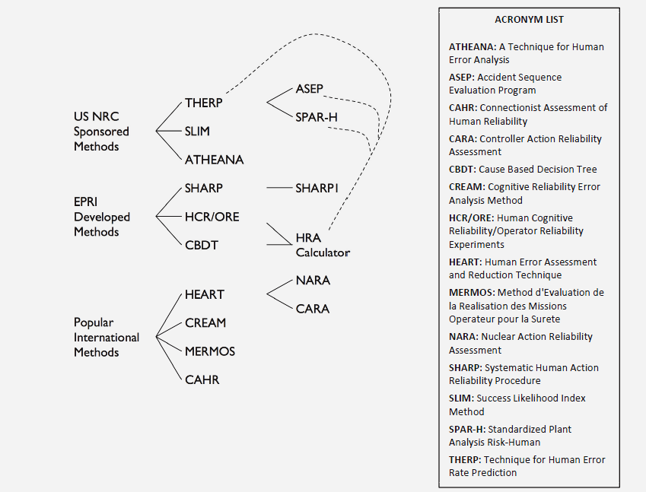
Figure 12-23– HRA method developments [9]
Table 12-11 provides information on HRA methods in Figure 12-23: application field(s), brief description and purposes, authors, year of development and main bibliography references. As preliminary overview, Table 12-11 : also provides the stage(s) of the risk assessment process during which each method is particularly adequate, including: Scope the assessment; Learning the nominal operation; Identify hazards; Combine hazards into risk framework; Evaluate risk; Identify potential mitigating measure to reduce risk; Safety monitoring and verification; Learning from safety feedback [10].
An overview on HRA methods (developed within the ASAMPSA_E project) should consider some general subjects (e.g. modelling of cognition, context, and error of commission) and specific topics focused on the assessment of human errors depending on external events.

Method | Application field | Description | Date | Ref. | Stage
ASEP | Nuclear | Abbreviated and slightly modified version of THERP. ASEP comprises pre-accident screening with nominal human reliability analysis, and post-accident screening and nominal human reliability analysis facilities. ASEP provides a shorter route to human reliability analysis than THERP by requiring less training to use the tool, less expertise for screening estimates, and less time to complete the analysis. Developed by A.D. Swain. Is often used as screening method to identify human actions that have to be assessed in more detail using THERP. However, is more conservative. | 1987 | [17]  [24]  [26]  [27] | Evaluate risk
ATHEANA | Nuclear | Aim is to analyse operational experience and understand the contextual causes of errors, and then to identify significant errors not typically included in PSAs for nuclear power plants, e.g. errors of commission. Key human failure events and associated procedures etc. are identified from the PSA, and unsafe acts are then identified that could affect or cause these events. Associated error-forcing conditions are then identified that could explain why such unsafe acts could occur. These forcing conditions are based on the system being assessed, i.e. the real context that is the focus of the assessment.  Developed by NRC (Nuclear Regulatory Commission) the method relies on operational experience and expert judgement. It is the intention of the authors to produce guidance material on the technical basis of the model. Such material could reduce the reliance on expert judgement and increase the auditability of the technique. Goes beyond THERP in its capability to account for and predict human errors, by examining cognitive processes. | 1996 | [20]  [28]  [29] | Learning from safety feedback
CAHR | Nuclear | The Database-System CAHR is a twofold tool aiming at retrospective event analysis and prospective assessment of human actions. It is implemented as a tool for analysing operational disturbances, which are caused by inadequate human actions or organisational factors using Microsoft ACCESS. Retrospectively, CAHR contains a generic framework for the event analysis supported by a knowledge base of taxonomies and causes that is extendable by the description of further events. The knowledge-base contains information about the system-state and the tasks as well as for error opportunities and influencing factors (Performance Shaping Factors). Prospectively it aims to provide qualitative and quantitative data for assessing human reliability.  The term Connectionism was coined by modelling human cognition on the basis of artificial intelligence models. It refers to the idea that human performance is affected by the interrelation of multiple conditions and factors rather than singular ones that may be treated isolated. | 1992-1998 | [14] | Evaluate risk
CARA | Air traffic management | This is HEART tailored to the air traffic controller. Uses the CORE-DATA human error database | 2007 | [16]  [30] | Evaluate risk
CREAM | Nuclear | Cognitive modelling approach. Applies cognitive systems engineering to provide a more thoroughly argued and theory supported approach to reliability studies. The approach can be applied retrospectively or prospectively, although further development is required for the latter. The ‘meat’ of CREAM is the distinction between phenotypes (failure modes) and genotypes (possible causes or explanations). Developed by Erik Hollnagel. Related to SHERPA, SRK and COCOM. A version of traffic safety has been implemented (DREAM - Driver Reliability And Error Analysis Method). Later, a version was developed for use in maritime accident analysis (BREAM - B for the ship's Bridge). | 1998 | [13]  [20] | Combine hazards into risk framework
HCR | Nuclear | Method for determining probabilities for human errors after trouble has occurred in the time window considered. Probability of erroneous action is considered to be a function of a normalised time period, which represents the ration between the total available time and the time required to perform the correct action. Different time-reliability curves are drawn for skill-based, rule-based and knowledge-based performance.  Not considered very accurate. | 1982 | [15]  [17]  [31] | Evaluate risk
HEART | Nuclear  Chemical  Defence | Quantifies human errors in operator tasks. Considers particular ergonomic and other task and environmental factors that can negatively affect performance. The extent to which each factor independently affects performance is quantified, and the human error probability is then calculated as a function of the product of those factors identified for a particular task. Popular technique. | 1985 | [15]  [17]  [18]  [19]  [24]  [25] | Evaluate risk
MERMOS | Nuclear  Electrical | MERMOS is a HRA method that deals with important underlying concepts of HRAs. The basic theoretical object of the MERMOS method is what is termed Human Factor Missions. The Human Factor Missions refer to a set of macro-actions the crew has to carry out in order to maintain or restore safety functions. Four major steps are involved in the MERMOS method. 1) Identify the safety functions that are affected, the possible functional responses, the associated operation objectives, and determine whether specific means are to be used. 2) Break down the safety requirement corresponding to the HF mission. 3) Bridge the gap between theoretical concepts and real data by creating as many failure scenarios as possible. 4) Ensure the consistency of the results and integrate them into PSA event trees.  Developed by Electricité de France. | 1998 | [14]  [22] | Combine hazards into risk framework
NARA | Nuclear | Enhanced and updated version of HEART specific to the nuclear industry. Developed by Corporate Risk Associates (CRA) and commissioned by the Nuclear Industry Management Committee (IMC) and British Energy. | 2004 | [32] | Evaluate risk
SHARP | Electrical | Helps practitioners picking up the right Human Reliability Analysis method to use for a specific action / situation. It employs a 4-phase procedure: 1) Identification of potential human errors (using detailed description of operator tasks and errors, and techniques like FMEA); 2) Selecting significant errors (e.g. based on likelihood and whether it leads directly to undesirable event); 3) Detailed analysis of significant errors (likelihood analysis); 4) Integration into a system model (studying the dependence between human errors and system errors and the dependence of human errors on other errors). SHARP suggests a number of techniques to be used. | 1984 | [23]  [33] | Identify hazards  Combine hazards into risk framework
SLIM | Nuclear  Chemical | Estimates human error probabilities. Two modules: MAUD (Multi-Attribute Utility Decomposition, used to analyse a set of tasks for which human error probabilities are required) and SARAH (Systematic Approach to the Reliability Assessment of Humans, used to transform success likelihoods into human error probabilities (HEP)).  Developed by D.E. Embrey, P. Humphreys, E.A. Rosa, B. Kirwan, and K. Rea, Brookhaven National Laboratory, July 1984. Human reliability family. Similar to APJ. Can be reserved for difficult HEP assessments that HEART and THERP are not designed for. | 1984 | [15]  [17]  [24]  [34]  [36] | Evaluate risk
SPAR-H | Nuclear | Quick easy to use screening level (i.e. not full scope) HRA technique. Significant revision of ASP (Accident Sequence Precursor). Supports ASP analysis of operating events at Nuclear Power Plants. Incorporates the advantages of other human reliability assessment methods (e.g. IPE, HPED, INTENT). Qualitative and quantitative. Was developed for the US NRC’s (Nuclear Regulatory Commission) Simplified Plant Analysis Risk (SPAR) program. | 2001 or older | [14]  [35] | Evaluate risk
THERP | Nuclear  Defence | Aim is to predict human error probabilities and evaluate degradation of a man-machine system likely to be caused by human error, equipment functioning, operational procedures and practices, etc. Steps are: 1. Define the system failures of interest. 2. List and analyse the related human operations, and identify human errors that can occur, as well as relevant human error recovery modes. This stage of the process necessitates a comprehensive task and human error analysis. The tasks and associated outcomes are input to an HRAET (human reliability analysis event tree) in order to provide a graphical representation of a task’s procedure. 3. Estimate the relevant human error probabilities (HEPs) for each sub-task, and enter these into the tree. 4. Estimate the effects of human error on the system failure events. 5. Recommend changes to the system and recalculate the system failure probabilities. Developed by Swain & Guttman. Longest surviving HRA (Human Reliability Analysis) technique. Developed in 1960-1970; released in 1981. This technique is the standard method for the quantifying of human error in industry. | 1981 | [15]  [17]  [20]  [21] | Evaluate risk
Table 12-11 : Preliminary overview on HRA Methods
References in Annex C
- P. Vestrucci (1990), “Modelli per la valutazione dell'affidabilità umana”. Franco Angeli
- A. Watson (1986), “Human Reliability, in Proceeding of Ispra Course Reliability Engineering”.
- R. L. Boring (2007), “Dynamic Human Reliability Analysis: Benefits and Challenges of Simulating Human Performance”, Proceedings of the European Safety and Reliability Conference (ESREL)
- Zio and Pedroni (2012). Uncertainty characterization in risk analysis for decision-making practice, number 2012-07 of the Cahiers de la Sécurité Industrielle, Foundation for an Industrial Safety Culture, Toulouse, France (ISSN 2100-3874). Available at http://www.FonCSI.org/en/cahiers/.
P.C. Cacciabue (1998), “Modelling and simulation of human behaviour for safety analysis and control of complex systems”. Safety Science, 28: 97-110.
- J. Rasmussen (1983), “Skills, rules, knowledge; signals, signs and symbols and other distinctions in human performance models”. IEEE Transactions on Systems, Man and Cybernetics. SMC-13
- IAEA (2010), Specific Safety Guide No.SSG-3 “Development and Application of Level 1 Probabilistic Safety Assessment for Nuclear Power Plants”.
- ASME/ANS RA-Sa-2009 (2012), “Standard for Level 1/Large Early Release Frequency Probabilistic Risk Assessment for Nuclear Power Plant Applications”.
- NUREG/CR-2300 (1983), “A Guide to the Performance of Probabilistic Risk Assessments for Nuclear Power Plants”. PRA PROCEDURES GUIDE
- R. L. Boring (2012), “Fifty Years of THERP and Human Reliability Analysis”. PSAM11
- NLR (2013), “Safety Methods Database”. Version 1.0
- ASAMPSA_E Technical report , “Lessons of the Fukushima Dai-ichi accident for PSA, ASAMPSA_E / WP30 / D30.2 / 2013-15.
- Sandia National Laboratory (2008), “Issues in Benchmarking Human Reliability Analysis Methods: A Literature Review”. Sandia report SAND2008-2619
- E. Hollnagel (1998), “Cognitive reliability and error analysis method: CREAM”. Elsevier
- US NRC (2001), “Draft proceedings HRA Washington workshop, Building the new HRA -Errors of Commission -from research to application”. Headquarters US NRC, Rockville, Maryland
- P. Humphreys (1988), “Human reliability assessors guide, Safety and Reliability Directorate UKAEA (SRD) Report No TRS 88/95Q”.
- B. Kirwan (2007), “Technical Reliability Assessment Capability for Air Traffic Safety Management”, EEC Note No. 06/07, Eurocontrol Basis for a Human Experimental Centre, Project: HRA
- B. Kirwan (1994), “A guide to practical human reliability assessment”. Taylor and Francis
- B. Kirwan (1996), “The validation of three human reliability quantification techniques – THERP, HEART and JHEDI: Part I – technique descriptions and validation issues, Applied Ergonomics”. Vol 27, No 6, pp. 359-373
- B. Kirwan (1997), “The validation of three human reliability quantification techniques – THERP, HEART and JHEDI: Part III – Practical aspects of the usage of the techniques, Applied Ergonomics”. Vol 28, No 1, pp. 27-39
- B. Kirwan (1998), “Human error identification techniques for risk assessment of high risk systems – Part 1: Review and evaluation of techniques, Applied Ergonomics”. Vol 29, No 3, pp. 157-177
- Swain, A. D., & Guttman, H. E. (1983). “Handbook of human reliability analysis with emphasis on nuclear power plant applications”. NUREG/CR-1278 (Washington D.C.).
- (2001) “THEMES WP4, Deliverable D4.1, Report on updated list of methods and critical description”. D’Appolonia S.p.A
- P. Wright, B. Fields and M. Harrison (1994), “Deriving human error tolerance Requirements from tasks”. Proceedings ICRE’94 – IEEE International Conference on Requirements Engineering
- B. Kirwan, R. Kennedy and D. Hamblen, Human reliability assessment in probabilistic safety assessment guidelines on best practice for existing gas-cooled reactors
- B. Kirwan, R. Kennedy, S. Taylor-Adams, B. Lambert (1997), “The validation of three human reliability quantification techniques – THERP, HEART and JHEDI: Part II – Results of validation exercise, Applied Ergonomics”. Vol 28, No 1, pp. 17-25,
- Gore, B. R., Dukelow, T. M. Jr. & Nicholson, W. L. (1995), “A limited assessment of the ASEP human reliability analysis procedure using simulator examination results” (NUREG/CR-6355). Washington, DC: Nuclear Regulatory Commission.
- Swain, A. D. (1987), “Accident sequence evaluation program: Human reliability analysis procedure (NUREG/CR-4772)”. Washington, DC: U. S. Nuclear Regulatory Commission.
- US Nuclear Regulatory Commission (1996), “A Technique for Human Error Analysis (ATHEANA), Technical Basis and Methodology Description”. NUREG/CR-6350
- US Nuclear Regulatory Commission (2000), “Technical Basis and Implementation Guidelines for A Technique for Human Event Analysis (ATHEANA)”. NUREG-1624, Rev. 1, U.S. Nuclear Regulatory Commission, Washington, DC
- W. H. Gibsona and B. Kirwan, “Application of the CARA HRA Tool to Air Traffic Management Safety Cases”. The University of Birmingham, Birmingham, UK Eurocontrol, Bretigny, France
- G.W. Hannaman, A. J. Spurgin and Y. D. Lukic (1984), “Human cognitive reliability model for PRA analysis”. Draft Report NUS-4531, EPRI Project RP2170-3. 1984, Electric Power and Research Institute: Palo Alto, CA.
- B. Kirwan, H. Gibson, R. Kennedy, J. Edmunds, G. Cooksley, I. Umbers (2004), “Nuclear Action Reliability Assessment (NARA): A Data-Based HRA Tool”. Probabilistic Safety Assessment and Management 2004, pp 1206-1211
- Systematic Human Action Reliability Procedure (SHARP) EPRI NP-3583 Project 2170-3 Interim Report June 1984
- D.E. Embrey, P.C. Humphreys, E. A. Rosa, B. Kirwan and K. Rea (1984), “SLIM-MAUD: An approach to assessing human error probabilities using structured expert judgement”. NUREG/CR-3518 US Nuclear Regulatory Commission: Washington DC.
- NUREG/CR-6883 INL/EXT-05-00509 - The SPAR-H Human Reliability Analysis Method
- P. Vestrucci (1988), “The Logistic Model for Assessing Human Error Probabilities Using the SLIM Method. Reliability Engineering and System Safety”.
- USNRC (2009), “Guidance on the treatment of uncertainties associated with pras in risk-informed decision making (NUREG-1855)”. Technical report, US Nuclear Regulatory Commission, Washington, D.C.
- A. Yamaguchi (2013), “MANAGEMENT OF BEYOND DESIGN BASIS EVENTS RISK – ROLE OF PROBABILISTIC AND DETERMINISTIC ASSESSMENTS”, ANS PSA 2013 International Topical Meeting on Probabilistic Safety Assessment and Analysis Columbia, SC
- USNRC (2006), “Evaluation of Human Reliability Analysis Methods Against Good Practices (NUREG-1842)”, Final report, US Nuclear Regulatory Commission, Washington, D.C.
- A. Poucet (1989), “HF-RBE. Human Factors Reliability Benchmark Exercise. Summary Contributions of Participants”. CEC
- A. Poucet (1989), “HF-RBE. Human Factors Reliability Benchmark Exercise. Synthesis Report”.
- Health and Safety Laboratory (2009), “Review of human reliability assessment methods”. HSE
- US Nuclear Regulatory Commission (1995), “Final policy statement on the use of probabilistic risk assessment methods in nuclear regulatory activities”. SECY-95-126

The differences between those hazards characterised at a single frequency (or small number of frequencies) and those that can only properly be characterised over a continuous range of frequencies. The latter category is meant to capture natural hazards such as extreme wind, flooding and earthquake, which are best described in terms of a hazard curve.
An example is an aircraft crash and fog - although the fog may increase the likelihood of an aircraft crash, it should be accounted for in the aircraft crash frequency.
Tsunami-like phenomena generated by meteorological or atmospheric disturbances.
E.g., up to a flood level of x meter no damage is incurred, between x and y meter the first floor equipment is lost; above y meter all equipment is lost; this situation can be handled by three initiating events, with their frequency – severity combination.
A Level 1 PSA for internal flooding is the probabilistic analysis of events relating to release of liquids (usually water) occurring inside plant buildings and the potential impact of such releases on safety (IAEA SSG-3).
For instance, in case the flooding level results in loss of (part of) the diesel generators, the trip or manual shutdown tree is the obvious choice.
SSC are identified on their role in maintaining the three basic safety functions (criticality, (decay)heat removal and confinement)
OPT method has been proposed within the Integrated Safety Assessment Methodology (ISAM) for Generation IV Nuclear Systems [5].

