ASAMPSA_E | Advanced Safety Assessment Methodologies: extended PSA

"NUCLEAR FISSION"
Safety of Existing Nuclear Installations Contract 605001

List of external hazards to be considered in ASAMPSA_E

Reference ASAMPSA_E
Technical report ASAMPSA_E / WP21 / D21.2 / 2015-10 Reference IRSN PSN-RES/SAG/2015-00085

Kurt Decker & Hans Brinkman

University Vienna NRG

Period covered: from 01/07/2013 to 31/12/2014 |  | Actual submission date: 26/02/2015
Start date of ASAMPSA_E: 01/07/2013 |  | Duration: 36 months
WP No: 21 | Lead topical coordinator : Kurt Decker |  | His organization name : University Vienna

Project co-funded by the European Commission Within the Seventh Framework Programme (2013-2016)
Dissemination Level
PU | Public | No
RE | Restricted to a group specified by the partners of the ASAMPSA_E project | Yes
CO | Confidential, only for partners of the ASAMPSA_E project | No

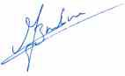
ASAMPSA_E | Advanced Safety Assessment Methodologies: extended PSA

ASAMPSA 2 Quality Assurance page

Partners responsible of the document : UNIVIE
Nature of document | Technical Report
Reference(s) | Technical report ASAMPSA_E/ WP21 / D21.2 / 2015-10
Title | List of External Hazards to be Considered in ASAMPSA_E
Author(s) | Kurt Decker & Hans Brinkman
Delivery date | 26/02/2015
Topical area | Initiating events (internal and external hazards) modeling
For Journal & Conf. papers | No
Summary :

The current report includes an exhaustive list of external hazards posing potential threats to nuclear installations. It includes both, natural and man-made external hazards. The list is regarded comprehensive including all types of hazards that were previously cited in documents by IAEA and WENRA-RHWG. 73 natural hazards (N1 to N73) and 24 man-made external hazards (M1 to M24) are included. Natural hazards are grouped into seismotectonic hazards, flooding and hydrological hazards, extreme values of meteorological phenomena, rare meteorological phenomena, biological hazards / infestation, geological hazards, and forest fire. The list of external man-made hazards includes industry accidents, military accidents, transportation accidents, pipeline accidents and other man-made external events.
The dataset further contains information on correlated and associated hazards. 579 correlations between individual hazards are identified shown in a cross-correlation chart. Correlations discriminate between:
(1) Causally connected hazards (cause-effect relation) where one hazard (e.g., liquefaction) may be caused by another hazard (e.g., earthquake); or where one hazard (e.g., high wind) is a prerequisite for a correlated hazard (e.g., storm surge). Causal links are not commutative. (2) Associated hazards (“contemporary” events) which are probable to occur at the same time due to a common root cause (e.g., drought and high temperature).

Visa grid
 | Main author(s) : | Verification | Approval (Coordinator)
Name (s) | K. Decker, H. Brinkman | WP21 Partners | E. Raimond
Date | 26-02-2015 | By e-mail | 26-02-2015
Signature |  | By e-mail | 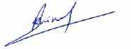

Report IRSN/PSN-RES/SAG/2015-00082
Technical report ASAMPSA_E/ WP30/ D30.2/2015-09
3/42
ASAMPSA_E | Advanced Safety Assessment Methodologies: extended PSA

MODIFICATIONS OF THE DOCUMENT

Version | Date | Authors | Pages or paragraphs modified | Description or comments
1 | Dec. 2014 | K. Decker |  | First version
2 | Feb. 2015 | E. Raimond |  | Editorial modification

LIST OF DIFFUSION

European Commission (Scientific Officer)
Name | First name | Organization
Passalacqua | Roberto | EC

ASAMPSA_E Project management group (PMG)

Name | First name | Organization
Raimond | Emmanuel | IRSN | Project coordinator
Guigueno | Yves | IRSN | WP10 coordinator
Decker | Kurt | Vienna University | WP21 coordinator
Klug | Joakim | LRC | WP22 coordinator
Wielenberg | Andreas | GRS | WP30 coordinator
Loeffler | Horst | GRS | WP40 coordinator

REPRESENTATIVES OF ASAMPSA_E PARTNERS

Name | First name | Organization
Grindon | Liz | AMEC NNC
Mustoe | Julian | AMEC NNC
Cordoliani | Vincent | AREVA
Dirksen | Gerben | AREVA
Godefroy | Florian | AREVA
Kollasko | Heiko | AREVA
Michaud | Laurent | AREVA
Sauvage | Estelle | AREVA

Name | First name | Organization
Hasnaoui | Chiheb | AREXIS
Hurel | François | AREXIS
Schirrer | Raphael | AREXIS
De Gelder | Pieter | Bel V
Gryffroy | Dries | Bel V
Jacques | Véronique | Bel V
Van Rompuy | Thibaut | Bel V
Cazzoli | Errico | CCA

Report IRSN/PSN-RES/SAG/2015-00082
Technical report ASAMPSA_E/ WP30/ D30.2/2015-09
4/42
ASAMPSA_E | Lessons of the Fukushima Dai-ichi accident for PSA

Name | First name | Organization
Vitázková | Jirina | CCA
Passalacqua | Roberto | EC
Banchieri | Yvonnick | EDF
Benzoni | Stéphane | EDF
Bernadara | Pietro | EDF
Bonnevialle | Anne-Marie | EDF
Brac | Pascal | EDF
Coulon | Vincent | EDF
Gallois | Marie | EDF
Hibti | Mohamed | EDF
Jan | Philippe | EDF
Lopez | Julien | EDF
Nonclercq | Philippe | EDF
Panato | Eddy | EDF
Parey | Sylvie | EDF
Romanet | François | EDF
Rychkov | Valentin | EDF
Vasseur | Dominique | EDF
Burgazzi | Luciano | ENEA
Hultqvist | Göran | FKA
Kähäri | Petri | FKA
Karlsson | Anders | FKA
Ljungbjörk | Julia | FKA
Pihl | Joel | FKA
Loeffler | Horst | GRS
Mildenberger | Oliver | GRS
Sperbeck | Silvio | GRS
Tuerschmann | Michael | GRS
Wielenberg | Andreas | GRS
Benitez | Francisco Jose | IEC
Del Barrio | Miguel A. | IEC
Serrano | Cesar | IEC
Apostol | Minodora | INR
Nitoi | Mirela | INR
Groudev | Pavlin | INRNE
Stefanova | Antoaneta | INRNE
Armingaud | François | IRSN
Bardet | Lise | IRSN
Bonnet | Jean-Michel | IRSN

Name | First name | Organization
Bonneville | Hervé | IRSN
Clement | Christophe | IRSN
Corenwinder | François | IRSN
Denis | Jean | IRSN
Duflot | Nicolas | IRSN
Duluc | Claire-Marie | IRSN
Dupuy | Patricia | IRSN
Georgescu | Gabriel | IRSN
Guigueno | Yves | IRSN
Guimier | Laurent | IRSN
Lanore | Jeanne-Marie | IRSN
Laurent | Bruno | IRSN
Ménage | Frédéric | IRSN
Pichereau | Frederique | IRSN
Rahni | Nadia | IRSN
Raimond | Emmanuel | IRSN
Rebour | Vincent | IRSN
Sotti | Oona | IRSN
Volkanovski | Andrija | JSI
Alzbutas | Robertas | LEI
Matuzas | Vaidas | LEI
Rimkevicius | Sigitas | LEI
Häggström | Anna | LRC
Klug | Joakim | LRC
Knochenhauer | Michael | LRC
Kumar | Manorma | LRC
Olsson | Anders | LRC
Borysiewicz | Mieczyslaw | NCBJ
Kowal | Karol | NCBJ
Potempski | Slawomir | NCBJ
La Rovere | Stephano | NIER
Vestrucci | Paolo | NIER
Brinkman | Hans (Johannes L.) | NRG
Kahia | Sinda | NRG
Bareith | Attila | NUBIKI
Lajtha | Gabor | NUBIKI
Siklossy | Tamas | NUBIKI
Caracciolo | Eduardo | RSE
Morandi | Sonia | RSE

ASAMPSA_E | Lessons of the Fukushima Dai-ichi accident for PSA

Name | First name | Organization
Dybach | Oleksiy | SSTC
Gorpinchenko | Oleg | SSTC
Claus | Etienne | TRACTEBEL
Dejardin | Philippe | TRACTEBEL
Grondal | Corentin | TRACTEBEL
Mitaille | Stanislas | TRACTEBEL
Oury | Laurence | TRACTEBEL
Zeynab | Umidova | TRACTEBEL
Bogdanov | Dimitar | TUS
Ivanov | Ivan | TUS
 | Kaleychev | TUS
Holy | Jaroslav | UJV
Hustak | Stanislav | UJV
Jaros | Milan | UJV
Kolar | Ladislav | UJV
Kubicek | Jan | UJV
Decker | Kurt | UNIVIE
Halada | Peter | VUJE
Prochaska | Jan | VUJE
Stojka | Tibor | VUJE

Report IRSN/PSN-RES/SAG/2015-00082
Technical report ASAMPSA_E/ WP30/ D30.2/2015-09 5/42

REPRESENTATIVE OF ASSOCIATED PARTNERS (External Experts Advisory Board (EEAB))

Name | First name | Company
Hirata | Kazuta | JANSI
Hashimoto | Kazunori | JANSI
Inagaki | Masakatsu | JANSI
Yamanana | Yasunori | TEPCO
Coyne | Kevin | US-NRC
González | Michelle M. | US-NRC

SUMMARY

The current report includes an exhaustive list of external hazards posing potential threats to nuclear installations. It includes both, natural and man-made external hazards. The list is regarded comprehensive including all types of hazards that were previously cited in documents by IAEA and WENRA-RHWG. 73 natural hazards (N1 to N73) and 24 man-made external hazards (M1 to M24) are included. Natural hazards are grouped into seismotectonic hazards, flooding and hydrological hazards, extreme values of meteorological phenomena, rare meteorological phenomena, biological hazards / infestation, geological hazards and forest fire.

The dataset further contains information on correlated hazards 546 correlations between individual hazards are identified and shown in a cross-correlation chart. Correlations discriminate between:

(1) Causally connected hazards (cause-effect relation) where one hazard (e.g., liquefaction) may be caused by another hazard (e.g., earthquake); or where one hazard (e.g., high wind) is a prerequisite for a correlated hazard (e.g., storm surge). It should be noted that causal links are not commutative. (2) Associated hazards (“contemporary” events) which are probable to occur at the same time due to a common root cause (e.g., drought and high temperature).

ASAMPSA_E PARTNERS

The following table provides the list of the ASAMPSA2 partners involved in the development of this document.

1 | Institute for Radiological Protection and Nuclear Safety | IRSN | France
2 | Gesellschaft für Anlagen- und Reaktorsicherheit mbH | GRS | Germany
3 | AMEC NNC Limited | AMEC NNC | United Kingdom
4 | Ricerca sul Sistema Energetico | RSE S.p.A. | Italy
5 | Lloyd’s Register Consulting | LRC | Sweden
6 | Nuclear Research Institute Rez pl | UJV | Czech
7 | Universität Wien | UNIVIE | Austria
8 | Cazzoli Consulting | CCA | Switzerland
9 | Italian National Agency for New Technologies, Energy and the Sustainable Economic Development | ENEA | Italy
10 | Nuclear Research and consultancy Group | NRG | Nederland
11 | IBERDROLA Ingeniería y Construcción S.A.U | IEC | Spain
12 | Electricité de France | EDF | France
13 | Lietuvos energetikos institutas (Lithuanian Energy Institute) | LEI | Lithuania
14 | NUBIKI | NUBIKI | Hungary
15 | Forsmark kraftgrupp AB | FKA | Sweden
16 | AREVA NP SAS France | AREVA NP SAS | France
17 | NCBJ Institute | NCBJ | Poland
18 | State Scientific and Technical Center for Nuclear and Radiation Safety | SSTC | Ukraine
19 | VUJE | VUJE | Slovakia
20 | NIER Ingegneria | NIER | Italy
21 | VGB PowerTech e. V | VGB | Germany
22 | TRACTEBEL ENGINEERING S.A. | TRACTEBEL | Belgium
23 | BeL V | BeL V | Belgium
24 | Institut Jozef Stefan | JSI | Slovenia
25 | Institute of nuclear research and nuclear energy – Bulgarian Academia of science | INRNE | Bulgaria
26 | Regia Autonoma Pentru Activatati Nucleare Droberta Tr. Severin RA Suc | INR | Roumania
27 | Technical University of Sofia – Research and Development Sector | TUS | Bulgaria
28 | AREXIS S.A.R.L. | AREXIS | France
 | United States Nuclear Regulatory Commission | US-NRC | USA
 | Tokyo Electric Power Company | TEPCO | Japan
 | Japan Nuclear Safety Institute | JANSI | Japan

CONTENT

MODIFICATIONS OF THE DOCUMENT 3
LIST OF DIFFUSION 3
Summary 7
ASAMPSA_E Partners 8
Content 9
Glossary 10
- Introduction 11
  - Objective 11
  - Definitions 12
  - Format of the hazard list 13
  - Format of the hazard correlation chart 14
- List of external hazard types 15
  - Natural hazards 15
  - Extended explanations of uncommon natural phenomena 24
  - External man-made hazards 27
  - References to international standards introducing external hazard types 32
- Event combinations and hazard correlations 33
  - Causally connected hazards 33
  - Associated hazards 34
  - Hazardous combinations of independent phenomena 34
  - Discussion of identified correlations 35
- List of references 38
- list of Tables 39
- List of Figures 39
- Appendix : Hazard correlation chart 40
  - Legend to the correlation chart 40
  - Table : Hazard correlation chart 41

GLOSSARY

IAEA | International Atomic Energy Agency
I&C | Instrumentation & Control
NPP | Nuclear Power Plant
PSA | Probabilistic Safety Assessment
SSCs | Systems, Structures and Components
UHS | Ultimate Heat Sink
WP | Work Package within ASAMPSA_E

INTRODUCTION

OBJECTIVE
The objective of this technical report is to provide an exhaustive list of external hazards which form potential threats to nuclear installations. It considers both, natural and external man-made hazards. The hazard list should be used as a starting point for the selection of hazards to be considered as initiating events in an extended PSA taking into account the site specifics.

The document further intends to provide information on hazardous events which have a significant probability to occur at the same time. Such correlated hazards may derive from causal dependencies between different hazard types or from hazards that share a common root cause. We therefore developed an extensive correlation chart that indicates such causal dependencies.

It is clear that not all of the hazards summarized in the exhaustive list and all possible hazard correlations uniformly apply to all nuclear sites. Site-specific screening of hazards is a necessary step in PSA. The definition of screening criteria to be used for the selection of external hazards and combinations of external hazards, however, is beyond the scope of the current report. The screening approach and the criteria to select initiating events are discussed in deliverable D30.3 of the ASAMPSA_E work package WP30.

The hazard list was used as a basis to select a limited number of hazard types for detailed discussion with specialists of the informed scientific community outside ASAMPSA_E and the development of guidance for hazard characterhization by ASAMPSA_E (deliverable D21.3). The following hazards have been selected: seismic hazards, flooding, extreme weather (storm, extreme temperature, snow pack), lightning, biological hazards, external fire, external explosion, and aircraft crash. Earthquake and flooding have been selected as a consequence of the Fukushima Dai-Ichi accident. The other hazard types were selected according to the needs of end-users after an in-depth discussion at the End-User Workshop of ASAMPSA_E in Upsala in May, 2014. The strategic reasoning for selecting these specific hazards is explained in Deliverable D10.2 of ASAMPSA_E’s work package WP10.

DEFINITIONS
The definitions adopted in the current report are summarized in Table 1.

Table 1 Definition of key terms used in the current document

Term | Definition | Reference
External hazards | Hazards originating from sources located outside the site of the nuclear power plant. | IAEA SSG-3 (2010)
Internal hazards (*) | Hazards originating from the sources located on the site of  the nuclear power plant, both inside and outside plant buildings. | IAEA SSG-3 (2010)
Site area | A geographical area that contains an authorized facility, authorized activity or source, and within which the management of the authorized facility or authorized activity may directly initiate emergency actions. This is typically the area within the security perimeter fence or other designated property marker. | IAEA Safety Glossary (2007)
Natural hazards | Natural hazards are defined as those hazards which occur in nature over which man has little or no control over the  magnitude or frequency. | WENRA RHWG (2014)
Man-made hazards (**) | Hazards originating from any kind of human activity, either accidental or due to malicious acts.
Initiating event | An identified event that leads to anticipated operational occurrences or accident conditions. This term is used in relation to event reporting and analysis, i.e. when such events have occurred. For the consideration of hypothetical events considered at the design stage, the term postulated initiating event is used. | IAEA Safety Glossary (2007)
Postulated initiating event | An event identified during design as capable of leading to anticipated operational occurrences or accident conditions. The primary causes of postulated initiating events may be  human induced or natural events. | IAEA Safety Glossary (2007)
(*) Some guidance documents refer to a different interpretation of “on-site hazards”: e.g., ASME-ANS (2009) lists “internal flooding”, “release of chemicals from on-site storage”, and “turbine missiles” among the external hazards.
(**) Malicious acts are not considered in the current document.

FORMAT OF THE HAZARD LIST
During the exhaustive discussion within WP21 several formats and approaches to structure the list of external hazards have been proposed. The current report adopts the format of the hazard list published in the IAEA Safety Standard SSG-3, Annex I (IAEA, 2010). This format is expanded to include additional information.

The current document hazards are listed in a table format with columns referring to:

    - Code (hazard number)
    - Hazard : natural phenomena and man-made accidents causing the hazard
    - References : international standards that introduced the hazard type
    - Duration (Dur.) : classification of hazard duration. Duration is classified into seconds to minutes (s-m), minutes to hours (m-h), hours to days (h-d), and longer (d-l)
    - Predictability and hazard progression (P&P) : predictable (e.g., by weather forecast) or unpredictable (U)
/ progressing rapidly (R) or gradually (G)
    - Hazard definition and hazard impact
    - Interfaces and comments : extended explanations of some uncommon natural phenomena are provided in chapter 2.2 subsequent to the table

Information on initiating events (i.e., the potential damage caused by a hazard and its impact on the plant, SSCs or humans) are not included in the hazard list. Their identification is in general plant specific and part of the ininitating event identification process of a PSA and therefore beyond the scope of the current report.

Previous external hazard lists adopted a wide variety of structures including simple alphabetic hazard lists (ASME/ANS, 2009, p. 267ff) and different thematic classifications of hazards (e.g., air based, ground based, water based natural hazards: IAEA, 2010). An exhaustive literature review revealed that classification schemes even differ between IAEA documents. The classification selected in the tables in the current report tries to adopt the logic followed in the majority of IAEA’s publications. Natural hazards are therefore grossly sorted according to the general processes causing the hazards resulting in a classification into seismotectonic, hydrological, meteorological, biological, and geological hazards.

External man-made hazards are grouped into industry, military, transportation, pipeline, aircraft and other accidents.

External man-made hazards which are security related (malicious acts, terrorist or military attack) are not included in the list.

FORMAT OF THE HAZARD CORRELATION CHART
Correlated hazards are shown in a cross correlation chart in chapter 2.4 of the report. The large number of individual natural and man-made hazards (73 and 24 hazard types, respectively) result in a large size of the chart with about 100 rows and columns. The full table is therefore included as an attachment to the report. It is also available in PDF-file format which is accessible through ASAMPSA_E’s FPT server at ftp.irsn.fr.

LIST OF EXTERNAL HAZARD TYPES

NATURAL HAZARDS

The exhaustive list of natural hazards is included in Table 2 (next pages).

Hazards are grouped into:

    - Seismotectonic hazards (earthquake)
    - Flooding and hydrological hazards
    - Meteorological events: extreme values of meteorological phenomena
    - Meteorological events: rare meteorological phenomena
    - Biological hazards / Infestation
    - Geological hazards
    - Forest fire

Table 2. Exhaustive list of natural hazards (73 hazard types). Explanation to columns: Dur.: duration of hazard phenomena classified as s-m (seconds to minutes), m-h (minutes to hours), h-d (hours to days), d-l (days and longer). P&P: Hazard predictability and hazard progression: predictable (P), unpredictable (U), progressing rapidly (R) or gradually (G). Ref: references to international standards introducing the hazard type.

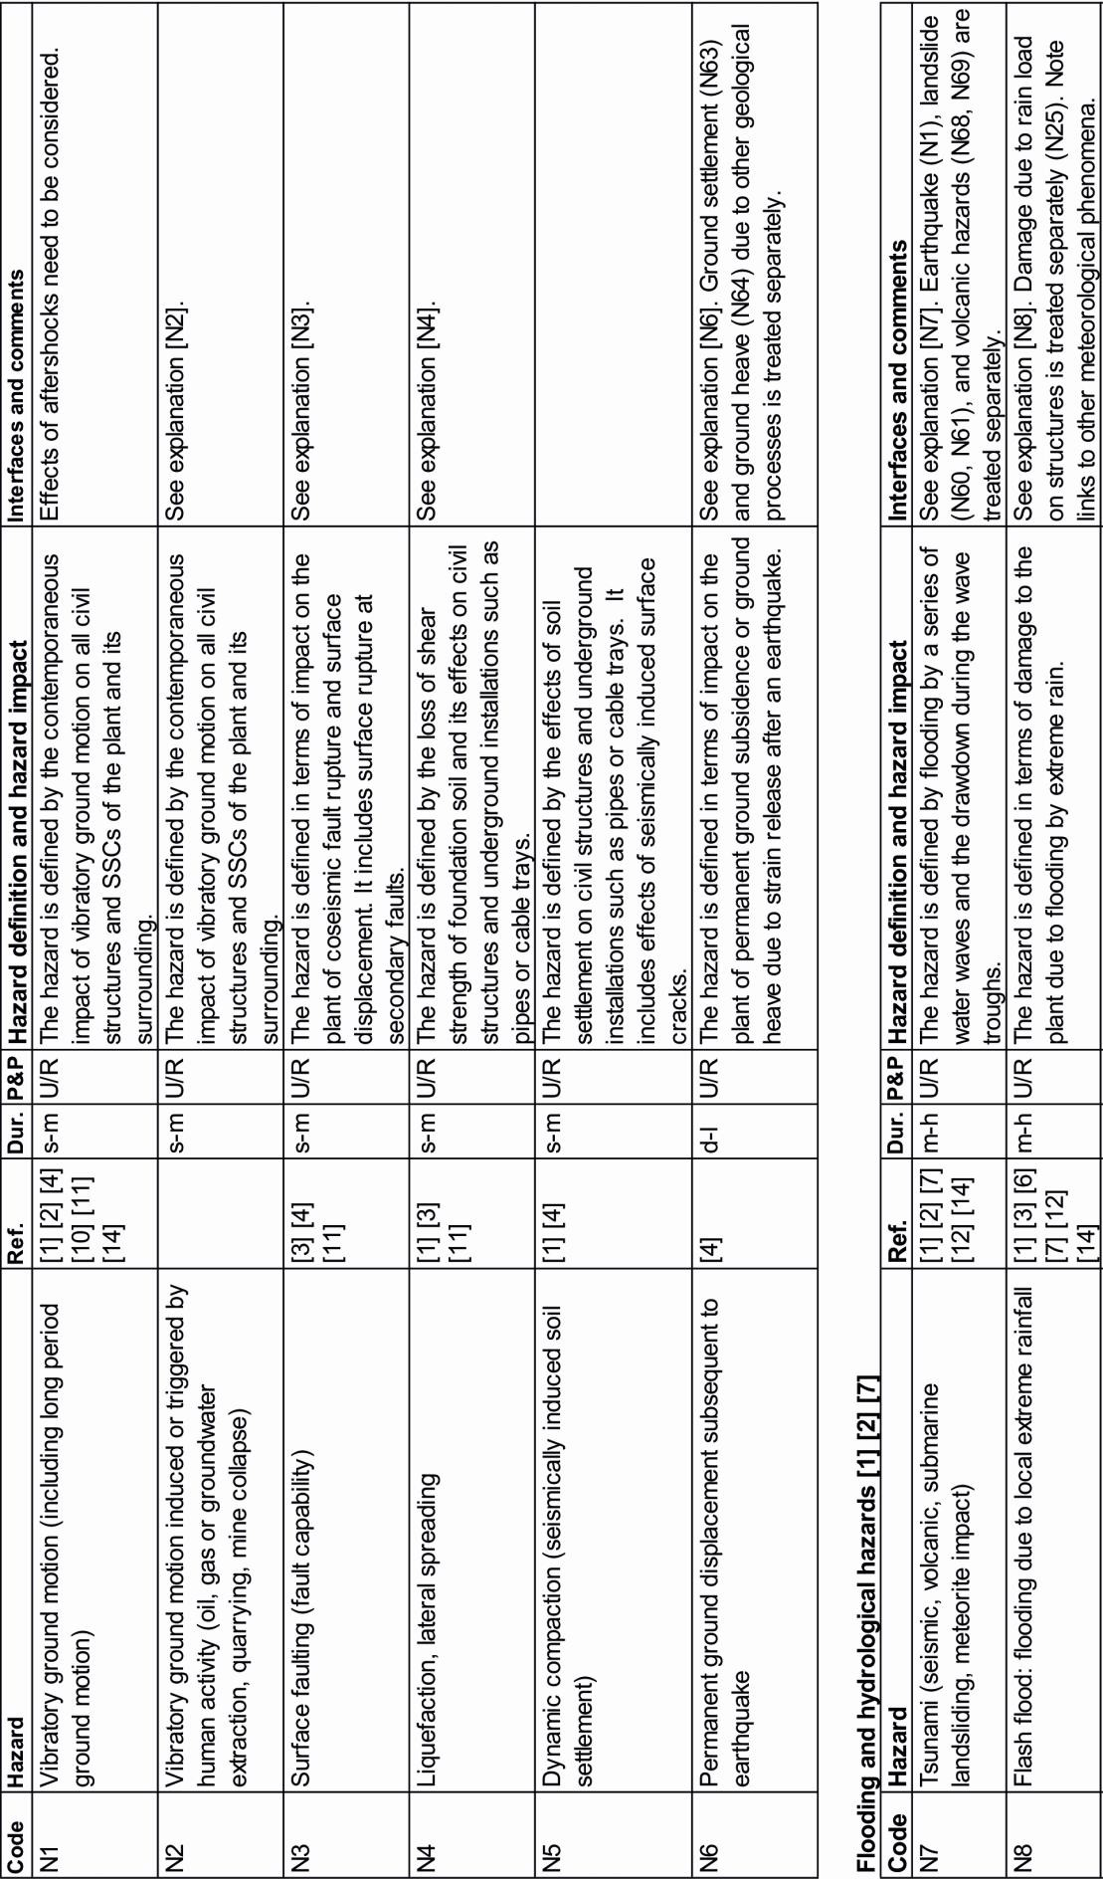

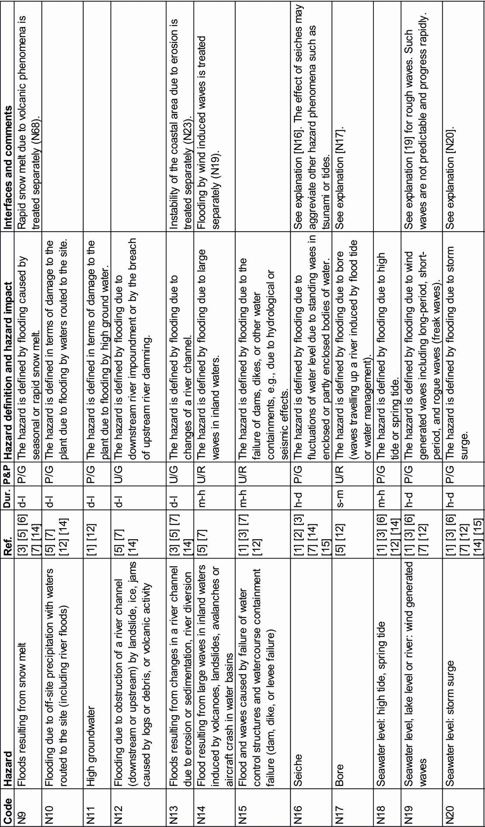

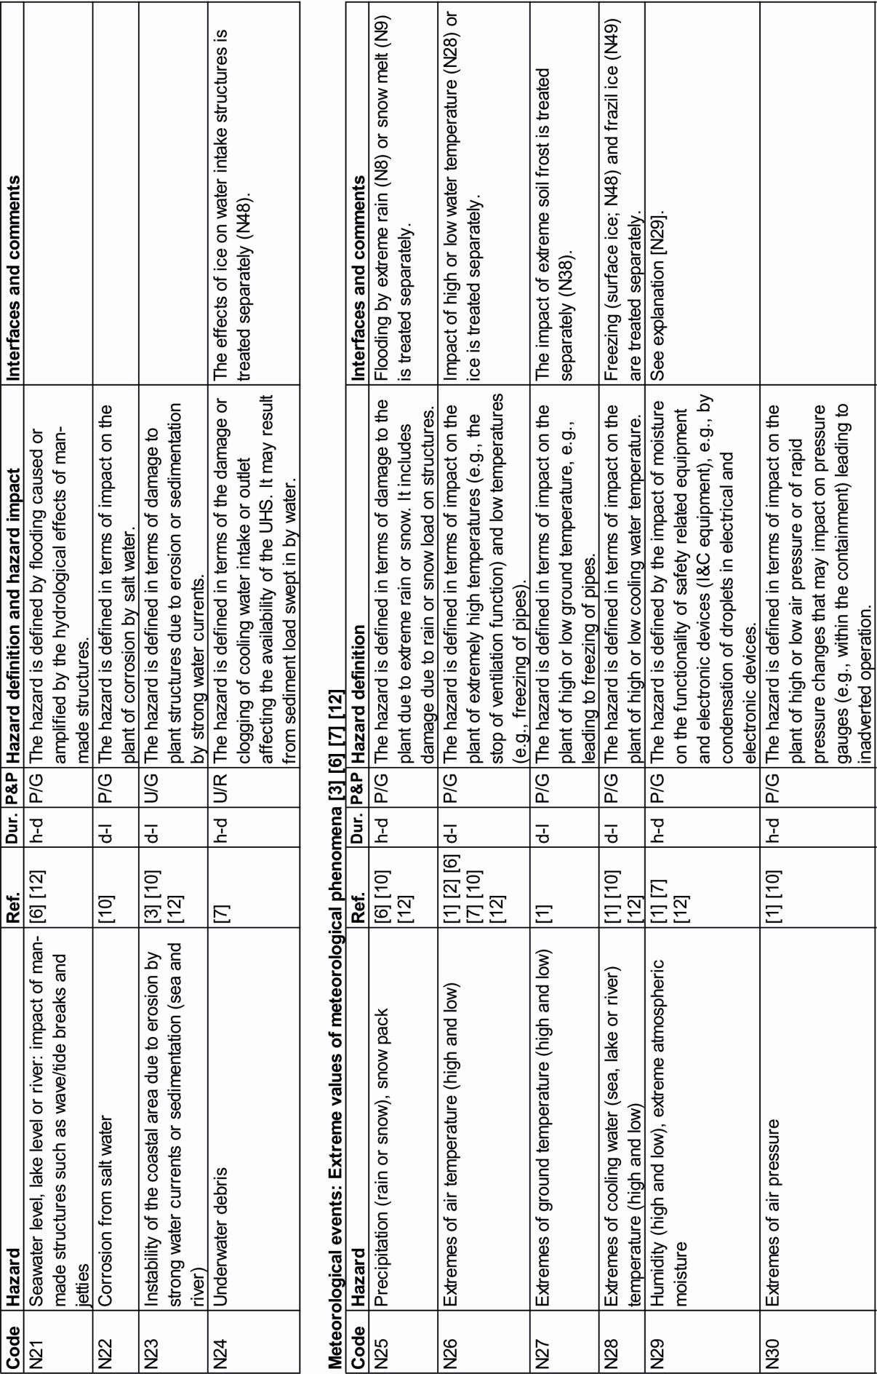

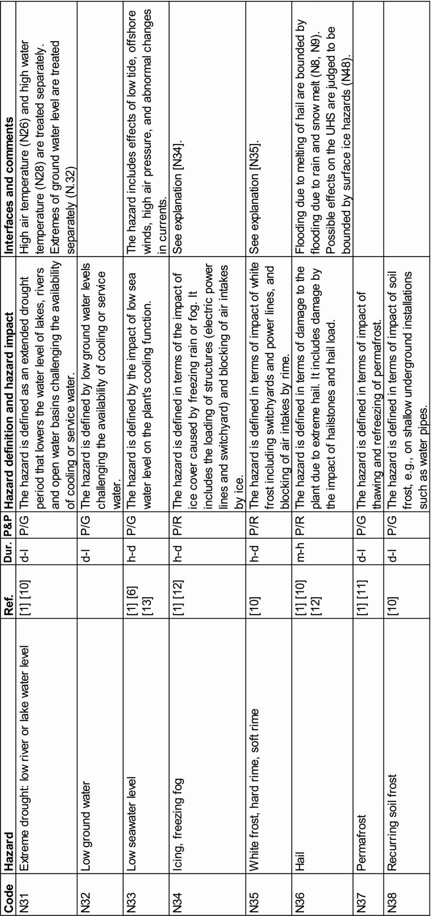

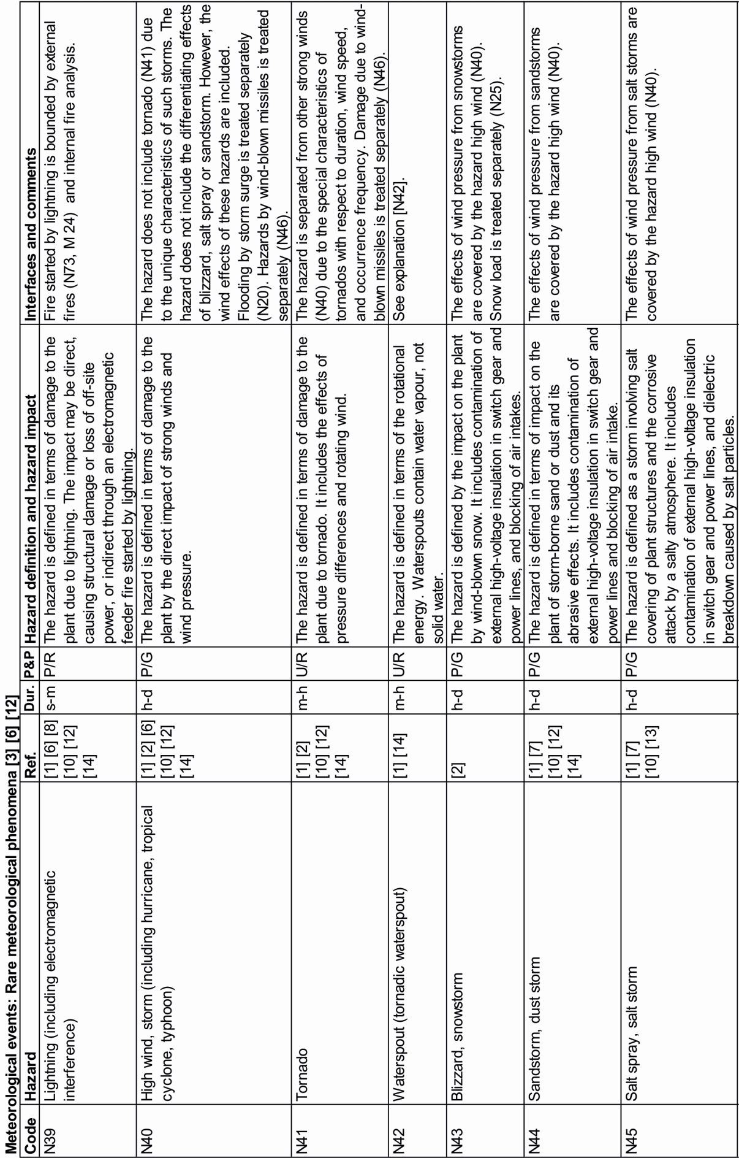

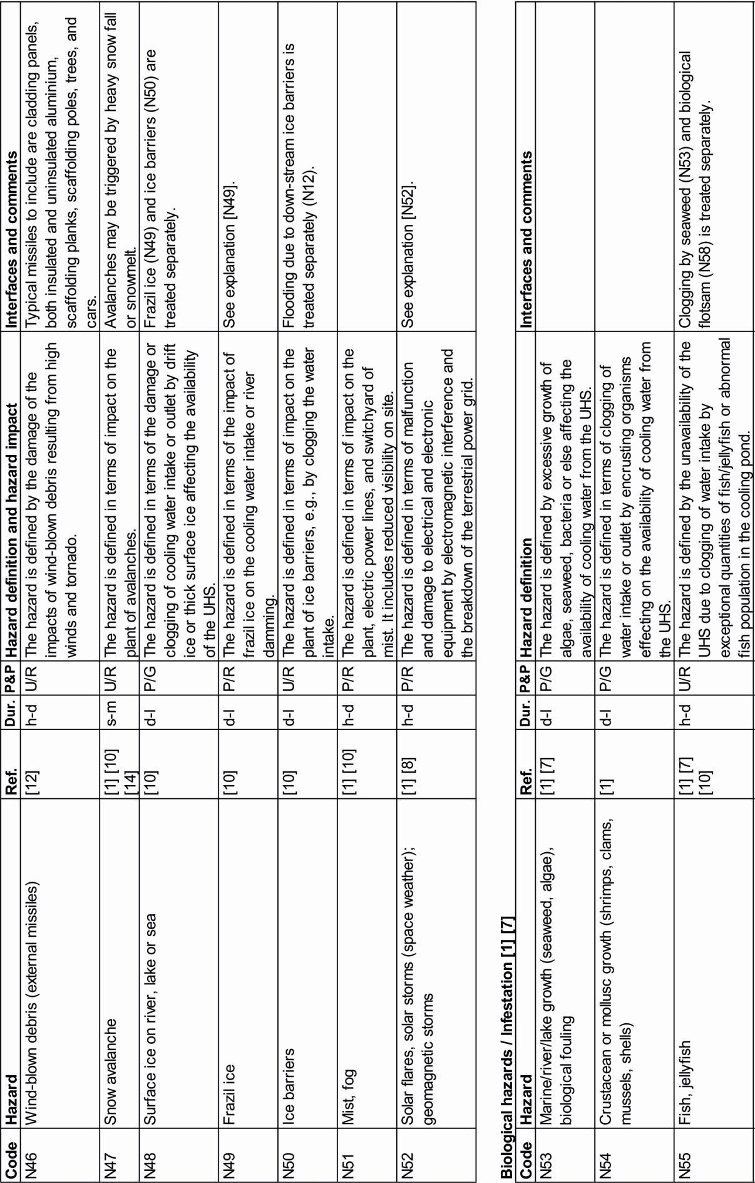

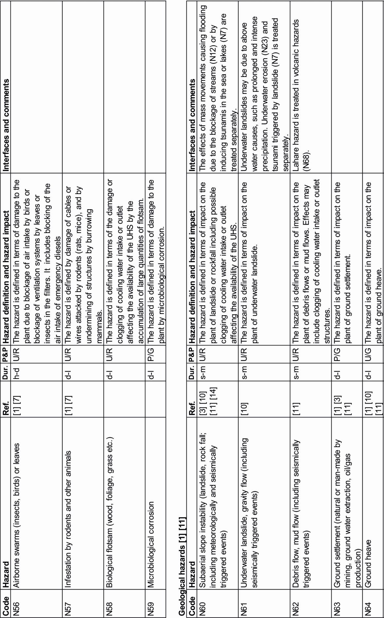

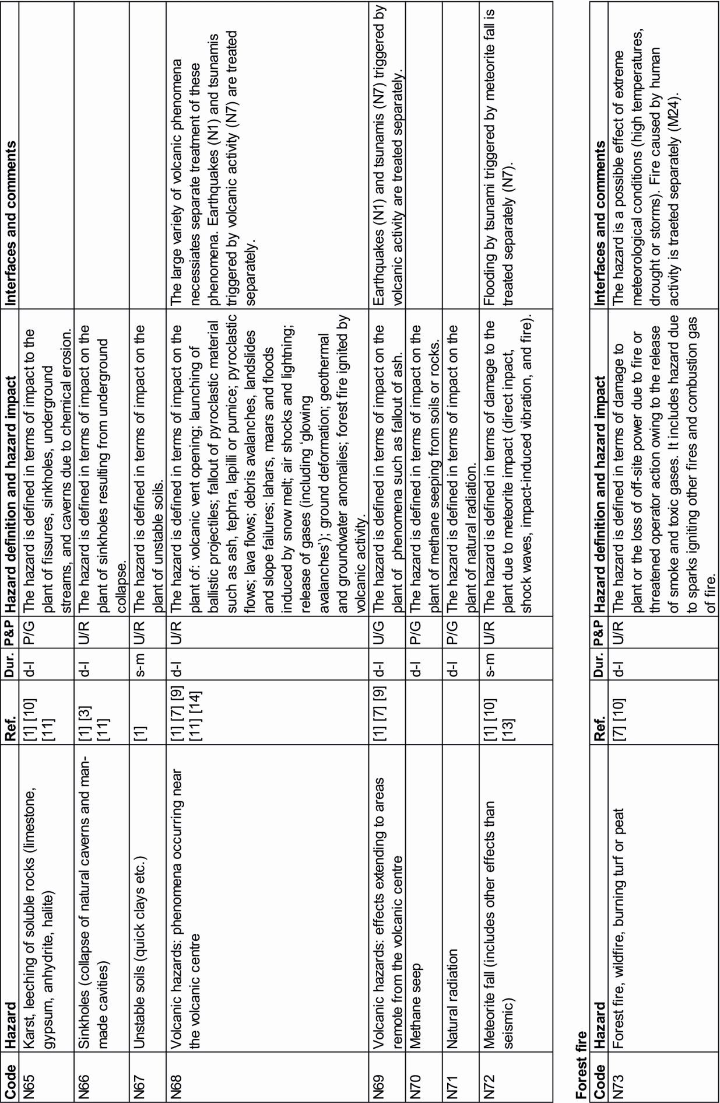

EXTENDED EXPLANATIONS OF UNCOMMON NATURAL PHENOMENA

[N2] Vibratory ground motion induced or triggered by human activity. Seismic ground motion caused by human activity is treated together with natural seismicity due to the identical effects of both phenomena and the difficulties which may arise to discriminate between man-made and natural events. The hazard type includes induced seismicity, which is entirely controlled by human intervention, and triggered seismicity. In the latter case human intervention causes the initiation of the seismic rupture process of a fault while the subsequent rupture propagation is controlled by natural stress. A triggered earthquake is advanced by human intervention and natural stress aggravates the ground shaking.

[N3] Fault capability. The displacement of the Earth’s surface at a fault during an earthquake is referred to as fault capability. Coseismic displacement may occur at the master fault or splay faults which fractured during the earthquake, or by induced slip at secondary faults which are not directly related to the earthquake fault.

[N4] Liquefaction, lateral spreading. Liquefaction of soil and unconsolidated fine-grained sediment is caused by ground shaking during an earthquake. The process results from the expulsion of pore water and leads to an extreme reduction of shear strength of the soil. In such cases, soil behaves more like a liquid than a solid and is unable to carry loads. Lateral spreading refers to the down-slope flow of liquefied soil. Both phenomena may lead to base failure at the foundation of buildings and the destruction of underground infrastructure (e.g., cables, pipes and pillars).

[N6] Permanent ground displacement subsequent to earthquake. Strain release after strong earthquakes may lead to permanent ground displacement of a large area that is caused by the release of elastic deformation (strain) during the earthquake. Elastic strain accumulates in the interseismic time period between earthquakes. Well- known examples of permanent ground displacement include cases of regional costal uplift above subduction zones and thrust faults. The type of ground displacement is distinct from the displacement caused by fault capability which is restricted to the earthquake fault or secondary faults.

[N7] Tsunami. A tsunami is a series of waves (wave train) in an ocean or lake that is caused by the displacement of a large volume of a body of water by earthquake, underwater landsliding, landsliding into water, volcanic eruption, or meteorite impact. Tsunamis travel very large distances. The phenomenon that triggered the wave train may therefore have occurred far from the site where the waves arrive.

[N8] Flash flood. “Extreme flood events induced by severe stationary storms have been considered as flash floods. Most generally, the storms inducing flash floods lead to local rainfall accumulations exceeding 100 mm over a few hours and affect limited areas: some tens to some hundreds of square kilometres. Larger scale and longer lasting stationary storm events may, however, occur in some meteorological contexts (Gaume et al., 2009).”

[N16] Seiche. Seiches are standing waves that form in enclosed or semi-enclosed water basins due to the reflection of waves at the basin edges. Repeated wave reflections and interference of waves lead to the formation of standing waves. The superposition of waves with frequencies equal to the eigenfrequency of the basin (or multiples of this frequency) lead to resonances in the body of water and amplitude amplification. Wave initiation may be due to meteorological effects (wind, atmospheric pressure variations), seismic activity, or tsunamis.

[N17] Bore. “A tidal bore is a series of waves propagating upstream as the tidal flow turns to rising. It forms during spring tide conditions when the tidal range exceeds 4 to 6m and the flood tide is confined to a narrow funnelled estuary. Its existence is based upon a fragile hydrodynamic balance between the tidal amplitude, the freshwater river flow conditions and the river channel bathymetry (Chanson, 2011).” Tidal bores are characterized by strong turbulence that may lead to sediment erosion beneath the bore wave and on banks. Turbulence may further lead to scouring and sediment entrainment, and impact on obstacles (Chanson, 2011).

[N19] Rough waves (freak wave). “Freak waves are extraordinarily large water waves whose heights exceed by a factor of 2.2 the significant wave height of a measured wave train (Onorato et al., 2001).“ The significant wave height is defined as the mean of the largest third of waves in a wave record. Rough waves often occur as single and steep wave crests that may cause severe damage to offshore/onshore structures and ships. The formation of such waves results, among other factors, from the presence of strong currents or from a simple chance superposition of different waves with coherent phases (Onorato et al., 2001).

[N20] Storm surge. Storm surge is a coastal flood phenomenon that can result from several different types of storms such as tropical cyclones, extratropical cyclones, squall lines (a line of thunderstorms ahead of a cold front), and hybrid storms in low-pressure weather systems. Flood levels are a function of the depth of the water body, the orientation of the shoreline, the wind direction, the storm path, and tides. “The two main meteorological factors contributing to a storm surge are a long fetch of winds spiraling inward toward the storm (i.e., the length of water over which wind has blown), and a low-pressure-induced dome of water drawn up under and trailing the storm's center. The second effect is responsible for destructive meteotsunamis associated with the most intense tropical systems (http://en.wikipedia.org/wiki/Storm_surge).”

[N29] Humidity. Extremes of humidity have an impact on the cooling capacity of nuclear power plants that utilize evaporation based designs for the ultimate heat sink (e.g. mechanical draught cooling towers). Together with other parameters such as wind, precipitation, temperature, and air pressure extremes of humidity may combine to meteorological conditions representing (a) maximum evaporation potential (leading to maximum cooling water consumption) and (b) minimum water cooling (e.g. cooling capacity of the cooling tower) (IAEA, 2011 [12]).

[N34] Icing. The term refers to clear ice that precipitates from rain or fog and covers cold objects in a sheet-like mass of layered ice. Such ice covers have a higher density than ice crystals formed by frost or rime (N35) and therefore a higher potential to damage objects by loading.

[N35] White frost, hoar frost, hard rime, soft rime. The hazard type summarizes the effects of several types of ice coatings that form in humid and cold air and produce ice crystals in a greater variety of forms. Crystals freeze to the upwind side of solid objects. Rime refers to ice deposits forming from water droplets in freezing fog or mist at calm or light wind. Supercooled water drops are involved in the formation of rime. Meteorological literature distinguishes hard rime, which has a comb-like appearance and firmly adheres to objects, from soft rime, which consists of fragile and delicate ice needles. In contrast to rime, where vapour first condensates to droplets before freezing, white frost and hoar frost forms by desublimation of ice directly from water vapour. Both types of frost do not form from fog but from air of different degrees of relative humidity at low temperatures. Frost and rime is less dense than solid ice and adheres to objects less tenaciously. Their damage potential is therefore less than that of clear ice covering objects (N34, Icing).

[N42] Waterspout. A waterspout (tornado occurring over water) is a small and weak rotating column of air over water. It consists of a columnar vortex which is upwards connected to a funnel-shaped cloud. The phenomenon is mostly weaker than tornadoes on land. Most of the water contained in the funnel of a waterspout is formed by the condensation of droplets, not by sucking up water from the underlying water body. Stronger waterspouts may originate in mesocyclone thunderstorms.

[N49] Frazil ice. “Fracil ice is a collection of loose, randomly oriented needle-shaped ice crystals in water. It resembles slush and has the appearance of being slightly oily when seen on the surface of water (http://en.wikipedia.org/wiki/Frazil_ice).“ Fracil ice forms in turbulent, supercooled water (rivers, lakes and oceans) when and air temperature reaches –6°C or lower. At high speeds of water currents the small ice crystals are not buoyant and may be carried into deeper water instead of floating at the surface. Continuing crystal growth may result in underwater ice adhering to objects in the water such as trash racks protecting water intake structures. This process may proceed very fast and lead to total blockage of trash bars (Daly, 1991).

[N52] Solar flares, solar storms (space weather); electromagnetic interference. A solar flare is a sudden release of extremely large energy of the Sun caused by electromagnetic phenomena within the Sun. Flares may lead to the ejection of plasma (coronal mass ejection) and particle storms (solar storms) with clouds of electrons, ions, and atoms moving through the corona of the sun into space. Such clouds may reach the Earth within hours or few days after the solar event. Massive solar flares with coronal mass ejections have a strong impact on the space weather near the Earth. They cause temporary disturbances of the Earth’s magnetosphere and magnetic field causing geomagnetic storms. The latter may lead to severe disturbances of electrical systems including the disruption of communication by absorption or reflection of radio signals, and the damage of terrestrial electric power grids by moving magnetic fields that induce currents in conductors of the power grid. These currents may particularly damage transformers. Geomagnetic storms may therefore cause long-lasting breakdowns of the electrical power grid.

EXTERNAL MAN-MADE HAZARDS

The exhaustive list of external man-made hazards is included in Table 3 (next pages).

Hazards are grouped into:

    - Industry accidents
    - Military accidents
    - Transportation accidents
    - Pipeline accidents
    - Other man-made external events

Table 3. Exhaustive list of external man-made hazards (24 hazard types). Explanation to columns: Dur.: duration of hazard phenomena classified as s-m (seconds to minutes), m-h (minutes to hours), h-d (hours to days), d-l (days and longer). P&P: Hazard predictability and hazard progression: predictable (P), unpredictable (U), progressing rapidly (R) or gradually (G). Ref: references to international standards introducing the hazard type.

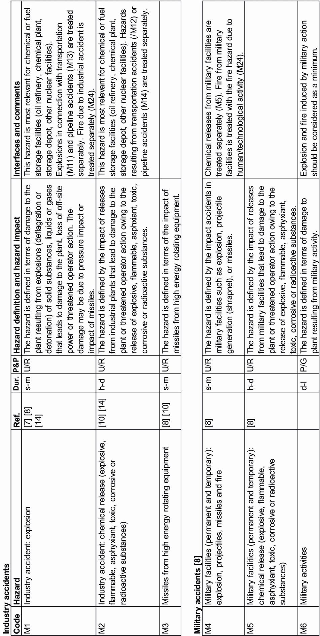

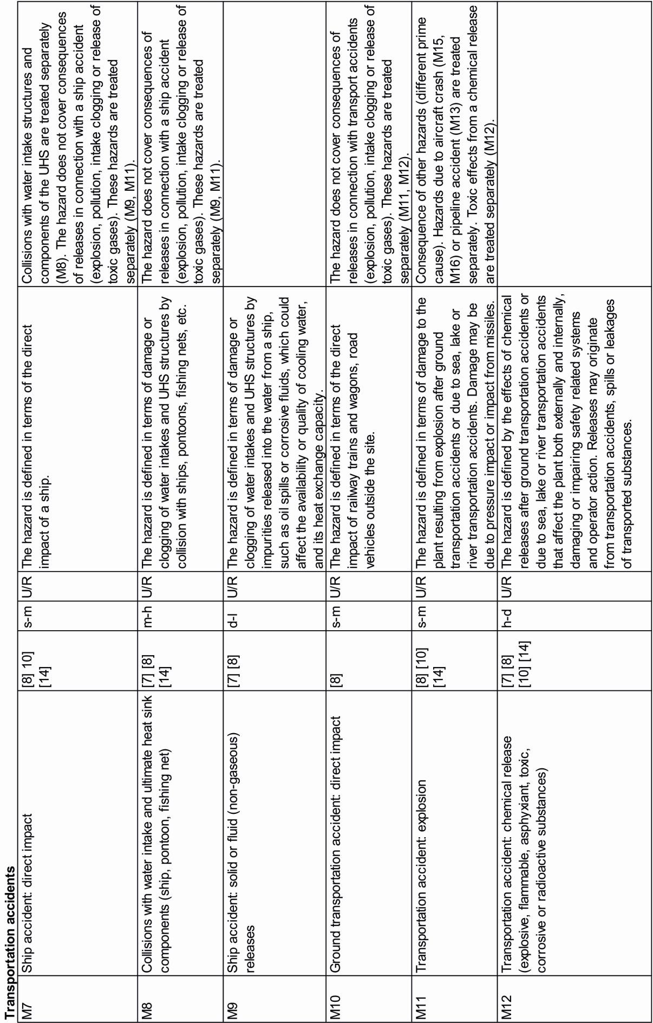

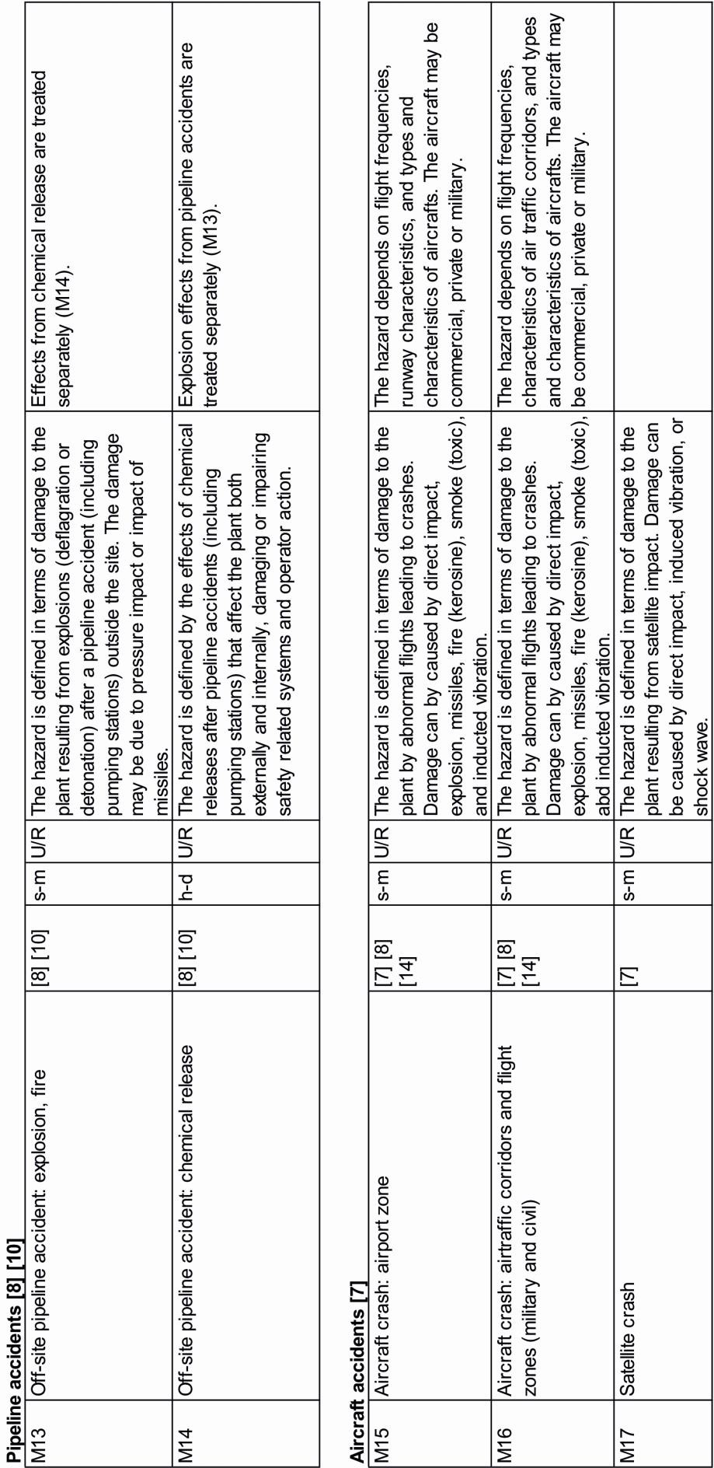

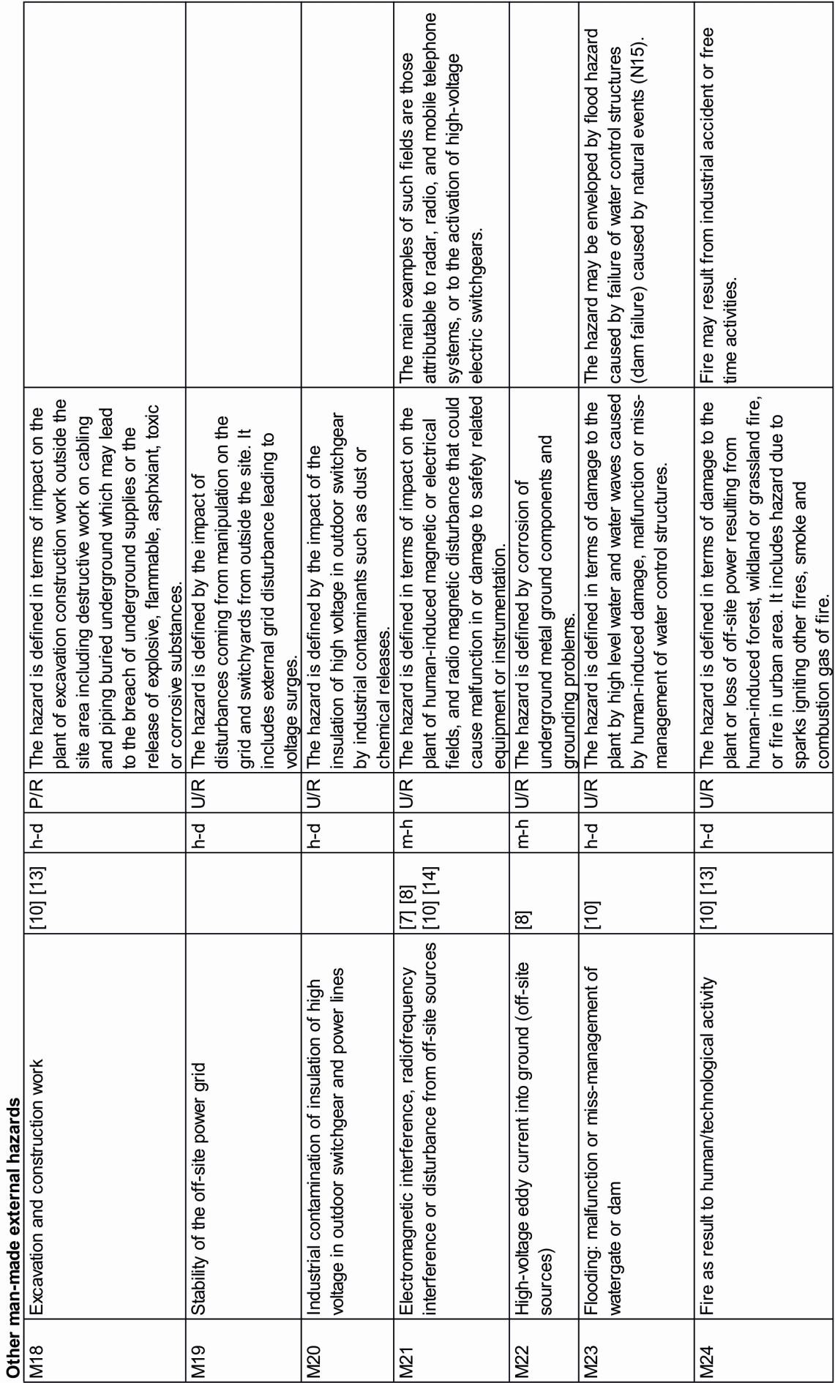

REFERENCES TO INTERNATIONAL STANDARDS INTRODUCING EXTERNAL HAZARD TYPES
[1] WENRA Reactor Harmonization Working Group, 2012. Safety of New NPP Designs. Draft No. 9, October 2012.
[2] IAEA, 2004. Design of Reactor Containment Systems for Nuclear Power Plants. Safety Guide No. NS-G-1.10, Vienna.
[3] IAEA, 2003. Site Evaluation for Nuclear Installations. Safety Requirements No. NS-R-3, Vienna.
[4] IAEA, 2010. Seismic Hazards in Site Evaluation for Nuclear Installations. Specific Safety Guide No. SSG-9, Vienna.
[5] IAEA, 2003. Flood Hazard for Nuclear Power Plants on Coastal and River Sites. Safety Guide No. NS-G-3.5, Vienna.
[6] IAEA, 2003. Meteorological Events in Site Evaluation for Nuclear Power Plants. Safety Guide No. NS-G-3.4, Vienna.
[7] IAEA, 2003. External Events Excluding Earthquakes in the Design of Nuclear Power Plants. Safety Guide No. NS-G-1.5, Vienna.
[8] IAEA, 2002. External Human Induced Events in Site Evaluation for Nuclear Power Plants. Safety Guide No.
NS-G-3.1, Vienna.
[9] IAEA, 2012. Volcanic Hazards in Site Evaluation for Nuclear Installations. Specific Safety Guide No. SSG- 21, Vienna.
[10] IAEA, 2010. Development and Application of Level 1 Probabilistic Safety Assessment for Nuclear Power Plants. Safety Guide No. SSG-3, Vienna.
[11] IAEA, 2004. Geotechnical Aspects of Site Evaluation and Foundations for Nuclear Power Plants, Safety Guide No. NS-G-3-6, Vienna.
[12] IAEA, 2011. Meteorological and Hydrological Hazards in Site Evaluation for Nuclear Installations. Specific Safety Guide No. SSG-18, Vienna.
[13] Kuramoto, T., et al., 2014. Development of Implementation Standard Concerning the Risk Evaluation Methodology Selection for the External Hazards. PSAM 12 - Probabilistic Safety Assessment and Management, 22-27 June 2014, Sheraton Waikiki, Honolulu, Hawaii, USA.
[14] IAEA, 2003. Extreme External Events in the Design and Assessment of Nuclear Power Plants. Tecdoc 1341, Vienna.

EVENT COMBINATIONS AND HAZARD CORRELATIONS

The analysis of event combinations uses a correlation chart that lists all natural and external man-made hazards (73 and 24 hazard types, respectively). Among the natural hazards extremes of air temperature, ground temperature, cooling water temperature, and humidity are split to list extreme highs and lows separately. This results in a correlation chart with 101 rows and 101 columns representing 10.100 possible hazard combinations. Out of these possible combinations 579 event combinations and hazard correlations were identified by expert opinion. Correlations discriminate between: (1) Causally connected hazards (cause-effect relation) where one hazard may cause another hazard; or where one hazard is a prerequisite for a correlated hazard. (2) Associated hazards which are probable to occur at the same time due to a common root cause.

CAUSALLY CONNECTED HAZARDS
This type of connection between hazards refers to a cause-effect relation, where hazard A triggers or may trigger hazard B (“causes-effects relation”, NIER, 2013; “common cause event”, Kuramoto et al., 2014). The causal connection is not commutative. The hazard correlation chart discerns to types of causal connections:

A may cause B
The relation indicates that A is not a prerequisite to B meaning that A and B can exist by themselves.

Examples :
Vibratory ground motion – tsunami : A strong offshore earthquake (including remote ones) may cause a tsunami ; a tsunami, however, may also result from other events (landsliding, volcanic activity etc.)
Industry explosion – wildfire : Industry accidents may under certain conditions result in wildfire but they are not the exclusive reason for wildfire

A is a prerequisite for B (no B without A).
The relation includes « A may cause B » meaning that A may occur without leading to B. The relation therefore does not indicate that B is an inevitable consequence of A.

Examples :
Vibratory ground motion – liquefaction : Soil liquefaction does not occur without earthquake shaking. The hazard must therefore be considered together with other effects of vibratory ground motion. However, not each earthquake will lead to soil liquefaction.
Low temperature – surface ice : Surface ice on water requires deep temerature. Surface ice must therefore be considered together with other possible effects of low temperature.

The probabilities for the causal connection (1) may vary from any value <0 to 1. The probability for connection (2) is 1. The causal connections (1) and (2) are not commutative. Cases where both causal relations (A may trigger B and B may trigger A) are plotted on different half spaces of the chart.

Causal connections of type (1) are usually restricted by further requirements. In the listed example, liquefaction will only occur under certain conditions such as the presence of liquefyable soil, a minimum ground acceleration, and a minimum duration of the earthquake. Surface ice will be caused by appropriate combinations of low temperatures and sufficiently long periods of freezing. The limiting parameters (earthquake magnitude, duration; temperature, duration of low temperature conditions) can usually be constrained by parameters derived from hazard assessment.

The correlation chart only lists the direct consequences of a certain hazards, causal chains are not considered. Example : a possible consequence of mismanagement of dam is flooding; further possible consequences of flooding such as biological flotsam clogging the water intake are not listed as a consequence of mismanagement of dam. Clogging by biological flotsam, however, is listed as a possible consequence of flooding.

ASSOCIATED HAZARDS
Associated hazards refer to events which are probable to occur at the same time due to a common root cause (“contemporary relation”, NIER, 2013). The common root cause (e.g., a meteorological situation) may not necessarily be regarded as a hazard by itself. Examples for associated hazards are:

- Cold front of a meteorological low pressure area: drop of air pressure, high wind, lightning (thunder storm), precipitation (heavy rain, hail)
- High-temperature summer period : high air and ground temperature, high cooling water temperature, low ground water, drought

Associated hazards are identified in the correlation chart.

HAZARDOUS COMBINATIONS OF INDEPENDENT PHENOMENA
The combinations of independent phenomena which, in combination, cause potential hazards are not specified in the current version of the correlation chart. Examples of such combinations are : flooding caused by the combination of high tide and storm surge ; slope instability due to a combination of precipitation and vibratory ground motion.

DISCUSSION OF IDENTIFIED CORRELATIONS
The close inspection of the hazard cross correlation chart reveals remarkable differences between the individual hazards in terms of the number of cross correlations with other hazards (Fig. 1 to 4). The cited figures distinguish
« isolated » hazards, which do not correlate with any or only very few other hazards (e.g., biological infestation) from hazards, which are correlated or associated with a large number of other phenomena.

Examples for the latter are vibratory ground motion (correlated with 30 other hazard types), industry explosion (40 correlated hazards), and stability of the power grid (40 correlations). External man-made hazards are generally characterized by relatively large numbers of cross-correlated phenomena. This is due to the fact that many natural hazards can impact the entire site vicinity and all man-made activities in the surrounding of a NPP in the same way as the NPP itself. This is particularly evident for seismotectonic, hydrological, and meteorological phenomena. A correlation between the man-made hazards and natural hazards may therefore be regarded not very informative. It should, however, be noted that some man-made structures or activities may not be vulnerable to a specific natural hazard which otherwise may have a strong impact on the safety of a nuclear power plant.

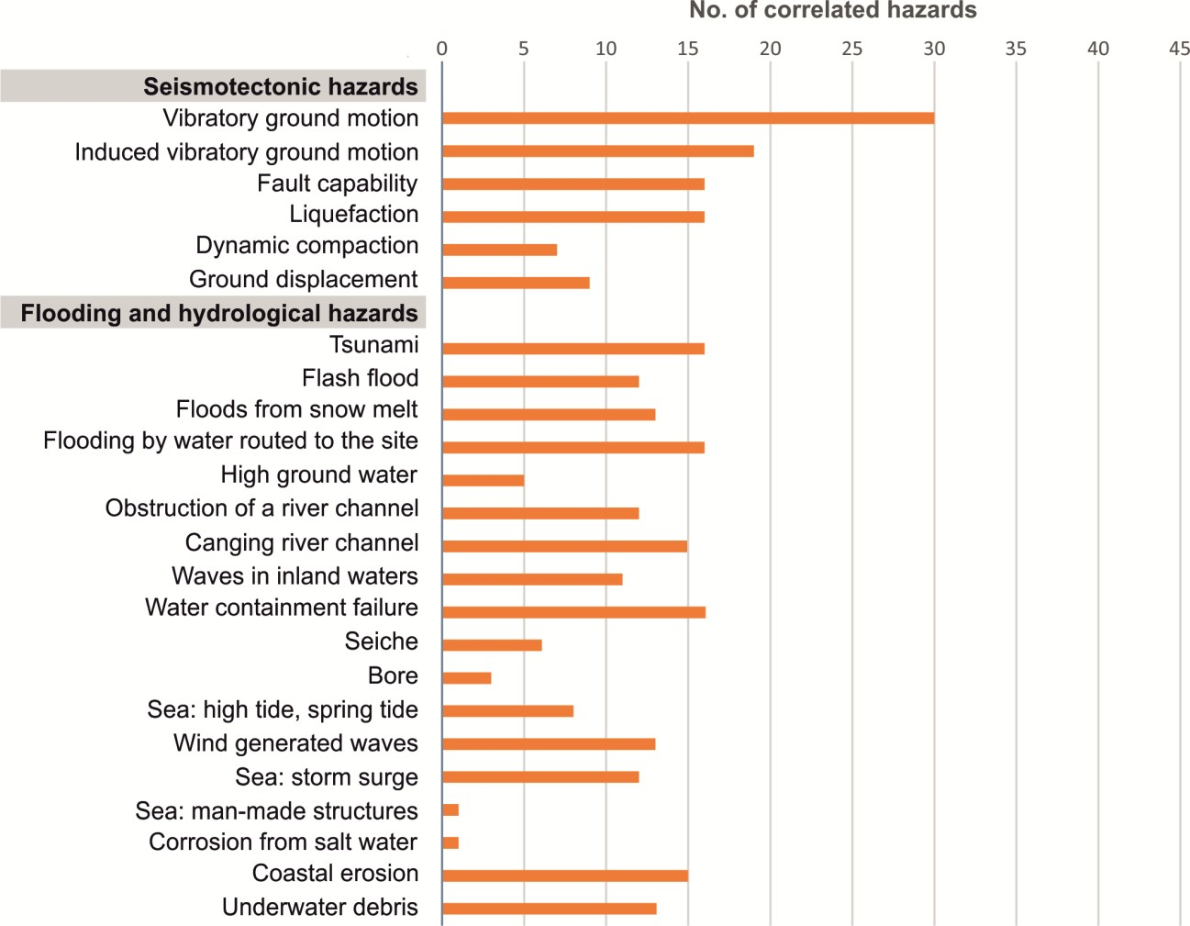

Fig. 1 Number of hazards correlated with seismotectonic and flooding hazards.

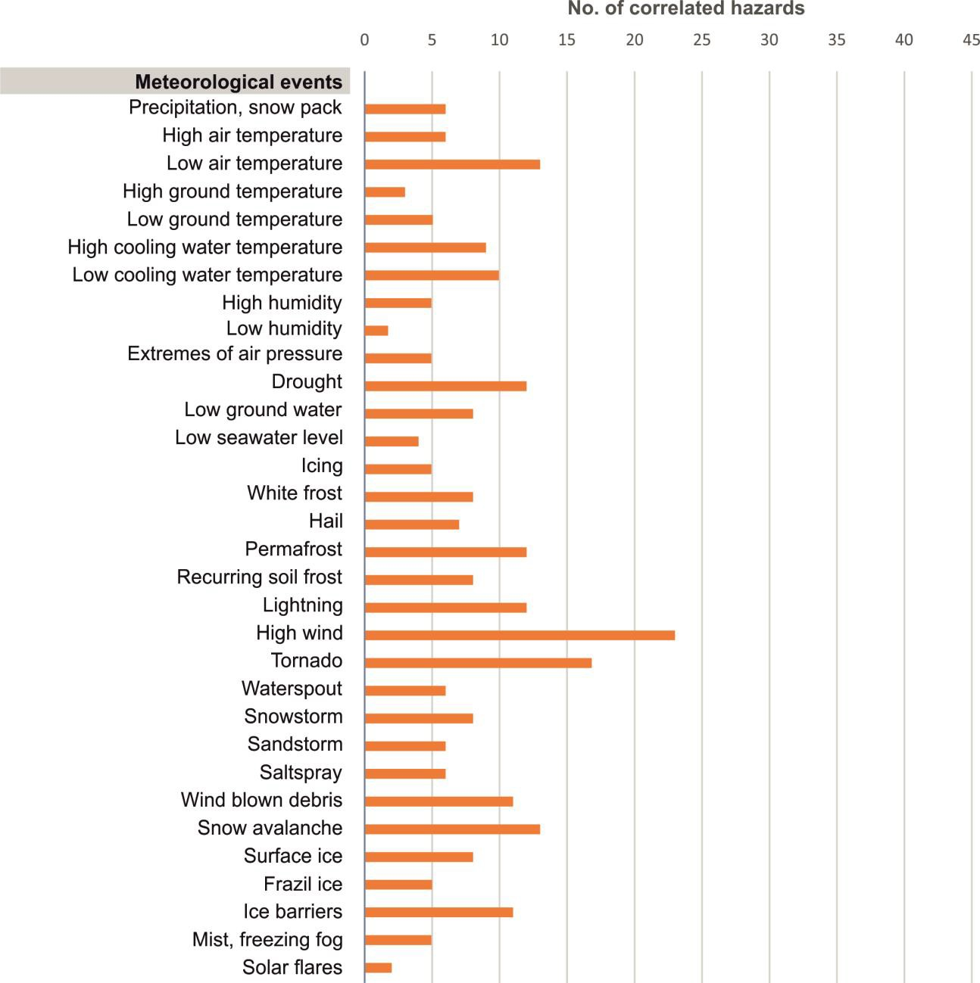

Fig. 2 Number of hazards correlated with meteorological events.

Fig. 3 Number of hazards correlated with biological hazards, geological hazards and forest fire.

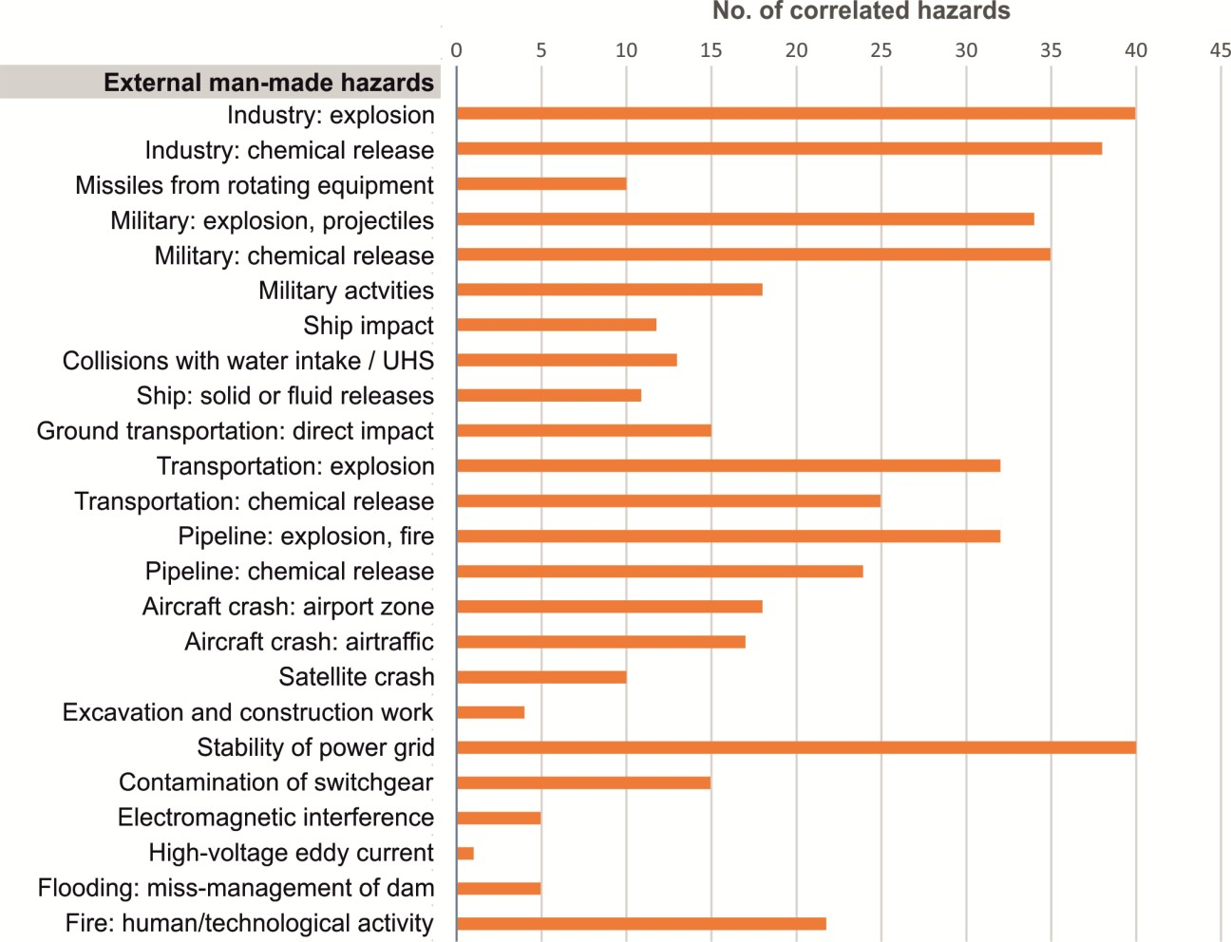

Fig. 4 Number of hazards correlated with external man-made hazards.

LIST OF REFERENCES

ASME/ANS, 2009. Addenda to ASME/ANS RA-S-2008 Standard for Level 1/Large Early Release Frequency Probabilistic Risk Assessment for Nuclear Power Plant Applications, 342pp.

Chanson, H. (2011). Tidal Bores, Aegir, Eagre, Mascaret, Pororoca. Theory and Observations. World Scientific, Singapore. ISBN 978-981-4335-41-6.

Daly, S.F., 1991. Frazil Ice Blockage of Intake Trash Racks. Cold Region Technical Digest, No. 91-1, 12 pp.

Gaume, E., Bain, V., Bernardara, P., et al., 2009. A compilation of data on European flash floods. Journal of Hydrology 367, 70-78.

IAEA, 2007. Terminology Used in Nuclear Safety and Radioation Prodection. IAEA Safety Glossary 2007 Edition, Vienna.

IAEA, 2010. Development and Application of Level 1 Probabilistic Safety Assessment for Nuclear Power Plants.
Safety Guide No. SSG-3, Vienna.

NIER Ingegneria, 2013. Hazards and threats ontology. Unpublished Report, Project reference number: HOME/2011/CIPS/AG/4000002102, 6 pp.

Kuramoto, T., Yamaguchi, A., Narumiya, Y., Ota, T., Mamizuka, Y., 2014. Development of Implementation Standard Concerning the Risk Evaluation Methodology Selection for the External Hazards, PSAM 12 - Probabilistic Safety Assessment and Management, 22-27 June 2014, Sheraton Waikiki, Honolulu, Hawaii, USA, 12 pp.

Onorato, M., Osborne, A.R., Serio, M., Damiani, T., 2001. Occurrence of Freak Waves from Envelope Equations in Random Ocean Wave Simulations. Proceedings Rogue Waves 2000.

WENRA-RHWG, 2014. WENRA Safety Reference Levels for Existing Reactors. Update in Relation to Lessons Learned from TEPCO Fukushima Dai-Ichi Accident. http://www.wenra.org/media/filer_public/2014/09/19/wenra_safety_reference_level_for_existing_reac tors_september_2014.pdf

LIST OF TABLES

Table 1. Definition of key terms used in the current document 12
Table 2. Exhaustive list of natural hazards (73 hazard types). Explanation to columns: Dur.: duration of hazard phenomena classified as s-m (seconds to minutes), m-h (minutes to hours), h-d (hours to days), d-l (days and longer). P&P: Hazard predictability and hazard progression: predictable (P), unpredictable (U), progressing rapidly
(R) or gradually (G). Ref: references to international standards introducing the hazard type. 15
Table 3. Exhaustive list of external man-made hazards (24 hazard types). Explanation to columns: Dur.: duration of hazard phenomena classified as s-m (seconds to minutes), m-h (minutes to hours), h-d (hours to days), d-l (days and longer). P&P: Hazard predictability and hazard progression: predictable (P), unpredictable (U), progressing rapidly (R) or gradually (G). Ref: references to international standards introducing the hazard type. 27

LIST OF FIGURES
Fig. 1 Number of hazards correlated with seismotectonic and flooding hazards 35
Fig. 2 Number of hazards correlated with meteorological events 36
Fig. 3 Number of hazards correlated with biological hazards, geological hazards and forest fire. 36
Fig. 4 Number of hazards correlated with external man-made hazards 37
Fig. 5 Legend to the hazard correlation chart (Appendix 7.2) 40

APPENDIX : HAZARD CORRELATION CHART

LEGEND TO THE CORRELATION CHART

A is prerequisite for B
 | B
A | ↗

B is prerequisite for A
 | B
A | ↙

A may cause B
 | B
A | ↗

B may cause A
 | B
A | ↙

Associated hazards: A and B derive from common root cause
B
A

Note:
Only direct consequences of individual hazards are listed. Causal chains are not considered.
Combinations of independent phenomena with low severity which cause potential hazards by
their contemporaneous occurrence are not identified.

Fig. 5 Legend to the hazard correlation chart (Appendix 7.2)

TABLE : HAZARD CORRELATION CHART

The hazard correlation chart is included in Table 4 (next page).

Table 4. Cross-correlation chart showing causally connected hazards (A may cause B, A is a prerequisite for B) and associated hazards (A and B may result from the same root cause). See Fig. 5 for explanation of symbology.

Report IRSN/PSN-RES/SAG/2015-00085 Technical report ASAMPSA_E/ WP21/ D21.1 2015-10 42/42
ASAMPSA_E
List of external hazards to be considered in ASAMPSA_E

