ASAMPSA_E | Advanced Safety Assessment Methodologies: extended PSA

"NUCLEAR FISSION"
Safety of Existing Nuclear Installations Contract 605001

List of external hazards to be considered in ASAMPSA_E

Reference ASAMPSA_E
Technical report ASAMPSA_E /WP21/D21.2/2017-41 Reference IRSN PSN-RES/SAG/2017-00011

Kurt Decker & Hans Brinkman

University Vienna NRG

Period covered: from 01/07/2013 to 31/12/2016 |  | Actual submission date: 31/12/2016
Start date of ASAMPSA_E: 01/07/2013 |  | Duration: 36 months
WP No: 21 | Lead topical coordinator : Kurt Decker |  | His organization name : University Vienna

Project co-funded by the European Commission Within the Seventh Framework Programme (2013-2016)
Dissemination Level
PU | Public | Yes
RE | Restricted to a group specified by the partners of the ASAMPSA_E project | No
CO | Confidential, only for partners of the ASAMPSA_E project | No

ASAMPSA_E | Advanced Safety Assessment Methodologies: extended PSA

ASAMPSA_E Quality Assurance page
Partners responsible of the document : UNIVIE, NRG
Nature of document | Technical Report
Reference(s) | Technical report ASAMPSA_E /WP21/D21.2/2017-41  IRSN PSN-RES/SAG/2017-00011  Reference IRSN PSN-RES/SAG/2017-00011
Title | List of External Hazards to be Considered in ASAMPSA_E
Author(s) | Kurt Decker & Hans Brinkman
Delivery date | 31/12/2016
Topical area | Initiating events (internal and external hazards) modelling
For Journal & Conf. papers | No
Summary :

The current report includes an exhaustive list of external hazards posing potential threats to nuclear installations. The list comprises of both, natural and man-made external hazards. Also, a cross correlation matrix of the hazards is presented. The list is the starting point for the hazard analysis process in Level 1 PSA as outlined by IAEA (2010; SSG-3) and the definition of design basis as required by WENRA (2014; Reference Levels for Existing Reactors).
The list is regarded comprehensive by including all types of hazards that were previously cited in documents by IAEA and WENRA-RHWG. 73 natural hazards (N1 to N73) and 24 man-made external hazards (M1 to M24) are included. Natural hazards are grouped into seismotectonic hazards, flooding and hydrological hazards, extreme values of meteorological phenomena, rare meteorological phenomena, biological hazards / infestation, geological hazards, and forest fire. The list of external man-made hazards includes industry accidents, military accidents, transportation accidents, pipeline accidents and other man-made external events.
The dataset further contains information on hazard correlations. 577 correlations between individual hazards are identified and shown in a cross-correlation chart. Correlations discriminate between: (1) Causally connected hazards (cause-effect relation) where one hazard (e.g., liquefaction) may be caused by another hazard (e.g., earthquake); or where one hazard (e.g., high wind) is a prerequisite for a correlated hazard (e.g., storm surge). Causal links are not commutative. (2) Associated hazards (“contemporary” events) which are probable to occur at the same time due to a common root cause (e.g., drought and high temperature).

Visa grid
 | Main author(s) : | Verification | Approval (Coordinator)
Name (s) | K. Decker, H. Brinkman | WP21 Partners | E. Raimond
Date | 12-01-2017 | By e-mail | 21-02-2017

ASAMPSA_E | Advanced Safety Assessment Methodologies: extended PSA

MODIFICATIONS OF THE DOCUMENT
Version | Date | Authors | Pages or paragraphs modified | Description or comments
1 | Dec. 2014 | K. Decker |  | First version
2 | Feb. 2015 | E. Raimond |  | Editorial modification
3 | Oct. 2016 | K.Decker, J.L. Brinkman |  | Final workshop comments incorporated
4 | Feb 2017 | E. Raimond |  | Editorial modification

LIST OF DIFFUSION

European Commission (Scientific Officer)

Name | First name | Organization
Passalacqua | Roberto | EC

ASAMPSA_E Project management group (PMG)

Name | First name | Organization
Raimond | Emmanuel | IRSN | Project coordinator
Guigueno | Yves | IRSN | WP10 coordinator
Decker | Kurt | Vienna University | WP21 coordinator
Klug | Joakim | LRC | WP22 coordinator
Wielenberg | Andreas | GRS | WP30 coordinator
Loeffler | Horst | GRS | WP40 coordinator

REPRESENTATIVES OF ASAMPSA_E PARTNERS

Name | First name | Organization
Grindon | Liz | AMEC NNC
Mustoe | Julian | AMEC NNC
Cordoliani | Vincent | AREVA
Dirksen | Gerben | AREVA
Godefroy | Florian | AREVA
Kollasko | Heiko | AREVA
Michaud | Laurent | AREVA
Sauvage | Estelle | AREVA
Hasnaoui | Chiheb | AREXIS
Hurel | François | AREXIS
Schirrer | Raphael | AREXIS
De Gelder | Pieter | Bel V
Gryffroy | Dries | Bel V
Jacques | Véronique | Bel V
Van Rompuy | Thibaut | Bel V
Cazzoli | Errico | CCA
Vitázková | Jirina | CCA
Passalacqua | Roberto | EC
Banchieri | Yvonnick | EDF
Benzoni | Stéphane | EDF
Bernadara | Pietro | EDF
Bonnevialle | Anne-Marie | EDF
Brac | Pascal | EDF
Coulon | Vincent | EDF
Gallois | Marie | EDF
Hibti | Mohamed | EDF
Jan | Philippe | EDF
Lopez | Julien | EDF
Nonclercq | Philippe | EDF
Panato | Eddy | EDF
Parey | Sylvie | EDF
Romanet | François | EDF
Rychkov | Valentin | EDF
Vasseur | Dominique | EDF
Burgazzi | Luciano | ENEA
Hultqvist | Göran | FKA
Kähäri | Petri | FKA
Karlsson | Anders | FKA
Ljungbjörk | Julia | FKA
Pihl | Joel | FKA
Loeffler | Horst | GRS
Mildenberger | Oliver | GRS
Sperbeck | Silvio | GRS
Tuerschmann | Michael | GRS
Wielenberg | Andreas | GRS
Benitez | Francisco Jose | IEC
Del Barrio | Miguel A. | IEC
Serrano | Cesar | IEC
Apostol | Minodora | INR
Nitoi | Mirela | INR
Groudev | Pavlin | INRNE
Stefanova | Antoaneta | INRNE
Armingaud | François | IRSN
Bardet | Lise | IRSN
Bonnet | Jean-Michel | IRSN
Bonneville | Hervé | IRSN
Clement | Christophe | IRSN
Corenwinder | François | IRSN
Denis | Jean | IRSN
Duflot | Nicolas | IRSN
Duluc | Claire-Marie | IRSN
Dupuy | Patricia | IRSN
Georgescu | Gabriel | IRSN
Guigueno | Yves | IRSN
Guimier | Laurent | IRSN
Lanore | Jeanne-Marie | IRSN
Laurent | Bruno | IRSN
Ménage | Frédéric | IRSN
Pichereau | Frederique | IRSN
Rahni | Nadia | IRSN
Raimond | Emmanuel | IRSN
Rebour | Vincent | IRSN
Sotti | Oona | IRSN
Volkanovski | Andrija | JSI
Alzbutas | Robertas | LEI
Matuzas | Vaidas | LEI
Rimkevicius | Sigitas | LEI
Häggström | Anna | LRC
Klug | Joakim | LRC
Knochenhauer | Michael | LRC
Kumar | Manorma | LRC
Olsson | Anders | LRC
Borysiewicz | Mieczyslaw | NCBJ
Kowal | Karol | NCBJ
Potempski | Slawomir | NCBJ
La Rovere | Stephano | NIER
Vestrucci | Paolo | NIER
Brinkman | Hans | NRG
Kahia | Sinda | NRG
Bareith | Attila | NUBIKI
Lajtha | Gabor | NUBIKI
Siklossy | Tamas | NUBIKI
Caracciolo | Eduardo | RSE
Morandi | Sonia | RSE
Dybach | Oleksiy | SSTC
Gorpinchenko | Oleg | SSTC
Claus | Etienne | TRACTEBEL
Dejardin | Philippe | TRACTEBEL
Grondal | Corentin | TRACTEBEL
Mitaille | Stanislas | TRACTEBEL
Oury | Laurence | TRACTEBEL
Zeynab | Umidova | TRACTEBEL
Bogdanov | Dimitar | TUS
Ivanov | Ivan | TUS
Holy | Jaroslav | UJV
Hustak | Stanislav | UJV
Jaros | Milan | UJV
Kolar | Ladislav | UJV
Kubicek | Jan | UJV
Decker | Kurt | UNIVIE
Halada | Peter | VUJE
Prochaska | Jan | VUJE
Stojka | Tibor | VUJE

REPRESENTATIVE OF ASSOCIATED PARTNERS (External Experts Advisory Board (EEAB))
Name | First name | Company
Hirata | Kazuta | JANSI
Hashimoto | Kazunori | JANSI
Inagaki | Masakatsu | JANSI
Yamanana | Yasunori | TEPCO
Coyne | Kevin | US-NRC
González | Michelle M. | US-NRC

SUMMARY

The current report includes an exhaustive list of external hazards posing potential threats to nuclear installations. It includes both, natural and man-made external hazards. Also, a cross correlation matrix of the hazards is presented.
The list should be used as a starting point for the hazard analysis process in Level 1 PSA as outlined by IAEA (2010 b) and the definition of design basis as required by WENRA (2014).
The list is regarded comprehensive including all types of hazards that were previously cited in documents by IAEA and WENRA-RHWG. 73 natural hazards (N1 to N73) and 24 man-made external hazards (M1 to M24) are included. Natural hazards are grouped into seismotectonic hazards, flooding and hydrological hazards, extreme values of meteorological phenomena, rare meteorological phenomena, biological hazards / infestation, geological hazards, and forest fire. The list of external man-made hazards includes industry accidents, military accidents, transportation accidents, pipeline accidents and other man-made external events.
The dataset further contains information on correlated and associated hazards. 577 possible correlations between individual hazards and 82 combinations of mutually exclusive hazards (hazards which cannot apply to the plant at the same time) are identified by expert opinion and shown in a cross-correlation chart. Correlations discriminate between:
1. Causally connected hazards (cause-effect relation) where one hazard (e.g., liquefaction) may be caused by another hazard (e.g., earthquake); or where one hazard (e.g., high wind) is a prerequisite for a correlated hazard (e.g., storm surge). The identified causal links are not commutative.
2. Associated hazards (“contemporary” events) which are probable to occur at the same time due to a common root cause (e.g., drought and high temperature).
3. Hazards that occur contemporaneously by random coincidence. Such combinations cannot include hazards which are mutually exclusive (e.g., high temperature and surface ice).

ASAMPSA_E PARTNERS

The following table provides the list of the ASAMPSA_E partners involved in the development of this document.
1 | Institute for Radiological Protection and Nuclear Safety | IRSN | France
2 | Gesellschaft für Anlagen- und Reaktorsicherheit mbH | GRS | Germany
3 | AMEC NNC Limited | AMEC NNC | United Kingdom
4 | Ricerca sul Sistema Energetico | RSE S.p.A. | Italy
5 | Lloyd’s Register Consulting | LRC | Sweden
6 | Nuclear Research Institute Rez pl | UJV | Czech
7 | Universität Wien | UNIVIE | Austria
8 | Cazzoli Consulting | CCA | Switzerland
9 | Italian National Agency for New Technologies, Energy and the Sustainable Economic Development | ENEA | Italy
10 | Nuclear Research and consultancy Group | NRG | Nederland
11 | IBERDROLA Ingeniería y Construcción S.A.U | IEC | Spain
12 | Electricité de France | EDF | France
13 | Lietuvos energetikos institutas (Lithuanian Energy Institute) | LEI | Lithuania
14 | NUBIKI | NUBIKI | Hungary
15 | Forsmark kraftgrupp AB | FKA | Sweden
16 | AREVA NP SAS France | AREVA NP SAS | France
17 | NCBJ Institute | NCBJ | Poland
18 | State Scientific and Technical Center for Nuclear and Radiation Safety | SSTC | Ukraine
19 | VUJE | VUJE | Slovakia
20 | NIER Ingegneria | NIER | Italy
22 | TRACTEBEL ENGINEERING S.A. | TRACTEBEL | Belgium
23 | BeL V | BeL V | Belgium
24 | Institut Jozef Stefan | JSI | Slovenia
25 | Institute of nuclear research and nuclear energy – Bulgarian Academia of science | INRNE | Bulgaria
26 | Regia Autonoma Pentru Activatati Nucleare Droberta Tr. Severin RA Suc | INR | Roumania
27 | Technical University of Sofia – Research and Development Sector | TUS | Bulgaria
28 | AREXIS S.A.R.L. | AREXIS | France
 | United States Nuclear Regulatory Commission | US-NRC | USA
 | Tokyo Electric Power Company | TEPCO | Japan
 | Japan Nuclear Safety Institute | JANSI | Japan

CONTENTS

1 INTRODUCTION 11
1.1 OBJECTIVE 11
1.2 DEFINITIONS 12
1.3 THE HAZARD ASSESSMENT PROCESS AND THE HAZARD LIST 13
1.4 FORMAT OF THE HAZARD LIST 14
1.5 FORMAT OF THE HAZARD CORRELATION CHART 15
2 LIST OF EXTERNAL HAZARD TYPES 16
2.1 NATURAL HAZARDS 16
2.2 EXTENDED EXPLANATIONS OF UNCOMMON NATURAL PHENOMENA 27
2.3 EXTERNAL MAN-MADE HAZARDS 30
3 EVENT COMBINATIONS AND HAZARD CORRELATIONS 36
3.1 CAUSALLY CONNECTED HAZARDS 37
3.2 ASSOCIATED HAZARDS 38
3.3 HAZARDOUS COMBINATIONS OF INDEPENDENT PHENOMENA 38
3.4 DISCUSSION OF IDENTIFIED CORRELATIONS 40
4 REFERENCES 44
LIST OF TABLES 46
LIST OF FIGURES 46
APPENDIX A: HAZARD CORRELATION CHART 47
APPENDIX B: INTERNAL HAZARDS 49

GLOSSARY

IAEA | International Atomic Energy Agency
I&C | Instrumentation & Control
LOOP | Loss of Off-site Power
NPP | Nuclear Power Plant
PSA | Probabilistic Safety Assessment
SSCs | Systems, Structures and Components
UHS | Ultimate Heat Sink
WENRA | Western European Nuclear Regulators Association
WP | Work Package within ASAMPSA_E

INTRODUCTION

OBJECTIVE
The main objective of this technical report is to provide an exhaustive list of external hazards which form potential threats to nuclear installations. It considers both, natural and external man-made hazards.
The document further intends to provide information on hazardous events which have a significant probability to occur at the same time. Such correlated hazards may derive from causal dependencies between different hazard types, from hazards that share a common root cause, or from hazards that occur by random coincidence. We therefore developed an extensive correlation chart that indicates such causal dependencies. The chart also highlights hazards which are mutually exclusive and cannot occur at the same time.
The hazard list and the identified possible hazard combinations can be used as a starting point for the hazard analysis process in Level 1 PSA to ensure that all external threats to a nuclear installation are covered by the analysis. The process is outlined in detail by IAEA (2010 b). Both, the hazard list and the correlation chart may further be helpful for the definition of design basis values and analyses of design extension conditions as required for natural hazards and hazard combinations by the “WENRA Reference Levels for Existing Reactors” (WENRA, 2014). It may be notable that the list of natural hazards adopted by WENRA (in WENRA, 2015, Appendix 1) is identical with the list developed for ASAMPSA_E. In addition to combinations of natural and external man-made hazards WENRA further requires to include internal hazards in the analysis of hazard combinations. To facilitate such analyses, we therefore include a (non-exhaustive) list of internal hazards in Appendix B of the current report although internal hazards are not in the scope of the ASAMPSA_E project.
It is clear that not all of the hazards summarized in the exhaustive list and all possible hazard correlations uniformly apply to all nuclear sites. Site-specific screening of hazards is a necessary step in PSA. The definition of screening criteria to be used for the selection of external hazards and combinations of external hazards, however, is beyond the scope of the current report. The screening approach and the criteria to select initiating events are discussed in deliverable D30.7 (vol 2) of the ASAMPSA_E work package WP30 (Wielenberg et al., 2017).
The hazard list was further used as a basis to select a limited number of hazard types for detailed discussion with specialists of the informed scientific community outside ASAMPSA_E and the development of guidance for hazard characterisation by ASAMPSA_E (deliverable D21.3). The following hazards have been selected: seismic hazards, flooding, extreme weather (storm, extreme temperature, snow pack), lightning, biological hazards, external fire, external explosion, and aircraft crash. Earthquake and flooding have been selected as a consequence of the Fukushima Dai-Ichi accident. The other hazard types were selected according to end-users requests received after an in-depth discussion at a dedicated workshop and a questionnaire sent to end-users (Guigueno et al., 2016). The strategic reasoning for selecting these specific hazards is explained in Deliverable D10.2 of ASAMPSA_E’s work package WP10 (Guigueno et al., 2016).

DEFINITIONS
The definitions adopted in the current report are summarized in Table 1.
Table 1: Definition of key terms used in the current document
Term | Definition | Reference
External hazard | Hazards originating from sources located outside the site area of the nuclear power plant. | IAEA SSG-3 (2010)
Internal hazard (*) | Hazards originating from the sources located on the site area of the nuclear power plant, both inside and outside of the plant buildings. | IAEA SSG-3 (2010)
Site area | A geographical area that contains an authorized facility, authorized activity or source, and within which the management of the authorized facility or authorized activity may directly initiate emergency actions. This is typically the area within the security perimeter fence or other designated property marker. | IAEA Safety Glossary (2007)
Natural hazard | Natural hazards are defined as those hazards which occur in nature over which man has little or no control over the magnitude or frequency. | WENRA RHWG (2014)
Man-made hazard (**) | Hazards originating from any kind of human activity, either accidental or due to malicious acts.
Initiating event | An identified event that leads to anticipated operational occurrences or accident conditions. This term is used in relation to event reporting and analysis, i.e. when such events have occurred. For the consideration of hypothetical events considered at the design stage, the term postulated initiating event is used. | IAEA Safety Glossary (2007)
Postulated initiating event | An event identified during design as capable of leading to anticipated operational occurrences or accident conditions. The primary causes of postulated initiating events may be  human induced or natural events. | IAEA Safety Glossary (2007)
(*) Some guidance documents refer to a different interpretation of “on-site hazards”: e.g., ASME-ANS (2009) lists “internal flooding”, “release of chemicals from on-site storage”, and “turbine missiles” among the external hazards.
(**) Malicious acts, including cyber-attacks are not considered in the current document.

THE HAZARD ASSESSMENT PROCESS AND THE HAZARD LIST
The hazard list presented in this report is the starting point of the hazard analysis process in PSA as outlined in the IAEA guide on Level 1 PSA (IAEA, 2010 b):

- Hazard identification, including single and combined hazards;
- Hazard screening analysis, both qualitative and quantitative;
- Bounding assessment;
- Detailed analysis and PSA modelling.
A very important point in this hazard analysis process is the completeness of the analysis with respect to the considered hazards. It needs to be ensured that all hazards which are site and risk relevant are identified and considered by the analyst. This hazard identification process is supported and simplified by using the exhaustive list of external natural and man-made hazards provided in this document as a starting point.
Up-to-date hazard analyses further are required to consider combinations of hazards (WENRA, 2014, Issue T; WENRA, 2015). This is due to the fact that the impact, from different combinations of hazards, may simultaneously affect different SSCs and safety functions, or the same SSCs or safety function might be affected more severely by the combined effects of different events occurring at the same time. The possible combinations of external hazards are identified based on the list of individual natural and external man-made hazards (see chapter 3, page 36).
As internal hazards are outside the scope of the ASAMPSA_E project, internal hazards are not part of the list and combinations of external and internal hazards are not discussed in this report. However, as such hazard combinations are possible and need to be included in hazard analyses (WENRA, 2014, Reference Level T3.1), we include a non-comprehensive list of internal hazards which should be considered in combination with external hazards or as consequences of external events in Appendix B.

FORMAT OF THE HAZARD LIST
During the exhaustive discussion within WP21 of the ASAMPSA_E project several formats and approaches to structure the list of external hazards have been proposed. The current report adopts the format of the hazard list published in the IAEA Safety Standard SSG-3, Annex I (IAEA, 2010 b). This format is expanded to include additional information.
The current document hazards are listed in a table format with columns referring to:
    - Code (hazard number);
    - Hazard : natural phenomena and man-made accidents causing the hazard;
    - References : international standards or guidelines that introduce the hazard type;
    - Duration (Dur.): classification of hazard duration. Duration is classified into seconds to minutes (s-m), minutes to hours (m-h), hours to days (h-d), and longer (d-l);
    - Predictability and hazard progression (P&P) : predictable (e.g., by weather forecast, P) or unpredictable (U), progressing rapidly (R) or gradually (G);
    - Hazard definition and hazard impact;
    - Interfaces and comments: extended explanations of some uncommon natural phenomena are provided in chapter 2.2 subsequent to the table.
Information on initiating events (i.e., the potential damage caused by a hazard and its impact on the plant, SSCs or humans) are not included in the hazard list. Their identification is in general plant specific and part of the initiating event identification process of a PSA and therefore beyond the scope of the current report.
Previous external hazard lists adopted a wide variety of structures including simple alphabetic hazard lists (ASME-ASN, 2009, p. 267ff) and different thematic classifications of hazards (e.g., air based, ground based and water based natural hazards; IAEA, 2010 b). An exhaustive literature review revealed that classification schemes even differ between IAEA documents. The classification selected for the hazard list in the current report tries to adopt the logic followed in the majority of IAEA’s publications. Natural hazards are therefore grossly sorted according to the general processes causing the hazards resulting in a classification into seismotectonic, hydrological, meteorological, biological, and geological hazards. The separation of seismotectonic and geological hazards is due to the generally high safety relevance of seismic hazards.
External man-made hazards are grouped into industry, military, transportation, pipeline, aircraft and other accidents. External man-made hazards which are security related (malicious acts, cyber-attack, terrorist or military attack) are not included in the list because of the public character of the documents produced within ASAMPSA_E.
The hazard list is meant to guide the analyst in identifying plant and location specific hazards. The way the list presents the hazards: grouped, alphabetically ordered, randomly listed, or otherwise is of little importance for this specific purpose. Also, the fact that some of the listed hazards (partly) overlap is not important. The purpose of the list is to ensure that the analysis does not miss a relevant hazard type. Grouping of the hazards relevant for the plant will be done during a plant and site-specific screening process as described in the ASAMPSA_E Report D30.7 (vol; 2) (Wielenberg et al., 2017).

FORMAT OF THE HAZARD CORRELATION CHART
Correlated hazards are shown in a cross correlation chart in chapter 2.4 of the report. The large number of individual natural and man-made hazards (73 and 24 hazard types, respectively) results in a large size of the chart with about 100 rows and columns. The full table is therefore included as an attachment to the report. It is also available in PDF-file format which is accessible through ASAMPSA_E’s FPT server at ftp.irsn.fr.

LIST OF EXTERNAL HAZARD TYPES

NATURAL HAZARDS
The exhaustive list of 74 natural hazards is included in Table 2 (next pages).
Hazards are grouped into:
    - Seismotectonic hazards (earthquake);
    - Flooding and hydrological hazards;
    - Meteorological events: extreme values of meteorological phenomena;
    - Meteorological events: rare meteorological phenomena;
    - Biological hazards / Infestation;
    - Geological hazards;
    - Forest fire (fire caused by natural causes).

Table 2 (next pages). Exhaustive list of natural hazards (73 hazard types). Explanation to columns:
Ref.: references to international standards and guidelines introducing the hazard type; [1] WENRA, 2013; [2] IAEA, 2004 a; [3] IAEA, 2003 a; [4] IAEA, 2010 a; [5] IAEA, 2003 b; [6] IAEA, 2003 c; [7] IAEA, 2003 d; [8] IAEA, 2002; [9] IAEA, 2012; [10] IAEA, 2010 b; [11] IAEA, 2004 b; [12] IAEA, 2011; [13] Kuramoto, T., et al., 2014; [14] IAEA, 2003 e; [15] USNRC, 2012. Dur.: duration of hazard phenomena classified as s-m (seconds to minutes), m-h (minutes to hours), h-d (hours to days), d-l (days and longer). P&P: Hazard predictability and hazard progression: predictable (P), unpredictable (U), progressing rapidly (R) or gradually (G). Ref: references to international standards introducing the hazard type.

Seismotectonic hazards (earthquake) [4]

Code | Hazard | Ref. | Dur. | P&P | Hazard definition and hazard impact | Interfaces and comments
N1 | Vibratory ground motion ( | [1] [2] [4] [10] [11] [14] | s-m | U/R | The hazard is defined by the contemporaneous impact of vibratory ground motion on all civil structures and SSCs of the plant and its surrounding. | Effects of long period ground motion and aftershocks need to be considered.
N2 | Vibratory ground motion induced or triggered by human activity (oil, gas or groundwater extraction, quarrying, mine collapse) |  | s-m | U/R | The hazard is defined by the contemporaneous impact of vibratory ground motion on all civil structures and SSCs of the plant and its surrounding. | See explanation [N2].
N3 | Surface faulting (fault capability) | [3] [4] [11] | s-m | U/R | The hazard is defined in terms of impact on the plant of coseismic fault rupture and surface displacement. It includes surface rupture at secondary faults. | See explanation [N3].
N4 | Liquefaction, lateral spreading | [1] [3] [11] | s-m | U/R | The hazard is defined by the loss of shear strength of foundation soil and its effects on civil structures and underground installations such as pipes or cable trays. | See explanation [N4].
N5 | Dynamic compaction (seismically induced soil settlement) | [1] [4] | s-m | U/R | The hazard is defined by the effects of soil settlement on civil structures and underground installations such as pipes or cable trays. It includes effects of seismically induced surface cracks. | -
N6 | Permanent ground displacement subsequent to earthquake | [4] | d-l | U/R | The hazard is defined in terms of impact on the plant of permanent ground subsidence or ground heave due to strain release after an earthquake. | See explanation [N6]. Ground settlement (N63) and ground heave (N64) due to other geological processes is treated separately.

Flooding and hydrological hazards [1] [2] [7]

Code | Hazard | Ref. | Dur. | P&P | Hazard definition and hazard impact | Interfaces and comments
N7 | Tsunami (seismic, volcanic, submarine landsliding, meteorite impact) | [1] [2] [7] [12] [14] | m-h | U/R | The hazard is defined by flooding by a series of water waves and the drawdown during the wave troughs. | See explanation [N7]. Earthquake (N1), landslide (N60, N61), and volcanic hazards (N68, N69) are treated separately.
N8 | Flash flood: flooding due to local extreme rainfall | [1] [3] [6] [7] [12] [14] | m-h | U/R | The hazard is defined in terms of damage to the plant due to flooding by extreme rain. | See explanation [N8]. Damage due to rain load on structures is treated separately (N25). Note links to other meteorological phenomena.
N9 | Floods resulting from snow melt | [3] [5] [6] [7] [14] | d-l | P/G | The hazard is defined by flooding caused by seasonal or rapid snow melt. | Rapid snow melt due to volcanic phenomena is treated separately (N68).
N10 | Flooding due to off-site precipitation with waters routed to the site (including river floods) | [5] [7] [12] [14] | d-l | P/G | The hazard is defined in terms of damage to the plant due to flooding by waters routed to the site. | -
N11 | High groundwater | [1] [12] | d-l | P/G | The hazard is defined in terms of damage to the plant due to flooding by high ground water. | -
N12 | Flooding or low water level due to obstruction of a river channel (downstream or upstream) by landslide, ice, jams caused by logs or debris, or volcanic activity | [5] [7] [14] | d-l | U/G | The hazard is defined by flooding due to downstream river impoundment or by the breach of upstream river damming, and low water level due to upstream damming. | -
N13 | Floods or low water level resulting from changes in a river channel due to erosion or sedimentation, river diversion | [3] [5] [7] [14] | d-l | U/G | The hazard is defined by flooding due to changes of a river channel or low water level caused by such phenomena. | Instability of the coastal area due to erosion is treated separately (N23).
N14 | Flood resulting from large waves in inland waters induced by volcanoes, landslides, avalanches or aircraft crash in water basins | [5] [7] | m-h | U/R | The hazard is defined by flooding due to large waves in inland waters. | Flooding by wind induced waves is treated separately (N19).
N15 | Flood and waves caused by failure of water control structures and watercourse containment failure (dam, dike, or levee failure) | [1] [3] [7] [12] | m-h | U/R | The hazard is defined by flooding due to the failure of dams, dikes, or other water containments, e.g., due to hydrological or seismic effects. | -
N16 | Seiche | [1] [2] [3] [7] [14] [15] | h-d | P/G | The hazard is defined by flooding due to fluctuations of water level due to standing waves in enclosed or partly enclosed bodies of water. | See explanation [N16]. The effect of seiches may aggravate other hazard phenomena such as tsunami or tides.
N17 | Bore | [5] [12] | s-m | U/R | The hazard is defined by flooding due to bore (waves travelling up a river induced by flood tide or water management). | See explanation [N17].
N18 | Seawater level: high tide, spring tide | [1] [3] [6] [12] [14] | m-h | P/G | The hazard is defined by flooding due to high tide or spring tide. | -
N19 | Seawater level, lake level or river: wind generated waves | [1] [3] [6] [7] [12] | h-d | P/G | The hazard is defined by flooding due to wind generated waves including long-period, short-period, and rogue waves (freak waves). | See explanation [N19] for rogue waves. Such waves are not predictable and progress rapidly.
N20 | Seawater level: storm surge | [1] [3] [6] [7] [12] [14] [15] | h-d | P/G | The hazard is defined by flooding due to storm surge. | See explanation [N20].
N21 | Seawater level, lake level or river: impact of man-made structures such as wave/tide breaks and jetties | [6] [12] | h-d | P/G | The hazard is defined by flooding caused or amplified by the hydrological effects of man-made structures. | -
N22 | Corrosion from salt water | [10] | d-l | P/G | The hazard is defined in terms of impact on the plant of corrosion by salt water. | -
N23 | Instability of the coastal area due to erosion by strong water currents or sedimentation (sea and river) | [3] [10] [12] | d-l | U/G | The hazard is defined in terms of damage to plant structures due to erosion or sedimentation by strong water currents. | -
N24 | Underwater debris | [7] | h-d | U/R | The hazard is defined in terms of the damage or clogging of cooling water intake or outlet affecting the availability of the UHS. It may result from sediment load swept in by water. | The effects of ice on water intake structures is treated separately (N48).

Meteorological events: Extreme values of meteorological phenomena [3] [6] [7] [12]

Code | Hazard | Ref. | Dur. | P&P | Hazard definition | Interfaces and comments
N25 | Precipitation (rain or snow), snow pack | [6] [10] [12] | h-d | P/G | The hazard is defined in terms of damage to the plant due to extreme rain or snow. It includes damage due to rain or snow load on structures. | Flooding by extreme rain (N8) or snow melt (N9) is treated separately.
N26 | Extremes of air temperature (high and low) | [1] [2] [6] [7] [10] [12] | d-l | P/G | The hazard is defined in terms of impact on the plant of extremely high temperatures (e.g., the stop of ventilation function) and low temperatures (e.g., freezing of pipes). | Impact of high or low water temperature (N28) or ice is treated separately.
N27 | Extremes of ground temperature (high and low) | [1] | d-l | P/G | The hazard is defined in terms of impact on the plant of high or low ground temperature, e.g., leading to freezing of pipes. | The impact of extreme soil frost is treated separately (N38).
N28 | Extremes of cooling water (sea, lake or river) temperature (high and low) | [1] [10] [12] | d-l | P/G | The hazard is defined in terms of impact on the plant of high or low cooling water temperature. | Freezing (surface ice; N48) and frazil ice (N49) are treated separately.
N29 | Humidity (high and low), extreme atmospheric moisture | [1] [7] [12] | h-d | P/G | The hazard is defined by the impact of moisture on the functionality of safety related equipment and electronic devices (I&C equipment), e.g., by condensation of droplets in electrical and electronic devices. | See explanation [N29].
N30 | Extremes of air pressure | [1] [10] | h-d | P/G | The hazard is defined in terms of impact on the plant of high or low air pressure or of rapid pressure changes that may impact on pressure gauges (e.g., within the containment) leading to inadverted operation. | -
N31 | Extreme drought: low river or lake water level | [1] [10] | d-l | P/G | The hazard is defined as an extended drought period that lowers the water level of lakes, rivers and open water basins challenging the availability of cooling or service water. | High air temperature (N26) and high water temperature (N28) are treated separately. Extremes of ground water level are treated separately (N.32)
N32 | Low ground water |  | d-l | P/G | The hazard is defined by low ground water levels challenging the availability of cooling or service water. | -
N33 | Low seawater level | [1] [6] [13] | h-d | P/G | The hazard is defined by the impact of low sea water level on the plant's cooling function. | The hazard includes effects of low tide, offshore winds, high air pressure, and abnormal changes in currents.
N34 | Icing, freezing fog | [1] [12] | h-d | P/R | The hazard is defined in terms of the impact of ice cover caused by freezing rain or fog. It includes the loading of structures (electric power lines and switchyard) and blocking of air intakes by ice. | See explanation [N34].
N35 | White frost, hard rime, soft rime | [10] | h-d | P/R | The hazard is defined in terms of impact of white frost including switchyards and power lines, and blocking of air intakes by rime. | See explanation [N35].
N36 | Hail | [1] [10] [12] | m-h | P/R | The hazard is defined in terms of damage to the plant due to extreme hail. It includes damage by the impact of hailstones and hail load. | Flooding due to melting of hail are bounded by flooding due to rain and snow melt (N8, N9). Possible effects on the UHS are judged to be bounded by surface ice hazards (N48).
N37 | Permafrost | [1] [11] | d-l | P/G | The hazard is defined in terms of impact of thawing and refreezing of permafrost. | -
N38 | Recurring soil frost | [10] | d-l | P/G | The hazard is defined in terms of impact of soil frost, e.g., on shallow underground installations such as water pipes. | -

Meteorological events: Rare meteorological phenomena [3] [6] [12]

Code | Hazard | Ref. | Dur. | P&P | Hazard definition and hazard impact | Interfaces and comments
N39 | Lightning (including electromagnetic interference) | [1] [6] [8] [10] [12] [14] | s-m | P/R | The hazard is defined in terms of damage to the plant due to lightning. The impact may be direct, causing structural damage or loss of off-site power, or indirect through an electromagnetic feeder fire started by lightning. | Fire started by lightning is bounded by external fires (N73, M 24) and internal fire analysis.
N40 | High wind, storm (including hurricane, tropical cyclone, typhoon) | [1] [2] [6] [10] [12] [14] | h-d | P/G | The hazard is defined in terms of damage to the plant by the direct impact of strong winds and wind pressure. | The hazard does not include tornado (N41) due to the unique characteristics of such storms. The hazard does not include the differentiating effects of blizzard, salt spray or sandstorm. However, the wind effects of these hazards are included. Flooding by storm surge is treated separately (N20). Hazards by wind-blown missiles are treated separately (N46).
N41 | Tornado | [1] [2] [10] [12] [14] | m-h | U/R | The hazard is defined in terms of damage to the plant due to tornado. It includes the effects of pressure differences and rotating wind. | The hazard is separated from other strong winds (N40) due to the special characteristics of tornados with respect to duration, wind speed, and occurrence frequency. Damage due to wind-blown missiles is treated separately (N46).
N42 | Waterspout (tornadic waterspout) | [1] [14] | m-h | U/R | The hazard is defined in terms of the rotational energy. Waterspouts contain water vapour, not solid water. | See explanation [N42].
N43 | Blizzard, snowstorm | [2] | h-d | P/G | The hazard is defined by the impact on the plant by wind-blown snow. It includes contamination of external high-voltage insulation in switch gear and power lines, and blocking of air intakes. | The effects of wind pressure from snowstorms are covered by the hazard high wind (N40). Snow load is treated separately (N25).
N44 | Sandstorm, dust storm | [1] [7] [10] [12] [14] | h-d | P/G | The hazard is defined in terms of impact on the plant of storm-borne sand or dust and its abrasive effects. It includes contamination of external high-voltage insulation in switch gear and power lines and blocking of air intake. | The effects of wind pressure from sandstorms are covered by the hazard high wind (N40).
N45 | Salt spray, salt storm | [1] [7] [10] [13] | h-d | P/G | The hazard is defined as a storm involving salt covering of plant structures and the corrosive attack by a salty atmosphere. It includes contamination of external high-voltage insulation in switch gear and power lines, and dielectric breakdown caused by salt particles. | The effects of wind pressure from salt storms are covered by the hazard high wind (N40).
N46 | Wind-blown debris (external missiles) | [12] | h-d | U/R | The hazard is defined by the damage of the impacts of wind-blown debris resulting from high winds and tornado. | Typical missiles to include are cladding panels, both insulated and uninsulated aluminium, scaffolding planks, scaffolding poles, trees, and cars.
N47 | Snow avalanche | [1] [10] [14] | s-m | U/R | The hazard is defined in terms of impact on the plant of avalanches. | Avalanches may be triggered by heavy snow fall or snowmelt.
N48 | Surface ice on river, lake or sea | [10] | d-l | P/G | The hazard is defined in terms of the damage or clogging of cooling water intake or outlet by drift ice or thick surface ice affecting the availability of the UHS. | Frazil ice (N49) and ice barriers (N50) are treated separately.
N49 | Frazil ice | [10] | d-l | P/R | The hazard is defined in terms of the impact of frazil ice on the cooling water intake or river damming. | See explanation [N49].
N50 | Ice barriers | [10] | d-l | U/R | The hazard is defined in terms of impact on the plant of ice barriers, e.g., by clogging the water intake. | Flooding due to down-stream ice barriers is treated separately (N12).
N51 | Mist, fog | [1] [10] | h-d | P/R | The hazard is defined in terms of impact on the plant, electric power lines, and switchyard of mist. It includes reduced visibility on site. | -
N52 | Solar flares, solar storms (space weather); geomagnetic storms | [1] [8] | h-d | P/R | The hazard is defined in terms of malfunction and damage to electrical and electronic equipment by electromagnetic interference and the breakdown of the terrestrial power grid. | See explanation [N52].

Biological hazards / Infestation [1] [7]

Code | Hazard | Ref. | Dur. | P&P | Hazard definition | Interfaces and comments
N53 | Marine/river/lake growth (seaweed, algae), biological fouling | [1] [7] | d-l | P/G | The hazard is defined by excessive growth of algae, seaweed, bacteria or else affecting the availability of cooling water from the UHS. | -
N54 | Crustacean or mollusc growth (shrimps, clams, mussels, shells) | [1] | d-l | P/G | The hazard is defined in terms of clogging of water intake or outlet by encrusting organisms effecting on the availability of cooling water from the UHS. | -
N55 | Fish, jellyfish | [1] [7] [10] | h-d | U/R | The hazard is defined by the unavailability of the UHS due to clogging of water intake by exceptional quantities of fish/jellyfish or abnormal fish population in the cooling pond. | Clogging by seaweed (N53) and biological flotsam (N58) is treated separately.
N56 | Airborne swarms (insects, birds) or leaves | [1] [7] | h-d | U/R | The hazard is defined in terms of damage to the plant due to blockage of air intake by birds or blockage of ventilation systems by leaves or insects in the filters. It includes blocking of the air intake of emergency diesels. | -
N57 | Infestation by rodents and other animals | [1] [7] | d-l | U/R | The hazard is defined by damage of cables or wires attacked by rodents (rats, mice), and by undermining of structures by burrowing mammals. | -
N58 | Biological flotsam (wood, foliage, grass etc.) |  | d-l | U/R | The hazard is defined in terms of the damage or clogging of cooling water intake or outlet affecting the availability of the UHS by the accumulation of large quantities of flotsam. | -
N59 | Microbiological corrosion |  | d-l | P/G | The hazard is defined in terms of damage to the plant by microbiological corrosion. | -

Geological hazards [1] [11]

Code | Hazard | Ref. | Dur. | P&P | Hazard definition and hazard impact | Interfaces and comments
N60 | Subaerial slope instability (landslide, rock fall; including meteorologically and seismically triggered events) | [3] [10] [11] [14] | s-m | U/R | The hazard is defined in terms of impact on the plant of landslide or rock fall including possible clogging of cooling water intake or outlet affecting the availability of the UHS. | The effects of mass movements causing flooding due to the blockage of streams (N12) or by inducing tsunamis in the sea or lakes (N7) are treated separately.
N61 | Underwater landslide, gravity flow (including seismically triggered events) | [10] | s-m | U/R | The hazard is defined in terms of impact on the plant of underwater landslide. | Underwater landslides may be due to above water causes, such as prolonged and intense precipitation. Underwater erosion (N23) and tsunami triggered by landslide (N7) is treated separately.
N62 | Debris flow, mud flow (including seismically triggered events) | [11] | s-m | U/R | The hazard is defined in terms of impact on the plant of debris flows or mud flows. Effects may include clogging of cooling water intake or outlet structures. | Lahar hazard is treated in volcanic hazards (N68).
N63 | Ground settlement (natural or man-made by mining, ground water extraction, oil/gas production) | [1] [3] [11] | d-l | P/G | The hazard is defined in terms of impact on the plant of ground settlement. | -
N64 | Ground heave | [1] [10] [11] | d-l | U/G | The hazard is defined in terms of impact on the plant of ground heave. | -
N65 | Karst, leeching of soluble rocks (limestone, gypsum, anhydrite, halite) | [1] [10] [11] | d-l | P/G | The hazard is defined in terms of impact to the plant of fissures, sinkholes, underground streams, and caverns caused by chemical erosion. | -
N66 | Sinkholes (collapse of natural caverns and man-made cavities) | [1] [3] [11] | d-l | U/R | The hazard is defined in terms of impact on the plant of sinkholes resulting from underground collapse. | -
N67 | Unstable soils (quick clays etc.) | [1] | s-m | U/R | The hazard is defined in terms of impact on the plant of unstable soils. | -
N68 | Volcanic hazards: phenomena occurring near the volcanic centre | [1] [7] [9] [11] [14] | d-l | U/R | The hazard is defined in terms of impact on the plant of: volcanic vent opening; launching of ballistic projectiles; fallout of pyroclastic material such as ash, tephra, lapilli or pumice; pyroclastic flows; lava flows; debris avalanches, landslides and slope failures; lahars, maars and floods induced by snow melt; air shocks and lightning; release of gases (including ‘glowing avalanches’); ground deformation; geothermal and groundwater anomalies; forest fire ignited by volcanic activity. | The large variety of volcanic phenomena necessitates separate treatment of these phenomena. Earthquakes (N1) and tsunamis triggered by volcanic activity (N7) are treated separately.
N69 | Volcanic hazards: effects extending to areas remote from the volcanic centre | [1] [7] [9] | d-l | U/G | The hazard is defined in terms of impact on the plant of volcanic phenomena such as fallout of ash. | Earthquakes (N1) and tsunamis (N7) triggered by volcanic activity are treated separately.
N70 | Methane seep |  | d-l | P/G | The hazard is defined in terms of impact on the plant of methane seeping from soils or rocks. | -
N71 | Natural radiation |  | d-l | P/G | The hazard is defined in terms of impact on the plant of natural radiation. | -
N72 | Meteorite fall | [1] [10] [13] | s-m | U/R | The hazard is defined in terms of damage to the plant due to meteorite impact (direct impact, shock waves, impact-induced vibration, and fire). | See explanation [N72]. Flooding by tsunami triggered by meteorite fall is treated separately (N7).

Forest fire

Code | Hazard | Ref. | Dur. | P&P | Hazard definition and hazard impact | Interfaces and comments
N73 | Forest fire, wildfire, burning turf or peat | [7] [10] | d-l | U/R | The hazard is defined in terms of damage to plant or the loss of off-site power due to fire or threatened operator action owing to the release of smoke and toxic gases. It includes hazard due to sparks igniting other fires and combustion gas of fire. | The hazard is a possible effect of extreme meteorological conditions (high temperatures, drought or storms). Fire caused by human activity is treated separately (M24).

EXTENDED EXPLANATIONS OF UNCOMMON NATURAL PHENOMENA
[N2] Vibratory ground motion induced or triggered by human activity. Seismic ground motion caused by human activity is treated together with natural seismicity due to the identical effects of both phenomena and the difficulties which may arise to discriminate between man-made and natural events. The hazard type includes induced seismicity, which is entirely controlled by human intervention, and triggered seismicity. In the latter case human intervention causes the initiation of the seismic rupture process of a fault while the subsequent rupture propagation is controlled by natural stress. A triggered earthquake is advanced by human intervention and natural stress aggravates the ground shaking. Seismic ground motion may be triggered or induced by oil, gas or deep groundwater extraction (including both producing and empty reservoirs), geothermal heat production, liquid waste dumping in deep boreholes, quarrying and mining.
[N3] Fault capability. The displacement of the Earth’s surface at a fault during an earthquake is referred to as fault capability. Coseismic displacement may occur at the master fault or splay faults which fractured during the earthquake, or by induced slip at secondary faults which are not directly related to the earthquake fault.
[N4] Liquefaction, lateral spreading. Liquefaction of soil and unconsolidated fine-grained sediment is caused by ground shaking during an earthquake. The process results from the expulsion of pore water and leads to an extreme reduction of shear strength of the soil. In such cases, soil behaves more like a liquid than a solid and is unable to carry loads. Lateral spreading refers to the down-slope flow of liquefied soil. Both phenomena may lead to base failure at the foundation of buildings and the destruction of underground infrastructure (e.g., cables, pipes and pillars).
[N6] Permanent ground displacement subsequent to earthquake. Strain release after strong earthquakes may lead to permanent ground displacement of a large area that is caused by the release of elastic deformation (strain) during the earthquake. Elastic strain accumulates in the interseismic time period between earthquakes. Well-known examples of permanent ground displacement include cases of regional costal uplift above subduction zones and thrust faults. The type of ground displacement is distinct from the displacement caused by fault capability which is restricted to the earthquake fault or secondary faults.
[N7] Tsunami. A tsunami is a series of waves (wave train) in an ocean or lake that is caused by the displacement of a large volume of a body of water by earthquake, underwater landsliding, landsliding into water, volcanic eruption, or meteorite impact. Tsunamis travel very large distances. The phenomenon that triggered the wave train may therefore have occurred far from the site where the waves arrive.
[N8] Flash flood. “Extreme flood events induced by severe stationary storms have been considered as flash floods. Most generally, the storms inducing flash floods lead to local rainfall accumulations exceeding 100 mm over a few hours and affect limited areas: some tens to some hundreds of square kilometres. Larger scale and longer lasting stationary storm events may, however, occur in some meteorological contexts” (Gaume et al., 2009).
[N16] Seiche. Seiches are standing waves that form in enclosed or semi-enclosed water basins due to the reflection of waves at the basin edges. Repeated wave reflections and interference of waves lead to the formation of standing waves. The superposition of waves with frequencies equal to the eigenfrequency of the basin (or multiples of this frequency) lead to resonances in the body of water and amplitude amplification. Wave initiation may be due to meteorological effects (wind, atmospheric pressure variations), seismic activity, or tsunamis.
[N17] Bore. “A tidal bore is a series of waves propagating upstream as the tidal flow turns to rising. It forms during spring tide conditions when the tidal range exceeds 4 to 6m and the flood tide is confined to a narrow funnelled estuary. Its existence is based upon a fragile hydrodynamic balance between the tidal amplitude, the freshwater river flow conditions and the river channel bathymetry” (Chanson, 2011). Tidal bores are characterized by strong turbulence that may lead to sediment erosion beneath the bore wave and on banks. Turbulence may further lead to scouring and sediment entrainment, and impact on obstacles (Chanson, 2011).
[N19] Rogue waves (freak wave). “Freak waves are extraordinarily large water waves whose heights exceed by a factor of 2.2 the significant wave height of a measured wave train” (Onorato et al., 2001). The significant wave height is defined as the mean of the largest third of waves in a wave record. Rough waves often occur as single and steep wave crests that may cause severe damage to offshore/onshore structures and ships. The formation of such waves results, among other factors, from the presence of strong currents or from a simple chance superposition of different waves with coherent phases (Onorato et al., 2001).
[N20] Storm surge. Storm surge is a coastal flood phenomenon that can result from several different types of storms such as tropical cyclones, extratropical cyclones, squall lines (a line of thunderstorms ahead of a cold front), and hybrid storms in low-pressure weather systems. Flood levels are a function of the depth of the water body, the orientation of the shoreline, the wind direction, the storm path, and tides. Two main meteorological factors contribute to storm surge: the long fetch (i.e., the length of water over which wind has blown) of winds spiralling towards the centre of the storm, and the elevated water dome drawn up by low the air pressure in the storm's centre. The second effect is responsible for destructive meteotsunamis (a tsunami-like wave of meteorological origin; Intergovernmental Oceanographic Commission, 2016).
[N29a/b] Humidity (high and low). Extremes of humidity have an impact on the cooling capacity of nuclear power plants that utilize evaporation based designs for the ultimate heat sink (e.g. mechanical draught cooling towers). Together with other parameters such as wind, precipitation, temperature, and air pressure extremes of humidity may combine to meteorological conditions representing (a) maximum evaporation potential (leading to maximum cooling water consumption) and (b) minimum water cooling (e.g. cooling capacity of the cooling tower) (IAEA, 2011).
[N34] Icing. The term refers to clear ice that precipitates from rain or fog and covers cold objects in a sheet-like mass of layered ice. Such ice covers have a higher density than ice crystals formed by frost or rime [N35] and therefore a higher potential to damage objects by loading. Examples of vulnerable structures include power lines and (high voltage) outdoor switchgears of NPPs.
[N35] White frost, hoar frost, hard rime, soft rime. The hazard type summarizes the effects of several types of ice coatings that form in humid and cold air and produce ice crystals in a greater variety of forms. Crystals freeze to the upwind side of solid objects. Rime refers to ice deposits forming from water droplets in freezing fog or mist at calm or light wind. Supercooled water drops are involved in the formation of rime. Meteorological literature distinguishes hard rime, which has a comb-like appearance and firmly adheres to objects, from soft rime, which consists of fragile and delicate ice needles. In contrast to rime, where vapour first condensates to droplets before freezing, white frost and hoar frost forms by desublimation of ice directly from water vapour. Both types of frost do not form from fog but from air of different degrees of relative humidity at low temperatures. Frost and rime is less dense than solid ice and adheres to objects less tenaciously. Their damage potential is therefore less than that of clear ice covering objects (N34, Icing).
[N42] Waterspout. A waterspout (tornado occurring over water) is a small and weak rotating column of air over water. It consists of a columnar vortex which is upwards connected to a funnel-shaped cloud. The phenomenon is mostly weaker than tornadoes on land. Most of the water contained in the funnel of a waterspout is formed by the condensation of droplets, not by sucking up water from the underlying water body. Stronger waterspouts may originate in mesocyclone thunderstorms.
[N49] Frazil ice. “Frazil ice is generally defined as the mass of ice crystals formed in a turbulent flow which is in a supercooled condition” (Michel, 1967). Supercooling results in a suspension of loose, randomly oriented needle-shaped ice crystals in water resembling slush. Frazil ice forms in turbulent, supercooled water (rivers, lakes and oceans) when air temperature reaches –6°C or lower. At high speeds of water currents the small ice crystals are not buoyant and may be carried into deeper water instead of floating at the surface. Continuing crystal growth may result in underwater ice adhering to objects in the water such as trash racks protecting water intake structures. This process may proceed very fast and lead to total blockage of trash bars (Daly, 1991).
[N52] Solar flares, solar storms (space weather); electromagnetic interference. A solar flare is a sudden release of extremely large energy of the Sun caused by electromagnetic phenomena within the Sun. Flares may lead to the ejection of plasma (coronal mass ejection) and particle storms (solar storms) with clouds of electrons, ions, and atoms moving through the corona of the sun into space. Such clouds may reach the Earth within hours or few days after the solar event. Massive solar flares with coronal mass ejections have a strong impact on the space weather near the Earth. They cause temporary disturbances of the Earth’s magnetosphere and magnetic field causing geomagnetic storms. The latter may lead to severe disturbances of electrical systems including the disruption of communication by absorption or reflection of radio signals, and the damage of terrestrial electric power grids by moving magnetic fields that induce currents in conductors of the power grid. These currents may particularly damage transformers. Geomagnetic storms may therefore cause long-lasting breakdowns of the electrical power grid. Other effects include the heating of long conductors such as pipelines. Since solar flares affect the whole Earth the assessment of the likeliness of hazardous events is fully not site specific. Occurrence probabilities and hazard severities depend on the geographical latitude (Boteler, 2003). Direct and indirect observations of solar flares show downward-cumulative frequency distributions of fluences of solar energetic particle events (Schrijver et al., 2012).
[N72] Meteorite fall. Observations and modelling of asteroid impacts support the assumption of uniform impact distribution for all parts of the Earth independent from geographical latitude and longitude (NASA, 2014; Rumpf et al., 2015). Hazard assessments for meteorite fall therefore are not site specific. Hazard estimates may be derived from globally established correlations between the size of the impacting object (or its impact energy) and the yearly probability to hit the Earth (Bland, 2005), and the correlation between the size of the area affected by destructive phenomena and the impact energy (e.g., Collins et al., 2005).

EXTERNAL MAN-MADE HAZARDS
The exhaustive list of 24 external man-made hazards is included in Table 3 (next pages).
Hazards are grouped into:
    - Industry accidents;
    - Military accidents;
    - Transportation accidents;
    - Pipeline accidents;
    - Aircraft accidents;
    - Other man-made external events.

Table 3 (next pages). Exhaustive list of external man-made hazards (24 hazard types).
Explanation to columns: Ref.: references to international standards and guidelines introducing the hazard type; [7] IAEA, 2003 d; [8] IAEA, 2002; [10] IAEA, 2010 b; [13] Kuramoto, T., et al., 2014; [14] IAEA, 2003 e. Dur.: duration of hazard phenomena classified as s-m (seconds to minutes), m-h (minutes to hours), h-d (hours to days), d-l (days and longer). P&P: Hazard predictability and hazard progression: predictable (P), unpredictable (U), progressing rapidly (R) or gradually (G).
Industry accidents

Code | Hazard | Ref. | Dur. | P&P | Hazard definition and hazard impact | Interfaces and comments
M1 | Industry accident: explosion | [7] [8] [14] | s-m | U/R | The hazard is defined in terms of damage to the plant resulting from explosions (deflagration or detonation) of solid substances, liquids or gases that leads to damage to the plant, loss of off-site power or threatened operator action. The damage may be due to pressure impact or impact of missiles. | This hazard is most relevant for chemical or fuel storage facilities (oil refinery, chemical plant, storage depot, other nuclear facilities). Explosions in connection with transportation (M11) and pipeline accidents (M13) are treated separately. Fire due to industrial accident is treated separately (M24).
M2 | Industry accident: chemical release (explosive, flammable, asphyxiating, toxic, corrosive or radioactive substances) | [10] [14] | h-d | U/R | The hazard is defined by the impact of releases from industrial plants that lead to damage to the plant or threatened operator action owing to the release of explosive, flammable, asphyxiating, toxic, corrosive or radioactive substances. | This hazard is most relevant for chemical or fuel storage facilities (oil refinery, chemical plant, storage depot, other nuclear facilities). Hazards resulting from transportation accidents (/M12) or pipeline accidents (M14) are treated separately.
M3 | Missiles from high energy rotating equipment | [8] [10] | s-m | U/R | The hazard is defined in terms of the impact of missiles from high energy rotating equipment. | -

Military accidents [8]

Code | Hazard | Ref. | Dur. | P&P | Hazard definition and hazard impact | Interfaces and comments
M4 | Military facilities (permanent and temporary): explosion, projectiles, missiles and fire | [8] | s-m | U/R | The hazard is defined by the impact accidents in military facilities such as explosion, projectile generation (shrapnel), or missiles. | Chemical releases from military facilities are treated separately (M5). Fire from military facilities is treated with the fire hazard due to human/technological activity (M24).
M5 | Military facilities (permanent and temporary): chemical release (explosive, flammable, asphyxiating, toxic, corrosive or radioactive substances) | [8] | h-d | U/R | The hazard is defined by the impact of releases from military facilities that lead to damage to the plant or threatened operator action owing to the release of explosive, flammable, asphyxiating, toxic, corrosive or radioactive substances. | -
M6 | Military activities |  | d-l | P/G | The hazard is defined in terms of damage to plant resulting from military activity. | Explosion and fire induced by military action should be considered as a minimum.

Transportation accidents

Code | Hazard | Ref. | Dur. | P&P | Hazard definition and hazard impact | Interfaces and comments
M7 | Ship accident: direct impact | [8] 10] [14] | s-m | U/R | The hazard is defined in terms of the direct impact of a ship. | Collisions with water intake structures and components of the UHS are treated separately (M8). The hazard does not cover consequences of releases in connection with a ship accident (explosion, pollution, intake clogging or release of toxic gases). These hazards are treated separately (M9, M11).
M8 | Collisions with water intake and ultimate heat sink components (ship, pontoon, fishing net) | [7] [8] [14] | m-h | U/R | The hazard is defined in terms of damage or clogging of water intakes and UHS structures by collision with ships, pontoons, fishing nets, etc. | The hazard does not cover consequences of releases in connection with a ship accident (explosion, pollution, intake clogging or release of toxic gases). These hazards are treated separately (M9, M11).
M9 | Ship accident: solid or fluid (non-gaseous) releases | [7] [8] | d-l | U/R | The hazard is defined in terms of damage or clogging of water intakes and UHS structures by impurities released into the water from a ship, such as oil spills or corrosive fluids, which could affect the availability or quality of cooling water, and its heat exchange capacity. | -
M10 | Ground transportation accident: direct impact | [8] | s-m | U/R | The hazard is defined in terms of the direct impact of railway trains and wagons, road vehicles outside the site. | The hazard does not cover consequences of releases in connection with transport accidents (explosion, pollution, intake clogging or release of toxic gases). These hazards are treated separately (M11, M12).
M11 | Transportation accident: explosion, fire | [8] [10] [14] | s-m | U/R | The hazard is defined in terms of damage to the plant resulting from explosion after ground transportation accidents or due to sea, lake or river transportation accidents. Damage may be due to pressure impact or impact from missiles. | Consequence of other hazards (different prime cause). Hazards due to aircraft crash (M15, M16) or pipeline accident (M13) are treated separately. Toxic effects from a chemical release are treated separately (M12).
M12 | Transportation accident: chemical release (explosive, flammable, asphyxiating, toxic, corrosive or radioactive substances) | [7] [8] [10] [14] | h-d | U/R | The hazard is defined by the effects of chemical releases after ground transportation accidents or due to sea, lake or river transportation accidents that affect the plant both externally and internally, damaging or impairing safety related systems and operator action. Releases may originate from transportation accidents, spills or leakages of transported substances. | -

Pipeline accidents [8] [10]

Code | Hazard | Ref. | Dur. | P&P | Hazard definition and hazard impact | Interfaces and comments
M13 | Off-site pipeline accident: explosion, fire | [8] [10] | s-m | U/R | The hazard is defined in terms of damage to the plant resulting from explosions (deflagration or detonation) after a pipeline accident (including pumping stations) outside the site. The damage may be due to pressure impact or impact of missiles. | Effects from chemical release are treated separately (M14).
M14 | Off-site pipeline accident: chemical release | [8] [10] | h-d | U/R | The hazard is defined by the effects of chemical releases after pipeline accidents (including pumping stations) that affect the plant both externally and internally, damaging or impairing safety related systems and operator action. | Explosion effects from pipeline accidents are treated separately (M13).

Aircraft accidents [7]

Code | Hazard | Ref. | Dur. | P&P | Hazard definition and hazard impact | Interfaces and comments
M15 | Aircraft crash: airport zone | [7] [8] [14] | s-m | U/R | The hazard is defined in terms of damage to the plant by abnormal flights leading to crashes. Damage can by caused by direct impact, explosion, missiles, fire (kerosene), smoke (toxic), and inducted vibration. | The hazard depends on flight frequencies, runway characteristics, and types and characteristics of aircrafts. The aircraft may be commercial, private or military.
M16 | Aircraft crash: air traffic corridors and flight zones (military/civil/agricultural) | [7] [8] [14] | s-m | U/R | The hazard is defined in terms of damage to the plant by abnormal flights leading to crashes. Damage can by caused by direct impact, explosion, missiles, fire (kerosene), smoke (toxic), and inducted vibration. | The hazard depends on flight frequencies, characteristics of air traffic corridors, and types and characteristics of aircrafts. The aircraft may be commercial, private or military.
M17 | Satellite crash | [7] | s-m | U/R | The hazard is defined in terms of damage to the plant resulting from satellite impact. Damage can be caused by direct impact, induced vibration, or shock wave. | -

Other man-made external hazards

Code | Hazard | Ref. | Dur. | P&P | Hazard definition and hazard impact | Interfaces and comments
M18 | Excavation and construction work | [10] [13] | h-d | P/R | The hazard is defined in terms of impact on the plant of excavation construction work outside the site area including destructive work on cabling and piping buried underground which may lead to the breach of underground supplies or the release of explosive, flammable, asphyxiating, toxic or corrosive substances. | -
M19 | Instability of the off-site power grid |  | h-d | U/R | The hazard is defined by the impact of disturbances coming from manipulation on the grid and switchyards from outside the site. It includes external grid disturbance leading to voltage surges. | -
M20 | Industrial contamination of insulation of high voltage in outdoor switchgear and power lines |  | h-d | U/R | The hazard is defined by the impact on the insulation of high voltage in outdoor switchgear by industrial contaminants such as dust or chemical releases. | -
M21 | Electromagnetic interference, radiofrequency interference or disturbance from off-site sources | [7] [8] [10] [14] | m-h | U/R | The hazard is defined in terms of impact of human-induced magnetic or electrical fields, and radio magnetic disturbance that could cause malfunction in or damage to safety related equipment or instrumentation. | The main examples of such fields are those attributable to radar, radio, and mobile telephone systems, or to the activation of high-voltage electric switchgears.
M22 | High-voltage eddy current into ground (off-site sources) | [8] | m-h | U/R | The hazard is defined by corrosion of underground metal ground components and grounding problems. | -
M23 | Flooding: malfunction or miss-management of watergate or dam | [10] | h-d | U/R | The hazard is defined in terms of damage to the plant by high level water and water waves caused by human-induced damage, malfunction or miss-management of water control structures. | The hazard may be enveloped by flood hazard caused by failure of water control structures (dam failure) caused by natural events (N15).
M24 | Fire as result to human/technological activity | [10] [13] | h-d | U/R | The hazard is defined in terms of damage to the plant or loss of off-site power resulting from human-induced forest, wildland or grassland fire, or fire in urban area. It includes hazard due to sparks igniting other fires, smoke, combustion gas of fire, and heat (thermal flux). | Fire may result from industrial accident or free time activities.

EVENT COMBINATIONS AND HAZARD CORRELATIONS
The general approach used for the identification of a realistic set of combinations of hazards is based on a systematic check of the dependencies between all external hazards. Possible combinations of hazards are identified based on the list of individual hazards discriminating three distinct combinations of multiple hazards:
- Causally connected (or consequential) hazards
A hazardous event may result in one or more causally connected (consequential) secondary hazardous events due to a direct causal relationship between the primary and secondary event(s).

- Associated (or correlated) hazards
Multiple external hazardous events may occur as a consequence of a single underlying cause, in which case they are assumed to be correlated or associated. Such hazards are probable to occur under the same conditions and at the same time. The underlying cause (e.g., a meteorological situation) is not necessarily a hazard by itself.

- Hazardous combinations of independent phenomena
Hazards are considered to be independent if no causal connection between the phenomena exists. Independent hazardous events can only be expected to occur together by random coincidence.
Following the occurrence of an external hazardous event, the state of the plant may be compromised due to potential unavailability of some SSCs including SSCs which provide fundamental safety function to the plant, and this must be taken into account in the assessment of hazard combinations. In the case of consequential or correlated external hazards, the primary and secondary hazardous event will, by definition, occur simultaneously or within a relatively short period of time.
The analysis of event combinations uses a correlation chart that lists all natural and external man-made hazards (73 and 24 hazard types, respectively). Among the natural hazards extremes of air temperature, ground temperature, cooling water temperature, and humidity are split to list extreme highs and lows separately. This results in a correlation chart with 101 rows and 101 columns representing 5.151 possible hazard combinations. Out of these possible combinations 577 hazard correlations were identified by expert opinion. Correlations discriminate between: (1) Causally connected hazards (cause-effect relation) where one hazard may cause another hazard or where one hazard is a prerequisite for a correlated hazard. (2) Associated hazards which are probable to occur at the same time due to a common root cause.
In addition to causally connected hazards and associated hazards the hazard correlation chart identifies hazards which are mutually exclusive and cannot occur at the same time. As it is presented, the correlation chart is symmetric with the line of symmetry as the diagonal line. The relationship between the causes and effects of the hazards as well as mutually exclusive hazards are only reflected in the lower left halve of the chart.
For a specific site possible combinations of hazards should be identified on the basis of the complete list of individual external hazards which apply to the site irrespective of the possible severity of each hazard. The entire list of physically possible hazards should be used for this purpose before any further screening analysis is carried out in order not to exclude hazards which in combination with other hazards have the potential to pose threats to the plant (WENRA, 2014). Hazards, that are fore instance screened out based on not reaching critical severities to challenge the physical integrity of the plant or because the hazard manifestation is within the design base, should be reconsidered in the combined assessment, as their combined loads or impacts could be challenging or even outside the design base.
Site-specific hazard assessments should also include possible combinations of external and internal hazards (WENRA, 2014; 2015). Although the latter are not in the focus of the ASAMPSA_E project a non-exhaustive list of internal hazards which should be considered in such analyses is included in Appendix B of the current report.

CAUSALLY CONNECTED HAZARDS
This type of connection between hazards refers to a cause-effect relation, where the hazardous phenomenon A triggers or may trigger the hazardous event B (“causes-effects relation”, NIER, 2013; “common cause event”, Kuramoto et al., 2014). The causal connections are not commutative. The hazard correlation chart discerns two types of causal connections:

- A may cause B
The relation indicates that A is not a prerequisite to B meaning that A and B can exist by themselves.

Examples:
Vibratory ground motion – tsunami: A strong offshore earthquake (including remote ones) may cause a tsunami; a tsunami, however, may also result from other events (landsliding, volcanic activity etc.);
Industry explosion – wildfire: Industry accidents may under certain conditions result in wildfire but they are not the exclusive reason for wildfire.

- A is a prerequisite for B (no B without A).
The relation indicates that the event B cannot occur without A. It includes « A may cause B » meaning that A may occur without leading to B. The relation therefore does not indicate that B is an inevitable consequence of A.

Examples:
Vibratory ground motion – liquefaction: Soil liquefaction does not occur without earthquake shaking. The hazard must therefore be considered together with other effects of vibratory ground motion. However, not each earthquake will lead to soil liquefaction.
Low temperature – surface ice: Surface ice on water requires a low enough temperature. Surface ice must therefore be considered together with other possible effects of low temperature.
The probabilities for causal connection type (1) may vary from any value between 0 and 1. The probability for connection type (2) is 1. The causal connections in (1) and (2) are not commutative.
Causal connections of type (1) are usually restricted by further requirements. In the listed example, liquefaction will only occur under certain conditions such as the presence of liquefiable soil, a minimum ground acceleration, and a minimum duration of the earthquake. Surface ice will be caused by appropriate combinations of low temperatures and sufficiently long periods of freezing. The limiting parameters (earthquake magnitude, earthquake duration; temperature, duration of low temperature conditions) can usually be constrained by parameters derived from the hazard assessments.
The correlation chart only lists the direct consequences of a certain hazards, causal chains and hazard cascades are not considered.
Example: a possible consequence of mismanagement of dam is flooding; further possible consequences of flooding such as biological flotsam clogging the water intake are not listed as a consequence of mismanagement of dam. Clogging by biological flotsam, however, is listed as a possible consequence of flooding.

ASSOCIATED HAZARDS
Associated hazards refer to events which are probable to occur at the same time due to a common root cause (“contemporary relation”, NIER, 2013). The common root cause (e.g., a meteorological situation) may not necessarily be regarded as a hazard by itself. Examples for associated hazards are:

Cold front of a meteorological low pressure area: drop of air pressure, high wind, lightning (thunder storm), precipitation (heavy rain, hail);
High-temperature summer period: high air and ground temperature, high cooling water temperature, low ground water, drought.
Associated hazards are identified in the correlation chart. The level of correlation between the different phenomena may range from weak to strong and must be identified on a case by case basis.

HAZARDOUS COMBINATIONS OF INDEPENDENT PHENOMENA
The combinations of independent phenomena which, in combination, cause potential hazards are not specified in the correlation chart. Examples of such combinations are:
The occurrence of a earthquake (vibratory ground motion) during high wind.
Slope instability due to a combination of precipitation and vibratory ground motion.
In principal all of the possible 5.151 combinations are possible to occur by random coincidence except for the 25 cases where one hazard is a prerequisite for another hazard (A is a prerequisite for B), and for 82 hazards that – depending on the time scale – are mutually exclusive. Examples for such mutually exclusive hazards are high and low air temperature or high air temperature and surface ice.
In practise, not all of the remaining 5.044 combinations need to be considered, because combinations of hazards would be assessed only after completion of the site specific hazards screening process. The single hazards that have not been screened out at this point form the main contribution for the list of hazards whose combinations should be evaluated.
Evaluations of random combinations of independent phenomena will further limit the number of combinations to be analysed by considering the time aspect. In the case of independent hazards, each of the hazards would have to occur within a given duration of time in order to be considered as a random hazard combination. The time period in which both hazards could have an impact on the plant needs to be defined by an assessment of how long the plant may still be affected by the consequences of the first hazardous event when the second event occurs. The duration of this time period would depend on the recovery time required to address the consequences of the first event. Depending on the duration and the occurrence frequencies of both hazards in the combination, the frequency of the combination can be estimated. It is expected that this frequency will often be lower than the screening frequency used for a single hazard.

DISCUSSION OF IDENTIFIED CORRELATIONS
The close inspection of the hazard cross correlation chart reveals remarkable differences between the individual hazards in terms of the number of cross correlations with other hazards (Fig. 3-1 to 3-4). The cited figures distinguish “isolated” hazards, which do not correlate with any or only very few other hazards (e.g., biological infestation) from hazards, which are correlated or associated with a large number of other phenomena.
Examples for the latter are vibratory ground motion (correlated with 26 other hazard types), industry explosion (31 correlated hazards), and instability of the power grid (40 correlations). External man-made hazards are generally characterized by relatively large numbers of cross-correlated phenomena. This is due to the fact that many natural hazards can impact the entire site vicinity and all man-made activities in the surrounding of a NPP in the same way as the NPP itself. This is particularly evident for seismotectonic, hydrological, and meteorological phenomena. A correlation between the man-made hazards and natural hazards may therefore be regarded not very informative. It should, however, be noted that many man-made facilities will not be engineered to the same safety levels as nuclear facilities. For example, an earthquake with a ground shaking severity which is not challenging the NPP may be destructive for a chemical plant nearby which is not engineered to the same safety standard. On the other hand some man-made structures or activities may not be vulnerable to a specific natural hazard which otherwise may have a strong impact on the safety of a nuclear power plant.
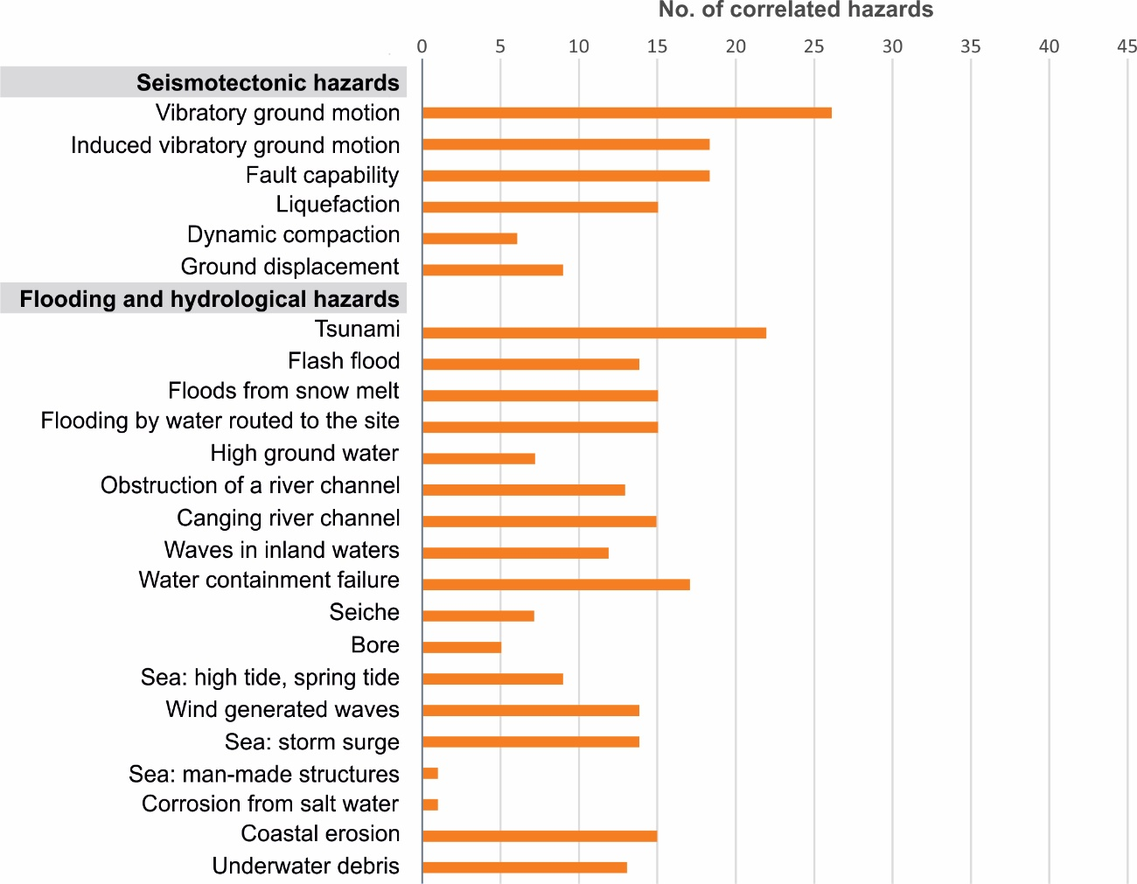

Figure 3-1: Number of hazards correlated with seismotectonic and flooding hazards.

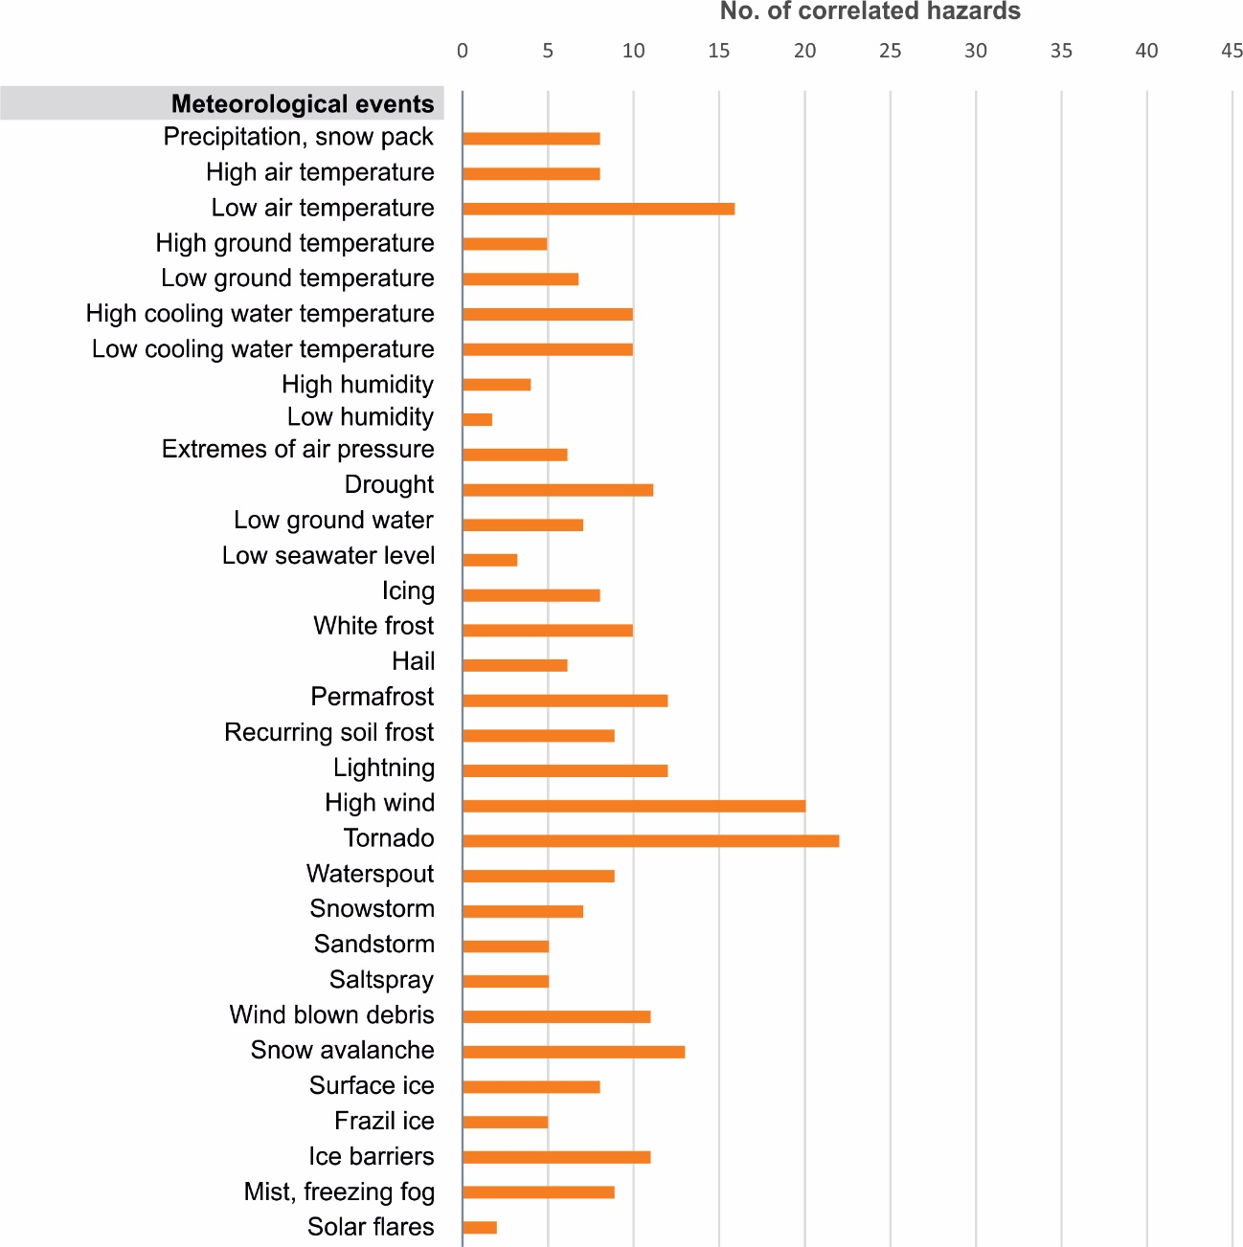

Figure 3-2: Number of hazards correlated with meteorological events.
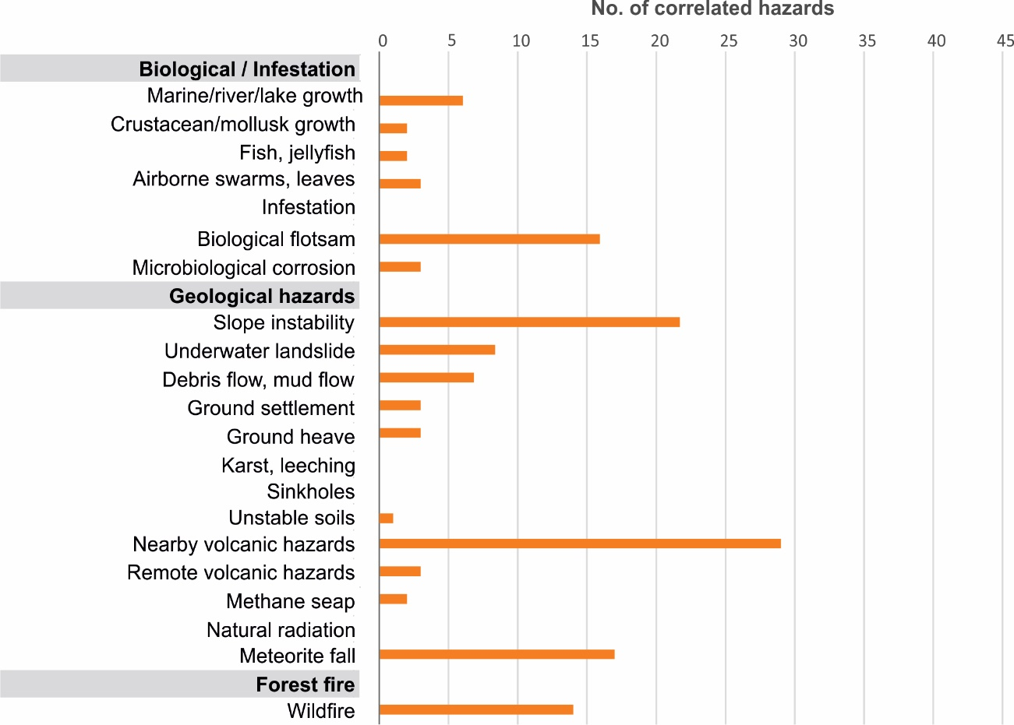

Figure 3-3: Number of hazards correlated with biological hazards, geological hazards and natural fire.
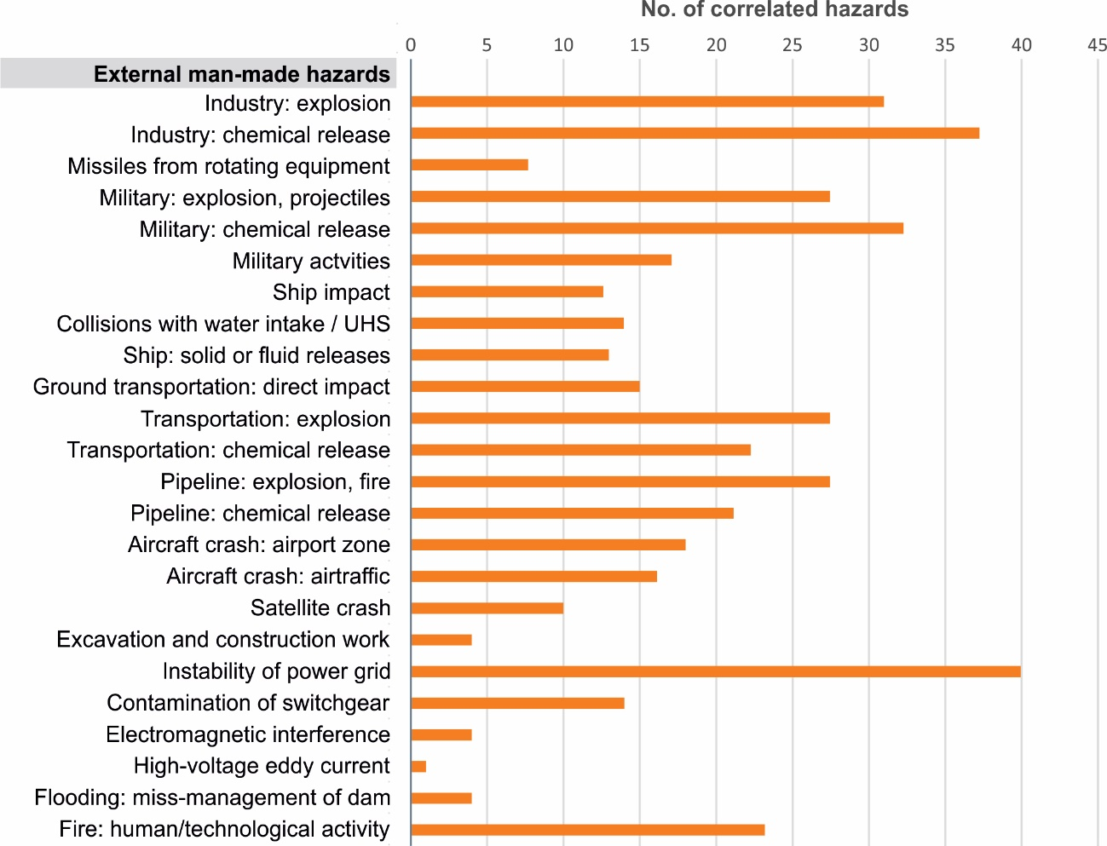

Figure 3-4: Number of hazards correlated with external man-made hazards.

REFERENCES

ASME/ANS, 2009. Addenda to ASME/ANS RA-S-2008 Standard for Level 1/Large Early Release Frequency Probabilistic Risk Assessment for Nuclear Power Plant Applications, 342pp.

Boteler, D.H., 2003. Geomagnetic hazards to conducting networks. Natural Hazards, 28: 537-561.

Chanson, H. (2011). Tidal Bores, Aegir, Eagre, Mascaret, Pororoca. Theory and Observations. World Scientific, Singapore. ISBN 978-981-4335-41-6.

Collins, G.S., et al., 2005. Earth Impact Effects Program: A Web-based computer program for calculating the
regional environmental consequences of a meteoroid impact on Earth. Meteoritics & Planetary Sciences, 40 (6): 817-840.

Daly, S.F., 1991. Frazil Ice Blockage of Intake Trash Racks. Cold Region Technical Digest, No. 91-1, 12 pp.

Gaume, E., Bain, V., Bernardara, P., et al., 2009. A compilation of data on European flash floods. Journal of Hydrology 367, 70-78.

Guigueno, Y., et al., 2016. Synthesis of the initial survey related to PSAs End-Users needs. Technical report ASAMPSA_E/WP10/D10.2/2014-05

IAEA, 2002. External Human Induced Events in Site Evaluation for Nuclear Power Plants. Safety Guide No. NS-G-3.1, Vienna.

IAEA, 2003 a. Site Evaluation for Nuclear Installations. Safety Requirements No. NS-R-3, Vienna.

IAEA, 2003 b. Flood Hazard for Nuclear Power Plants on Coastal and River Sites. Safety Guide No. NS-G-3.5, Vienna.

IAEA, 2003 c. Meteorological Events in Site Evaluation for Nuclear Power Plants. Safety Guide No. NS-G-3.4, Vienna.

IAEA, 2003 d. External Events Excluding Earthquakes in the Design of Nuclear Power Plants. Safety Guide No. NS-G-1.5, Vienna.

IAEA, 2003 e. Extreme External Events in the Design and Assessment of Nuclear Power Plants. Tecdoc 1341, Vienna.

IAEA, 2004 a. Design of Reactor Containment Systems for Nuclear Power Plants. Safety Guide No. NS-G-1.10, Vienna.

IAEA, 2004 b. Geotechnical Aspects of Site Evaluation and Foundations for Nuclear Power Plants, Safety Guide No. NS-G-3-6, Vienna.

IAEA, 2007. Terminology Used in Nuclear Safety and Radiation Protection. IAEA Safety Glossary 2007 Edition, Vienna.

IAEA, 2010 a. Seismic Hazards in Site Evaluation for Nuclear Installations. Specific Safety Guide No. SSG-9, Vienna.

IAEA, 2010 b. Development and Application of Level 1 Probabilistic Safety Assessment for Nuclear Power Plants. Safety Guide No. SSG-3, Vienna.

IAEA, 2011. Meteorological and Hydrological Hazards in Site Evaluation for Nuclear Installations. Specific Safety Guide No. SSG-18, Vienna.

IAEA, 2012. Volcanic Hazards in Site Evaluation for Nuclear Installations. Specific Safety Guide No. SSG-21, Vienna.

Intergovernmental Oceanographic Commission, 2016. Tsunami glossary. UNESCO, Technical Series 85, 48 pp.

Kuramoto, T., Yamaguchi, A., Narumiya, Y., Ota, T., Mamizuka, Y., 2014. Development of Implementation Standard Concerning the Risk Evaluation Methodology Selection for the External Hazards, PSAM 12 - Probabilistic Safety Assessment and Management, 22-27 June 2014, Sheraton Waikiki, Honolulu, Hawaii, USA, 12 pp.

Michel, B.l, 1967. Morphology of frazil ice. Physics of Snow and Ice, Proceedings 1 (1): 119-128.

NASA, 2014. New Map Shows Frequency of Small Asteroid Impacts, Provides Clues on Larger Asteroid Population. Bolide Events 1994-2013. http://www.jpl.nasa.gov/news/news.php?feature=4380

NIER Ingegneria, 2013. Hazards and threats ontology. Unpublished Report, Project reference number: HOME/2011/CIPS/AG/4000002102, 6 pp.

Onorato, M., Osborne, A.R., Serio, M., Damiani, T., 2001. Occurrence of Freak Waves from Envelope Equations in Random Ocean Wave Simulations. Proceedings Rogue Waves 2000.

Rumpf et al., 2015. The Global Impact Distribution of Near-Earth Objects. Icarus, 265: 209-223.

Schrijver, C.J. et al., 2012. Estimating the frequency of extremely energetic solar events,
based on solar, stellar, lunar, and terrestrial records. J Geophysical Research, 1217: A08103, doi:10.1029/2012JA017706

USNRC, 2012. Guidance for Performing a Tsunami, Surge, or Seiche Hazard Assessment. JLD-ISG 2012-06.

WENRA, 2013. Report Safety of New NPP Designs. Study by the Reactor Harmonization Working Group, March 2013. http://www.wenra.org/publications/

WENRA-RHWG, 2014. WENRA Safety Reference Levels for Existing Reactors. Update in Relation to Lessons Learned from TEPCO Fukushima Dai-Ichi Accident. http://www.wenra.org/publications/

WENRA, 2015. Guidance Document Issue T: Natural Hazards Head Document. http://www.wenra.org/publications/

Wielenberg, A., et al., 2017. Methodology for Selecting Initiating Events and Hazards for Consideration in an Extended PSA´. ASAMPSA_E/ WP 30 / D30.7 vol 2/ 2017-31, IRSN-PSN-RES/ SAG/2017-00017 ,2016.

LIST OF TABLES
Table 1: Definition of key terms used in the current document 12
Table 2: Exhaustive list of natural hazards (73 hazard types) 16
Table 3: Exhaustive list of external man-made hazards (24 hazard types) 30

LIST OF FIGURES
Figure 3-1: Number of hazards correlated with seismotectonic and flooding hazards 40
Figure 3-2: Number of hazards correlated with meteorological events 41
Figure 3-3: Number of hazards correlated with biological hazards, geological hazards and natural fire 42
Figure 3-4: Number of hazards correlated with external man-made hazards 43

APPENDIX A: HAZARD CORRELATION CHART

Cross-correlation chart showing causally connected hazards (A may cause B, A is a prerequisite for B), associated hazards (A and B may result from the same root cause), and mutually exclusive hazards. See the legend below for the explanation of the symbols used in the table. Note that:
- Only direct consequences of individual hazards are listed. Causal chains are not considered explicitly, but can be derived with the help of the table;
- Combinations of independent phenomena which may cause potential hazards by their contemporaneous occurrence by random coincidence are not identified;
- The chart is symmetric with the line of symmetry as the diagonal line. All hazard combinations are only plotted in the lower left half space of the table.

LEGEND TO THE CORRELATION CHART
 | B
A | f

A is prerequisite for B

B is prerequisite for A
 | B
A | c

A may cause B
 | B
A | f

B may cause A
 | B
A | c

A A may cause B or B may cause A
 | B
A | ↕

Associated hazards: A and B derive from a common root cause
B
A

Hazards A and B are mutually exclusive
B
A

APPENDIX B: INTERNAL HAZARDS

On-site accidents [10]: internal hazards to be considered as possible consequences of external events in extended PSA

Code | Hazard | Ref. | Hazard definition and hazard impact | Interfaces and comments
M25 | Direct impact of heavy transportation within the site | [10] | The hazard is defined in terms of damage to the plant resulting from direct impact of heavy transportation within the site, but outside the plant buildings. This also includes transportation of the containment external maintenance platform. | Heavy transportation within plant buildings is analysed as part of the PSA for internal hazards.
M26 | Explosion within the site | [10] | The hazard is defined in terms of damage to the plant resulting from explosions (deflagration or detonation) of solid substances or gas clouds within the site, but outside the plant buildings. It includes explosion after a pipeline rupture on the site. The damage may be due to pressure impact or impact of missiles. | The explosions within plant buildings are analysed as part of the PSA for internal hazards.
M27 | Fire within the site | [10] | The hazard is defined in terms of damage to the plant resulting from fire fires affecting the site and originating from sources outside of the site, or caused by the impact of other natural events such as earthquake. | -
M28 | Chemical release within the site: explosive, flammable, asphyxiating, toxic, corrosive or radioactive substances | [10] | The hazard is defined by the effects of chemical releases that affect the plant both externally and internally, damaging or impairing safety related systems and operator action. | These releases may originate from process accidents inside the plant or from leakages of substances stored within the site, but outside the plant buildings. The chemical releases from substances stored inside buildings are analysed as part of the PSA for internal hazards.
M29 | On-site pipeline accident: explosion, fire | [10] | The hazard is defined in terms of damage to the plant resulting from explosions (deflagration or detonation) or fire after a pipeline accident at the site. The damage may be due to pressure impact or impact of missiles. | Effects from a chemical release after on-site pipeline accident are treated separately. Explosion effects from a release outside the site are treated separately.
M30 | On-site pipeline accident: chemical release (explosive, flammable, asphyxiating, toxic, corrosive or radioactive substances) | [10] | The hazard is defined by the effects of chemical releases after an on-site pipeline accident that affect the plant both externally and internally, damaging or impairing safety related systems and operator action. | Consequence of other hazards (different prime cause). Explosion effects from pipeline accidents are treated separately.
M31 | Excavation and construction work at the site | [10] | The hazard is defined in terms of impact on the plant of excavation work and civil construction within the site area including destructive work on cabling and piping buried underground. | -
M32 | Stability of the on-site power grid |  | The hazard is defined by the impact of electrical current fluctuations coming from manipulation on switch yards/grid from inside the plant. | -
M33 | Electromagnetic interference, radiofrequency interference or disturbance from on-site sources | [7] [8] [10] | The hazard is defined in terms of impact on the plant of human-induced magnetic or electrical fields, and radio-magnetic disturbance that could cause malfunction in or damage to safety related equipment or instrumentation. | The main examples of such fields are those attributable to radio communication and mobile telephone systems.
M34 | High-voltage eddy current into ground (on-site sources) | [8] | The hazard is defined by corrosion of underground metal ground components and grounding problems. | -
M35 | Flooding from on-site tanks | [7] | The hazard is defined by the impact of flooding due to failure of on-site tanks. | -
M36 | Missiles from other units on the site | [10] | The hazard is defined in terms of damage to the plant resulting from missiles generated by high energy rotating equipment at another unit or installation on the site. | -
M37 | Internal fire spreading from other units on the site | [10] | The hazard is defined in terms of impact on the plant of fires originating in another unit on the site. | External fires are treated separately. Fires resulting as secondary effects from other external hazards are treated as part of these hazards.
M38 | Internal flood and harsh environment spreading from other units on the site | [10] | This hazard is defined in terms of damage to the plant resulting from water spreading effects from other units. | -
M39 | Effects of accidents at other units on the site |  | This hazard is defined in terms of damage to the plant resulting from explosion (e.g., hydrogen) or radioactive releases at other units of the site. | -

References (Ref.): [7] IAEA, 2003 d; [8] IAEA, 2002; [10] IAEA, 2010 b.

ASAMPSA_E 1st End-Users Workshop, Uppsala, Sweden, May 26-28, 2014

