**"NUCLEAR FISSION"**

**Safety of Existing Nuclear Installations**

**Contract 605001**

**Complement of existing ASAMPSA2 guidance for Level 2 PSA for shutdown states of reactors, Spent Fuel Pool and recent R&D results**

**Reference ASAMPSA\_E**

**Technical report ASAMPSA\_E / WP40/D40.7/2017-39 volume 4**

**Reference IRSN PSN/RES/SAG/** **2017-00005**

M. Kumar (LR), H. Löffler (GRS), S. Morandi (RSE), D. Gumenyuk (SSTC),P. Dejardin (TRACTEBEL), S. Yu (TRACTEBEL), P. Jan (EDF), J. Kubicek (UJV), C. Serrano (IEC), E. Raimond (IRSN), G. Dirksen (Areva), A. Olsson (LR), I. Ivanov (TUS), P. Groudev (INRNE), K. Kowal (NCBJ), A. Prošek (JSI), M. Nitoi (RATEN ICN), J. Vitazkova (CCA), K. Hirata (JANSI), L. Burgazzi (ENEA)

|  |  |  |  |
| --- | --- | --- | --- |
| Period covered: from 31/12/2014 to 31/12/2016 | | Actual submission date: 31/12/2016 | |
| Start date of ASAMPSA\_E: 01/07/2013 | | Duration: 42 months | |
| WP No: 4.0 | Lead topical coordinator : Horst Löffler | | His organization name : GRS |

|  |  |  |
| --- | --- | --- |
| **Project co-funded by the European Commission Within the Seventh Framework Programme (2013-2016)** | | |
| **Dissemination Level** | | |
| PU | Public | Yes |
| RE | Restricted to a group specified by the partners of the ASAMPSA\_E project | No |
| CO | Confidential, only for partners of the ASAMPSA\_E project | No |

**ASAMPSA\_E Quality Assurance page**

|  |  |
| --- | --- |
| **Partners responsible of the document : LR, GRS, IRSN, RSE, SSTC, Tractebel, EDF, UJV, IEC, NCBJ, TUS, INRNE** | |
| **Nature of document** | Technical report |
| **Reference(s)** | Technical report ASAMPSA\_E/ WP40/D40.7/2017-39 volume 4  Report IRSN/PSN-RES-SAG 2017-00005 |
| **Title** | Complement of existing ASAMPSA2 guidance for shutdown states of reactors, SFP and recent R&D results |
| **Author(s)** | M. Kumar (LR), H. Löffler (GRS), S. Morandi (RSE), D. Gumenyuk (SSTC), P. Dejardin (TRACTEBEL), S. Yu (TRACTEBEL), P. Jan (EDF), J. Kubicek (UJV), C. Serrano (IEC), E. Raimond (IRSN), G. Dirksen (Areva), A. Olsson (LR), I. Ivanov (TUS), P. Groudev (INRNE), K. Kowal (NCBJ), A. Prošek (JSI), M. Nitoi (RATEN ICN), J. Vitazkova (CCA), K. Hirata (JANSI), L. Burgazzi (ENEA) |
| **Delivery date** | 31/12/2016 |
| **Topical area** | L2 PSA, Shutdown states, Spent fuel pool, recent R&D in L2 PSA |
| **For Journal & Conf. papers** | No |
| **Summary :**  The objectives of this report are to provide:   * complementary guidance for Level 2 PSA for the shutdown states of reactors; * complementary guidance for the modelling of risks associated to the spent fuel pools; and * information on the recent Research and Development (R&D) to support Level 2 PSA development.   The report will complete the existing ASAMPSA2 guidance for L2 PSA. | |

|  |  |  |  |
| --- | --- | --- | --- |
| Visa grid | | | |
|  | **Main author(s) :** | **Verification** | **Approval (Coordinator)** |
| Name (s) | M. Kumar et. al. | H. Löffler | E. Raimond |
| Date | 2016-12-19 | 2017-01-16 | 2017-01-23 |
| Signature |  |  |  |

**Modifications of the document**

|  |  |  |  |  |
| --- | --- | --- | --- | --- |
| Version | Date | Authors | Pages or paragraphs modified | Description or comments |
| 0 | 2015-07-01 | All | All | Preliminary draft issued |
| 1 | 2015-08-14 | See QA page | All | WP 40 partners comments and contribution incorporated |
| 2 | 2015-11-17 | M. Kumar (LRC) | All | Comments and contribution received from JSI, CCA, GRS, Areva, EDF, INRNE, TUS, UJV, Tractebel, Iberdrola |
| 3 | 2016-03-22 | M. Kumar (LRC) | All | Comments and contributions received from GRS, LRC, Areva, Nubiki, CCA, JSI, INRNE, TUS, UJV, SSTC, IRSN, RATEN ICN, JANSI, ENEA. |
| 4 | 2016-05-18 | M. Kumar (LRC) | Review comments | Incorporation of review comments received from GRS, LRC, JSI, INRNE, Iberdrola and EDF. |
| 5 | 2016-05-23 | E. Raimond (IRSN) | Review | Approval review. Few editorial modifications and additions in the report. |
| 6 | 2016-11-14 | M. Kumar (LR) | Review comments | Incorporated final End-User comments and ASAMPSA\_E workshop recommendations. SARNET comments are also included. Contribution from GRS, SSTC, INRNE, LR. |
| 7 | 2016-12-19 | M. Kumar (LR) | All | Final technical editing, review comments received from GRS and JSI. |
| 8 | 2017-01-16 | H. Löffler (GRS) | Mostly Section 4 | Inclusion of IRSN updates |
| 9 | 2017\_01-23 | E. Raimond (IRSN) | Few | Approval reading. |

**List of diffusion**

**European Commission (scientific officer)**

|  |  |  |
| --- | --- | --- |
| **Name** | **First name** | **Organization** |
| Passalacqua | Roberto | EC |

**ASAMPSA\_E Project management group (PMG)**

|  |  |  |  |
| --- | --- | --- | --- |
| **Name** | **First name** | **Organization** |  |
| Raimond | Emmanuel | IRSN | Project coordinator |
| Guigueno | Yves | IRSN | WP10 coordinator |
| Decker | Kurt | Vienna University | WP21 coordinator |
| Klug | Joakim | LR | WP22 coordinator until 2015-10-31 |
| Kumar | Manorma | LR | WP22 coordinator from 2015-11-01 |
| Wielenberg | Andreas | GRS | WP30 coordinator until 2016-03-31 |
| Löffler | Horst | GRS | WP40 coordinator  WP30 coordinator from 2016-04-01 |

**REPRESENTATIVES OF ASAMPSA\_E PARTNERS**

| **Name** | **First name** | **Organization** |
| --- | --- | --- |
| Grindon | Liz | AMEC NNC |
| Mustoe | Julian | AMEC NNC |
| Cordoliani | Vincent | AREVA |
| Dirksen | Gerben | AREVA |
| Godefroy | Florian | AREVA |
| Kollasko | Heiko | AREVA |
| Michaud | Laurent | AREVA |
| Hasnaoui | Chiheb | AREXIS |
| Hurel | François | AREXIS |
| Schirrer | Raphael | AREXIS |
| De Gelder | Pieter | Bel V |
| Gryffroy | Dries | Bel V |
| Jacques | Véronique | Bel V |
| Van Rompuy | Thibaut | Bel V |
| Cazzoli | Errico | CCA |
| Vitázková | Jirina | CCA |
| Passalacqua | Roberto | EC |
| Banchieri | Yvonnick | EDF |
| Benzoni | Stéphane | EDF |
| Bernadara | Pietro | EDF |
| Bonnevialle | Anne-Marie | EDF |
| Brac | Pascal | EDF |
| Coulon | Vincent | EDF |
| Gallois | Marie | EDF |
| Henssien | Benjamin | EDF |
| Hibti | Mohamed | EDF |
| Jan | Philippe | EDF |
| Lopez | Julien | EDF |
| Nonclercq | Philippe | EDF |
| Panato | Eddy | EDF |
| Parey | Sylvie | EDF |
| Romanet | François | EDF |
| Rychkov | Valentin | EDF |
| Vasseur | Dominique | EDF |
| Burgazzi | Luciano | ENEA |
| Hultqvist | Göran | FKA |
| Karlsson | Anders | FKA |
| Ljungbjörk | Julia | FKA |
| Pihl | Joel | FKA |
| Loeffler | Horst | GRS |
| Mildenberger | Oliver | GRS |
| Sperbeck | Silvio | GRS |
| Tuerschmann | Michael | GRS |
| Wielenberg | Andreas | GRS |
| Benitez | Francisco Jose | IEC |
| Del Barrio | Miguel A. | IEC |
| Serrano | Cesar | IEC |
| Apostol | Minodora | RATEN ICN |
| Farcasiu | Mita | RATEN ICN |
| Nitoi | Mirela | RATEN ICN |
| Groudev | Pavlin | INRNE |
| Stefanova | Antoaneta | INRNE |
| Andreeva | Marina | INRNE |
| Petya | Petrova | INRNE |
| Armingaud | François | IRSN |
| Bardet | Lise | IRSN |
| Baumont | David | IRSN |
| Bonnet | Jean-Michel | IRSN |
| Bonneville | Hervé | IRSN |
| Clement | Christophe | IRSN |
| Corenwinder | François | IRSN |
| Denis | Jean | IRSN |
| Duflot | Nicolas | IRSN |
| Duluc | Claire-Marie | IRSN |
| Dupuy | Patricia | IRSN |
| Durin | Thomas | IRSN |
| Georgescu | Gabriel | IRSN |
| Guigueno | Yves | IRSN |
| Guimier | Laurent | IRSN |
| Lanore | Jeanne-Marie | IRSN |
| Laurent | Bruno | IRSN |
| Pichereau | Frederique | IRSN |
| Rahni | Nadia | IRSN |
| Raimond | Emmanuel | IRSN |
| Rebour | Vincent | IRSN |
| Sotti | Oona | IRSN |
| Volkanovski | Andrija | JSI |
| Prošek | Andrej | JSI |
| Alzbutas | Robertas | LEI |
| Matuzas | Vaidas | LEI |
| Rimkevicius | Sigitas | LEI |
| Häggström | Anna | LR |
| Klug | Joakim | LR |
| Kumar | Manorma | LR |
| Olsson | Anders | LR |
| Borysiewicz | Mieczyslaw | NCBJ |
| Kowal | Karol | NCBJ |
| Potempski | Slawomir | NCBJ |
| La Rovere | Stephano | NIER |
| Vestrucci | Paolo | NIER |
| Brinkman | Hans | NRG |
| Kahia | Sinda | NRG |
| Bareith | Attila | NUBIKI |
| Lajtha | Gabor | NUBIKI |
| Siklossy | Tamas | NUBIKI |
| Morandi | Sonia | RSE |
| Caracciolo | Eduardo | RSE |
| Dybach | Oleksiy | SSTC |
| Gorpinchenko | Oleg | SSTC |
| Claus | Etienne | TRACTEBEL |
| Dejardin | Philippe | TRACTEBEL |
| Grondal | Corentin | TRACTEBEL |
| Mitaille | Stanislas | TRACTEBEL |
| Oury | Laurence | TRACTEBEL |
| Zeynab | Umidova | TRACTEBEL |
| Yu | Shizhen | TRACTEBEL |
| Bogdanov | Dimitar | TUS |
| Ivanov | Ivan | TUS |
|  | Kaleychev | TUS |
| Holy | Jaroslav | UJV |
| Hustak | Stanislav | UJV |
| Jaros | Milan | UJV |
| Kolar | Ladislav | UJV |
| Kubicek | Jan | UJV |
| Decker | Kurt | UNIVIE |
| Halada | Peter | VUJE |
| Prochaska | Jan | VUJE |
| Stojka | Tibor | VUJE |

**REPRESENTATIVE OF ASSOCIATED PARTNERS (External Experts Advisory Board (EEAB))**

|  |  |  |
| --- | --- | --- |
| **Name** | **First name** | **Organization** |
| Hirata | Kazuta | JANSI |
| Hashimoto | Kazunori | JANSI |
| Inagaki | Masakatsu | JANSI |
| Yamanana | Yasunori | TEPCO |
| Coyne | Kevin | US-NRC |
| González | Michelle M. | US-NRC |

**Executive summary**

This report can be considered as an addendum to the existing ASAMPSA2 guidance for Level 2 PSA. It provides complementary guidance for Level 2 PSA for accident in the NPP shutdown states and on spent fuel pool and comments on the importance of these accidents on nuclear safety. It includes also information on recent research and development useful for Level 2 PSA developments.

The conclusions of the ASAMPSA\_E end-users survey and of technical meetings of WP10, WP21, WP22, and WP30 at Vienna University in September 2014 which are relevant for Level 2 PSA have been reflected and are taken into account as much as it is possible with the current status of knowledge.

For Level 2 PSA in shutdown states, two plant conditions are to be distinguished:

* accident sequences with RPV head closed,
* accident sequences with RPV head open.

When the RPV head is closed, core melt accident phenomena are very similar to the sequences going on in full power mode. Therefore, the large body of guidance which is available for full power mode is basically applicable to shutdown mode with RPV closed as well. When the RPV is open, some of the L2 PSA issues become irrelevant compared to full power mode, while others come into existence. The situation is different for aspects which do not exist or which are less pronounced in sequences with RPV closed.

The report also covers containment issues in shutdown states and discusses the applicability of existing guidance, potential gaps and deficiencies and recommendations are provided.

For spent fuel pool accidents in Level 2 PSA, a set of issues is identified and addressed. If the spent fuel pool is located inside the containment, the potential release paths to the environment are almost the same as for core melt accidents in the RPV. If the spent fuel pool is located outside the containment, the potential release paths to the environment depend very much on plant specific properties, e.g. ventilation systems, building doors, roof under thermal impact, size of rooms on the path etc. In any case the impact of very hot gas and of hydrogen has to be considered. The dependencies between reactor accident and SFP management appear to be an important issue for L2 PSA risk assessment.

The report provides information on ongoing R&D activities which may support the preparation of guidelines for “traditional” and extended L2 PSA. In addition, a list is provided for those topics which seem to have inadequate covering in present activities.

Appendices cover the level 1 shutdown states PSA and country-specific examples related to shutdown PSA and spent fuel pool PSA from ASAMPSA\_E WP40 contributing organizations.

**ASAMPSA\_E Partners**

The following table provides the list of the ASAMPSA\_E partners involved in the development of this document.

|  |  |  |  |
| --- | --- | --- | --- |
| 1 | Institute for Radiological Protection and Nuclear Safety | IRSN | France |
| 2 | Gesellschaft für Anlagen- und Reaktorsicherheit mbH | GRS | Germany |
| 4 | Ricerca sul Sistema Energetico | RSE S.p.A. | Italy |
| 5 | Lloyd’s Register Consulting | LR | Sweden |
| 6 | Nuclear Research Institute Rez pl | UJV | Czech Republic |
| 8 | Cazzoli Consulting | CCA | Switzerland |
| 9 | Italian National Agency for New Technologies, Energy and the Sustainable Economic Development | ENEA | Italy |
| 11 | IBERDROLA Ingeniería y Construcción S.A.U | IEC | Spain |
| 12 | Electricité de France | EDF | France |
| 14 | NUBIKI | NUBIKI | Hungary |
| 15 | Forsmark kraftgrupp AB | FKA | Sweden |
| 16 | AREVA NP SAS France | AREVA NP SAS | France |
| 17 | National Centre for Nuclear Research Institute | NCBJ | Poland |
| 18 | State Scientific and Technical Center for Nuclear and Radiation Safety | SSTC | Ukraine |
| 22 | TRACTEBEL ENGINEERING S.A. | TRACTEBEL | Belgium |
| 24 | Institut Jožef Stefan | JSI | Slovenia |
| 25 | Institute of nuclear research and nuclear energy – Bulgarian Academia of science | INRNE | Bulgaria |
| 26 | Regia Autonoma Technologii pentru Energia Nucleara Institutul de Cercetari Nucleare | RATEN INR | Romania |
| 27 | Technical University of Sofia – Research and Development Sector | TUS | Bulgaria |

**CONTENT**

[**Modifications of the document** 3](#_Toc473047357)

[**List of diffusion** 4](#_Toc473047358)

[**Executive summary** 6](#_Toc473047359)

[**ASAMPSA\_E Partners** 7](#_Toc473047360)

[**CONTENT** 8](#_Toc473047361)

[**GLOSSARY** 11](#_Toc473047362)

[1 INTRODUCTION 14](#_Toc473047363)

[2 COMPLEMENT OF EXISTING GUIDANCE FOR SHUTDOWN STATES 15](#_Toc473047364)

[2.1 DEFINITION 16](#_Toc473047365)

[2.2 INTERFACE BETWEEN L1 AND L2 PSA 19](#_Toc473047366)

[2.3 SHUTDOWN STATES L2 PSA 20](#_Toc473047367)

[2.4 ACCIDENT SEQUENCES WITH RPV CLOSED 22](#_Toc473047368)

[2.5 ACCIDENT SEQUENCES WITH RPV OPEN 23](#_Toc473047369)

[2.5.1 FISSION PRODUCT RELEASE FROM CORE MELT IN OPEN REACTOR 25](#_Toc473047370)

[2.5.2 HEAT LOAD FROM THE CORE MELT 27](#_Toc473047371)

[2.6 CONTAINMENT ISSUES FOR ACCIDENTS IN SHUTDOWN MODE 27](#_Toc473047372)

[2.6.1 MODIFIED CONTAINMENT STATUS (RPV OPEN OR CLOSED) 27](#_Toc473047373)

[2.6.2 CONTAINMENT RESPONSE ANALYSIS 29](#_Toc473047374)

[2.6.3 CONTAINMENT EVENT TREE 30](#_Toc473047375)

[2.6.4 Simultaneous accident progression in reactor and spent fuel pool 31](#_Toc473047376)

[2.7 SUMMARY FOR L2 PSA IN SHUTDOWN STATES 32](#_Toc473047377)

[3 COMPLEMENT OF EXISTING GUIDANCE FOR SPENT FUEL DAMAGE 33](#_Toc473047378)

[3.1 INTRODUCTION 33](#_Toc473047379)

[3.2 EXISTING GUIDANCE/ METHODOLOGY FOR SPENT FUEL POOLS 35](#_Toc473047380)

[3.3 ISSUES RELATED TO SFD WITHIN EXTENDED L2 PSA 39](#_Toc473047381)

[3.3.1 IDENTIFICATION OF INITIATING EVENTS 41](#_Toc473047382)

[3.3.2 ACCIDENT SEQUENCE ANALYSIS 45](#_Toc473047383)

[3.3.3 THERMAL HYDRAULIC CALCULATIONS AND SUCCESS CRITERIA 46](#_Toc473047384)

[3.3.4 HUMAN RELIABILITY ANALYSIS 47](#_Toc473047385)

[3.3.5 FUEL DEGRADATION PROCESS IN SPENT FUEL POOLS 47](#_Toc473047386)

[3.3.6 HYDROGEN ISSUES IN SPENT FUEL POOL MELTING 49](#_Toc473047387)

[3.3.7 HEAT LOAD DUE TO SPENT FUEL POOL MELTING 50](#_Toc473047388)

[3.3.8 RELEASE PATHWAYS TO THE ENVIRONMENT IN CASE OF SPENT FUEL POOL MELTING 52](#_Toc473047389)

[3.3.9 CORRELATIONS BETWEEN ACCIDENT PROGRESSION IN SPENT FUEL POOL AND IN THE REACTOR VESSEL 54](#_Toc473047390)

[3.3.10 CORE CONCRETE INTERACTIONS FOR SPENT FUEL POOL ACCIDENTS 54](#_Toc473047391)

[3.3.11 CRITICALITY IN SPENT FUEL POOLS 55](#_Toc473047392)

[3.3.12 SAFETY ASSESSMENT OF SPENT FUEL POOL DURING DECOMMISSIONING 56](#_Toc473047393)

[3.4 SUMMARY FOR L2 PSA FOR SPENT FUEL POOLS 56](#_Toc473047394)

[4 COMPLEMENT OF EXISTING GUIDANCE BASED ON RECENT R&D 58](#_Toc473047395)

[4.1 Recent R&D ON CORE MELT ISSUES IN GENERAL 58](#_Toc473047396)

[4.1.1 RECENT R&D ON ACCIDENTS IN REACTOR SHUTDOWN STATES 58](#_Toc473047397)

[4.1.2 ANALYSIS OF THE COMPLEXITY OF SEVERE ACCIDENT PHENOMENOLOGY BY CODE SIMULATION (ASTEC AND MELCOR) 59](#_Toc473047398)

[4.1.3 INVESTIGATION OF IN-VESSEL MELT RETENTION STRATEGY 62](#_Toc473047399)

[4.1.4 STATUS OF SOURCE TERM RESEARCH AND PERSPECTIVES FOR L2 PSA 64](#_Toc473047400)

[4.1.5 MOLTEN CORIUM CONCRETE INTERACTION (MCCI) 71](#_Toc473047401)

[4.2 RECENT R&D ON SPENT FUEL POOL ACCIDENTS 72](#_Toc473047402)

[4.2.1 CSNI STATUS REPORT ON SPENT FUEL POOL UNDER ACCIDENT CONDITIONS 72](#_Toc473047403)

[4.2.2 EXPERIMENTS WITH RELEVANCE TO SFP COOLING ACCIDENTS 72](#_Toc473047404)

[4.2.3 Detailed SIMULATION TOOLS 74](#_Toc473047405)

[4.2.4 ABILITY OF REACTOR CORE SEVERE ACCIDENT CODES TO SIMULATE SFP SEVERE ACCIDENTS 74](#_Toc473047406)

[4.2.5 ONGOING R&D ACTIVITIES 75](#_Toc473047407)

[4.2.6 ANALYSIS OF HEAVY LOAD DROPS INTO THE SFP (UJV) 78](#_Toc473047408)

[4.3 KNOWLEDGE GAPS AND FUTURE NEEDS 79](#_Toc473047409)

[4.4 SUMMARY FOR L2 PSA CONSIDERING RECENT R&D 82](#_Toc473047410)

[4.5 Safety Research areas identified in the NEA-SAREF-Project 83](#_Toc473047411)

[5 CONCLUSION AND RECOMMENDATIONS 85](#_Toc473047412)

[5.1 COMPLEMENTARY GUIDANCE FOR LEVEL 2 PSA FOR THE SHUTDOWN STATES OF REACTORS 85](#_Toc473047413)

[5.2 COMPLEMENT OF EXISTING GUIDANCE FOR SPENT FUEL DAMAGE 87](#_Toc473047414)

[5.3 Recent R&D in L2 PSA 89](#_Toc473047415)

[5.4 List of General Recommendations 90](#_Toc473047416)

[6 List of References 92](#_Toc473047417)

[7 List of Tables 100](#_Toc473047418)

[8 List of Figures 101](#_Toc473047419)

[9 APPENDICES 103](#_Toc473047420)

[9.1 Practical containment analysis during shutdown states for French PWR (EDF) 103](#_Toc473047421)

[9.1.1 IDENTIFICATION 103](#_Toc473047422)

[9.1.2 QUANTIFICATION 103](#_Toc473047423)

[9.2 LEVEL 1 SHUTDOWN STATES PSA 104](#_Toc473047424)

[9.3 Examples of ACCIDENT PROGRESSION in shutdown state 105](#_Toc473047425)

[9.3.1 An example from Belgian PWRs 105](#_Toc473047426)

[9.3.2 An Example from German PWR’s 107](#_Toc473047427)

[9.3.3 An example from Spanish BWR (Mark-III containment) 108](#_Toc473047428)

[9.3.4 An example from Swedish NPP’s 109](#_Toc473047429)

[9.3.5 An example from Swiss NPP’s (CCA) 112](#_Toc473047430)

[9.3.6 An example from Ukrainian VVER’s (SSTC) 119](#_Toc473047431)

[9.3.7 EXAMPLE FROM BULGARIA (INRNE) 123](#_Toc473047432)

[10 Examples of ACCIDENT PROGRESSION in spent fuel pool 134](#_Toc473047433)

[10.1 Example from GRS for Spent fuel pool accident in a PWR 134](#_Toc473047434)

[10.2 ASETC Calculations OF SFP ACCIDENTS IN L2 PSA (IRSN) 137](#_Toc473047435)

[10.2.1 CONTEXT IN FRANCE 137](#_Toc473047436)

[10.2.2 900 AND 1300 MWE PWR SFP CONFIGURATIONS STUDIED WITH ASTEC 138](#_Toc473047437)

[10.2.3 PHYSICAL PHENOMENA 139](#_Toc473047438)

[10.2.4 SUMMARY OF ASTEC RESULTS AND LIMITATIONS OF THE CODE 140](#_Toc473047439)

[10.2.5 CONCLUSIONS 141](#_Toc473047440)

[10.3 Example Spent fuel pool in Sweden (LRC) 141](#_Toc473047441)

[10.4 Example Spent fuel pool in France (EDF) 142](#_Toc473047442)

[10.5 Example Spent fuel pool IN JAPAN (jansi) 142](#_Toc473047443)

[10.6 EXAMPLE SPENT FUEL POOL IN HUNGARY (NUBIKI) 143](#_Toc473047444)

[10.7 Example Spent fuel pool in Ukraine (SSTC) 148](#_Toc473047445)

[10.8 EXAMPLE FROM BULGARIA (INRNE) 151](#_Toc473047446)

**GLOSSARY**

|  |  |
| --- | --- |
| ACWS | Auxiliary Cooling Water System |
| AECL | Atomic Energy of Canada Limited |
| AEKI | Atomic Energy Research Institute (Hungary) |
| AFW | Auxiliary Feed Water |
| ALPS | Advanced Liquid Processing System |
| ASTEC | Accident Source Term Evaluation Code |
| BBN | Bayesian Belief Networks |
| BDBA | Beyond Design Basis Assessment |
| BEEJT | Benchmark Exercise on Expert Judgment Techniques |
| BRU‑A | Steam Relief Valve to Atmosphere |
| BRU‑K | Steam Dump Valve to Condenser |
| BWR | Boiling Water Reactor |
| CAV | Cavity Package |
| CCI | Corium Concrete Interaction |
| CDF | Core Damage Frequency |
| CET | Containment Event Tree |
| CFD | Computational Fluid Dynamics |
| CFF | Containment Failure Frequency |
| CFR | Code of Federal Regulations |
| CFVS | Containment Filtered Venting System |
| CHRS | Containment Heat Removal System |
| CIS | Containment Isolation System |
| CNFW | Condensate And Feedwater System |
| CO | Carbon Monoxide |
| COR | Core Behaviour Package |
| CRD | Control Rod Drive Pumps |
| CSNI | Committee on the Safety of Nuclear Installations |
| CSS | Containment Spray System |
| CVH | Control Volume Hydrodynamics |
| DBA | Design Basis Assessment |
| DCH | Direct Containment Heating |
| ECCS | Emergency Core Cooling System |
| EOP | Emergency Operating Procedures |
| EPRI | Electric Power Research Institute |
| ERG | Emergency Response Guidelines |
| EUR | European Utility Requirements |
| FASTNET | Fast Nuclear Emergency Tools |
| FCVS | Filtered Containment Venting System |
| FHB | Fuel Handling Building |
| FL | Flow Paths |
| FMEA | Failure Mode Effect Analysis |
| FP | Fission Product |
| FPCS | Fuel Pool Cooling System |
| FWS | Fire Water System |
| GDC | General Design Criteria |
| HRA | Human Reliability Analysis |
| IAEA | International Atomic Energy Agency |
| IE | Initiating Event |
| ISTP | International Source Term Program |
| IVMR | In-Vessel Melt Retention |
| KNPP | Kozloduy Nuclear Power Plant |
| LERF | Large Early Release Frequency |
| LLOCA | Large-Break Loss Of Coolant Accident |
| LOCA | Loss Of Coolant Accidents |
| LOOP | Loss Of Offsite Power |
| LPP | Low Pressure Pump |
| LPSD | Low Power And Shutdown |
| LPSIS | Low-Pressure Safety Injection System |
| LTO | Long Term Operation |
| LWR | Light Water Reactors |
| MAAP | Modular Accident Analysis Program |
| MCCI | Molten Core Concrete Interaction |
| MCCI | Molten Corium Concrete Interaction |
| MCP | Main Coolant Pump |
| MCR | Main Control Room |
| MELCOR | Methods For Estimation Of Leakages And Consequences Of Releases |
| NCO | Niigataken-Chuetsu-Oki |
| NPP | Nuclear Power Plant |
| NRA | Nuclear Regulation Authority (Japan) |
| NRC | Nuclear Regulatory Commission |
| NUREG | Nuclear Regulatory Commission Regulation (USA) |
| OECD | Organisation For Economic Co-Operation And Development |
| OPEX | Operating Experience |
| PAR | Passive Autocatalytic Recombiner |
| PDS | Plant Damage State |
| PHWR | Pressurizer Heavy Water Reactors |
| PIRT | Phenomena Identification And Ranking Table |
| PORV | Power Operated Relief Valve |
| POS | Plant Operating State |
| PRV | Pressure Relief Valves |
| PSA | Probabilistic Safety Assessment |
| PWR | Pressurised Water Reactor |
| R&D | Research And Development |
| RASTEP | Rapid Source Term Prediction |
| RC | Release Categories |
| RCPB | Reactor Coolant Pressure Boundary |
| RCS | Reactor Coolant System |
| RHR | Residual Heat Removal |
| RHRS | Residual Heat Removal System |
| RN | Radionuclide Behaviour Package |
| RPV | Reactor Pressure Vessel |
| RUSET | Ruthenium Separate Effect Tests |
| RV | Reactor Vessel |
| RWST | Refuelling Water Storage Tank |
| SAFEST | Severe Accident Facilities For European Safety Targets |
| SAMG | Severe Accident Management Guideline |
| SAREF | Safety Research Opportunities Post-Fukushima |
| SARNET | Severe Accident Research Network |
| SASA | Severe Accident Sequence Analysis |
| SBO | Station Black Out |
| SC | Shutdown Cooling |
| SFD | Spent Fuel Damage |
| SFP | Spent Fuel Pool |
| SG | Steam Generators |
| SGTR | Steam Generator Tube Rupture |
| SNAP | Symbolic Nuclear Analysis Package |
| SPSA | Shutdown PSA |
| SRV | Safety Relief Valves |
| SSC | System Structure And Components |
| SSM | Swedish Radiation Safety Authority |
| ST | Source Term |
| STCS | Shutdown And Torus Cooling System |
| TBICWS | Turbine Building Intermediate Cooling Water |
| TCS | Torus Cooling System |
| TS | Technical Specification |
| VVER | Water Water Energetic Reactor (Russian Design) |

# INTRODUCTION

The objectives of this report are to provide:

* complementary guidance for Level 2 PSA for the shutdown states of reactors;
* complementary guidance for the modelling of risks associated to the spent fuel pools; and
* information on the recent Research and Development (R&D) useful for Level 2 PSA development.

The report aims at completing the existing ASAMPSA2 guidance for L2 PSA [1], [2], [3]. WP40 deliverable D40.3 [4] defined the road map and structure of this report which is taken into consideration.

It is worthwhile to briefly summarize the D40.3, which described how this report shall proceed and what issues shall be addressed. The initial step suggested is to identify the most relevant items for shutdown states (different shutdown states and related accident sequences), and spent fuel pools (types of accidents) and related items, including how to better introduce recent R&D items into L2 PSA.

For **shutdown states** with closed Reactor Pressure Vessel (RPV), core melt accident phenomena are very similar to the sequences going on in full power mode. Therefore, the large body of guidance which is available for full power mode is largely applicable to shutdown mode with RPV closed as well. Some specifics of the containment isolation status may be an important part of the L2 PSA. When the RPV is open, some of the L2 PSA issues become irrelevant compared to full power mode, while others come into existence. In this report also suggestions are provided for harmonized shutdown state definitions.

For **Spent Fuel Damage (SFD)** accidents in L2 PSA a set of issues have been identified and listed in D40.3 which needs additional guidance, and which is addressed in the present report.

The section on **recent R&D achievements** concentrates on on-going R&D activities which may support the preparation of guidelines for “traditional” and extended L2 PSA, including results presentation and application (this is addressed in D40.4 [50]). In addition, a list is provided for those topics which seem to have inadequate covering in present activities.

# COMPLEMENT OF EXISTING GUIDANCE FOR SHUTDOWN STATES

Traditionally, the risk associated with the nuclear power plants are assumed to be dominated by the full power operation, however as the safety significant events are increasing during shutdown states, the risk associated with shutdown states are assumed to be comparable to the full power operation. The overall plant status in shutdown mode may be very different from the full power mode. The containment hatch or the containment head (BWR) could be open, several systems might be offline, alarms and set points are different, activities in the plant could increase fire risk or cause power disturbances in the electric systems, redundancies in safety systems might be unavailable. All these issues tend to decrease the plant’s ability to cope with unforeseen challenges, which in some sense are compensated by the lower decay heat in shutdown states. The incidents during shutdown states could lead to substantial loss of reactor coolant through draining events, or to loss of heat removal. The performance of PSA for shutdown states can support the enhancement of the safety during plant outage, and may contribute to the reduction of the outage duration.

ASAMPSA2 guidelines [1] provided summary on specific issues related to shutdown states, for instances, the structural barriers normally used to ensure nuclear safety is challenged by the maintenance and refuelling activities, open containment and open RPV head during refuelling, unavailability of the systems and equipment’s, success criteria for phenomena mitigation, presence of additional personnel, presence of additional heavy loads and flammable materials. For BWRs in particular, shutdown states present difficulties as the RPV head is also a part of the containment barrier (in Swedish BWR design it is ‘containment lid’) and the containment integrity cannot be easily recovered if an accident occurs. Although the decay heat level is low in shutdown states but can still be substantial, at least in the beginning of the outage period. Also, the core inventory is very different, for instance after fuel reloading, the severe accident progressions and the phenomena’s are similar to power operation; however it also depends on when the phenomena’s occur for instance new fuel elements do not have any decay heat. In some operating PWRs the fuel might be removed from the RPV to the Spent Fuel Pool (SFP) at the beginning of shutdown. The issues related with SFPs are discussed in section 3 of this report.

The purpose of shutdown PSA is normally to analyse an outage period with maintenance activities and refuelling; and calculate the risk of radionuclide release from potential sources such as (for light water reactors):

* Reactor core,
* **Spent fuel storages (e.g. SFP)** (normally not included in PSA for nominal power or low power, more emphasis after Fukushima though),
* **Spent fuel handling facilities and pathways** (except for heavy lifts this is normally not included in Shutdown PSA),
* **Waste facilities** (normally not included).

The level of details may vary from different shutdown PSA’s, it is important though that it is sufficient to make comparisons with full and low power PSAs, e.g. a shutdown PSA tends to be more dependent on analysis of human actions than full and low power PSA. For example, at Forsmarks nuclear power plant at Sweden has strategy to perform a yearly assessment of the shut down state depending on which system is unavailable during outage. This yearly assessment guide the operators into optimize the closure of safety systems during shut down operation.

## DEFINITION

Depending on the plant design and operation procedures, in some plants the shutdown sequence would be turbine trip and simultaneous reactor trip, while for other plants a slow reduction of power level follows the trip of the turbine. Typically the full scope PSA considers full power PSA, Low Power and Shutdown PSA; whereas the differences between the low power operational states and shutdown states are dependent on definitions used in the Technical Specification for each plants, which can be described as follows:

Low power operational states:

* Reactor critical, turbine not operating;
* Reactor subcritical, RCPB (Reactor Coolant Pressure Boundary) pressure above residual heat removal conditions.

Shutdown states:

* Reactor subcritical, low pressure residual heat removal system in operation;
* Reactor subcritical, main circuit open (e.g. refuelling, steam generator maintenance, primary pump maintenance).

NUREG/CR-6144 [23] defines the plant operating and shutdown states. It begins when the plant moves from steady state operating conditions to a decrease in power operation (15% power interface point is applied here), ends with the reactor start-up and the plant entry to normal power condition (15% power and up) (see **Figure 2.1.1** below). This definition of shutdown states seems adequate; however the most important is to have clear plant operating states definitions to avoid double accounting of low power, shutdown and full power states.



**Figure 2.1.1 Full Power, Low Power & Shutdown PSA Definition [23]**

A typical example of BWR operational modes according to technical specifications are as follows:

* Power operation (full power PSA) – Thermal power >5% of full power;
* Nuclear low power (low power PSA) – Thermal power <5% and operation mode switch in position ”SS” – scram available;
* Hot stand-by (low power PSA) - Subcritical reactor at pressure 1 bar < p < 70 bar and temperature >100 °C and operation mode switch in position “0” or V-chain actuated (the control rods are electrically maneuvered into the core in a BWR);
* Cold shutdown (Shutdown PSA) - Subcritical reactor at temperature <100 °C and operation mode switch in position “0”.

An example of plant operating modes and criticality for PWR design is given in the table below:

**Table 2.1.1 Plant Operating Modes and Criticality (PWR)**

|  |  |  |  |  |
| --- | --- | --- | --- | --- |
| **Mode** | **Operating Mode** | **Reactivity Condition (Keff)** | **% Rated Thermal Power (a)** | **Average Reactor Coolant Temperature (*°C*)** |
| 1 | Power Operation | Critical | > 5 | N/A |
| 2 | Start-up | Critical | ≤ 5 | N/A |
| 3 | Hot Standby | Subcritical | N/A | ≥ 177 |
| 4 | Hot Shutdown(b) | Subcritical | N/A | 177 > Tavg > 93 |
| 5 | Cold Shutdown(b)  (RPV close) | Subcritical | N/A | ≤ 93 |
| 6 | Cold Shutdown -Refuelling(c)  (RPV open) | N/A | N/A | N/A |
| 7 | Empty (unloaded) Core(d) | N/A | N/A | N/A |

(a) Excluding decay heat;

(b) All reactor vessel head closure bolts fully tensioned;

(c) One or more reactor vessel head closure bolts less than fully tensioned.

(d) The reactor vessel is empty and the fuel is located in the spent fuel pool.

Typically a Nuclear Power Plant (NPP) experiences various types of outages, for instance short unplanned (forced outage) for repair or “adjustment” and regular planned for refuelling and maintenance. In principle each outage is unique with respect to plant conditions, plant configuration, time and transitions between different operational modes. In order to not having to analyse an “infinite” number of initiating events for each type of outage and configuration it is practice to use screening, classification & grouping of initiating events and plant configuration which is often an iterative process. By defining a limited number of plant operating states (POSs) where plant status and configuration are stable, the problem of performing a Shutdown PSA becomes manageable. Each POS has a defined set of ‘boundary’ conditions within which there would be no changes in major characteristics which are important for PSA modelling. A typical number of POSs considered in shutdown PSA varies from 10 to 20. An example list of POSs after grouping and their correspondence with technical specification modes is shown in Table 2.1.2 below:

**Table 2.1.2 An example of Plant Operating States (POS) (PWR) [38]**

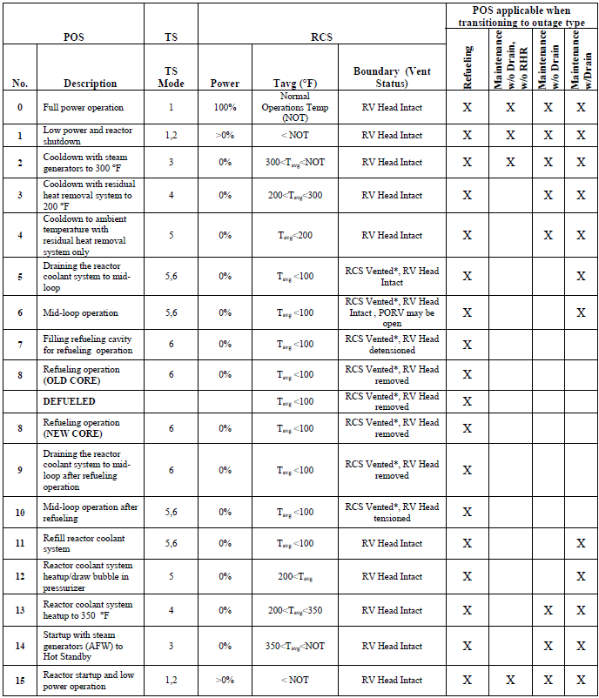

\* RCS may be vented via PORVs, pressurizer manways, or safety valves. Purge valves are not considered vent paths.

The plant damage states (PDS) shall be checked carefully for shutdown PSA. In some cases additional PDSs are specified for shutdown states if there are significant differences that could have a major impact on plant behaviour in severe accidents or if there are other reasons for performing a more accurate representation of specific states [10].

The country specific examples of shutdown PSA including POSs are given in section 9.3.

## INTERFACE BETWEEN L1 AND L2 PSA

The interface between L1 PSA and L2 PSA is accomplished through the plant damage states (PDS). The PDS defines the plant state at the beginning of the core damage and the conditions necessary for conducting severe accident progression analysis. The general overview of the development of a typical L2 PSA is given in IAEA SSG- 4 [10], as shown in **Figure 2.2.1**. If the status of containment system is not addressed in the L1 PSA, it needs to be considered by means of so-called ‘bridge trees’ (also called extended L1 event trees) of the interface between L1 and L2 PSA or as the first step of the L2 PSA. The extended L1 event trees must also consider all system conditions that are necessary in order to analyse the future accident progression. For example, L1 PSA event trees do not distinguish between RCPB high pressure and RCPB low pressure core damage, although RCPB pressure is important for determination of future accident progression.

**Figure 2.2.1 General overview of the development of a typical L2 PSA [10]**

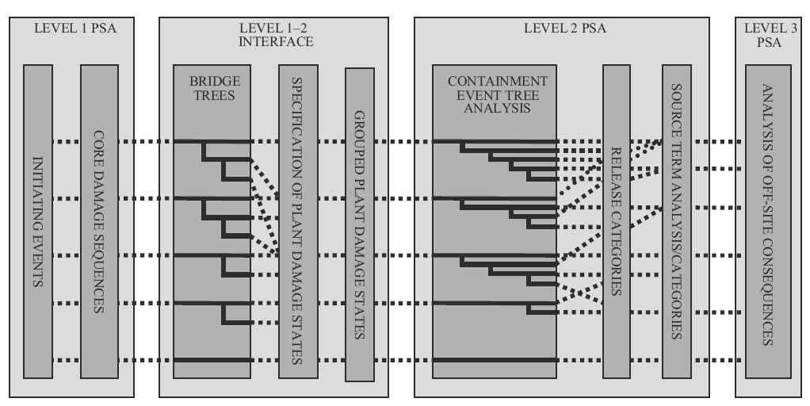

The additional PDSs are considered for L2 shutdown states, which are based on following characteristics:

* Location of the fuel (core or spent fuel pool)
* Containment/SFP building integrity/isolation
* Type of initiating event
* Time when fuel damage occurs (related to the IE)
* Amount of water surrounding the fuel
* Status of the containment protection and mitigation systems
* Recovery of fuel cooling
* Amount of water in Refuelling Water Storage Tank (RWST) (PWR specific)
* Amount of water in the condensation pool (BWR specific)
* Primary system pressure boundary integrity, e.g.
  + Primary system intact
  + Primary system open but RPV head still mounted
  + RPV head dismounted
* Primary system pressure
* Status of high pressure and low pressure safety injection system.

The PDSs are grouped based on the POSs of the plant at power operation and during refuelling outage [47], e.g.

* Group 0 – Full power operation
* Group 1 – POSs similar to full power operation. Both the RCS and the containment are normally closed.
* Group 2 – POSs in which the RCS is closed but the containment is open.
* Group 3 – POSs in which both the RCS and containment are open. The fuel is located in the reactor vessel.
* Group 4 – POSs which is a special case because the fuel is relocated to the SFP.

## SHUTDOWN STATES L2 PSA

This section on guidance for shutdown states is focusing on the RPV and the reactor core and complement to the existing ASAMPSA2 guidance [1] for L2 PSA. Obviously, the spent fuel pool is of interest in shutdown states, but the SFP is addressed separately in section 3 of this report below. In general, shutdown states are subdivided into two main groups based on the primary system integrity:

* states with closed RPV head and
* states with open RPV head.

These states might also be subdivided in different subgroups, the number of which depends on reactor type and operational instructions.

These sub-states are defined based on their impact on the core damage (L1 criteria) or fuel damage during shutdown and are associated to different plant configurations (barriers of retention and boundary conditions) and mitigation systems availability during the refuelling process. For L2 PSA, also the source term confinement into the containment should be taken into account and new sub-states need to be included when the containment at full power is modified into the plant configuration during the refuelling. If primary system integrity is given up for maintenance works before opening of RPV head, this period can be separated in a new sub-state or integrated into the states with open RPV head.

For each plant configuration the boundary conditions are not perfectly constant. They have to be defined as realistically as possible, or if this assessment can be made conservatively. The most important conditions for L2 PSA, in line with L1 criteria are mass, pressure and temperature of coolant and decay heat of core. Obviously, the reduction of the decay heat with time slows down the degradation processes into the L2 phase, increasing the effectiveness of late mitigation processes and also modifying the source term activity composition to be released (**Table 2.3.1**). So, it is recommended to add new sub-states on the previous ones for a more realistic treatment of L2 PSA if they were not implemented during the L1 PSA (i.e. separating the POSs before and after refuelling for some of the subgroups defined before, see **Table 2.3.2**). A list of source terms for a 900 MWe PWR expressed as percentage of the initial activity of the radioactive substances present in the reactor core is given in [46].

**Table 2.3.1 Decay power fraction distribution per fission product groups for different times from scram**

**(an example from Spain)**

|  |  |  |  |  |  |  |  |  |
| --- | --- | --- | --- | --- | --- | --- | --- | --- |
| Time since reactor scram (h) | Decay power fraction | Distribution per fission product groups (%) | | | | | | |
| Nobles gases  (Kr, Xe) | Main volatiles (Cs, Rb, I) | Metalloids (Te, Sb) | Noble metals (Mo, Tc, Rh, Ru) | Rare earth metals  (La, Pr, Nd, Sm, Y, Zr, Nb, Am, Cm) | Alkaline earth  (Ba, Sr) | Others (Ce, Np, U, Pu,..) |
| 0 | 1 | 7 | 17.1 | 10.3 | 10.8 | 31.9 | 9.6 | 13.3 |
| 2 | 0.1 | 3.8 | 21.5 | 6.9 | 6.4 | 37 | 7.2 | 17.2 |
| 4 | 0.01 | 3.4 | 19.1 | 4.8 | 7 | 38.9 | 6.6 | 20.2 |
| 8 | 0.008 | 2.9 | 17.9 | 4.3 | 7 | 39.3 | 5.7 | 22.9 |
| 15 | 0.007 | 2.4 | 17.1 | 4.1 | 7.9 | 39.3 | 5.2 | 24 |
| 30 | 0.006 | 1.9 | 15.7 | 4 | 8.6 | 40.4 | 5 | 24.4 |
| 60 | 0.005 | 1.4 | 13.8 | 3.5 | 9.5 | 44.4 | 5.4 | 22 |

**Table 2.3.2 Total decay power for different stages**

**(Values of a generic PWR 1000 MWe for a generic 25-days outage)**

|  |  |  |
| --- | --- | --- |
| Stages | Initial time since reactor scram (days) | Decay power (MW) |
| before / after refuelling | before / after refuelling |
| RPV closed - Hot shutdown | 0.5 / 23 | 22 / 4 |
| RPV closed - Cold shutdown  (RPV filled) | 0.75 / 21 | 20 / 4.2 |
| RPV closed - Cold shutdown  (middle loop) | 1.25 / 20 | 15 / 4.3 |
| RPV open – Maintenance works | 1.5 / 18 | 14.5 / 4.5 |
| RPV open - Refuelling | 4 / 13 | 12 / 7 |

In L2 PSA, one question is how the external hazard impacts the core melt process and the related plant response. In deliverable D40.4 [50], it is stated for full power scenarios that the accident progression after core damage does not depend much on the external initiating event. This is true also for shutdown states. The only and obvious particular issue to be addressed additionally is the status of SSCs (e.g. containment structure, venting system and other systems that are important to mitigate radioactive release) after impact of the external hazard. An example may be mobile equipment, diesel generators, system for filling the containment with water and other SAMG measures.

## ACCIDENT SEQUENCES WITH RPV CLOSED

When the RPV is closed, core melt accident phenomena are very similar to the sequences going on in full power mode. Therefore, the large body of guidance which is available for full power mode is largely applicable to shutdown mode with RPV closed as well. However, the decay heat level is lower compared to full power mode, and additionally in some states the coolant level in the RPV is reduced. The reduced coolant level in the RPV may reduce the amount of time until core uncovery; however core degradation and the further accident progression will progress more slowly than for power operation. Therefore, the core degradation does not require additional methods for analysis or modified methodology in general. There is no need for specific guidance from the L2 PSA point of view. Already the existing frameworks take into account e.g. loss of the containment ventilation isolation, or the failure of dedicated safety systems. The probably higher likelihood of such detrimental issues does not imply that additional or modified guidance is needed. It is simply required that the evaluation of such plant conditions and plant responses is correctly adapted to the shutdown state (see appendix 9.1 for a practical containment analysis in shutdown states for French PWR).

For example for generic 25-days outage, the RPV closed phase may represent the 25% of the total outage period (see **Table 2.3.2**, section 2.3). From this percentage, for example 5% is before refuelling and 20% is after refuelling, where the decay heat power is significantly lower. Therefore in these conditions, the higher risk would be assigned to the cold shutdown stage before refuelling due to unavailability of the high pressure mitigation systems and the reduction of water inventory inside the RPV in combination with the higher decay heat power. The severe accident phenomenology should be dominated by low pressure degradation processes, mainly if it is implemented during RPV depressurisation and without relevant impact on the L2 PSA risk as the containment is tight and maintained.

Therefore, in this report shutdown states with closed RPV are mentioned for completeness, but it will probably be sufficient to recommend proper application and adaptation (e.g. due to different decay heat levels) of the existing L2 PSA guidance to these plant conditions, and to draw the attention to the possibly difficult plant conditions impacting mainly on L1 PSA. At transient states when RPV is closed, but drivers of main control rods are unsealed, the total area for potential release of coolant and fission products from the reactor is in the order of 100 cm2. In some PSAs, these transient conditions with closed but unsealed RPV are classified as states with open reactor. Also, special attention shall be devoted to the following issues:

* availability or recovery of safety systems (e.g. spray pumps, high pressure emergency core cooling systems) which can be under maintenance;
* the state of the containment i.e. it is opened and questionable to be closed (an additional question may be introduced to the containment event tree reflecting this issue);
* accident management systems.

## ACCIDENT SEQUENCES WITH RPV OPEN

When the RPV is open, some of the L2 PSA issues become irrelevant compared to full power mode, while others come into existence. The following specific aspects shall be considered for shutdown L2 PSA for states with open RPV head:

* the list of the Initiating Events (IEs) is reduced in comparison with tight RPV (less possibilities for Loss of Coolant Accidents (LOCAs)[[1]](#footnote-2), or for leaks from primary to secondary side, etc.);
* containment state (usually containment is opened, and probability for closing to be assessed);
* containment or the reactor building status (e.g. VVER-440: in case of open reactor or SFP accident, the steam, hydrogen and fission products release into the reactor hall, which is outside the containment. The reactor hall is not a hermetic building, but the fission products can be settled in it. The status of the reactor hall (intact, failed, filtered vented) should be calculated in case of external event);
* availability and efficiency of safety related systems may be reduced;
* low decay heat power leads to increased available time before core damage;
* some phenomena could not occur (e.g. Direct Containment Heating (DCH), alpha mode failure, etc.);
* new IEs (specific for open RPV) shall be considered (e.g. heavy load drops, man-induced LOCA, etc.);
* different procedures for personnel, human errors of different extent/types/more relaxed attitude on one side (e.g. performance shaping factors), but more stress from the point of view of pressure to keep deadlines for shutdown and to start in planned time (economic reasons), therefore work performed in parallel, frequently disturbing/causing errors of one group of personnel to other group;
* limited amount of instrumentation available (due to maintenance of power supplies, disconnection of sensors - e.g. water level, temperature etc.).

For most shutdown states with open RPV head, reactor vessel and SFP are connected by a large water pool in some reactor designs. L1 PSA as well as L2 PSA for shutdown states should consider interconnection between RPV and SFP (possibility to use common safety systems, common SAMG strategies, etc.).

The following issues obviously are less significant as compared to closed RPV head:

* high pressure core melt sequences with the large number of associated complications;
* retention of radionuclides inside the reactor coolant loop; and
* restoration of heat removal system.

For those issues, the existing guidance needs to be complemented. Depending on the structure of guidance (e.g. closely linked sections with high pressure RPV issues) it might be useful to consider a modification of guidance documents. However in principle, there is no need for developing additional guidance. The situation is different for aspects which do not exist or which are less pronounced in sequences with RPV open. The following sections summarize such issues, together with a suggestion how to address them.

Table 2.5.1 contains the list of specific issues for open RPV, together with remarks how they are addressed in the present guidance.

Table 2.5.1 Specific L2 PSA issues for open RPV and associated guidance suggestions

| Specific L2 PSA issue for open RPV | Present status of guidance | Suggestion for improvement of guidance in ASAMPSA\_E |
| --- | --- | --- |
| Fission product release from core melt in open reactor into containment or other building (e.g. reactor hall), including different chemical environment (air versus steam) of core degradation | No specific guidance exists for open RPV | See Section 2.5.1: application of state-of-the-art integral codes with focus on flow paths above RPV in order to calculate potential air ingress. If air enters RPV, discuss impact on Zr oxidation and Ru release. |
| Heat load from the core melt in the open RPV to structures above (e.g. to the containment roof) | No specific guidance exists for open RPV | See Section 2.5.2: application of state-of-the-art integral codes with focus on flow paths above RPV in order to calculate convection and thermal radiation to containment structures. |
| Influence of modified containment and plant status (e.g. open containment, mitigating systems not available, ventilation operation modified etc.) | Present status of guidance covers such issues. | See Section 2.6: existing guidance must be properly applied or adapted, e.g.: open containment could be represented by previous analyses with containment isolation failure.  Practical containment analysis proposal in appendix 9.1 |
| Influence of an accident progression in open reactor on spent fuel pool (including accident management actions). | No specific guidance exists for coupled accident in RPV and spent fuel pool. | See Section 2.6.4:   1. Suggest conditions (e.g. relevant probabilities, high consequences) which require analysis of simultaneous accident in RPV and spent fuel pool. 2. Suggest analysis method for simultaneous accidents in RPV and spent fuel pool (state-of-the-art integral codes cannot model two melting volumes). |

Deterministic analysis for L2 PSA in cold shutdown conditions has the same purposes as for other operating modes. The purpose of the deterministic analysis performed within L2 PSA will mainly be to:

* calculate released amount of fission products during shutdown conditions depending on containment spray availability,
* analyse the importance of lower residual heat and different water level in RC during shutdown compared to power operating conditions,
* verify the use of release category calculations for power operating conditions during shutdown conditions and if necessary determine shutdown specific release categories (RCs),
* verify the structure and modelling of containment event trees (or accident progression event trees),
* determine system success criteria for shutdown conditions (this is more related to fault tree modelling).

In practice, there are several software codes and tools available for deterministic analysis:

* MAAP (Modular Accident Analysis Program)
* MELCOR (Methods for Estimation of Leakages and Consequences of Releases)
* ASTEC (Accident Source Term Evaluation Code)

These are integral codes in the sense that a full accident sequence can be analysed from the IE to the source term released to the environment. MAAP is designed for calculating scenarios where:

* the initiating event occurs at power operation,
* RPV is intact, i.e. RPV lid in place,
* containment is intact,
* core is in place in RPV, and
* reactor internals are in place in RPV.

MAAP5 [48] includes improvements for modelling shutdown configurations, including cases with the reactor head open with water in the refuelling pool. Similar information about MELCOR and ASTEC codes are covered in the appendices.

MELCOR has been applied by several organisations in the shutdown regime, also with open RPV head. Apart from a few cautionary warnings regarding heat radiation and convection above the RPV, MELCOR is applicable for such analyses.

### FISSION PRODUCT RELEASE FROM CORE MELT IN OPEN REACTOR

In case of a core melt accident with the RPV open, two cases can be identified. The first case is the RPV bottom closed (always the case for PWR, not always for BWR accident scenarios). In this case, core uncovery can only occur due to coolant boiling.

Severe accident analyses (for MELCOR and MAAP examples see appendix 9.3.2) showed several MELCOR analyses with open RPV, for PWR and for BWR as well. The analyses showed that steam evaporating from the core replaces the air from the atmosphere above the RPV to a very large extent. Therefore, when the core melts, the atmosphere above the RPV is almost pure steam. Secondly, the containment atmosphere hardly moves downward towards the hot core. Consequently, almost no air-driven oxidation of zirconium has been observed, and the amount of hydrogen produced with open RPV is similar to that with closed RPV. However, this finding is based on a few calculations, and has been made with a traditional nodalization of volumes above the core. It is recommended that each extended L2 PSA for accidents with open RPV performs several pertinent analyses with integral codes.

The main difference between such a sequence with intact RPV bottom and open RPV head and a sequence at power operation is the size of the connection between the RPV and the containment. During power operation, this is either given by the size of a LOCA or by pressurizer relief valves, and may be in the range between 1 and 1000 cm² approximately. In such a release pathway there is considerable potential for retention of aerosols in the coolant system. However, with the RPV open it is more than 100,000 cm². With such a large opening, there is practically no retention of fission products in the RCS.

Therefore, release fractions for closed RPV cannot be transferred to open RPV sequences. It is justified to assume that all fission products which are released from the degrading core will be transferred to the containment atmosphere. Moreover, in BWRs with closed RPV, the release in most accident sequences (i.e. when we do not have a large LOCA) passes through the wetwell, thereby scrubbing large fractions of the radionuclides. This significant mitigating feature also does not exist when the RPV is open.

If there is a RPV bottom leak (e.g. at circulation pumps in a BWR) in parallel to the open RPV head, natural draft and air ingress into the melting core is possible. The presence of air can lead to accelerated oxidation of the zircaloy cladding compared to that in steam because it has a faster kinetic and 85% higher heat of reaction. The combined effects can give rise to an increased rate of core degradation. In addition, under oxygen-starved conditions, nitriding of the metals can occur, the resulting zirconium nitride is highly flammable and indeed can detonate on re-introduction of oxygen, or steam as can occur during reflood [16].

Air ingress and its contact with fuel can result in significant releases of some fission products. This is especially the case for ruthenium which has the same radiotoxicity as iodine in short term through 103Ru isotope and as caesium in medium term through 106Ru isotope. Globally, the ruthenium release from the core may be 10 to 50 times higher than with steam only and the ruthenium tetra-oxide might represent a problem comparable with that of iodine. The safety impacts of such air ingress was analysed in an AECL test [18] and most recently in an AEKI RUSET test [19] and also discussed at the PHEBUS Air Ingress Working Group.

A BWR scenario with open RPV head and bottom leak has been calculated (see appendix 9.3.2) with MELCOR 1.8.6. There was a fast accident progression and a low hydrogen production because of the water leak at the RPV bottom, as can be expected. However, the released fission product quantity out of the open RPV head was not significantly different from an accident with intact RPV bottom. This result of a single calculation should not be considered as a general rule, and pertinent analyses are recommended if such a scenario has to be evaluated.

It should be mentioned that severe accidents emanating from full power mode also can have this type of issues after the RPV bottom has failed, part of the fuel is still inside the RPV and a large leak exists somewhere higher in the reactor coolant loops. Probably, under such conditions the atmosphere in the cavity contains neither oxygen nor nitrogen so that significant effects need not be expected. However, discussions or guidance related to the accompanying effects are not available.

In source term calculations the initial core inventory, which is different after refuelling, has to be taken into account. Initial core inventory in L2 PSA source term calculations has to be chosen according to the plant operating mode.

The methodology developed in the frame of the Belgian L2 PSA studies (see appendix 9.3.1) for the assessment of fission products release and transport relies upon ORIGEN calculations for the core inventory and upon MELCOR 1.8.6 calculations for the quantification of the different distribution pathways, called distribution parameters. The quantifications of these distribution parameters for the shutdown states with an open RCS are based on the quantification performed for the full power state but assuming either a large LOCA (if only the pressurizer manhole is open) or a situation similar to the late phase of the accident with a large vessel break area (if the RPV is open). The source term in these shutdown states can then be estimated based on their proper core inventory at the initiating event occurrence and on their respective distribution parameters.

### HEAT LOAD FROM THE CORE MELT

Convection and thermal radiation from core melt in an open RPV may generate significant thermal loads to structures above the RPV, in particular to the containment itself. This is different from a closed RPV where the massive RPV head obstructs any direct impact from the melting core.

The heat tends to accumulate at the containment top and its integrity may be threatened. The magnitude of this effect for severe accident sequences with RPV open has been addressed by a few analyses only. These and other conventional analyses show the importance of those phenomena:

* Several MELCOR analyses with open RPV are performed (see some examples in appendix 9.3.2), for PWR and for BWR as well. These analyses were performed with a typical nodalisation of the volumes above the open RPV. Therefore, the results are subject to considerable uncertainty. But as expected, the analyses show that temperatures above the open RPV are significantly elevated compared to core melt calculations for closed RPV.
* Results from the Severe Accident Sequence Analysis (SASA) program analyses of the Mark I BWR have indicated that high temperatures in the drywell during ex-vessel core-concrete interactions may result in containment failure due to seal degradation prior to gross failure due to over-pressurization.

It is recommended that extended L2 PSA for sequences with open RPV carefully evaluate temperature evolutions above the RPV. Typical integral accident simulation codes may be applied for this purpose; however care has to be exercised in the nodalization of the flow paths above the RPV.

## CONTAINMENT ISSUES FOR ACCIDENTS IN SHUTDOWN MODE

### MODIFIED CONTAINMENT STATUS (RPV OPEN OR CLOSED)

Typically, when the RPV is open, also containment hatches will be opened. Depending on the time evolution of the accident, and on specific conditions of the shutdown operations, it may be possible to close the containment hatches before significant accident evolution occurs. Therefore, L2 PSA with and without closed containment have to be taken into account.

When the containment is closed, the severe accident phenomenology threatens its integrity. With open RPV some of the containment threats normally addressed in L2 PSA do not exist, in particular all issues related to high pressure scenarios. On the other hand, it has to be evaluated whether the open RPV causes some additional threats, e.g. significant heat load to structures above the RPV. Such issues are in principle mentioned in the sections above.

When the containment is open and cannot be closed, the issue of containment loads and threats is almost insignificant, because in such case the containment function is lost. What remains to be investigated is the release of fission products and containment atmosphere (including hydrogen) into the reactor building(s) and beyond. Even if the containment is open, the availability of means for flooding the damaged core from external sources, using portable pumps, and even the possibility of spraying on the emission point from the containment should be taken into account as strategies to minimize the source term released to the environment. Cooling a degrading core in an open RPV and assessment of the efficiency of sprays to minimize releases should be covered by guidance for extended PSA.

When containment is open, pathways throughout it can generate gas circulation inside of the containment which has the potential of affecting fuel degradation.

Even if the containment is open, the availability of water systems inside the containment should be taken into account in their capability to mitigate the source term. This applies in particular to BWR design where the isolation of the containment is more difficult than in PWR design once the containment head is removed, during shutdown conditions. Although such equipment is provided to avoid core damage, it could also be used in severe accidents. The effectiveness of such equipment in mitigating the source term has to take into account that all water injected into the containment has to be confined.

In L1 PSA, the function “closing of the containment airlock” becomes necessary in case of a LOCA inside (to enable feed and bleed to avoid core damage in L1) of the containment during shutdown periods, when this airlock usually is open. From a L2 PSA perspective, it is more important to know if the containment is intact for any initiating events, not only the "outage LOCA" scenario. This is to ensure that any radioactive release inside the containment will stay inside the containment during the accident sequence.

During shutdown, a lot of persons are likely to be in the containment because of maintenance work. They may notice and report water in the containment. In some situations, it might be the case that specific persons (plant worker and/or persons from the radiation safety) may be walking in the plant and report irregularities. In any case, water in the containment has to be reported to the control room due to radiation safety regulations.

The following description of the scenario is given as an example [49] for containment airlock:

* water in the containment sump;
* because of the maintenance during shutdown, there are persons in the containment who will notice and report water in the containment;
* there will also be an alarm in the control room (“water in the containment”);
* to close the airlock, it is sufficient to close either the inner or the outer gate;
* the closing of the airlock gate will be checked from the person on-site and from the control room via camera.

If the initiating event is not a LOCA but a transient, this cannot be detected immediately, however several alarms, depending on the type of transient, will show up in the control room. In general, it has to be analysed if there is enough time for closing the airlock before critical conditions in the core are reached.

A specific issue to be taken into account is the fact that during shutdown a significant number of staff could be present inside the containment. It has to be made sure that nobody remains inside the containment when critical conditions begin. Since emergency escape routes exist for leaving the containment even if it is closed, shutting the airlocks will not have to be prevented by staff safety considerations. However, if there are detrimental conditions inside the containment (e.g. steam, water, smoke, fallen objects, loss of lighting, obstacles in escape routes, injured personnel) some staff could be unable to leave the containment, or it could be uncertain whether everyone has left the containment. In such cases, rescue teams would probably enter the containment. But even under such conditions it is hardly conceivable that both doors of an airlock or hatch remain open, except if harsh environnemental conditions (temperature, radiation) are obtained very shortly.

As a summary, it can be considered likely that hatches and airlocks are closed when critical conditions in the containment begin if time before harsh conditions is sufficient. However, since the consequences of an open containment are very severe, a PSA should quantify the probability for an open containment. Some plants have a preparedness to close the containment hatch during certain maintenance, e.g. related to main circulation pumps. In the context of an extended PSA also internal and external hazards should be taken into account which may affect the possibility to close the containment. Also according to Swedish BWR PSA experience, the possibility to put the containment head back in place is not credited in the PSAs but it might be possible in theory.

### CONTAINMENT RESPONSE ANALYSIS

A containment analysis may have three purposes, determine the structural integrity of the containment, mapping of those systems that need to be isolated in order to guarantee the containment function and containment venting system. The venting system is part of containment systems, and could be considered a surrogate for the containment function, admitting that otherwise the containment will fail (loss of the last barrier in DiD). However, it shall be noted that if containment fails, containment venting (filtered) will have no effect since it will be bypassed. A plant-specific containment strength analysis is desirable to determine the probability of failure as a function of internal pressure and temperature for critical failure modes of the containment. The variability in the probability of failure and the sizes of the leak areas is also of interest.

The detailed containment structure capability and failure modes analysis performed in full power L2 PSA can be applied also in extended PSA. Regarding the need for closing an unisolated containment, this is a particular shutdown topic relevant in those phases when the containment integrity is intact and containment is not closed in a similar way as during power operation, and if the fuel is located inside the containment (as discussed in Section 2.6.1).

According to NUREG/CR-6906 [6], analysis of containments for the specified design loads can usually be done with elastic or mildly nonlinear analysis since the code-specified design limits on stresses are usually constraining the response to the elastic regime. But predictions of containment response to severe accidents or ultimate capacity typically require capabilities for simulation far into the nonlinear range of response. A summary of analytical model types used for containment studies is given in NUREG/CR-6906 [6]. The US NRC guide [7] explained the acceptable simplified methods for determining the pressure capacity of cylindrical containments.

Another issue specific for accidents with open RPV – or even more pronounced for accidents in a spent fuel pool inside the containment – are elevated temperatures impacting on the containment. They may occur due to heat transfer (convection and radiation) upwards from the degrading fuel.

A complete evaluation of the internal pressure capacity should also address major containment penetrations, such as the removable drywell head and vent lines for BWR designs, equipment hatches, personnel airlocks, and major piping penetrations. Normally, the containment penetrations are stronger than the containment wall itself. From a L2 PSA perspective, in shutdown PSA more emphasis has to be given to the issue whether penetrations are open, and whether it can be closed in order to prevent the radioactive release.

An important activity in the containment analysis for shutdown is therefore mapping of containment status in the different phases of shutdown. It is also important to note that for those phases when the containment is not closed, i.e. the hatch or airlock is open and closure of any of these are not successful, it is not of any relevance to look at the containment integrity at all. What remains to be considered is the flow path through the reactor building and auxiliary building or turbine hall or ventilation systems – whatever is applicable – to the environment. Hydrogen threats in the release path and deposition of fission products are the most relevant aspects in this regard. However, a detailed analysis of such buildings and flow paths and systems may be beyond the possibilities of the most PSA. It seems to be acceptable to assume that severe hydrogen combustion occurs inside the buildings - see the Fukushima experience – and that a large release path to the environment will be opened.

If, on the other hand, the containment openings (hatch and airlock) is closed in due time, the containment may again be challenged due to high pressure and temperature build-up, so therefore the containment analysis for full power is relevant again. Also, it is of relevance to use the “containment by-pass analysis” from full power also for Low Power and Shut Down (LPSD) L2 PSA.

### CONTAINMENT EVENT TREE

Containment Event Tree (CET) delineates the accident sequences. Its entry point is defined by a PDS (discussed in Section 2.2). The CET construction needs to consider the timing and mode of containment failure, as well as the atmospheric release of the radioactive materials into the environment. The considerations which influence the progression of core damage, the time and mode of containment failure, and the release of radioactive materials to the environment, fall into the following categories:

* the physical conditions and fission product characteristics in the RCS and containment at the time of core damage, RPV breach and containment leak opening;
* the status and availability of containment systems for mitigating fission product release and removing decay heat;
* the functions that can be used to mitigate consequences of severe accidents, including SFP issues.

When it comes to definition of containment event trees for low power and shutdown, the CET’s already defined for power operating conditions will be used when appropriate. This report only deals with shutdown issues as discussed in previous sections. Phenomena that may threaten the containment (or SFP building) integrity and therefore are of importance for the accident progression are also to be included in the CET.

In a PSA including sequences with open RPV (see section 2.5); it is recommended to perform a set of integral code runs with particular focus on:

* heat load to structures / containment above the RPV,
* fission product release through open RPV head,
* differences in containment atmosphere between sequences with open / closed RPV, in particular related to hydrogen issues.

Based on these deterministic analyses, the CET and probabilistic assessments should address:

* probability for exceeding design loads (temperature / pressure) of containment,
* source term characteristics,
* differences (if any) between full power and open RPV sequences with regard to hydrogen threats,
* particular issues affecting containment function (open hatches, containment bypass, containment isolation) under the specific conditions of shutdown.

The VVER-440/230 type NPPs have little pressure capabilities for the containment, which is therefore sometimes called confinement only. Even modest releases from the reactor coolant loops may lead to opening of unfiltered and uncontrolled release paths to the environment. The CET in this case will be less complicated regarding structural mechanics issues, but it may be of particular interest to add items like spray systems which could significantly mitigate releases.

### Simultaneous accident progression in reactor and spent fuel pool

The analysis of simultaneous accidents in the core and in the spent fuel pool is rather straightforward for sequences with station black out (SBO), which may probably be the highest contributor to such simultaneous melting. However, when power is (at least partly) available, human response in utilizing resources needs to be modelled. It may be reasonable to assume that all resources will be dedicated to that source (core or spent fuel) which tends to melt first. If this rescue attempt fails for the leading source, there is probably no resource left for the other source which melts later. However, no good practice can be identified for performing PSA under such conditions.

The following remarks address simultaneous accident progression in the reactor and in a spent fuel pool which is located inside the containment. For reactors with a spent fuel pool melting outside of the containment there may be dependencies on a system level in the field of L1 PSA (e.g. in availability of power or heat sink or human resources), but not related to containment issues.

The following considerations assume an existing containment event tree analysis for core melt sequences in the reactor core. The following generic considerations apply when a melt process inside the spent fuel pool (which is located inside the containment) has to be added to the analysis. The accident progression is structured into four phases:

* Before boiling starts in the SFP: no effect of the SFP on the accident evolution in the RPV.
* After boiling started in the SFP and before fuel damage in the SFP: Steam from the SFP adds to temperature and pressure inside the containment and also increases inertisation by steam.
* After fuel damage in the SFP begins and before MCCI in the SFP: The hydrogen generation in the SFP adds to the hydrogen from the core. Radionuclides from the SFP add to the radiological threat.
* After MCCI in the SFP begins: The generation of various gases influences the atmosphere. Radionuclides from the SFP add to the radiological threat.

These generic considerations apply to the full power state as well as for shutdown, for open and closed RPV.

The practical realization of these analysis principles proves to be difficult because none of the available accident simulation codes is capable of simulating more than one melting fuel entity. Therefore, at present it will be necessary to combine accident analyses from the core and from the SFP with the help of expertise. The task may become less complicated when considering that, e.g. in the most cases the fuel degradation in the SFP is expected to begin much later than the reactor core.

## SUMMARY FOR L2 PSA IN SHUTDOWN STATES

For L2 PSA in shutdown states, two plant conditions are to be distinguished:

* Accident sequences with RPV head closed,
* Accident sequences with RPV head open.

When the RPV head is closed, core melt accident phenomena are very similar to the sequences going on in full power mode. Therefore, the large body of guidance which is available for full power mode is largely applicable to shutdown mode with RPV closed as well.

MAAP4 can be used to perform calculations; however, the assessment of open reactor cases is limited. For example, heat radiation and convection above the RPV, the air inlet into the RPV cannot be assessed appropriately using MAAP4. MAAP5 can assess SFP severe accidents and it can perform assessments for open reactor cases too. MELCOR has been applied by several organisations in the shutdown regime, also with open RPV head. Apart from a few cautionary warnings regarding heat radiation and convection above the RPV, MELCOR is applicable for such analyses.

When the RPV is open, some of the L2 PSA issues become irrelevant compared to full power mode, while others come into existence. The following issues obviously are less significant as compared to closed RPV head:

* high pressure core melt sequences with the large number of associated complications;
* retention of radionuclides inside the reactor coolant loop; and
* restoration of heat removal system.

The situation is different for aspects which do not exist or which are less pronounced in sequences with RPV closed. The following summarize such issues, such as:

* fission product release out of the RPV,
* containment issues.

Fission product release out of the RPV

In case of a core melt accident with the RPV open, two cases can be identified. The first case is the RPV bottom closed (always the case for PWR, not always for BWR accident scenarios). In this case, core uncovery can only occur due to coolant boiling. The second case is a RPV bottom leak (e.g. at circulation pumps in a BWR), which leaves the RPV open at top and bottom.

In both cases it can be imagined that air contacts the melting core, generating different conditions and releases compared to the pure steam atmosphere which is present in a closed RPV. However, present analyses do not indicate significant differences. This may be due to the fact that the air in the atmosphere near the RPV top and bottom is almost completely replaced by steam. This statement cannot be considered as a general rule, and pertinent analyses are recommended for such scenarios in a PSA.

Release fractions for closed RPV cannot be transferred to open RPV sequences. It is justified to assume that all fission products which are released from the degrading core will be transferred to the containment atmosphere. Moreover, in BWRs with closed RPV, the release in most accident sequences passes through the wetwell, thereby scrubbing large fractions of the radionuclides. This significant mitigating feature also does not exist when the RPV is open.

Containment issues

It can be considered likely that hatches and airlocks are or will be closed when critical conditions in the containment begin. However, since the consequences of an open containment are very severe, a PSA should quantify the probability for an open containment. The flow path through the reactor building and auxiliary building or turbine hall or ventilation systems – whatever is applicable – to the environment has to be considered for an open containment. Hydrogen threats in the release path and deposition of fission products are the most relevant aspects in this regard. However, a detailed analysis of such buildings and flow paths and systems may be beyond the possibilities of most PSA. It seems to be acceptable to assume that severe hydrogen combustion occurs inside the buildings - see the Fukushima experience – and that a large release path to the environment will be opened.

In the context of an extended PSA also internal and external hazards should be taken into account which may affect the possibility to close the containment.

It is recommended that extended PSA Level 2 for sequences with open RPV carefully evaluate temperature evolutions in structures above the RPV. Heat radiation as well as convection out of the open RPV shall be considered. Typical integral accident simulation codes may be applied for this purpose; however care has to be exercised in the nodalization of the flow paths above the RPV.

# COMPLEMENT OF EXISTING GUIDANCE FOR SPENT FUEL DAMAGE

## INTRODUCTION

For this section, the heading “spent fuel damage” (SFD) has been chosen, in addition to the more common “spent fuel pool”. The expression is motivated by the fact that apart from the RPV not only a spent fuel pool filled with coolant may experience fuel damage, but also dry storage or fuel handling systems. In the latter, a prominent event occurred in the Paks plant in Hungary, where a unique fuel cleaning system failed to properly cool the fuel, causing severe damage to several fuel elements. However, to limit the scope of discussion, this section will be more focused on fuel damage in spent fuel pool (SFP) only.

According to definition, L2 PSA deals with fuel degradation, considering all issues which occur before fuel degradation belong to the L1 PSA. Therefore such important items such as the vulnerability of the spent fuel pool against external events or the possibility of emergency measures to recover cooling before degradation are not discussed here.

The SFP storages used nuclear fuel from the nuclear reactor. The pool is typically situated near the reactor either in the containment or in the reactor building, or in a nearby building. During the refuelling outage, part of the fuel, or in some cases even all fuel, is offloaded to the SFP. The SFP can therefore, be a source of risk for radiation release.

There can be more fuel in the SFP than in the reactor core, so that more hydrogen and more long-lived radionuclides can be released, it will take longer time though. Also, the fragility analysis of SFP should cover the 'likelihood' that cooling of the fuel is affected by the amount of fuel in SFP in different POSs and the amount of fuel increases over time.

Light water reactors are equipped with an on-site storage facility for fuel elements that were unloaded from the reactor core after having reached their target burn-up and fresh fuel elements waiting to be loaded into the core during an outage. The storage facility is usually constructed as an open rectangular cavity filled with water. The fuel elements are stored vertically in racks inside this pool. Spacing is such that criticality is excluded. The water level is kept several meters above the fuel to provide for radiation shielding. Decay heat is removed from the fuel by an active cooling circuit. The fuel in this pool, a full core load or more, contains a large amount of radioactivity that has to be confined by the fuel rod cladding tubes. There is no pressure boundary around like for the fuel in the reactor, and the spent fuel pool is open to the atmosphere of the fuel building or the reactor building.

Figures **3.1.1** and **3.1.2** represent a generic SFP layout outside and inside the containment respectively. Typically, SFPs are about 12 m deep in light water reactors and vary in width and length. The fuel is stored in stainless steel racks and submerged with approximately 7 m of water above the top of the stored fuel. For fuel cooling, demineralised water or borated water is used. The SFP water inventory provides radiological shielding for personnel in the fuel pool area and adjacent areas. Besides spent and fresh fuel, many other components and in-reactor equipment (e.g. control rods, fuel channels, flow restrictors, in-core instrumentation, primary and secondary neutron sources, etc.), may be stored in the SFP [27].

**Figure** **3.1.1 Generic SFP layout outside of containment [28]**

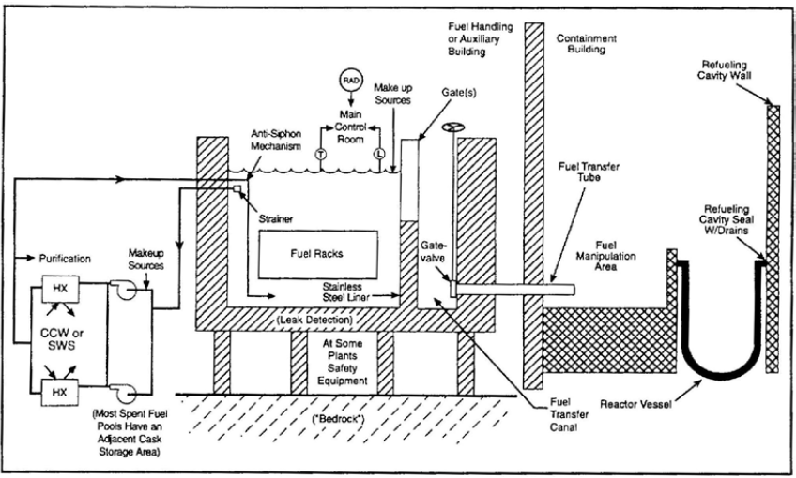

**Figure** **3.1.2 Generic SFP layout inside containment [28]**

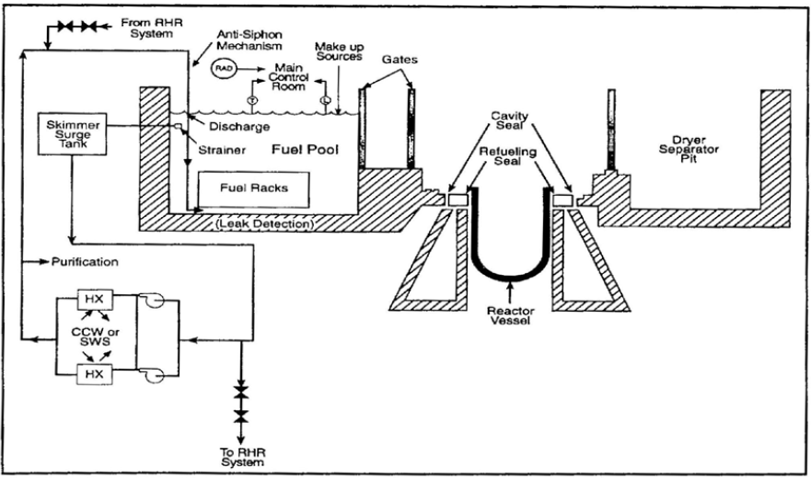

In the past, the SFP has not been considered a high safety risk for operating plants. Studies, such as the one conducted by Idaho National Engineering Laboratory in 1996 [12], generally showed that the frequency for an accident involving the SFP was low compared to the contribution of the core to the fuel damage frequency. It could be considered that this is again demonstrated in Fukushima Dai-chi where three cores melted, but no damage in a SFP occurred. Nevertheless, the anxiety during the Fukushima Dai-chi accident for the SFP N°4 was extremely high and the SFP have only been stabilized thanks to emergency recovery actions.

There are some challenges in considering SFP PSA, for instance reactor-SFP interactions, radioactive and hydrogen release, shared support system between reactor and SFP, maintaining SFP cooling and human actions/responses in these scenarios.

In principle, fuel damage in the SFP can be caused by a loss of coolant (e.g. due to a leak in the structure) or due to loss of heat removal (e.g. due to loss of ultimate heat sink). Issues associated with accidents in a SFP are addressed in the following sections.

## EXISTING GUIDANCE/ METHODOLOGY FOR SPENT FUEL POOLS

The ASAMPSA2 [1], [2], [3] guidelines provide some best practice guidelines for the performance and application of L2 PSA development for the Gen II PWR, Gen II BWR L2 PSAs and extension to Gen III and Gen IV reactors, however discussion on SFP guidance is not included, and is proposed in this report.

The L2 PSA methodology mentioned e.g. in ASAMPSA2 [1] consists of the following activities:

* Plant familiarization;
* Definition of the L2 PSA objectives;
* Accident Sequence Analysis, Analysis of Phenomena, Source Term Analysis;
* Containment Analysis;
* Human Reliability Analysis;
* Systems Analysis;
* Event Tree Modelling;
* Quantification of Event Trees, Results, Presentation, and Interpretation;
* Documentation.

In recent years, it has been concluded that there is a need to better understand the risks associated with the SFPs. EPRI presented their development and pilot application of a generic framework and methodology for conducting PSA for SFPs at BWR plants with Mark I or II containment designs [17]. A similar methodology is now being developed for PWRs and the results are presented in an EPRI report [21], however there are still more guidance needed for L2 PSA for SFP, e.g. on phenomenology for fuel melting in air environment.

The European Utility Requirements (EUR) requirements regarding SFP are somewhat more general, for instance, EUR Chapter 2.17 [24] section 2.17.2.3 states that:

**“C:** The PSA shall check that potential radioactive releases from the spent fuel storage pool, from the spent fuel handling facilities and from the radioactive waste storage tanks can be reasonably neglected, due to their comparatively low magnitude and to their low frequency.”

The SFP PSA in many respects is similar to the PSA performed for the reactor core and includes the same elements. It should be performed for all plant operating modes and will require the shutdown period to be divided into a number of SFP PSA specific POSs. The consequence addressed in the SFP PSA is fuel damage leading to a radioactive release. The initiating event analysis includes events that could impact both the reactor core and the SFP, but also SFP specific events. The analysis of accident sequences addresses system responses, phenomena and operator actions specific for the SFP and should be followed by detailed system and human reliability analysis. The analysis also needs to be supported by thermal hydraulic calculations.

The detailed SFP PSA methodology could be based on non-BWR specific findings and recommendations from the EPRI report on SFP risk assessment [21] together with experiences from recent industry projects. It has been judged that at present there is no widely accepted standard for SFP PSA.

Both at-power and shutdown conditions should be addressed in the SFP PSA, however different operating modes for a SFP PSA may not be as relevant as for the reactor core. During shutdown conditions the plant configuration typically varies more and POSs that cover all these different configurations should be defined. The definition is made in the same way as for the reactor core shutdown PSA (for instance regarding system availabilities), but for the SFP PSA the following specific conditions also need to be taken into consideration:

* transfer canal (if applicable) between SFP and reactor building pool;
  + opened,
  + closed,
* amount of fuel offloaded to the SFP;
  + complete core offload,
  + partial core offload,
* reloading of new fuel;
* fuel movement complete;
* amount of cooling water in the SFP.

Note that this section covers issues that can be of interest for the SFP PSA for a plant to be commissioned or already in operation.

In principle the types of accidents in SFP PSA can be divided into two categories:

* drain-down events/ sequences,
* loss of cooling events/ sequences (or non-draining IEs).

Draining events may be caused by inappropriate operator action, seismic induced structural failures, heavy load drops, loss of coolant accidents (LOCAs), and reactor-related phenomena causing structural failure (e.g. steam explosion, hydrogen detonation). For non-draining events, the set of initiating events can be derived from an analysis of the situations leading to the temperature increase, i.e. to the loss of the cooling system, which may be due either to malfunctions in the cooling system itself or its support functions including electrical supply or the cooling chain. In L1 PSA, it is necessary to study each plant state (POS) because of the different configurations or characteristics of structural failures and support systems of electrical supply or cooling chain. Also, the timing of the release is very dependent on the sequence/ initiating event. This is also important for operator actions. However in L2 PSA it is almost irrelevant which particular combination of initiating event and failure has led to loss of cooling or draining and loss of coolant.

The following spent fuel pool events leading to fuel damage should be taken into account:

* loss of cooling to the SFP (including failure of support systems and loss of power);
* coolant inventory loss from the SFP;
* heavy load drops,
* loss of coolant accidents (LOCAs),
* reactor-related phenomena causing structural failure,
* reactivity accidents;
* seismic events;
* simultaneous failures related to the initiating event.

As far as criticality is concerned the following scenario can be considered: if the stored assemblies are separated by neutron absorber plates (e.g., Boral or Boraflex), loss of these plates could result in a potential criticality. The absorber plates are generally enclosed by cover plates (stainless steel or aluminium alloy). The tolerances of cover plates tend to prevent any appreciable fragmentation and movement of the enclosed absorber material. The total loss of the welded cover plate is not considered feasible.

Heavy load (e.g. fuel transfer cask) drop on the SFP walls or into the SFP could result in structural failure of the SFP and liner, creating a loss of inventory event leading to fuel damage in the SFP with very short time left to prevent fuel damage and subsequent radionuclide release. The assessment of other adverse plant conditions introduced by the failure of fuel cooling in the reactor or the SFP and the propagation of adverse conditions to the other on-site radionuclide sources is of particular importance.

The SFP event tree assessment should address the following:

* random independent failures that challenge the cooling of used fuel in the SFP (i.e., reactor core is in a safe stable configuration),
* common or simultaneous failures that challenge both adequate core cooling and SFP cooling,
* consequential severe accident progression events that may lead to challenges to the integrity of the SFP and the continued cooling of used fuel.

According to EPRI [21] critical elements of the PSA framework need to describe the following methodology issues:

* the interrelationship of the PSA logic models as they influence the probabilistic assessment of the continued cooling of the used fuel in the SFP;
* L2 Full Power Internal Events PSA sequences transferring to the SFP event tree structures;
* L2 Shutdown PSA sequences transferring to the SFP event tree.

The key phenomena for the analysis of the risk profile associated with operation of the SFP and the reactor lead to the following issues:

* equipment failures;
* containment failures;
* inaccessibility for local actions;
* fuel disruption;
* reactor Building equipment failures;
* reactor Building and SFP structural failures;
* increase in radionuclide releases.

These phenomenological events are related to the postulated core/fuel melt progression within the reactor or the SFP. A general framework has been applied to pilot project to address the technical elements employed in PSA, consistent with the guidance provided in the ASME/ANS PRA Standard [26].

Adverse synergistic effects related to accidents involving the RPV and SFP can be postulated. These synergistic effects can be related to either: a common event (e.g., loss of power) that cause simultaneous challenges to the safety functions for SFP and RPV or a resulting consequential failure during the accident progression in the RPV or SFP that affects safety functions for the other radioactive source.

It seems that the increased risk associated with interactions between the reactor and containment systems, and the SFP should be treated in an integrated way. These interactions during a severe accident can have an impact on the total risk of radioactive release (in early and late phases) in the environment around the plant.

The analysis of used fuel accident scenarios requires analytical tools and methods including the following: deterministic models that address important accident progression details; realistic assessment of seismic fragilities; fault tree models focused on systems and configurations generating unwanted interactions between the event progression in the reactor cooling system and the SFP protection system; and consideration of operator actions in response to events affecting SFP cooling.

The interaction between primary containment and SFP in case when the reactor building houses the primary containment and the SFP can be of particular importance. The events involving primary containment also have the potential to cause reactor building or secondary containment challenges. In such cases, there is a potential that primary containment scenarios could lead to SFP events. Such scenarios may involve degraded conditions where reactor core damage is avoided but not SFP. On the other hand, reactor core damage events could be affected by a subsequent SFP fuel damage event initiated by primary containment failure modes.

Severe accident with containment failure as a result of a severe accident can lead to both a significant radiation release to the reactor building plus a combustible gas mixture discharge inside the building. This combination of effects is expected to fail equipment in the building and preclude access for any local actions, also limiting or precluding access to the refuel floor. As long as the SFP itself is not damaged, an extended time is available before fuel damage in the SFP would occur. However, overcoming the lack of access to the refuel floor could present a lingering problem. Solutions could be to prepare injection to the SFP prior to the containment failure, or alternatively, if an installed secure injection path is available.

The following section addresses those issues which are specific for SFD events, and which need consideration in guidance for an extended PSA.

## ISSUES RELATED TO SFD WITHIN EXTENDED L2 PSA

**Inventory of SFP**

In contrast to the reactor core which has a very well defined configuration, the SFP may have very different inventories during the lifetime of a plant. It could go from almost zero inventories in new plants to an inventory at the design limit for old plants or during core unloading in shutdown modes. L2 PSA in SFP needs guidance how to define the initial loading, residual heat generation and radionuclide inventory inside the SFP.

**Criticality in SFP**

Depending on the SFP design and its inventory, it may be imagined that criticality occurs during an accident sequence. Guidance is needed whether and how to address this issue in L2 PSA.

Different initial conditions in core and SFP

When considering core and SFP, one of the two components may be in a degrading condition (pertaining to the realm of L2 PSA), while the other component is still undamaged (pertaining to the realm of L1 PSA). This is the traditional approach in L2 PSA, where core damage is investigated assuming undisturbed conditions in the SFP. However, both components may be linked by systems (e.g. cooling systems – the most obvious example is SBO which affects both components) and by boundary conditions (e.g. containment atmosphere). Accident progression or successful SAM in one of the components can affect the other component in one way or another. Guidance is needed how to address this “mixed” L1/L2 PSA level.

**Reactor-SFP interactions**

When both core and SFP are degrading, this is clearly a L2 PSA issue. It seems that the increased risk associated with interactions between the reactor and containment systems and the SFP should be treated in an integrated way. The interactions can take one of three forms:

* SFP events impacting the reactor,
* reactor events impacting the SFP (for example, a leakage from the reactor in the SFP building can induce hydrogen explosion and contamination that could make local action impossible),
* common events impacting the reactor and SFP simultaneously.

For example, radiation levels in the reactor building at all elevations may increase dramatically due to the boiling of SFP inventory. At present, there is only very limited material available which addresses simultaneous degradation in core and SFP and existing tools shall be adapted for this purpose.

**Containment-SFP interactions**

When the SFP is located inside the containment, the events during SFP degradation will threaten the containment. Most existing L2 PSAs are limited to core damage accidents, and to the related containment threats (e.g. due to hydrogen, pressurization, temperature). An important reason for this limitation is related to mission time. However, the Fukushima events demonstrated that this argument may not be convincing.

Melting in a SFP will cause different threats - an example is the heat load from the melting pool to structures above the pool. Guidance is needed how to take these different threats into account in extended L2 PSA.

Moreover, the influence of containment phenomenological effects on SFP risk should be addressed. There are a number of postulated effects related to severe accident progression and consequential containment challenges that can influence the risk evaluation of the SFP. Effects of reactor accident progression on SFP accident mitigation include phenomena, accident characteristics and containment failure, e.g. un-isolated break outside containment or interfacing system LOCA during at-power operation state, transfer of contamination and hydrogen.

**SAM**

SAMs are discussed in deliverable D40.5 of the ASAMPSA\_E project [51]. Particularities for SAM in SFP shall be mentioned there (e.g. limited accessibility to SFP due to high radiation when water level gets low or in case or leakage from the reactor building).

**Other fuel locations than SFP**

Depending on the plant design, apart from the SFP there may be other locations where fuel is present e.g. cleaning loops, fuel handling systems, dry storage, and transport casks. It is plant specific whether events in these locations can lead to fuel damage in the related system, or whether an event in these systems can trigger other failures and fuel damage in other locations, however this guidance is focused on fuel damage only in SFP.

**Shared SFPs**

Not each reactor is assigned to one dedicated SFP. For example, two reactors may share a single pool. Also, a single reactor may store fuel in more than one pool, or two reactors at the same site may move fuel between both pools located in common or separated buildings that may or may not be connected. Thus, guidance is needed to address the differences and potential interactions between shared SFPs in an integrated way.

**Density of spent fuel racks**

Some pools contain high-density spent fuel racks which allow multiplying the number of stored assemblies. In such a case the consequences of fuel damage may propagate too much larger populations of fuel assemblies. These racks also have much higher overall decay heat and larger fission product inventory. Therefore, the density of the fuel racks should be considered.

**Spent fuel building ventilation**

The spent fuel building ventilation flow rate is important in determining the overall building energy balance. Airflow through the building is an important heat removal mechanism. On the other hand it also provides a source of oxygen for zirconium oxidation.

**Particular heat transfer mechanisms for spent fuel pools**

There are several heat transfer mechanisms that can influence the cooling of spent fuel during various postulated severe accident scenarios. These include:

* convective cooling to the surrounding water,
* steam cooling from surrounding steam generated by boiling coolant,
* conduction through the ends of the fuel rods,
* radiation cooling.

The degree of success associated with different heat transfer mechanisms depends on the configuration of the SFP, rack/canister design (e.g., closed or open lattice), density of the fuel assemblies, arrangement of the hottest bundles within the SFP lattice and the SFP water level.

**Structural integrity of fuel racks**

For recently discharged fuel or for severely restricted air flow (e.g. high density spent fuel racks) the exothermic oxidation reaction is predicted to be very vigorous and failure of both the fuel rods and the fuel racks is expected. The steel racks may not be able to maintain structural integrity because of the sustained loads at high temperatures. Thus, a large fraction of fuel rods would be expected to fall to the bottom of the pool and will tend to heat the adjacent assemblies, which appears to be an additional mechanism for oxidation propagation.

### IDENTIFICATION OF INITIATING EVENTS

Internal as well as external events can lead to loss of spent fuel pool water due to boil off or drain down. NUREG-1738 [13] provides the generic list of initiating events leading to spent fuel pool boil off or bottom leaks.

The initiating events of interest are those that impact the SFP. Which events to analyse depend to some extent on the specific plant design but also on plant location. Possible initiating event that should be considered includes:

* Loss of SFP cooling:
* Failure of SFP cooling system including support systems as a result of:
* equipment failures,
* loss of offsite power (e.g. as a result from external hazards),
* internal fire/flooding.
* Loss of SFP coolant inventory:
* Draindown events
* SFP structural failures[[2]](#footnote-3) as a result of:
* seismic events or other external hazards,
* heavy load drops,
* reactor-related phenomena.

Loss of SFP coolant inventory includes draindown events and structural failures. Draindown events can occur due to breaks or alignment errors on pipes connected to the SFP. In refuelling state, where the transfer canal is opened, they may also occur due to breaks or alignment errors on pipes connected to the reactor building pool. In addition, draindown events may lead to loss of SFP cooling if the SFP water level is lowered below the suction lines of the SFP residual heat removal system.

A loss of coolant inventory can also be caused by SFP structural failures following for example an earthquake. A seismic event may also lead to an initial limited loss of coolant inventory due to sloshing. Another type of events with the potential of causing structural failures is reactor-related phenomena.

* Reactivity accidents:
* reduction of SFP boron concentration,
* fuel handling accidents.

Reactivity accidents of interest are any events where criticality can lead to insufficient fuel cooling and thereby fuel damage. Criticality is prevented by dispersal of the fuel assemblies and equipping the pool storage racks with neutron absorbers. The impact of a reduction of boron concentration in the SFP should be analysed. In addition, fuel handling accident such as a drop (of a fuel assembly) or incorrectly placed fuel should be evaluated as potential initiators.

Figure 3.3.1 illustrates the accident progression and phenomenology in the various stages of SFP loss of cooling/coolant accidents in Light Water Reactors (LWRs). It should be noted that spent fuel is stored horizontally in CANDU design reactors and storage racks are open to both horizontal and vertical flow, therefore some of the phenomena shown in the figure below is not applicable to CANDU SFPs [27].

**Figure 3.3.1 SFP loss of cooling/coolant accidents – accident progression and phenomenology [27]**

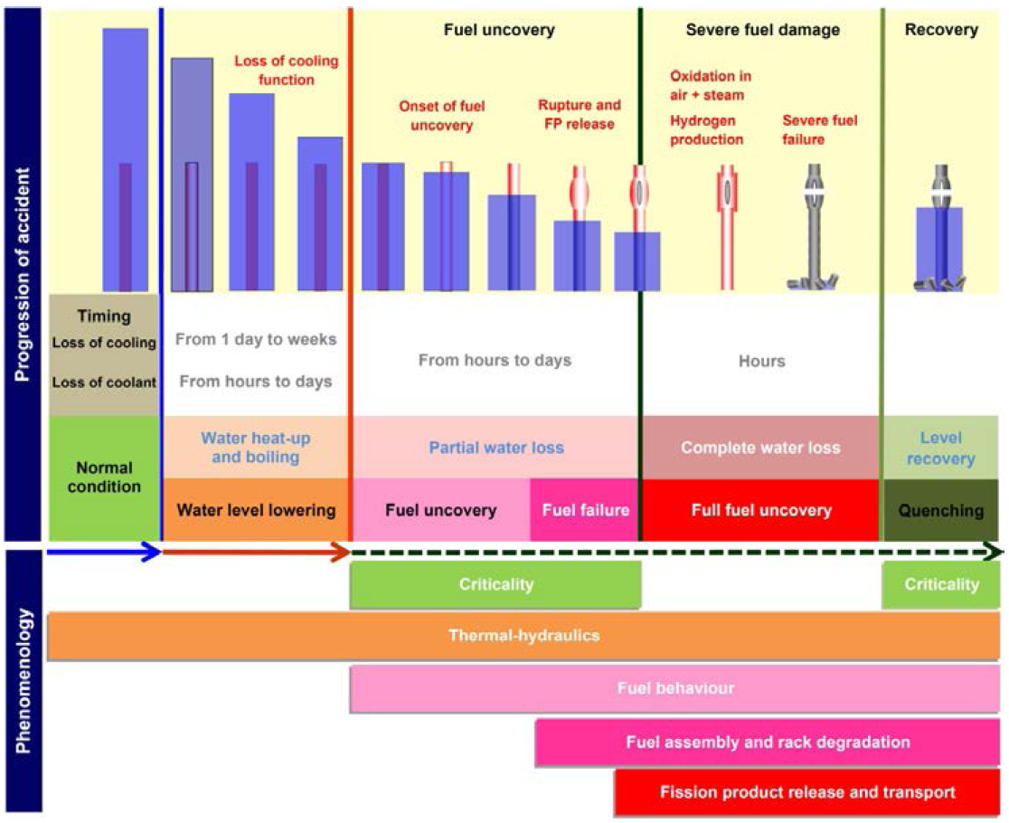

#### INITIATING EVENTS LEADING TO SPENT FUEL POOL BOIL OFF

1. **Loss of pool cooling**

The loss of pool cooling initiating event can be caused by the failure of pumps or valves, piping failures leading to flow diversion, failure of heat exchangers, failures in cooling service water system etc.

1. **Loss of offsite power from plant centered and grid-related events[[3]](#footnote-4)**

This initiating event involves power system component failures (including impact from severe weather), human errors in maintenance and switching or problems in the offsite power grid. The loss of power must last very long in order to lead to significant boil off. This is also true for loss of cooling events, internal fire and internal flooding events.

1. **Internal fire**

This initiating event is caused due to fires at the plant locations affecting the SFP cooling system.

1. **Internal flood**

This initiating event is caused due to internal flooding as a result of pipe leak or rupture etc. at the plant location affecting the SFP cooling system.

#### INITIATING EVENTS LEADING TO LOSS OF COOLANT IN THE SFP

ASAMPSA\_E WP21 and WP22 address the initiating event (internal and external hazards) modelling and how to introduce some selected hazards in L1 PSA and all possibilities of event combinations. WP21 and WP22 provides the generic guidance on selected hazards but not specifically address initiating events leading to loss of coolant in the SFP.

1. **Loss of coolant inventory from internal reasons**

This initiating event can be caused due to configuration control errors, siphoning, piping failures, and gate and seal failures.

1. **Heavy load (or cask) drop**

Spent fuel casks are heavy enough to catastrophically damage the pool if dropped. Cask drops on the floor or walls of fuel pools may result in catastrophic damage to the fuel pool. This may result in fuel pool loss of coolant with no recovery possible. Also, all heavy loads (>1 ton) should be considered and also ‘not so heavy loads’ that might threaten the SFP sealing etc., for instance there might be “pointy” tools that are lifted over the SFP.

1. **Seismic event**

In some PWR plants, the SFP structures are outside the containment and are supported on the ground or partially embedded in the ground.

Following inputs are required to evaluate the risk from a seismic event at SFP:

* hazard curve for the site;
* fragilities for SFP structure, enclosing building, SFP cooling system components etc.

It is suggested to perform site specific seismic risk assessment based on PSA to identify the risk (if the SFP is outside the containment, any loss of coolant may cause a large to very large release) in case of severe seismic events.

1. **Aircraft crash**

Aircraft crash can affect the structural integrity of the spent fuel pool or the availability of nearby support systems, such as power supplies, heat exchangers, or water makeup sources, and may also affect recovery actions. The methodology to estimate frequency of catastrophic PWR spent fuel pool damage from an aircraft crash (i.e., the pool is so damaged that it rapidly drains and cannot be refilled from either onsite or offsite resources) is described in NUREG/CR-5042 [16].

* Carry out the plant specific aircraft hazard analysis to estimate the frequency of different size/category aircraft crash at the concerned NPP site. For example - big, medium, and small or commercial, light and military.
* Carry out engineering evaluation of the likelihood of damage of SSCs of SFP and SFP itself caused by various size/categories of aircraft crash.

Model the aircraft crash induced failures in the PSA model which may consequently lead to SFP damage.

1. **Tornado**

Very severe tornadoes (F4 to F5 category on Fujita scale) could have the potential to cause catastrophic damage to SFP resulting in SFP loss of coolant. Lower category tornadoes will result in LOOP and possibly to 'Fuel pool boil off'.

* Carry out the plant specific tornado hazard analysis to estimate the frequency of occurrence of different size/intensity at the concerned NPP site. For example-F2 to F5 category tornadoes as per Fujita scale.
* Carry out engineering evaluation of the likelihood of damage of SFP SSCs and the SFP itself.
* Model the tornado induced failures in the PSA model.

As mitigation and recovery will not be possible in case of loss of coolant, the probability of catastrophic failure caused by tornado is expected to be extremely low.

Considering the low frequency of very severe tornadoes, structural strength of buildings housing the spent fuel pools and the thickness of the spent fuel pools themselves; the conditional probability of catastrophic failure given a tornado missile is expected to be very low.

### ACCIDENT SEQUENCE ANALYSIS

The accident sequences analysis is performed in a similar way as in the PSA for the reactor core. The analysis should describe scenarios that can lead to the defined consequence. It should address system responses, operator actions, phenomena and also dependencies that can impact the availability of the mitigating systems.

Specific event trees should be developed for the SFP. End state in the SFP L1 PSA is fuel damage. In some SFP PSAs the frequency for boiling in the SFP is assessed separately. Boiling in the SFP would lead to a continuously decreasing water level. It could also affect the environment in the spent fuel pool and building and could for example make it impossible to perform necessary manual actions. The radioactive release should be categorized based on magnitude and timing to constitute appropriate L2 end states.

Since there are limited barriers to contain a radioactive release from the fuel in the SFP if the pool is not located in the containment, it might be possible to integrate the L1 and L2 event trees in this case.

**Combustible gas deflagration**

Hydrogen generated by spent fuel as a product of Zircaloy water reaction could accumulate in the Fuel Handling Building or Reactor Building in a combustible mixture. The subsequent combustion or deflagration may result in significant collateral damage such that mitigation equipment, sprinkler outlets, even structural integrity of the SFP may be compromised. In addition, potential generation of Carbon Monoxide (CO) may occur which has similar deflagration characteristics as hydrogen. Hydrogen management concepts developed for hydrogen release from a degrading core (e.g. autocatalytic recombiners, igniters) need to be checked for their efficiency in SFP.

**Safety assessment of spent fuel pool during decommissioning**

Spent fuel from the reactor vessel is removed at an early stage of decommissioning of the plant to SFP. Its timely removal from the installation simplifies monitoring and surveillance requirements on plant safety systems. For a defueled reactor in decommissioning state, public risk is predominantly from potential accidents involving spent fuel.

### THERMAL HYDRAULIC CALCULATIONS AND SUCCESS CRITERIA

Thermal hydraulic calculation is needed to determine the accident progression parameters. These should be used to support realistic system success criteria, to provide timing to assess necessary operator actions and to provide the fission product release magnitude and timing. The calculations provide information on the following:

* Time to boiling;
* Time to fuel uncovery;
* Time to fuel damage;
* Time to SFP structure breach;
* Time to penetration of concrete around SFP;
* Source term magnitude and timing.

Success criteria should be defined for different configurations and different decay heat loads. Calculations should be performed based on the amount of fuel that normally is replaced during a refuelling outage and should also be performed for a full core offload if this will be put into practice.

Calculation can for example be performed with MAAP5, which includes a spent fuel pool model capable of modelling severe accidents in the SFP, or MELCOR.

### HUMAN RELIABILITY ANALYSIS

No change in Human Reliability Analysis (HRA) method compared to the PSA for the reactor vessel is required, but a number of additional operator actions will need to be analysed in connection with the SFP PSA. These actions include:

* Handling of fuel

During a refuelling outage fuel is being transferred to and from the SFP. Identified fuel handling accidents that could cause for example criticality should be analysed.

* Heavy load operations

Analysis of dropped heavy load, for example a fuel cask, should be performed. It could lead to a structural failure of the SFP or cause damage to fuel already in the pool. A dropped object could result in closer spacing of fuel assemblies which could create the potential for criticality.

* Manual alignment of possible cooling and make-up systems

Non-automated cooling and make-up systems available for the SFP should be analysed. There might also be systems not originally intended for SFP cooling or make-up that can be used for this purpose. In these cases operator instructions might be missing. Also, since the operators in most cases will have long time for their actions it can be questioned if the HRA is necessary for those long-term scenarios.

Typical for the manual actions associated with the SFP is that they may occur over long time frames and that they may need to be performed during harsh environmental conditions. Various calculations have been performed regarding the radiation level during severe accident events in a SFP [20]. In the following example, only the direct gamma radiation from fuel is accounted for. Calculated radiation levels from a drained SFP one meter above the level of the floor results in 14,000 rem/hr. Even out of direct sight of the spent fuel, the radiation dose rates from gamma rays scattered by the air, roof and walls are over a hundred rems/hr [17].

### FUEL DEGRADATION PROCESS IN SPENT FUEL POOLS

In the event of a failure of all cooling systems, the pool water would gradually heat up to the boiling point and then slowly evaporate with a rate depending on the total decay heat generated in the pool. When the fuel elements become partially uncovered, cladding heats up because the steam flow is low and not capable of removing the decay heat by convection. With the water level further down, Zircaloy-cladding material will be oxidized and hydrogen will be generated. Calculations show that this process takes several days to develop. If cooling cannot be restored, the fuel rods will fail. Under the extreme assumption of fast draining of the pool, either through cracks in the pool walls or through connected systems, the process of degrading could be much faster.

At first sight, it seems reasonable to assume that air could be present when melting occurs in the open spent fuel pool, in contrast to the closed RPV where no air access is possible. The presence of air instead of steam would, in particular, change the chemistry of the degradation process: Zr would be oxidized by Oxygen from air instead of by Oxygen from water. The thermal output of Zr-air oxidation is higher, but on the other hand less or no hydrogen would be produced. Volatile Ruthenium oxide could be produced by air impact, which is very relevant in terms of radiological effect. However, analyses performed (see appendix 10.1) with MELCOR under various conditions show that the previous evaporation of the large amount of water from the SFP would almost completely generate a steam atmosphere with little air having access to the degrading fuel. There are only two potential scenarios which may lead to significant oxidation by air: A rather fast loss of coolant from the SFP (can be practically excluded in some SFP designs), or an extremely low evaporation from the SFP with most of the steam being condensed before fuel degradation. However, the latter sequence may last for weeks, and have such a low energetic level that even without water the SFP may not heat up to the threshold for chemical reaction.

During fuel degradation in the SFP (before Molten Corium Concrete Interaction (MCCI) begins) the temperatures in some of the sequences are lower than in RPV accidents during normal operation. Therefore less radionuclides are released from fuel. However, after MCCI has started the release fractions from fuel reach levels which are known from accidents in the RPV.

There are no specific accident simulation codes available for spent fuel pool degradation. Therefore, the codes for reactor core degradation need to be applied. The models provided by the codes need to be adequately modified in order to achieve meaningful results. Some experience by ASAMPSA\_E partners exists with the application of the code MELCOR, and the related issues are as follows:

* Modelling of the spent fuel can be done straight forward using the available models for representing the core. Of course the number of fuel elements, their decay heat level and fission product inventory have to be adapted. If the geometry of the fuel element array is significantly different from a rectangle or cylinder, this will introduce uncertainties.
* If there are specific supporting structures inside the spent fuel storage, their representation may be difficult to achieve.
* The RPV which does not exist in the spent fuel pool has successfully been represented by a very thin metal sheet which in reality is the metal liner on the spent fuel pool bottom and walls.
* There is concern that air ingress into the pool might change some aspects of the events. However, in loss of heat sink accidents the evaporation of the spent fuel pool water will create so much steam and replace the air that such concern is not relevant. (Leakage accidents with a fast loss of coolant accidents have not been simulated by this partner).
* Core-concrete interaction and the detruction of structures below the spent fuel pool bottom could be calculated similar to core melt accidents.
* Heat readiation from the degrading fuel to structures above needed particular additional modelling.
* The modelling of fission product release is certainly not perfect. However, there is an inherent mechanism which stabilizes the results: If the initial fuel degradation provides little release, more nuclides remain and are relocated to the core concrete interaction phase. They will then be released there – and vice versa. Therefoe, it is expected that the uncertainty in the total released amount is limited and acceptable.

Apart from this experience by an ASAMPSA\_E partner, at the time of drafting the present report an international benchmark on this issue is in its final phase (<http://s538600174.onlinehome.fr/nugenia/portfolio/air-sfp/>). A final report should be available very soon. Several codes have been applied by different partners in order to calculate loss of cooling and loss of coolant accidents in a spent fuel pool. It seems that the differences among the results are significant – however, the analyses did not cover the full scenario, and fission product release was not discussed. In summary, this benchmark demonstrates that most of the available codes can be applied in principle, but that the lack of experience and precision is significant.

### HYDROGEN ISSUES IN SPENT FUEL POOL MELTING

As mentioned above, several analyses performed (see appendix 10.1) with MELCOR for loss of heat removal scenarios show that the evaporation of the large amount of water from the SFP would almost completely generate a steam atmosphere with little air having access to the degrading fuel. Consequently, in such scenarios hydrogen generation by steam in a melting SFP is an issue. In addition, large amounts of hydrogen will be generated when concrete erosion occurs.

Further discussion of the issue requires to distinguish SFP which are inside the containment (e.g. German PWRs), and SFP which are outside the containment (e.g. French PWRs). Almost all plants worldwide have SAM and/or specific systems to cope with RPV core melt accidents, including the associated hydrogen issues. Therefore, hydrogen generated in a SFP inside the containment is in principle covered by these arrangements. For example, Passive Autocatalytic Recombiner (PARs) installed in German PWRs recombine the hydrogen produced by a SFP accident until all the oxygen is used up. Later, when still more hydrogen is generated without oxygen available for recombination, the hydrogen accumulates inside the containment and becomes a threat when it is released from the containment – either by purpose through the venting system, or accidentally through leaks.

The situation is different if the SFP is located outside the containment in the reactor building or in specific buildings (e.g. French PWRs). There, in general no provisions for hydrogen challenge are available. Consequently, it has to be assumed that a significant risk of deflagration or even detonation exists. Furthermore, the barriers between the SFP and the environment are less reliable than the containment. Altogether, there is a high probability for catastrophic releases if a SFP outside the containment begins to melt.

In majority of OECD member countries, for SFP location either inside or outside containment, PARs and thermal recombiners are installed for hydrogen mitigation in the reactor containment. Filtered venting system is also available for the majority of PWRs. In some countries like Japan and South Korea filtered venting system are not available, so the hydrogen mitigation system includes PARs, glow plug igniters and hydrogen monitoring system.

In the frame of the SARNET project [131], the studies on hydrogen also included the reaction kinetics inside PARs.

Figure 3.3.2 provides the summary of codes capabilities and codes validation status for modelling Hydrogen generation, distribution, combustion and mitigation in the Containment and SFPs. There are some calculating assumptions made in each code which are described in **Erreur ! Source du renvoi introuvable.**. Amongst the 11 codes shown in Figure 3.3.2, only the integral or system codes are capable of calculating hydrogen generation in the reactor core and/or from MCCI in the cavity. The application of these codes in SFP SAs has started after the Fukushima accident, but needs further attention.

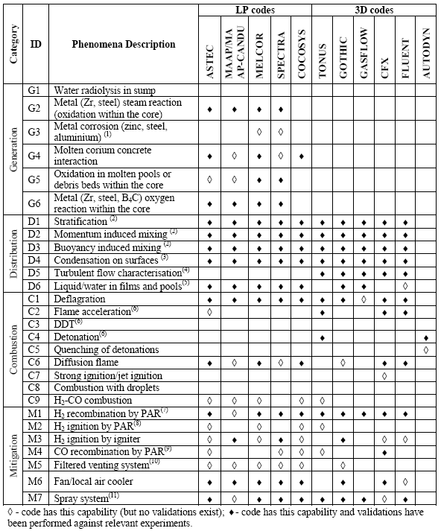

**Figure 3.3.2 Codes used for Hydrogen related issues in the Containment/SFPs [123]**

### HEAT LOAD DUE TO SPENT FUEL POOL MELTING

Several analyses performed (see appendix 10.1) with MELCOR under different conditions show that the heat load from the SFP upwards to structures above (containment dome, or roof of reactor hall) is significant. Depending on assumptions about heat radiation, nodalization, and accident sequence maximum temperatures of up to 1000 K have been calculated pessimistically in the upper atmosphere and in the containment structure. This is by far beyond design temperature.

Based on these analyses, the following comments are due:

* Heat transfer from melting SFP (convection and radiation) seriously affects the temperatures of structures above the SFP.
* The models for thermal radiation from a melting SFP to the surrounding structures need validation and probably improvement.
* Calculating thermal convection upwards from a melting SFP is a challenge for state-of-the art lumped parameter codes. Coarse nodalization could, in principle, miss local plumes of hot gas.
* Very high temperatures will be experienced not only by the upper structures, but also by the upper atmosphere and by several components and systems in the vicinity (e.g. crane, refuelling machine, penetrations, doors, venting system, building ventilation, roof, isolation valves, cables etc.). There seems to be a significant probability that everything which is located above the melting SFP will fail.
* Only for low decay heat inside SFP, where uncovering of the fuel assemblies is terminated before their heat-up, air oxidation can occur after steam concentration has been depleted.
* It might be helpful to initiate filtered containment venting early in case of severe accident inside SFP in order to prevent high containment loads and high venting temperatures later. In any case, it is very likely that severe accident sequences run into venting of building where SFP is located.
* During fuel degradation in the SFP (before MCCI begins) the temperatures are lower than in RPV accidents during normal operation 🡪 less release of radionuclides from fuel. After MCCI has started, the release fractions from fuel reach levels which are known from accidents in the RPV.
* With full loading of the SFP, the fuel melt layer thickness (including material of the racks) at the bottom of the SFP is in the order of 1 m. Such a thick melt layer would probably develop heat transfer mechanisms (convection, steel layer on top) which enhance lateral erosion. Depending on the NPP design, this may lead to different sequences than vertical erosion. In case of the German PWR design, radial melt-through of the containment may be possible. If, on the other hand, corium penetrates through the bottom of the SFP into the sump region, MCCI could be stopped because of the large amount of water in the sump, and because the melt spreads on bigger areas.
* For normal loading of the SFP (i.e. in normal operation with RPV fully loaded) the accident evolution in the SFP is much slower than in the RPV.

### RELEASE PATHWAYS TO THE ENVIRONMENT IN CASE OF SPENT FUEL POOL MELTING

The mechanisms which influence the transport of mobile radioactive species from the spent fuel pool through building volumes to the environment are, in principle, the same as those which command the transport of material from the core. Therefore, the codes which are used for release after core melt accidents can be used also for spent fuel pool accidents. Of course, the usual care has to be applied when doing the analysis and when interpreting the results, because the codes still have deficiencies, and the users must be well qualified. But there are no particular phenomena involved compared to core melt accidents.

Obviously, release paths from the SFP to the environment are different depending on the location of the SFP i.e.:

1. the SFP is located inside the containment,
2. the SFP is located outside the containment.

If the SFP is located inside the containment, the potential release paths to the environment are almost the same as for core melt accidents in the RPV. Depending on the specific design an additional release path may be possible as follows: After penetrating the concrete wall or bottom of the SFP, the molten debris may come into contact with the containment wall (see **Figure 10.1.1**, appendix 10.1) and penetrate it. This would lead to a unique containment failure mode. However, from a general perspective this is just another type of late containment failure.

A BWR is taken as example for a SFP which is located outside of the containment in the upper floors of the reactor building. BWR reactor buildings have a predefined release path in case of loss of coolant which is directed into the turbine hall. Also on top of the turbine hall flaps are provided for release of steam into the atmosphere. In case of a melting SFP in the reactor building, this is the preferred release path as well. Since the volumes of reactor building and turbine hall are very large, significant deposition of aerosols will occur there, mitigating the environmental impact. A severe additional concern exists with regard to hydrogen generation from the melting SFP. This hydrogen will enter the reactor building atmosphere, and it is very likely that hydrogen combustion occurs inside the building. Depending on the building design (e.g. concrete or light construction like Fukushima Dai-chi) and on specific issues like ventilation ducts or doors, a more direct release path to the atmosphere may open up.

Another example of the SFP located outside the containment is the pressurized water reactor VVER 440. Some interesting outcomes were obtained from analyses of three different types of severe accident scenarios (Heavy load drops, SFP leakage, Loss of SFP cooling system) in the SFP for VVER 440. A very important question is, if any decontamination factor for released fission products can be considered. In case of VVER 440 reactors, the fission products are released directly into a reactor hall, if

1) ventilation flow above the SFP is turned off and

2) a cover of the SFP is removed for fuel handling.

The reactor hall, which is part of so called airtight zone, is common for two units, so it has a large volume of 150 000 m3 (compare to the volume of the containment - 25 700 m3). Specific MELCOR calculations - performed for above mentioned scenarios - showed that the large volume of the reactor hall has a positive influence on release of fission products to the environment, since in combination with natural air circulation it guarantees low concentration of hydrogen for a long time period. Risk of global hydrogen combustion is also decreased by high steam concentration which makes the atmosphere of the reactor hall inert. In the early phase of the accident, several pressure peaks occurred after hydrogen combustion in limited volumes only but they had no effect on reactor hall integrity.

Retention of the radioactive material inside the reactor hall can be illustrated on alkali metals. From the total amount of 462 kg of alkali metals contained in fuel in the SFP, 420 kg was transported into the reactor hall and 80 kg from these 420 kg was released into environment. Most of the fission products were released into environment during the first 24 hours after the beginning of the accident, which is observed as absence of effective SAM during that time period. The reactor hall was considered as properly isolated (closed doors, isolated ventilation systems, etc.) in all calculations.

Although the decontamination factor of the reactor hall (80/420) is significant, a release of approx. 20% of the core inventory into the environment is catastrophic. This is also confirmed by the EDF position, where all L2 PSA releases for spent fuel pool melting are supposed to be large releases.

In a Slovenian reactor of the Westinghouse type PWR, the spent fuel pit is located outside the containment. The Fuel Handling Building (FHB) is an integral part of the auxiliary building and is a reinforced concrete structure that utilizes shear walls and beam and slab floor systems [22]. The potential release paths are through the FHB ventilation system and leakage through the truck door may appear due to pressurization. The FHB damage (e.g. due to external events) may also cause a release path. Potentially due to human errors a release path may be created through alternate means of FHB ventilation. Alternate means of FHB ventilation are opened doors and other openings to establish ventilation of FHB. Severe accident management guidelines suggest FHB ventilation in order to prevent hydrogen accumulation. However, if later there would be a need to mitigate fission product releases, the FHB ventilation should not to be used to prevent negative impacts. Therefore, the doors and other openings to establish alternate means of FHB ventilation should be closed. Potentially, the actions to close the doors and openings may not be successful.

Spent Fuel Pool inventory: In case of SFP analysis, a dedicated source term analysis must be performed, based on the age distribution of the FE. For most relevant cases, only few FE will have a contribution from short-lived isotopes like Xe-133 and I-131; however the inventory for long-lived isotopes like Cs-137 and Ba-133 will be much higher than in the reactor core. It shall be analysed what would be the core inventory of the SFP at potential accident times; taking into account the history of refuelling and the subsequent mixture of newer and older fuel elements.

### CORRELATIONS BETWEEN ACCIDENT PROGRESSION IN SPENT FUEL POOL AND IN THE REACTOR VESSEL

The following different conditions have to be considered:

* RPV fully loaded with high absolute decay heat level, SFP loaded partially, with rather low decay heat level (normal operation),
* RPV partially unloaded with intermediate decay heat level, SFP loaded partially, with medium decay heat level,
* RPV completely unloaded with zero decay heat level, SFP loaded completely, with high decay heat level. In this case the issue of correlation between RPV and SFP does not exist.

Most experience in L2 PSA exists for analysis of accidents in the RPV in normal operation, not taking into account any correlations between reactor core and SFP. In an extended PSA, such potential correlations should be explored, according to the following reasons:

* Core melt occurs only if the plant status is in severe disorder. It seems difficult to prove that the SFP systems would not be affected by such disorder. This is especially the case for external hazards. For such scenarios, it should be considered that subsequent SFP melting may significantly increase the source term.
* Core melt phenomena will threaten the containment. This is evaluated in most PSA, and in general there is a satisfactory reliability of the containment for mitigating the consequences. However, additional loadings due to SFP steam generation and melting processes will add an additional challenge. Therefore, it is conceivable that containment and its systems (e.g. venting system) would be able to manage a core melt accident, but not a combination of core melt and SFP accident. This could be considered as a cliff-edge effect.
* Depending on the plant design, it is conceivable that melt-through of the SFP structure could affect systems and components which are important for safety. This is, for example conceivable in some PWRs (see **Figure 10.1.1**, appendix 10.1) where radial melt-through of the SFP could damage the containment. For reactors where the SFP is outside the containment but inside the reactor building, melt-through of the SFP could lead to fuel melt impact onto the containment outside, or onto safety systems in the bottom of the building.
* MCCI in the SFP could induce an accident inside the RPV if, for example, the SFP is located inside the containment, and melt from the SFP gets into the containment sump. This might damage ECCS components (e.g. blocking of filters), leading to failure of core cooling.

### CORE CONCRETE INTERACTIONS FOR SPENT FUEL POOL ACCIDENTS

Depending on the amount of spent fuel and rack material, the melt level in the SFP can become significant. Such a thick melt layer would probably develop convection patterns which predominantly transfer the heat to the upper edge of the melt. In addition, a metal layer could float on top of the melt and also create local high lateral heat fluxes. On the other hand, vigorous bubbling due to fuel-concrete interaction would tend to equalize heat fluxes. In summary, it has to be taken into account that local peak heat fluxes at the upper edge of the melt pool in the SFP can exist.

Therefore, when considering consequences of MCCI in SFP melt accidents, melt breakthrough has to be assumed in various positions. Depending on the plant design, different consequences can develop, like damage to the containment, or damage to systems in the vicinity. If circumstances are unfavourable, an accident in the SFP could induce an accident inside the RPV as well. This could occur, for example, if the SFP is located inside the containment, and melt from the SFP gets into the containment sump. This might damage ECCS components (e.g. blocking of filters), leading to failure of core cooling.

Obviously, when the SFP is located away from RPV and containment in a separate building, such dependencies as mentioned above can probably be excluded.

### CRITICALITY IN SPENT FUEL POOLS

In a typical PWR SFP, high density boraflex racks are used to store and shelf the spent fuels for long time under water. The boraflex is a neutron absorbing material. For low density PWR racks, in case of loss of these plates the soluble boron in the fuel pool water is sufficient to maintain subcriticality.

A compression or buckling of the stored fuel assemblies from the impact of a dropped heavy load (such as a fuel cask) could result in closer spacing of fuel and thus can create the potential for criticality. A qualitative analysis can be performed to demonstrate that SFP criticality is not likely in case of PWR spent fuel pool as it has sufficient fixed neutron absorber plates to mitigate any reactivity increase.

The US Nuclear Regulatory Commission (NRC) specified subcriticality requirements for SFPs by Title 10 of the Code of Federal Regulations Section 50.68 (10 CFR 50.68) or General Design Criteria (GDC) 62. Each operating SFP in the entire US fleet is required to meet its subcriticality requirement of k*eff[[4]](#footnote-5)* ≤ 0.95 [25] i.e.

10 CFR 50.68: part (b)(2) states that "...(k-effective) of the fresh fuel in the fresh fuel storage racks shall be calculated assuming the racks are loaded with fuel of the maximum fuel assembly reactivity and flooded with unborated water and must not exceed 0.95, at a 95 percent probability, 95 percent confidence level."

The US NRC report [13], [130] identified the potential scenarios that could lead to criticality in decommissioned SFPs, which are discussed as below:

* A compression or buckling of the stored assemblies due to heavy load drop (e.g. fuel cask) could result in closer spacing (geometry) in SFP and could lead to potential for criticality. However, this scenario is mitigated by using fixed neutron absorber plates in high density PWR or BWR racks and soluble boron in low density PWR racks. But compression of a low density BWR rack could lead to a criticality since BWR racks contain neither soluble nor solid neutron absorbing material. The reason is low density BWR fuel racks use only geometry and fuel spacing to maintain subcriticality and high density racks utilise both fixed neutron absorbers and geometry to control reactivity.
* For BWR SFPs, if the stored assemblies are separated by neutron absorber plates (e.g. Boral or Boraflex), loss of these plates could result in a potential for criticality. But for PWR SFPs, soluble boron is sufficient to maintain subcriticality and absorber plates are generally enclosed by cover plates (stainless steel or aluminium alloy).

In the USA NPPs, boraflex has been found to degrade in SFPs because of gamma radiation and exposure to the wet pool environment. Therefore many licensees replaced the boraflex racks in their SFPs or reanalysed the criticality aspects, assuming no reactivity credit for boraflex.

From the neutronics point of view, SFPs are designed to be subcritical systems [27]. The amount of fissile material contained in an SFP, as well as its geometrical configuration, varies from unit to unit; special care in the arrangement design is therefore always taken in order to maintain a given subcriticality margin which guarantees criticality safety under both operational and accident conditions for the entire lifetime of the SFP itself [132].

### SAFETY ASSESSMENT OF SPENT FUEL POOL DURING DECOMMISSIONING

Spent fuel from the reactor vessel is removed to the SFP at an early stage of decommissioning of the plant. Its timely removal from the installation simplifies monitoring and surveillance requirements on plant safety systems. For a defueled reactor in decommissioning state, public risk is predominantly from potential accidents involving spent fuel. Therefore, safety assessment of SFP is required as long as any spent fuel is left.

All phenomena of SFP accidents which are relevant in operating reactors are relevant for the decommissioning phase as well. An interesting additional issue is whether after a certain extended time the decay heat is so low that even without water no significant fuel damage and radioactive release would occur, which of course depends on how long time intervals are considered.

## SUMMARY FOR L2 PSA FOR SPENT FUEL POOLS

The ASAMPSA2 [1], [2], [3] guidelines provide the best practice guidelines for the performance and application of L2 PSA development for the Gen II PWR, Gen II BWR L2 PSAs and extension to Gen III and Gen IV reactors, however discussion on SFP guidance is not included in the scope of ASAMPSA2, so the SFP L2 PSA discussion is complemented in this report.

In the past, the SFP has not been considered with a high safety risk for operating plants. Studies, such as the one conducted by Idaho National Engineering Laboratory in 1996 [12], generally showed that the frequency for an accident involving the SFP was low compared to the contribution of the core to the fuel damage frequency.

Nevertheless, the anxiety during the Fukushima Dai-chi accident for the SFP N°4 was extremely high and has increased the interest of the nuclear safety community for the SFP issues.

There are some challenges in considering SFP PSA, for instance reactor-SFP interactions, radioactive and hydrogen release, shared support system between reactor and SFP, maintaining SFP cooling and human actions/responses in these scenarios.

Table 3.4.1 contains a list of the issues which have been compiled within deliverable [D40.3] [4]. This deliverable was some kind of road map to be followed in the subsequent ASAMPSA\_E activities. It can be seen that the issue list is covered to a large extent by the assessments and statements given in the previous sections.

Table 3.4.1 Specific L2 PSA issues for spent fuel pool and associated guidance suggestions

| **#** | **Specific L2 PSA issue for spent fuel pool** | **Suggestion for improvement of guidance in ASAMPSA\_E** |
| --- | --- | --- |
|  | Fuel degradation process, including energy and fission product release from melting spent fuel into containment | There is concern about the impact of air on the fuel degradation process. However, this may not be relevant for loss of heat removal scenarios. Several analyses performed with MELCOR show that the previous evaporation of the large amount of water from the SFP would almost completely generate a steam atmosphere with little air having access to the degrading fuel. It is recommended to further substantiate this statement by performing additional analyses.  During fuel degradation in the SFP (before MCCI begins) the fuel temperatures in some of the sequences are lower than in RPV accidents during normal operation. Therefore less radionuclide are released initially. However, after MCCI has started, the release fractions from fuel reach levels which are known from accidents in the RPV. |
|  | Hydrogen generation in spent fuel pool and its distribution in containment | As mentioned earlier for loss of heat removal sequences, above the SFP there is a steam atmosphere with little air having access to the degrading fuel. Consequently, hydrogen generation by steam in a melting SFP is an issue. In addition, large amounts of hydrogen will be generated when concrete erosion occurs.  Hydrogen generated in a SFP inside the containment is in principle covered by the arrangements foreseen for core melt accidents.    If the SFP is located outside the containment in the reactor building or in specific buildings, in general no provisions against hydrogen challenge are available. Consequently, a significant risk of deflagration or even detonation exists. Furthermore, there are less reliable barriers between the SFP and the environment. Altogether, there is a high probability for catastrophic releases if a SFP outside the containment begins to melt. |
|  | Heat load from the melting spent fuel to structures above (e.g. to the containment roof) | Several analyses show that the heat load from the SFP upwards to structures above (containment dome, or roof of reactor hall) is significant. Analytical models should include thermal radiation and apply a suitable nodalization to model convection. Consequences of the high thermal load should be considered (e.g. reduction of containment pressure bearing capacity, impact of hot gas on venting system, induced fires). |
|  | Release pathway for radionuclides from degrading spent fuel to environment | If the SFP is located inside the containment, the potential release paths to the environment are almost the same as for core melt accidents in the RPV.  If the SFP is located outside the containment, the potential release paths to the environment depend very much on plant specific properties, e.g. ventilation systems, building doors, roof under thermal impact, size of rooms on the path etc. In any case the impact of very hot gas and of hydrogen has to be considered. |
|  | Concurrent accident progression in spent fuel pool and reactor system | Fuel melt occurs only if the plant status is in severe disorder. It seems difficult to prove that not both the reactor and the SFP would be affected by such disorder. This is especially the case for external hazards.  There are a large number of analyses for various containments to cope with the consequences of core melt accidents. However, additional loadings due to SFP steam generation and melting processes will add an additional challenge for containments which house the SPF. This could be considered as a cliff-edge effect for containment performance.  It is conceivable that melt-through of the SFP bottom or wall could affect systems and components which are important for reactor safety, e.g. molten material from the SFP could enter the sump and damage ECCS components. |
|  | Core concrete interactions for spent fuel pool accidents | The melt level in the SFP can become rather thick. Such a thick melt layer would probably develop convection patterns which predominantly transfer the heat to the upper edge of the melt. In addition, a metal layer could float on top of the melt and also create local high lateral heat fluxes. On the other hand, vigorous bubbling due to fuel-concrete interaction would tend to equalize heat fluxes. In summary, it has to be taken into account that local peak heat fluxes at the upper edge of the melt pool in the SFP can exist. |
|  | Criticality | A qualitative analysis can be performed to demonstrate that SFP criticality is not likely in case of PWR spent fuel pool as it has sufficient fixed neutron absorber plates to mitigate any reactivity increase. |
|  | Safety assessment of spent fuel pool during decommissioning | All phenomena of SFP accidents which are relevant in operating reactors are relevant for the decommissioning phase as well. An interesting additional issue still to be solved is whether after a certain extended time the decay heat is so low that even without water no significant fuel damage and radioactive release would occur. |

# COMPLEMENT OF EXISTING GUIDANCE BASED ON RECENT R&D

## Recent R&D ON CORE MELT ISSUES IN GENERAL

### RECENT R&D ON ACCIDENTS IN REACTOR SHUTDOWN STATES

The examples of MELCOR analyses performed for German PWR for accidents occurring in the reactor core in shutdown state (SFP analyses have been performed separately) are described in appendix 9.3.2. The key issue with regard to potential consequences is whether an open path from the melting core to the environment exists or develops. This is possible for PWR if the hatch cannot be closed fast enough (very unlikely in any situation), or for BWR if the containment head is removed (impossible to reinstall after accident begins).

Another significant boundary condition is whether the RPV volume is connected to the large SFP water volume by fuel transfer routes, or if it is isolated from the SFP volume.

The accident analyses available so far, in principle, did not reveal unexpected phenomena or evolutions. Of course the timing of events is different from full power accidents, and specific issues occur with open RPV (see section 2.5). Therefore, it can be concluded that existing guidance to perform L2 PSA for full power mode can be applied, in principle, for shutdown sequences in the RPV as well. However, a significant difference exists between L1 full power sequences and L1 shut down sequences.

In assessment of SA scenarios progression and consequences the analysts shall take into account the results of SA computational analysis are characterized by significant uncertainties which are associated with limited code validation basis, assumptions/simplifications applied during input model (deck) development, as well as with initial and boundary conditions selected for particular analysis. As an example, recent benchmark studies for the spent fuel pool loss of cooling and loss of coolant SA scenarios performed under NUGENIA+ Air-SFP project demonstrate that significant differences in the results obtained with different and even with the same computer codes can be observed regardless of the fact that initial and boundary conditions are well-defined and fixed. These differences were related to different approaches applied for SFP modeling (e.g., advanced vs simple SFP models) and assumptions of boundary conditions for the calculations (position/orientation and hydraulic losses of the leakage flow path, conditions for oxidation start, etc.). To account these uncertainties in SA analysis it is recommended to perform case studies of key SA scenarios with different codes, model assumptions, and variation of initial and boundary conditions.

### ANALYSIS OF THE COMPLEXITY OF SEVERE ACCIDENT PHENOMENOLOGY BY CODE SIMULATION (ASTEC AND MELCOR)

This section highlights the recent modelling improvements since ASAMPSA2’s end (thus from 2014 to 2016) by using ASTEC and MELCOR code.

The ASTEC integral severe accident code, jointly developed by IRSN and GRS since 1996, has multiple applications, including:

* evaluation of possible releases of radioactivity outside the containment;
* PSA2 studies, including determination of uncertainties;
* accident management studies, with emphasis on measures for prevention and mitigation of severe accident consequences;
* phenomenological analyses of scenarios to improve understanding of physical phenomena, as part of the support for experimental programs.

ASTEC integrates state-of-the-art, severe accident modelling into a processing structure so flexible that it evolves to accommodate subsequent input from R&D. It supplements the “mechanistic” codes, which describe certain aspects of an accident in much greater detail (e.g. IRSN’s ICARE/CATHARE core degradation code).

ASTEC code development, validation and plant applications were conducted by European partners in the frame of SARNET and SARNET2 FP7 projects and are currently progressing in the frame of CESAM FP7 project. The ASTEC V2.1 code version under development that includes a new thermal-hydraulics (CESAR module) and core degradation (ICARE module) coupling technique is expected to overcome some of the deficiencies found in previous analyses of the in-vessel core melt progression.

Besides the evaluation of ASTEC physical modelling by the assessment on experimental data, the consistency of the ASTEC results under real plant conditions has been evaluated through comparison of ASTEC reactor applications with results of other codes (CATHARE, ATHLET, ICARE/CATHARE, ATHLET-CD, COCOSYS) on a wide range of severe accident scenarios, such as TLFW, SBO, SBLOCA, MBLOCA, LBLOCA, SGTR and SGTR/SLB which correspond respectively to NPP accidents initiated by a total loss of steam generator feed-water, a station black-out, a small/medium/large break loss-of-coolant accident and finally a steam generator tube(s) rupture possibly combined with a steam line break. These very detailed benchmarks are notably performed in support to Probabilistic Safety Assessment level 2 (PSA2) on French 1300 MWe PWR, EPR and German Konvoi 1300 MWe PWR. Furthermore, independent code-to-code benchmark activities were carried out by several partners in the frame of SARNET2 project and are ongoing in the frame of CESAM project using RELAP5, ATHLET-CD, MAAP and MELCOR codes [89].

Consistently with severe accident R&D priorities, key model improvements have already been identified for the next code versions, in particular in-vessel and ex-vessel corium coolability. In accordance, the main ongoing modelling efforts are spent in priority on the reflooding of severely damaged cores, on pool-scrubbing phenomena in the containment, on MCCI (in particular on the coolability aspects) as well as on kinetics of iodine and ruthenium chemistry in the circuits, and in lower priority on DCH. In addition, though first calculations of the Fukushima-Daiichi accidents were successfully performed with the current V2.0 version, developments are underway to more properly account for the specifics of BWR cores.

MELCOR [90], [91], [92] is a fully integrated severe accident code able to simulate the thermal-hydraulic phenomena in steady and transient condition and the main severe accident phenomena characterizing the reactor pressure vessel, the reactor cavity, the containment, and the confinement buildings typical of LWR. The estimation of the source term is obtained by MELCOR code as well. MELCOR is being developed at Sandia National Laboratories for the US NRC [92]*.*

The code is based on the *“control volume”* approach. MELCOR can be used with the Symbolic Nuclear Analysis Package (SNAP) [93] in order to develop the nodalization and for the post processing data by using its animation model capabilities.

The MELCOR code is able to characterize the

* thermal-hydraulic phenomena of the reactor coolant system, reactor cavity, containment and confining structures and the impact of engineering safety features;
* core degradation phenomena;
* RPV lower head thermal and mechanical loading; possible lower head failure and consequent core materials transfer to the reactor cavity;
* core-concrete attack and aerosol generation;
* fission product release, transport and deposition;
* hydrogen production, transport and combustion;
* aerosol behaviour of fission product, aerosol and vapours and other species, scrubbing in water pools, aerosol dynamics, aerosol deposition and impact of engineering safety features on radionuclide behaviour.

MELCOR has a modular structure and is based on packages. Each package simulates a different part of the transient phenomenology. In particular the Control Volume Hydrodynamics (CVH) and Flow Paths (FL) packages simulate the mass and energy transfer between control volumes, the Heat Structure (HS) package simulate the thermal response of the heat structure, the Core Behaviour (COR) package evaluates the behaviour of the fuel, core and lower plenum structures including the degradation phenomena, the Cavity (CAV) package models the core-concrete interactions, and the Radionuclide behaviour (RN) package characterizes the aerosol behaviour, transport, dynamics and deposition, and removal by engineering safety features. It is to underline the role of the CVH/FP packages that provide the boundary condition for other packages.

The validation of the MELCOR code [92] is based mainly on comparison with analytical results, code to code benchmark with other validated computer codes, validation against experimental data, and comparison to published real accident/events. The experiments, used for the validation of the code, can be grouped considering the physical phenomena investigated as following:

* RN Physics/Transport:
* ABCOVE; ACE AA1, AA2, AA3; AHMED; CSE-A9; DEMONA; FALCON 1&2; LACE LA1 & LA3; LACE-LA4; Marviken ATT-4; Poseidon; RTF ISP-41; STORM; VANAM-M3; VERCORS; VI (ORNL);
* RN Release:
* VERCORS; VI (ORNL);
* Core Heat-up and Degradation:
* CORA-13; DF-4; FPT1 & FPT3; LHF/OLHF; LOFT-FP2; MP1&MP2 (SNL); PBF-SFD; Quench 11; VERCORS; VI (ORNL);
* RPV and Primary Thermal Hydraulic:
* BETHSY; FLECHT-SEASET; GE Level Swell; LOFT-FP; Marviken; Blowdown tests; NEPTUN; RAS MEI;
* Ex-Vessel debris:
* IET-DCH; OECD-MCCI; SURC;
* Containment:
  + CSE-A9; CSTF Ice Condenser test; CVTR; DEHBI; GE Mark II suppression Pool; HDR E-11; HDR V44; IET 1 though IET 7 and IET 9; JAERI spray tests; NST Hydrogen Burn; NUPEC M-7-1, M-8-1, M-8-2; PNL Ice Condenser Tests; Wisconsin flat plate;
* **Integral/Accidents:** FPT1&FPT3; TM1-2; Fukushima.

In the framework of 2013-2015 MELCOR development [94] different tasks have been completed, i.e. mechanistic fan cooler model, new debris cooling models in the CAV package (water-ingression and melt eruption through crust). Other model developments are in progress, i.e. CONTAIN/LMR model for liquid metals reactors and multiple fuel rod types in a COR cell.

### INVESTIGATION OF IN-VESSEL MELT RETENTION STRATEGY

During a severe accident a large quantity of molten core material may relocate to the lower plenum of the reactor pressure vessel, where it starts to interact with the stainless steel of the vessel. This causes heat up of the lower head vessel and eventually its failure.

In-vessel melt retention strategy through external cooling of the reactor vessel is a promising SAM measure at nuclear power plants. The aim is to terminate the progress of a core melt accident and to ensure the final coolability of the reactor pressure vessel. IVMR strategy is a potential solution to avoid or mitigate reactor vessel failure and further fission products release to the containment and to the environment outside.

The European H2020 project IVMR (In-Vessel Melt Retention Severe Accident Management Strategy for Existing and Future NPPs), leaded by IRSN, is aimed at analysing the applicability and technical feasibility of the IVMR strategy to high power reactors, both for existing ones (e.g. VVER 1000 type 320 units) as well as for future reactors of different types (PWR or BWR). In this regards, the specific project objectives, are:

* Review, from an analytical point of view, the possibility to retain the corium inside the vessel by external cooling, for several kinds of reactors in Europe (existing or under project), following the standard methodology already applied to some existing VVER-440 (Loviisa and Paks) and to new concepts like AP-600, AP-1000 and APR-1400;
* Provide new experimental results to assess the models used in the methodology, in particular to cover all possible configurations of corium in the lower plenum and all geometries of lower head (VVER-1000 and BWR geometries were less studied in the past).
* Investigate several options to improve the IVMR methodology by reducing the degree of conservatism in order to derive more realistic safety margins, which is necessary when considering in-vessel melt retention in high power reactors.
* Elaborate an updated and harmonized methodology for the analysis of IVMR that will be used for various types of reactors and implemented in various codes used in Europe.

The main outcomes of the project will be relevant assumptions and scenarios to estimate the maximum heat load on the vessel wall, improved numerical tools for the analysis of IVMR issues and a harmonized methodology on the IVMR. To this end, in the frame of the project will be done:

* Making a comparative assessment of the existing results, assumptions and models that are applicable to evaluate the safety margins of various types of existing reactors, including high power reactors (1000 MWe or above) for which the safety demonstration is more difficult because the margins are low.
* Providing new experimental results that will allow making less conservative assumptions in the models used to evaluate heat transfers from the molten corium to the vessel wall. Experiments with real materials will help to understand the transient evolutions of material layers in the molten pool and the effects of the presence of crusts. Experiments with simulant materials will help to understand the heat transfers associated to transient evolutions of material layers.
* Providing new experimental results for external cooling of the vessel, including innovative technologies such as porous coating, spray cooling or optimization of baffle shape for semi-elliptical vessels.
* Establishing a new methodology using new (less conservative) assumptions and new models based on the new data obtained. The methodology will consider several reactor designs (including Gen-II and Gen-III) and will consider complementary accident management options to optimize IVMR, such as the combined in-vessel reflooding. The methodology will also include uncertainty evaluation.

Below, the recent researches concerning the IVMR, conducted by the INRNE, are presented.

The INRNE has done some investigations on the applicability of the In-Vessel Melt Retention (IVMR) strategy with external vessel water cooling to the reactors of VVER-1000/v320 type. IVMR strategy is one of the feasible solutions to mitigate reactor vessel failure and further fission products release to the containment and to the environment outside.

The reference power plant for this investigation is VVER-1000/v320 reactor sited at Unit 5 and 6 of Kozloduy NPP. The ASTECv2.0r3 severe accident computer code was used to simulate Large Break LOCA (2×850 mm) with full Station blackout (SBO) in VVER1000/v320 reactor model. In the calculation external water cooling of the vessel lower head was simulated and the model boundary conditions for the vessel/water heat exchange are applied.

The aim of these investigations is topredict the heat fluxes from the corium to the vessel and the heat fluxes from the vessel to the outside coolant.There were also accounted periods of maximum heat input from the corium to the vessel steel wall. The results identified the most demanding points for the heat fluxes that need to be coped with by a VVER1000 reactor vessel to survive and retain the corium in-vessel.

The following results from three calculations have been assessed:

1. The first study is a stand-alone calculation made with ICARE/ASTECv2.0r3 where the vessel was modelled without internals and coolant and the corium slumps in portions with appropriate composition and temperature during the transient time. Beforehand a scenario of Large Break LOCA (2×850 mm) with full station blackout for VVER-1000 design was calculated with ASTECv2.0r3 to determine the corium slump history. After that this corium slump history was used as initial condition for the IVMR stand-alone calculation with ICARE code. The investigation shows that under certain conditions the vessel of VVER-1000 could be saved from failure using the outside water cooling.

2. The next study is a continuation of a previous one. A stand-alone calculation has been done with the ICARE module of ASTECv2.0r3 but this time the corium is poured in the vessel as one big portion in the beginning of calculation.

3. The third calculation is an integral calculation with ASTECv2.0r3 computer code. The ASTECv2.0r3 modules 'CESAR', 'ICARE', 'SOPHAEROS' and 'CPA' have been used in performing the “Integral calculation”. This calculation addresses the IVR issues from a transient perspective using the severe accident code ASTECv2.0r3 for a four-loop, 3000 MWt pressurized water reactor with passive safety features. The analysis is mainly focused on the severe accident transient including core degradation and relocation, molten pool formation and growth, and heat transfer within a molten pool. External RPV conditions and the decay heat after the reactor scram are assumed to be the same as in the second stand-alone calculation. The comparison between the integral ASTEC calculation and stand-alone ICARE calculation show some similarities.

Sensitivity investigations:

1. Based on the input for VVER1000 used in the second calculation four sensitivity stand-alone calculations with different masses of metal in the corium poured in the vessel bottom head have been performed with ICARE/ASTECv2.0r3p3 computer code. The metal masses of 10 t, 30 t, 80 t and 120 t were investigated. The sensitivity calculations show how the different amount of the metal in the corium influences on the calculated heat fluxes from the corium to the vessel and the heat fluxes from the vessel to the outside water. The results from these sensitivity calculations show that the maximum heat flux was accounted at the stand-alone calculation with 10 t metal in the corium. Since the decay heat in the corium is the same, in the smaller steel volume of 10 t the heat flux profile in the surface corium/vessel is higher in comparison with the heat flux profiles for 30 t, 80 t, and 120 t steel in the corium.

2. The other sensitivity investigation concerns the issue how the modelling of vessel bottom head discretization in ASTECv2.0r3p2 model influences on the vessel failure in case of severe accident. This investigation was done on the base of previous investigation of the applicability of the In-Vessel Melt Retention (IVMR) strategy with external vessel water cooling for the reactors of VVER-1000/320 type. An ICARE model for VVER 1000 vessel without internals and without coolant has been modelled. Some calculations have been done with different discretization of the vessel bottom head, where:

* the lower head vessel lower head has been divided into 20 elements,
* the lower head vessel lower head has been divided into 50 elements,
* the lower head vessel lower head has been divided into 90 elements.

The three sensitivity calculations were performed without simulation of externalwater cooling. The results show that vessel failure appears earlier (at 7430 s) when the vessel lower head is modelled by 90 elements and later (at 11040 s) when the vessel lower head is modelled by 20 elements. The results from the same calculations with external water cooling show that vessel failure doesn’t occur. According to this study, external water cooling can be a successful strategy for severe accident management.

In the frame of the European project IVMR (grant no. 662157) for the future activities it is planned to assess the applicability IVMR SAM strategy for VVER 1000 reactor type based on results from experimental test facilities. This will consist in performing calculations with state of the art computer codes used for Severe Accident analyses like ASTEC computer code.

### STATUS OF SOURCE TERM RESEARCH AND PERSPECTIVES FOR L2 PSA

Source Term (ST), research remains of high priority for evaluation and reduction of radioactive releases during accidents in NPP [53]. Despite the recent achievement of major experimental programs, see for instance [54], and significant advances in understanding of ST issues, as reported in [55], additional research is still required as recently reviewed in an international OECD/NEA-NUGENIA-SARNET workshop [56] for the consolidation of ST and radiological consequences analyses. A short synthesis of acquired knowledge and remaining gaps, as discussed at the international workshop, is provided below with some updates.

#### FISSION PRODUCTS RELEASE FROM FUEL UNDER ACCIDENTAL CONDITIONS

The existing large experimental database on Fission Product (FP) release from fuel [57], [58], [59] in accidental conditions highlights that volatile FPs (I, Cs, Te) are nearly completely released in core meltdown accidents involving significant fuel degradation, while release of semi-volatile FPs (Mo, Ba, Ru) is strongly dependent on fuel oxidation and oxygen potential in the coolant flow. Mo and Ru release tend to be large in oxidant conditions while Ba release tends to be larger in reducing conditions.

Semi-volatile FP-release understanding and modelling have still to be improved since presently FP release models do not capture well the effects of fuel oxidation and of oxygen potential in the coolant flow [60], [61]. Further, recently obtained data are challenging hypotheses used in accident analyses for volatile FPs (notably Cs) release for DBA and BDBA with limited fuel degradation, particularly for mixed oxide fuel [62]. Research is being designed, with more mechanistic approaches, to progress in the modelling of semi-volatile FP release taking consideration of the fuel matrix structure[[5]](#footnote-6).

With respect to ST assessment and radiological consequences analyses, semi-volatile FP contributions are and will be reassessed based on research results, more particularly that of ruthenium which, through the gaseous RuO4 species, may contribute significantly to short and long term consequences in accidents involving oxidant conditions.

#### FP TRANSPORT IN REACTOR COOLANT SYSTEM FOCUSING ON IODINE AND RUTHENIUM

Much progress was made on understanding and modelling of gas-phase iodine chemistry in the Reactor Coolant System (RCS) based on PHEBUS FP and CHIP tests results [63], [64] and [65]. Severe accident system codes such as ASTEC and MELCOR benefited from model developments related to the effect of Mo on Cs and I chemistry[[6]](#footnote-7) and transport [66] and [67]. Data were generated with the support of ab-initio approaches to treat the kinetics and thermodynamic modelling of influential reactions for the Cs, Mo, B, I, H, O chemical system [68] to [73]. The experimental and kinetic database is currently being extended at IRSN to treat Ag, In and Cd effect on iodine transport and chemistry (CHIP+ program). All these developments aim at providing better predictions of the gaseous iodine fractions at the RCS break during a severe accident – which is highly scenario dependent and affected by carrier gas composition, compounds resulting from control rod degradation and other FPs and reduce related uncertainties on iodine ST evaluations.

Some progress in understanding Ru transport was obtained from experimentation [74]. The issue is to develop models, with the help of theoretical approach [75], [76]. Ru rapidly deposits on RCS surfaces after its release from the fuel, so these models shall be able to calculate Ru re-emission from RCS deposits. The Ru source to the containment would then be very dependent on such re-emission processes. However, experiments with more representative deposition surfaces are necessary to provide data for the development of applicable models.

A remaining important issue is the development of a well focused research approach to tackle complex heterogeneous processes (interactions of gas species with surfaces and aerosols in the RCS) and assess the effect of re-suspension/re-volatilization/decomposition of deposits resulting from mechanical, thermal and dose loadings. These may be important delayed sources of FPs (I, Cs and Ru) to the containment potentially contributing to the ST in later stages of the accident, notably in case of Filtered Containment Venting system (FCVS) use. Limited experimentations on Cs and Ru re-vaporization processes were and are still being performed [77]. This is proposed to be continued for Ru in the OECD/NEA STEM-2 program. However, performing reactor-relevant experiments and developing models still appear challenging due to the complexity of the involved processes and the importance of using representative surface states and deposits.

#### FP BEHAVIOUR IN THE CONTAINMENT FOCUSING ON IODINE AND RUTHENIUM

The knowledge gained on the containment gas phase (aerosols and gases/vapours) during all stages of the accident should help assess releases through containment leaks and through FCVS. Following PHEBUS FP [78], [79], research focused on gas-phase and heterogeneous processes (interaction of gaseous iodine with paints and organic iodides (Org-I) production [80], with reactive aerosols, iodine-oxide (IxOy) particle formation/decomposition [81], gaseous iodine release by decomposition of deposited aerosols by radiation). The research was recently conducted in the International Source Term Program (ISTP) conducted by IRSN and CEA [62], [65], [78], the OECD/NEA BIP-1 and BIP-2 [82] conducted by CNL, the OECD/NEA THAI-1 and THAI-2 [83] conducted by Becker Technologies and OECD/NEA STEM [84] project conducted by IRSN. Gas-phase processes are reasonably well covered by past, on-going and planned research (within the OECD/NEA BIP-3,  
 STEM-2, THAI-3 follow-up projects which were launched in 2016) with a focus on inorganic gaseous iodine species, IxOy, Org-I and gaseous ruthenium tetroxide (RuO4) behaviour. Significant progress has been made through all performed projects on the understanding and modelling of such processes. Part of the gained knowledge is implemented in SA system codes such as ASTEC [67]. Estimates of remaining uncertainties in ST evaluations were examined in [85]. Such studies were also helpful in identifying main sources of remaining uncertainties and these research programs are well targeted for their reduction.

Following the Fukushima Dai-ichi accident, considering potential long-term loss of containment heat removal systems, questions were raised on FP remobilization from deposits on containment surfaces and from sumps/suppression pools during long-term stages of a SA, notably in relation to assessing FP release during containment venting. This contributed to the definition of research projects intending to increase knowledge on such processes. This is included in the OECD/NEA BIP-3, STEM-2 and THAI-3 projects.

Less work was recently performed on containment aqueous-phase chemistry in SA as the main source of volatile iodine was considered to be in the gas phase [80], [81]. The effect of impurities in sumps on iodine volatility was investigated, notably showing a low effect for chlorine and generating data to model nitrate/nitride effects. Recently, following the Fukushima Dai-ichi accident, questions were raised as to the effect of seawater compounds on water-phase chemistry concerning the FP-scrubbing efficiency in suppression pools and in liquid-type FCVS considering evolving hydrodynamics and chemical conditions during the accident and considering the long-term aqueous-phase chemistry in relation to long-term accident management (corrosion reactions and leaching of corium/debris). Additional necessary research efforts to tackle these issues are currently being debated.

The effect of seawater is currently investigated in Japan with possible effects of bromine on iodine chemistry. Work in this field will continue in the coming years to develop the corresponding models [56].

The effects of evolving hydrodynamic and chemical conditions on FP pool scrubbing efficiency in suppression pools and FCVS during a severe accident were, are or will be partly investigated. However, the modelling of hydrodynamics, with existing modelling unable to represent flow instabilities which may strongly affect FP scrubbing efficiencies, has to be improved. There are presently only limited concerted research actions in the field, with the notable exception of the EU-PASSAM[[7]](#footnote-8) project covering some aspects, and a larger collaboration is currently being built in the NUGENIA-SARNET network to progress on scrubbing modelling (IPRESCA project).

#### FP FILTRATION IN FILTERED CONTAINMENT VENTING SYSTEMS

Important efforts were led in the past for the development and qualification of FCVS but questions remain as to the efficiency and robustness of such systems in severe accident conditions as they may be envisaged post-Fukushima [86]. For some countries where safety criteria associated with releases are more stringent, there is a search for more efficient filtration to further reduce radiological consequences [86]. Such issues, with the assessment of innovative filtration technologies, are being covered in current research projects (e.g., EU PASSAM and French MIRE project). There are also some specific FCVS national developments notably in China, India, Japan and in the Republic of Korea.

As for filtration, besides aerosols and gaseous molecular iodine, specific attention is being given to Org-I and IxOy particles in the EU/PASSAM and MIRE project as these species where not initially considered in the design of FCVS implemented in the TMI2 aftermath and as they may contribute significantly to the ST in some accidents. Possible contribution of ruthenium-oxide species to the ST is also being investigated in the OECD/STEM2 program.

#### IODINE CHEMISTRY IN THE ENVIRONMENT

Little attention was given to iodine chemistry in the environment for the assessment of its dispersion and related radiological consequences with the exception of an IRSN preliminary work [87], [56]. Due to the complexity of the chemical systems to be treated and the lack of validation of the existing preliminary modelling, the potential impact of iodine chemistry in the environment on radiological consequences has to be further assessed. If the impact is shown to be strong, a pragmatic approach to model it will have to be developed.

#### UNCERTAINTIES

It was underlined in [55], [56] that, with the significant progress of knowledge in the ST area, more efforts have to be put in the development of methodologies to assess properly major sources of uncertainties in ST evaluations. A project dealing with this issue was proposed at the September 2016 H2020 European call.

#### FUTURE MILESTONES

In terms of research in the ST area, the next identified major milestones will correspond to the achievement of main on-going research programs (STEM2, BIP3, THAI3, and PASSAM) and the implementation of their outcomes in SA codes; i.e. in 2020.

The final objectives of the ST research are to contribute to the consolidation of reference ST calculations used, notably, for design of population protection measures and of fast-running calculation tools used to support emergency response. The question of the methodology of implementation of ST-research outcomes into these tools and of the assessment of their robustness remains a key issue that was highlighted in [56]. Some on-going projects are dealing with this issue such as the on-going EU FASTNET project which started[[8]](#footnote-9) in 2015. One of the objectives of the project will be first to define main categories of accident scenarios in main types of operating reactors in Europe, including spent fuel pool accidents and to benchmark source term calculations for these “reference” categories of accidents.

#### IMPLEMENTATION OF SOURCE TERM RESEARCH RESULTS IN L2 PSA AT IRSN

Outcomes of source term research, notably related to the iodine behaviour in the RCS and the containment, is regularly implemented in L2 PSA, see for instance [88] illustrating the implementation of PHEBUS FP and some ISTP results in L2 PSA conducted at IRSN. Most recent developments of models related to FP behaviour in RCS and containment (outcomes of ISTP, BIP2, THAI2 and STEM all concluded in 2014 and 2015) have been included, for instance, in the ASTEC V2.1 version released by IRSN at the end of 2015.

Efforts are also undertaken to implement research results in other codes such as MELCOR, COCOSYS and MAAP. In this paragraph, we present in more detail as an example the IRSN approach.

The source term studies that support L2 PSA will be progressively performed at IRSN with the support of these ASTEC V2.1 calculations. In parallel with ASTEC V2.1, IRSN updates the L2 PSA very fast source term code (MER) [88], which is used to calculate the source term release for the thousands of accident scenarios that can be generated by L2 PSA quantification.

In parallel with L2 PSA development, IRSN is conducting a “source term assessment project” which aims at calculating radioactive releases for a limited set of scenarios of accident for the 900 MWe, 1300 MWe and EPR. Three methodologies are applied:

* best-estimate ASTEC calculations using a set of physico-chemical parameters recommended by the ASTEC development team;
* bounding ASTEC calculations using a set of parameters allowing to demonstrate that the results are conservative;
* uncertainties ASTEC calculations using a range of values and a distribution function for a set of key parameters and Monte-Carlo sampling.

The consistency with the results of the L2 PSA very fast source term code (MER) is also ensured. This “source term assessment project” is applied to a limited set of mitigated accident scenarios: core melt accident with corium stabilisation with no containment failure (for 900, 1300 MWe PWRs and EPR), core melt accident with filtered containment venting (for 900, 1300 MWe PWRs); it is also applied to a set of not mitigated scenarios like core melt accident with SGTR.

This project will help providing a better understanding of the research results impacts for reactor scale accident prediction (for example the effects of IOx production and destruction). It will be also very useful to predict the environmental conditions inside the containment in view of assessing equipment operability. In the framework of the French PWRs long term operation, obtaining the corium stabilization with no containment failure is now one safety objective. This “source term assessment” will contribute to the verification that the objectives are met.

First consolidated results of this “source term assessment project” with ASTEC V2.1 are expected to be available at the end of 2017. The project will then continue to take into account the details of operating PWRs upgrades which are prepared by EDF for LTO (severe accident qualified additional CHRS, basemat reinforcement etc.). As explained above, the main outcomes will be in parallel taken into account in IRSN L2 PSAs.

#### ACCIDENT PROGRESSION AND POSSIBLE OFF-SITE CONSEQUENCES

In the event of a nuclear power plant accident, protection of the public and environment from the potential release of radioactive materials would need efficient diagnosis and anticipated decision. Local and national emergency crisis organisations applied solutions to decide timely implementation of protective measures. This is an area where L2 PSA results and supporting studies provide useful insights for emergency teams and crisis center.

Different approaches may be applied. For example, in France at IRSN, the emergency crisis center applied dedicated series of softwares (SESAM), which have been validated using knowledge and modelling obtained during L2 PSA. In a real situation, crisis team would apply these softwares, additional synthesis reports and expert judgement to recommend promptly protective measures to the public authorities if needed.

Some organizations are also developing more sophisticated approach using deterministic and probabilistic approaches.

For example, Lloyd’s Register Consulting has developed the RASTEP (RApid Source TErm Prediction) tool alongside the Swedish Radiation Safety Authority (SSM). This product is a dynamic new type of software tool, supporting fast diagnosis and clear, informed decision-making.

RASTEP supports emergency preparedness at SSM, provides an independent view of the progression of a nuclear accident and the possible off-site consequences to the public and environment. RASTEP is a single, dynamic tool that carries out simulation modelling of an affected nuclear power plant, predicting plant states and the probability of various accidental sequences, including assessing potential radioactive releases. These estimates are essential for effective off-site emergency response planning, involving national regulators, such as SSM, local authorities and the nuclear power plant operator. RASTEP is capable of modelling causes and effects in extremely complex cases, where there are lots of potential variables, certain data is missing or incomplete and the level of uncertainty is high. It is the joining up of all of the known and missing data and establishing all the connections that is a unique development.

RASTEP is based on Bayesian Belief Networks (BBNs). This is an established method of representing uncertain relations among random variables and capturing the probabilistic relationship between these variables (using Bayes’ theorem). The BBN approach is to take prior beliefs at the outset and, later on, when information on the progression of an event becomes available, modify and update those beliefs. To deliver diagnoses and predictions, the RASTEP tool integrates the two complementary disciplines of Deterministic and Probabilistic Safety Analysis (DSA and PSA), mapping deterministic couplings between systems and then characterising the initial states of these systems with results from PSA calculations, which provide insights into the plant’s safety status. The tool also allows for source term calculations to be applied to different accident sequences obtained from PSA, building up a picture of possible escalations.

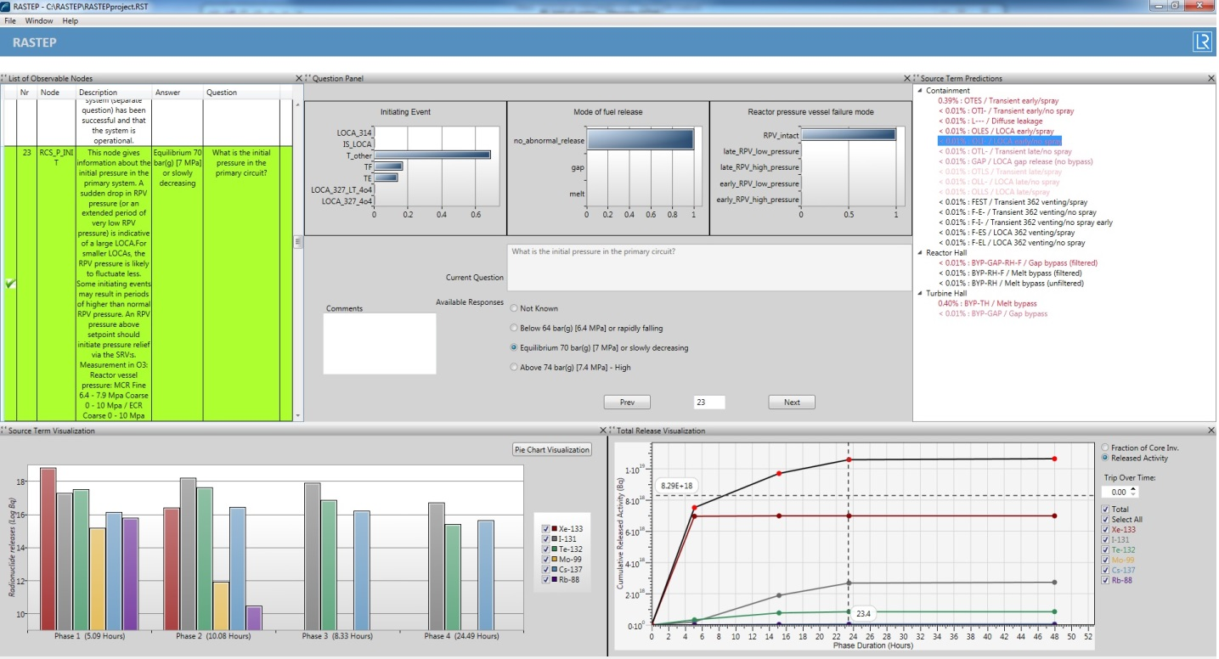

**RASTEP’s emergency ‘dashboard’:** A clear, real-time picture of events at an affected nuclear power plant

The screenshot of the user interface featured shows RASTEP’s emergency ‘dashboard’. Different panels provide real-time information on system (node) status, predictions of different source terms and visualisation of releases of different radionuclides over time, with a section set aside for dialogue with the user. The radiological source terms’ output is critical for emergency response activities, such as providing data for off-site radiation dose assessment and atmospheric dispersion calculations.

Lloyd’s Register Consulting work with SSM contributes to the new FASTNET (FAST Nuclear Emergency Tools) project, funded by the EU Research and Innovation programme, Horizon 2020. This project brings together a group of experts, including Lloyd’s Register Consulting, to further explore the industry’s knowledge of severe nuclear accidents and risk mitigation tools. The overall objective is to qualify a graduated response methodology that integrates several tools and methods to deliver both diagnosis and prognosis of severe accident progression. This methodology will also estimate the consequences of a nuclear incident on the surrounding population and environment. Another key project aim is to build a source term database forany nuclear power plant concept or spent fuel pool facility in Europe as a first step for a harmonisation in methodologies. Behind the enormous level of complexity lies a simple fact: the more potential accidental scenarios the industry knows about, the better the public and environment can be protected. This international collaboration will enhance further understanding at a critical point in nuclear energy’s evolution.

Independently from Lloyd’s Register Consulting and RASTEP, GRS in Germany has developed a tool which is based on the same principles and which has the same objectives [129]. It is already implemented in most German NPPs in order to support the crisis teams for predicting source terms in case of an accident. The tool is being further developed, adding features for accidents in the spent fuel pool and in shutdown conditions.

It is interesting to note that two organizations independently of each other develop very similar solutions. This seems to be an indication that this approach is promising and that it may be recommended for general use.

### MOLTEN CORIUM CONCRETE INTERACTION (MCCI)

The ASAMPSA2 guidance [2] already includes considerations on modelling the phenomena associated to molten corium concrete interaction. Since the publication of this guidance, a MCCI state of the art report (SOAR) has been prepared in the context of OECD/NEA projects. This report is not yet publically available (publication is planned in 2017) but will be an important reference to be considered by L2 PSA practitioners. It addresses the following issues:

* What can be learnt from the experimental data base including the last results of the MCCI Project and complementary national or European projects?
* What progress has been made and what is the level of remaining uncertainties on the modelling of corium concrete interaction and molten core coolability?
* What could be concluded about the capabilities of the codes to predict corium concrete interaction and molten core coolability with respect to containment integrity assessment in plant application?
* What are the remaining issues and opportunity to define further experimental or analytical activities?

A summary of the main conclusions is available in [134].

## RECENT R&D ON SPENT FUEL POOL ACCIDENTS

While the SFP damage frequency may be lower than for reactor cores, severe accidents to SFPs may lead potentially to higher radiological consequences and ASAMPSA\_E recognizes the importance of filling large knowledge gaps to predict the evolution and consequences of these accidents. Phenomenology of severe accidents in SFPs includes complex thermal-hydraulics phenomena in the pool up to dewatering coupled to thermal-hydraulics in the containment, oxidation mechanisms and hydrogen generation, fuel degradation and possible release pathways that have been partly addressed in the past. In a post-Fukushima context areas to be further developed or investigated have been identified that include the remaining uncertainties of simulation codes. In this section, existing experimental database relevant to SFP severe accident and capabilities of available simulation codes are first summarized. Then R&D activities on-going worldwide are detailed. Finally the specific initiating event of heavy load drops in a SFP is presented to illustrate safety evaluation activities.

### CSNI STATUS REPORT ON SPENT FUEL POOL UNDER ACCIDENT CONDITIONS

As part of the CSNI activities motivated by the Fukushima Dai-ichi accident, WGAMA and WGFS have produced a “CSNI Status Report on Spent Fuel Pool under loss of cooling and loss of coolant accident conditions” [99]. The main objectives were:

(1) to produce a brief summary of the status of Spent Fuel Pool accident and mitigation strategies to better contribute to the post-Fukushima Daiichi NPP accident decision making process;

(2) to provide a brief assessment of current experimental and analytical knowledge about loss of cooling accidents in spent fuel pool and their associated mitigation strategies;

(3) to briefly describe the strengths and weaknesses of analytical methods used in codes to predict spent fuel pool accident evolution and assess the efficiency of different cooling mechanisms for mitigation of such accident; and

(4) to identify and list additional research activities required to address gaps in the understanding of relevant phenomenological processes, to identify where analytical tool deficiencies exist, and to reduce the uncertainties in this understanding.

### EXPERIMENTS WITH RELEVANCE TO SFP COOLING ACCIDENTS

Separate and integral effect tests have been conducted since the 1980s to better understand the fuel behaviour and degradation under severe accident conditions in NPP. The main objective of these tests was to provide data for model development and validation of computer codes used for reactor safety analysis. Results of these tests cannot be directly applied to SFP severe accidents but analytical activities conducted to support these experimental programs led to increase globally the knowledge on severe accident phenomenology that can be used to anticipate SFP specifities. For example, the international PHEBUS Fission Product program, conducted in France, provided insights and data on the fission product release and late phase melt progression for LWRs. Nevertheless some experiments can be applied more straightfoward to SFP accidents like the QUENCH-10 and QUENCH-16 tests conducted in Germany. These tests not only provided an improved understanding of the oxidation phenomena, but also examined the phenomena associated with recovery and quenching of overheated fuel rods. Also the experiments and tests carried out to investigate the 2003 Paks cleaning tank incident have provided useful data.

The only integral tests specifically targeted for SFP loss of cooling accidents were conducted at Sandia National Laboratories, USA, partly within the OECD/NEA Sandia Fuel Project [100]. The main objective of the experimental work was to provide basic thermal-hydraulic data for completely uncovered and air cooled fuel assemblies for boiling and pressurized water reactors, and facilitate severe accident code validation and reduce modelling uncertainties. The accident conditions of interest for the SFP were simulated in a full-scale prototypic fashion.

The experimental program is based on a scenario where an almost instantaneous pool water draindown occurs and the fuel elements are exposed to an atmosphere of steam and air. Fast heat-up and igniting is expected and the propagation of the Zr-fire is investigated. This scenario is different from the events in Fukushima Dai-ichi and addresses what happens if SFP tighness is globally lost. Analytical activities are needed to link both scenarios. They are part of the joint research project and involve calculations with severe accident codes, such as MELCOR, ATHLET or ASTEC.

A large number of separate effect tests have been done to characterize high temperature air oxidation of various cladding materials, and further tests are underway. These tests provide necessary data for modelling cladding degradation and zirconium fire initiation in SFP accidents. Most of the tests were done under isothermal conditions and studied the phenomena of oxidation kinetics in air and air/steam environments, oxidation breakaway, and nitriding.

Recent results obtained during separate-effect test campaigns at IRSN, FZK and INR were presented in [101]. The reaction between Zircaloy and air and the investigation of air attack under prototypical conditions for air ingress during a hypothetical severe nuclear reactor accident have been investigated. Conditions relevant to spent fuel pool dewatering accident or handling accident have also been addressed.

There have also been various separate effect tests to examine the fission product release characteristics of the fuel under air-rich conditions, where enhanced release of otherwise low-volatile species like ruthenium can become important [102], [103], [104]. Major recent experiments of this kind include VERCORS [105] and VERDON [62] conducted in France, the VEGA program [106] in Japan, and the CRL program [107] at AECL where both high burnup UO2 fuel and (U, Pu) O2 fuel were investigated. Clearly the adaptation of the measured fission release rates to all SFP accidental situations imply to investigate the air/steam ratio atmosphere of the fuel during the whole dewatering progression (this issue is one of the objective of the DENOPI program presented in a section below).

Finally, there were also some tests conducted in Korea that were designed for the evaluation of siphon breaker performance.

### Detailed SIMULATION TOOLS

Simulation tools applied to SFP accidents include computer programs developed for analysis of thermal- hydraulics, nuclear criticality, fuel rod behaviour and severe accidents. For the simulation of SFP thermal-hydraulics, CFD tools can be used in cases where 3D phenomena/regimes are important. They have the capacity to address problems at the local scale in 3D. However, SFP analyses are usually done at a larger scale, and the large simulation domain necessitates simplified modelling of the storage racks (porous medium approximation) and relatively coarse meshes in the CFD simulations. Thermal-hydraulics system codes are mostly applied for accident analysis at a large scale. System codes make use of 1D or 2D representations of the considered geometry, but they are being further developed into 3D tools.

Computational tools used for evaluation of the nuclear criticality safety of SFPs calculate the effective neutron multiplication factor of the SFP for any static configuration described in terms of geometry, material compositions, and extra information regarding cladding degradation, debris formation and physical state and level of the cooling water. These codes can in fact be used for both operational and accident conditions. Three types of calculation schemes are employed: a purely stochastic, a purely deterministic, and a hybrid scheme. A high level of accuracy in the results can typically be obtained by any of the schemes. The burnup dependent fuel composition can be provided by dedicated codes, which perform an in-core fuel depletion and fission products build-up analysis.

The fuel rod behaviour during the early phase of a loss of cooling incident or accident, up to the loss of rod-like geometry, can be simulated with transient fuel behaviour codes, which simulate the thermo-mechanical phenomena and the changes in fuel pellet and cladding in detail. However, they usually lack models for cladding high temperature oxidation in air-containing environments.

Severe accident codes originally developed for reactor applications are also used for analyses of SFP cooling accidents even if geometry and conditions expected in SFP accidents differ from those in reactor accidents, and the applicability of models in different severe accident codes is currently being verified for SFP conditions.

### ABILITY OF REACTOR CORE SEVERE ACCIDENT CODES TO SIMULATE SFP SEVERE ACCIDENTS

The European Severe Accidents Research Network SARNET investigated the capabilities of severe accident codes to analyse SFP accidents [108]. This investigation comprised:

(1) the state of knowledge, especially with regard to phenomena related to oxidation in air of the fuel rod claddings,

(2) the state of code assessments on integral tests like QUENCH or PARAMETER; tests allowing to study accidental transients of oxidation in air of fuel rod claddings, ending by reflooding; and SFP tests allowing to study the behaviour of one or several fuel assemblies for representative transients of loss of coolant SFP accident, inducing fuel claddings oxidation in air and burn propagation, and

(3) the assessment of different SFP accidents with different severe accident codes for different SFP geometries, different scenarios, and different levels and partition of the residual power on fuel assemblies.

The first two tasks clearly identified lacks in knowledge, and therefore on physical relevance of available models in severe accident codes; regarding the phenomena related to the oxidation in air or steam/air mixtures of the fuel claddings, especially the role of nitrogen in the acceleration mechanisms of cladding degradation and on the mechanical behaviour of oxidized/nitrided claddings. Moreover, difficulties were revealed to model correctly the real 3D geometry and heterogeneity of fuel assemblies with the 2D cylindrical geometry usually applied by severe accident codes.

Concerning calculations of SFP transients, five different severe accident codes were used, namely: ASTEC, MELCOR, ATHLET-CD, ICARE/CATHARE, and RELAP/SCDAPSIM. The calculations have shown the impact of modelling assumptions such as the number of nodes used to represent the fuel building, which can have strong impact on the gas flow between the different parts of the building. They also raise questions about the reliability of some results obtained with these severe accident codes, regarding in particular:

* the phenomena related to the cladding behaviour in the presence of air or a steam / air mixture, such as oxidation, nitriding and embrittlement;
* the phenomena of natural convection and boiling in the fuel building. In fact, the conclusions on the coolability of fuel assemblies can be very different depending on the calculations; some studies show, for a loss of water transient (conducting to fast dewatering and air ingress in the fuel assemblies), that air flow is sufficient to remove the power, for other studies this conclusion depends on the air flow that could actually flow in the fuel assemblies;
* the conditions of air ingress in the assembly, according to the water depth, the assembly power, and the intensity of boiling; some studies show that for certain conditions, during the phase of fuel assembly dewatering, the air ingress flow through the top of the assembly (counter-current of steam flow) can cool down the upper part of the fuel assembly;
* the coolability of dewatered fuel assemblies with water injections.

### ONGOING R&D ACTIVITIES

#### FRANCE

The DENOPI project, operated by IRSN and supported by the French government in the framework of post-Fukushima activities, is devoted to the experimental study of SFPs under loss of cooling and loss of coolant accident conditions [109]. The project is divided into 3 parts:

* Two-phase convection phenomena in SFPs under loss of cooling conditions: The approach proposed in the DENOPI project is to conduct experiments on models of an SFP at reduced scale to contribute to the development and validation of two-phase flow convection models across the entire SFP.
* Physical phenomena at the scale of a fuel assembly under loss of coolant conditions: Experiments will be performed with partially uncovered fuel assemblies in order to study:

(1) the conditions for air penetration into the fuel assemblies;

(2) the void fraction in the fuel assemblies during boil-off, which is an important parameter in the evaluation of criticality issues; and

(3) the efficiency of a water spray to cool the fuel assemblies in case of a loss of coolant accident.

* Oxidation of zirconium by an air/steam mixture: Experiments on oxidation and nitriding of zirconium alloy fuel cladding will be performed in order to better estimate the margin to runaway of these exothermal reactions, leading to the destruction of the cladding.

#### GERMANY

Karlsruhe Institute of Technology (KIT) is also planning to perform another semi-integral bundle test in the QUENCH facility, with special focus on SFP conditions, including steam-air mixtures. Such a test is expected to be conducted in the framework of the EC-sponsored Severe Accident Facilities for European Safety Targets (SAFEST) program.

The AIR\_SFP project, launched recently in the framework of the European NUGENIA plate form, is dedicated to the application of accident codes to spent fuel pools, with three main objectives:

* improving severe accident code models to simulate air oxidation phenomena,
* defining recommendations to the use of severe accident codes for SFP accident applications,
* defining more precisely needs of R&D on different topics like large-scale flow convection, impact of partial dewatering or air flow on thermal runaway and fuel degradation**.**

GRS has been working on a research project financially supported by the German Federal Ministry of Economics and Technology (BMWi) regarding the extension of probabilistic analyses for spent fuel pools - see appendix 10.1. Supporting deterministic analyses of the accident progression inside the SFP were a main part of the project. The accident progression has been analysed for both PWR and BWR pools by using the integral code MELCOR 1.8.6. The objective of the research project was the development of a basic approach for consideration of SFP within L2 PSA, a preliminary quantification of event trees, and the identification of possible mitigative accident measures.

Some of the more relevant findings are provided in appendix 10.1 and will be summarized below:

* vaporization of large water volume in case of loss of heat removal will provide steam-saturated atmosphere – no oxidation in air;
* very strong heat transfer from melting SFP to structures above (containment or roof);
* melt through of SFP concrete can occur vertically or radially;
* consider combination of RPV accident and SFP accident - additional load to containment or buildings.

From a R&D perspective, it is interesting to note that:

* MELCOR (and probably all other integral codes as well) cannot model melting in more than one “core”. This means that simultaneous melting in RPV and SFP cannot be calculated. Before melting begins, the water evaporation can be estimated by modelling the “first core” correctly, and assuming a certain heat load to the water in the “second core”.
* Heat transfer by radiation upwards from a melting SFP is not well represented by present integral simulation tools.

#### JAPAN

NRA has been carrying out a spray test program for BWR spent fuel to obtain quantitative spray effects for accidental situations in SFP since 2014. The target scenarios are loss of coolant accidents (LOCAs) in SFP. Water spray is injected from a spray nozzle located above the fuel assemblies when spent fuel assemblies are uncovered fully or partially due to abnormal decrease in water level. In the tests, important knowledge of spray effects such as thermal hydraulic characteristics of liquid droplets atomization, counter-current flow and heat transfer between fuel rods and liquid droplets/liquid film will be obtained by measurements of fuel rod temperature, liquid velocity and void fraction inside/outside spent fuel assemblies. The tests will start in 2016 after the test facility which consists of a storage tank, spent fuel assemblies (single bundle or multi bundles), storage racks and spray injection system is fabricated.

#### OECD

In 2015 the Status Report on Spent Fuel Pools under Loss-of-Cooling and Loss-of-Coolant Accident Conditions (NEA/CSNI/R(2015)2) [99] was issued. The report addresses number of topics including:

* phenomenology of SFP loss of cooling and loss of coolant accidents (criticality, thermal-hydraulic behavior) with an emphasis on severe accidents (fuel behavior, fuel assembly and rack degradation, fission product release and transport);
* integral tests and separate effect tests with relevance to SFP accidents;
* simulation tools used for analysis of SFP accidents.

In 2016 a Phenomena Identification and Ranking Table (PIRT) exercise on SFP under loss of cooling or coolant accidents conditions has been launched under the OECD/NEA/CSNI auspices. A particular emphasis will be placed on mitigation strategies.

#### NUGENIA and Air-SFP Project

NEA/CSNI/R(2015)2 Status Report [99] indicated the necessity of benchmark activities to evaluate limitations associated with use of the codes originally developed for reactor applications in the SFP accident analyses. Recent activities in this area were performed under NUGENIA+ Air-SFP project (funded by the EURATOM 7th FP) and included evaluation of loss of cooling and loss of coolant SA scenarios for SFP geometry similar to Fukushima unit 4 spent fuel pool (to be presented in ERMSAR 2017). Calculations were performed with 6 different computer codes, either developed for calculation of severe accidents in a reactor (ASTEC, ATHLET-CD, MELCOR, SCDAPSIM and SPECTRA) or for the calculation of thermal hydraulic problems (RELAP5). Evaluation of benchmark results identified that for the loss of cooling scenario the onset of fuel heat-up is rather well predicted. However, for the loss of coolant scenario the SFP draining velocities show a wide range of results which can be partly explained by differences in assumptions used for modelling of SFP leak flow path. For both scenarios, the heating rate of the recently unloaded fuel differs by a factor of 3 and this leads to an important spreading of the onset of fuel melting. The total amount of hydrogen produced differs significantly by a factor of 5 for the loss of cooling scenario and a factor of 10 for the loss of coolant scenario.

The discrepancies between computations highlight the strong impact of the representation of the spent fuel assemblies with huge differences observed between computations carried out with the same code but with a different modelling of the racks configuration. It is thus recommended that each code development team provides guidelines for the modelling of the SFP geometry. Another phenomenon that drives the heat up is the oxidation of the cladding that occurs in SFP under a mixture of steam, oxygen and nitrogen. Although much progress was made in the recent years in phenomenological understanding of zirconium oxidation in nitrogen containing atmospheres, computer codes simulating SA still have problems taking into account the effect of nitrogen and accurately predict air ingress sequences. Differences in oxidation/nitriding modelling between the computations can consequently be another reason for scattering of the results for the temperature range where oxidation is significant (above around 900°C). The boundary conditions are another key point and they should be carefully defined. In particular, it was shown that the modelling of the building above the pool has an influence on the calculated temperature of the pool.

### ANALYSIS OF HEAVY LOAD DROPS INTO THE SFP (UJV)

One of typical initiating events for SFP represents IE “Heavy load (or cask) drops”. For reactors with a cover above the SFP, one of the most probable loads is such a cover, which is manipulated during uncovering or covering SFP for removing fuel assemblies from the reactor into the SFP.

There are relatively large uncertainties connected to extent and type of fuel damage after the load drop. That is why it is necessary to perform a special deterministic analysis using an expert code dedicated for very fast non-stationary dynamic events like for example crash tests. Such analysis is necessary for definition of scope and type of damage for different loads.

The next step is analysis of selected scenarios (usually the most serious) using some of the integral codes for severe accident (MELCOR, MAAP, etc.). For Level 2 PSA, there are basically two most important factors:

1) degree of fuel damage and

2) location of the SFP (inside or outside containment).

Other key factors are isolation of the containment (if SFP is located inside the containment), status of ventilation and availability of water resources and status of water supply systems (in case of extensive fuel damage).

Above described analyses were performed for a VVER-440 reactor at UJV Rez. The results proved that even for the worst case (fall of SFP cover with weight 6900 kg, speed 20 m/s) only a very limited number of fuel rods (26 = 14 in the central fuel assembly + 2 in each of the 6 neighbouring assemblies) would be damaged directly. However, the fall of the SFP cover causes compression of the fuel rods together, so water cannot flow around the rods and the damaged rods heat up and melt. The melting process takes approximately 1 day and according to the analyses less than 1% of fuel is melted. The associated release of fission products into environment was assessed as late low release.

## KNOWLEDGE GAPS AND FUTURE NEEDS

Even today’s advanced L2 PSA and the related research encounter some important knowledge gaps. The following topics belong to this group where research is needed to improve the L2 PSA quality.

**Fuel coolant interaction**

In Water-cooled reactors, the liquid corium might come into contact with water at several occasions, during melt relocation phases, or reflooding. These phases are potentially marked by strong melt cooling through fragmentation, hydrogen production and produce new melt configurations. Additionally, under certain circumstances, FCI might lead to a so-called steam explosion.

Despite continuous progress, in particular through international collaboration, e.g. the OECD SERENA-2 program and work done in SARNET-2 network project [135], there are still a number of knowledge gaps on both understanding and modelling, particularly for the frame of PSAs where simple models are preferable.

Due to the fact that attention on steam explosion has been focused on the ex-vessel situation, e.g. if IVR strategy comes to fail, little attention has been put on the phase of relocation of melt in the lower head. Although there is no formal proof, it is admitted that a steam explosion is unlikely in this situation and that the structures will probably withstand an associated power peak. Nevertheless, when it is taken into account in models, the mixing itself does not take into account the oxidation and hydrogen production. Also, the particular and still unclear melt flow conditions themselves render the existing evaluations very uncertain.

The ex-vessel situation is of high interest for PWRs with failed IVR strategies and BWRs, particularly those with large pits. It was concluded from recent international coolaborations that a reasonable achievement of understanding and modelling has been reached for the following simplified configuration:

* 2D axisymmetric,
* UO2/ZrO2 melts,
* central gravity driven melt injection.

The application to more realistic situations is then regognized as uncertain. In particular, a probable situation is the one of vessel failure during inversion of melt stratification in the vessel. This would lead to the release at first of highly superheated metal, a situation which has not been investigated experimentally with sufficient attention.

It is noticed that steam explosion is the current subject of an OECD Technical Opinion Paper, which should be released by 2017.

**Debris bed coolability.**

The coolability of a corium debris bed is currently the subject of numerous investigations and a recent review can be found in [136]. The CFD codes have shown their overall capacity in modelling the phenomenon. Nevertheless, the applicability to PSA studies is quite complex due to the large number of potential geometrical configurations.

Moreover, for cases where corium falls into water, a directly coolable debris bed seems difficult to be created, unless with very large pits and small jet diameter. In a large number of situations, the fragmentation may not be complete and the melt could partly spread on the concrete or along the vessel. Such intermediate situations have not been investigated with sufficient details.

**Steam explosion triggering during melt spreading**.

Recent experiments conducted by KTH in the SES-PULIMS installation showed that, under certain circumstances that are to be clarified, melt spreding under water could lead to strong explosion triggering. This is in contradiction with previous conclusions on the stratified steam explosion. The mechanisms in these recent experiments needs clarification: the visualizations indicate that the spreading occurs with a very unstable melt interface. More research is needed for application to L2 PSA or reactor safety studies.

**Molten corium-concrete interaction**

The general comprehension of MCCI phenomena and of mechanism for corium stabilization has progressed significantly, even if some gaps are still identified (see the future OECD MCCI SOAR or [134]), for example on:

* the effects of presence of metal within the melt or within the concrete (steel rebars);
* the initial conditions for MCCI based on melt pour conditions into the reactor pit;
* the impact of presence of impurities in cooling water (e.g., seawater or brackish water).

In the context of L2 PSA, the importance of uncertainties has be determined specifically for each plant design and should not be addressed in general.

**Releases into the waters and ground**

The ASAMPSA\_E May 2014 meeting participants noted (among other issues) that most of L2 PSA exclusively addresses releases into the atmosphere. Quantitative analyses of releases into water (river, lake, sea – see the Fukushima Dai-chi experience) were considered as missing. This is rooted in historic developments which concentrated on (immediate) health effects, and which seem to be less significant for water and ground releases. Nevertheless the consequences of such releases may be very significant.

Therefore, the related source term characteristics should be explored by L2 PSA. The WP40 partners note that relevant research and guidance in this field is missing.

**Long-time effects inside plants**

The ASAMPSA\_E May 2014 meeting participants noted (among other issues) that long time effects – in particular related to the long term resilience of containments against fuel degradation accidents – should be addressed by L2 PSA. There may be some activities going on in this field, but the state of the art seems unfit for producing guidance.

**Iodine and Ruthenium chemistry**

L2 PSA typically considers iodine releases to the environment in the chemical form of CsI. However, in the presence of intense radiation fields, as would be expected in severe accident conditions, complex iodine chemistry can develop over time resulting in the formation of additional gaseous molecular iodine (I2) via a number of routes, as well as stimulating other reactions with containment surfaces and aerosols that consume the gaseous iodine. In long-term accident sequences which do not develop early catastrophic source terms, the release of various iodine compounds may dominate over the CsI release.

With regard to Ruthenium, the amount of ruthenium produced by nuclear fission is important and increases with the fuel burn-up. Ruthenium has a high specific activity and high radio-toxicity compared to the other released fission products. The formation of volatile Ruthenium compounds is a significant concern.

Much basic research has been done in the radiochemistry field, but the existing models are not yet suitable for routine application in L2 PSA. Therefore, guidance is needed how to introduce the existing information in L2 PSA, and practically usable methods should be developed.

Source term R&D programmes conducted in the last two decades have shown that iodine oxide particles, gaseous organic iodides and gaseous ruthenium tetroxide may contribute significantly to the environment source term in case of venting. The filtration efficiency review and update of the filtered containment venting systems is the scope in European ongoing projects (MIRE and PASSAM). Furthermore the potential revolatization of the various deposited iodine and ruthenium species has to be further assessed for conditions representative of a SA.

**Combustible gases outside the containment**

Hydrogen and carbon monoxide issues within the containment are routinely taken into account in PSA. However, related issues outside the containment seem to require more attention. As an example, still today there is no conclusive interpretation of the combustion events in the Fukushima Dai-chi accident sequences, notably within block four. It seems that PSA need to focus more on the related issues. The following topics belong to that field:

* distribution and transport of combustible gas in containment venting systems, in particular connected to steam condensation processes;
* leak of combustible gases out of the containment into adjacent rooms, and related distribution of these gases;
* distribution and transport in ventilation systems, taking into account the disturbed plant conditions after core melt;
* probabilities of ignition for potentially ignitable atmosphere in different parts of the disturbed plant.

Detailed CFD models or lumped-parameter containment models may in principle be available for precise evaluations, but given the multitude of potential accident sequences, their routine application in PSA is not practical. Additional guidance seems to be needed for adequately addressing these issues.

**Treatment of uncertainties**

Assessment of uncertainties should provide among other things a measure of the confidence that the results provided by PSA represent “real life” (what used to be called “robustness of results”). If the confidence is found to be low, the uncertainty analysis in L2 PSA shall provide information on the possible deviation in accident progression on the NPP and impact on the accident consequences.

The IAEA [10] provides a discussion of the sources of uncertainties (and some methodologies applied to Design Basis Accidents safety demonstrations that can be extrapolated also to severe accidents), and the USNRC [16] provides some guidance on the treatment of uncertainties for decision making. The ASAMPSA2 guidelines [2] in Vol. 2 provide discussions on this subject.

Solutions to this issue with respect to L2 PSA have been investigated within the EU project BEEJT (Benchmark Exercise on Expert Judgment Techniques) summarized in [133]. However, several sources of uncertainties cannot be easily addressed or quantified (see [85]). Some may actually be the biggest sources of uncertainties (Fukushima Dai-chi may be the best example in terms of modelling uncertainties and completeness). Nevertheless, advances in this area have not been forthcoming since issuance of the ASAMPSA2 guidelines; hence ASAMPSA\_E needs not address or repeat what has been already discussed at length in the past in these areas.

Since the Fukushima accidents sometimes doubts were raised whether PSA truly represent the accidental risk of NPPs. In this discussion it seems prudent to distinguish between L1 PSA issues and L2 PSA issues which are subject of the present document. With regard to L2 PSA the available experience in TMI, Chernobyl and Fukushima is not at all surprising. If L2 PSA had been performed based on the status of these NPPs at the onset of core damage, L2 PSA would have probably provided results not far from the actual experience.

## SUMMARY FOR L2 PSA CONSIDERING RECENT R&D

The present section concentrates on fields of research which affect L2 PSA. In principle, the present section is updating the pertinent ASAMPSA2 documentation [1], [2], [3]. Recent R&D and the ongoing research with relevance on extended L2 PSA are evaluated. The survey concentrated on ASAMPSA\_E, SARNET (Severe Accident Research Network), SARNET-2, OECD and European projects (public results only), NUGENIA roadmap and ASAMPSA2.

The following Table 4.4.1 summarizes some R&D activities which are considered relevant for taking them into account in the discussion of further L2 PSA guidance. This list is preliminary, and since it is at least partly covering projects which are not yet finalized, no references are given. Where appropriate, the relevant leading organization(s) responsible for the topic is provided. Most of the issues mentioned below have links to one of the previous sections in the present document.

Table 4.4.1 Recent R&D related to L2 PSA and associated guidance suggestions for extended PSA

| **#** | **Recent R&D issues related to L2 PSA** | **Suggestion for improvement of guidance in ASAMPSA\_E** |
| --- | --- | --- |
|  | Analysis of fuel melt process in spent fuel pool with integral code (e.g. MELCOR) | There is no specific guidance for fuel melting in spent fuel pools; however existing guidance for core melting is largely applicable. Heat transfer from SFP to structures above and large scale MCCI need particular consideration, but no specific R&D or guidance is needed on this topic (see section 3.3.6). |
|  | Deterministic and probabilistic analysis of accidents caused by external hazards in full power state | There is no specific guidance for accident analysis caused by external hazards; however existing guidance for internal initiators is generally applicable. According to D40.4 [50] L2 PSA for external events needs no specific guidance. |
|  | Conditional probability of containment loss of tightness after an earthquake | Seismic fragility of the Containment Vessel for overall structure failure and local failure can be evaluated based on the seismic design where response analyses for design basis earthquakes are conducted. In the context of an extended PSA also internal and external hazards could be taken into account which may affect the possibility to close the containment.  Definition of mechanical criteria for loss of tightness is beyond the common practices of mechanical and seismic engineering practices.  The definition of mechanical criteria for loss of containment tightness is not elaborated in this report. This issue shall be addressed in L1 PSA. Regarding L2 PSA, this issue is already discussed in D40.4 [50]. |
|  | Source term assessment for L2 PSA | Source term research remains of high priority for evaluation and reduction of radioactive releases during accidents in NPP. Despite the recent achievement of major experimental programs and significant advances in understanding of source term issues, additional research is still required. A short synthesis of acquired knowledge and remaining gaps, e.g. fission product release, its behaviour focusing on iodine and its chemistry is provided in this report.  On-going research programs (STEM2, BIP3, THAI3, PASSAM) and the implementation of their outcomes in Severe Accident codes are expected by 2020. |
|  | Analysis of the complexity of severe accident phenomenology by code simulation, ASTEC and MELCOR | Existing guidance for L2 PSA is generally applicable.  In the framework of 2013-2015 MELCOR development different tasks, i.e. mechanistic fan cooler model, new debris cooling models in the CAV package (water-ingression and melt eruption through crust) is completed. Other model development is in progress, i.e. CONTAIN/LMR model for liquid metals reactors, multiple fuel rod types in a COR cell. |
|  | Analysis of heavy load drops into the SFP | There is no specific guidance.  Existing guidance for core melting is generally applicable. |
|  | Investigation of the IVR by external cooling of reactor vessel for VVER-1000 type reactors | Guidance is under development  The European project IVMR (grant no. 662157) – H2020 is started with the main objective to review, from an analytical point of view, the possibility to retain the corium inside the vessel due to external cooling, for several kinds of reactors in Europe (existing or under project). |
|  | Accident progression and possible off-site consequences | On-going research activities in FASTNET.  Development of two tools is summarised in section 4.1.4.9. These tools (developed by LRC and GRS) facilitate diagnosis and decision-making by prognosis of source terms for nuclear emergency management. |
|  | Spent Fuel Pool Rupture Characterization Based on Water Level Monitoring | There is no specific guidance on critically important instrumentation and measurements. In case of SFP LOCA the location and size of SFP rupture is critical. Therefore pertinent instrumentation availability deserves consideration in L2 PSA and related guidance. |

## Safety Research areas identified in the NEA-SAREF-Project

The NEA/CSNI undertook the “Safety Research Opportunities Post-Fukushima” (SAREF) initiative to provide guidance on potential examinations of the damaged reactors at Fukushima Daiichi, with the twofold goal of addressing safety research gaps and of supporting Japan in achieving safe and timely decommissioning. The following sections essentially are an excerpt of the SAREF draft report which will probably be competed in 2017, after finalization of the present ASAMPSA\_E document. Since the following text is based on a draft only, the reader is encouraged to address CSNI for obtaining the final document.

A group of senior experts in nuclear safety research as well as decommissioning was assembled to identify areas of common interest and recommend to the CSNI safety research activities including their priority. The group reviewed research areas relevant to three categories: 1) severe accident progression, 2) SSC performance and condition, and 3) the recovery phase of an accident – and included a fourth category – 4) general or already addressed. For each research area consideration was given to the international safety research interest, the decommissioning interest, potential examinations, challenges (e.g. cost, timing, dose, etc.), feasibility and ongoing R&D activities. A research area is identified as having high safety research interest if information that can be gained during Fukushima Daiichi decommissioning addresses significant knowledge gaps. If the knowledge gaps are not significant, or the information could be better gained another way, the safety research interest is only medium or low. For example, the safety research interest in information on hydrogen combustion is rated medium even though the combustion events at Fukushima Daiichi were the first for a nuclear plant during a severe accident. This rating was chosen because it is difficult to retroactively determine how the hydrogen behaved, and because the effects of the combustion events cannot be easily separated from other sources of pressurisation and damage.

Similarly, decommissioning interest in a research area is high if the information gained is necessary to support safe and timely decommissioning. For example, information on the survivability of instruments during and following the accident is of low interest to decommissioning as any malfunctioning equipment is either not required to ensure ongoing safety or can be replaced without determining how it survived the accident.

With these factors in mind, the Senior Expert Group on SAREF is recommending four long-term considerations. There are two long-term considerations on fuel debris retrieval and characterisation from inside and outside reactor pressure vessels that directly address the areas of in-vessel and ex-vessel phenomena. The ex-vessel proposal also addresses in part containment failure and venting. There is a long-term consideration to compile a database on fission product measurements that addresses fission product behaviour and source term. The last long-term consideration is based on opportunities for examinations of reactor components that may arise as decommissioning proceeds to address areas of high safety interest under mission time and system survivability. Recognising that these long-term considerations require additional information and development of decommissioning planning and processes, two near-term proposals are also recommended, which are of less significance from a PSA point of view.

Issues which have been associated with high safety research interest are:

|  |
| --- |
| In-vessel phenomena: knowledge gaps in BWR severe accident progression, corium formation and relocation within RPV, key to improve understanding and modelling of late severe accident progression. |
| Primary system and RPV failure: addresses gaps in reactor system, RPV or component failure mechanisms of BWRs; key to improve understanding and modelling of late SA progression. |
| Ex-vessel phenomena: knowledge gaps in melt relocation from RPV, in interaction with BWR typical ex-vessel structures, in molten core concrete interaction and melt coolability by water; is important to SAM strategies and mitigation technologies (e.g. melt flooding); key to improve understanding and modelling of ex-vessel severe accident progression; focus is on melt relocation and MCCI and not on fuel coolant interaction or direct containment heating phenomena. |
| Containment failure and venting: knowledge gaps in containment failure mechanisms under SA conditions and high containment pressure and temperature loads, could provide information to SAM and modelling |
| FP behaviour and source term: Supports public dose assessment, EQ, Reducing uncertainty in dose significant FPs. |
| Pool scrubbing: Fission product (FP) transport through the reactor coolant system and into the containment (especially through the suppression pool), as well as potential FP release from the containment, are of major importance when assessing the release of activity to the environment. |
| Cable and Sealing: Ability of containment seals and electrical systems to continue to perform its function as designed is key to SAM. |
| Instrumentation: Key instruments are required for SAM. |
| RCIC: RCIC system performance had a major influence on accident progression at Fukushima. |
| Relief valves and piping: Performance of valves and / or piping failure key to RPV depressurisation |

These issues of high interest mentioned above are not specifically linked to PSA topics, but they contribute to the completeness and quality of PSA in general. One specific PSA topic has been assigned a medium research interest: External effects and multi-unit risk and loss of ultimate heat sink. According to SAREF, many countries have interest in estimating these issues.

# CONCLUSION AND RECOMMENDATIONS

ASAMPSA2 guidelines [1] provided summary on specific issues related to shutdown states, spent fuel pools and recent R&D in L2 PSA. This present report complements the existing ASAMPSA2 guidance by providing:

* complementary guidance for Level 2 PSA for the shutdown states of reactors;
* complementary guidance for the modelling of risks associated to the spent fuel pools; and
* information on the recent R&D in Level 2 PSA.

The following sections describe the gaps identified in the existing guidance, and comment on the current state of the know-how in L2 PSA for these topics. It also summarises the conclusions drawn and recommendations made in sections 2, 3 and 4 of this report.

## COMPLEMENTARY GUIDANCE FOR LEVEL 2 PSA FOR THE SHUTDOWN STATES OF REACTORS

In shutdown states the correct core inventory and decay heat level, which is different from full power states, has to be taken into account according to the plant operating modes. This has implications for the accident progression and for source term calculations.

The definition of shutdown states are discussed in section 2.1, which seems adequately covered in the present guidance. For L2 PSA in shutdown states, two plant conditions are to be distinguished:

* Accident sequences with RPV head closed,
* Accident sequences with RPV head open.

When the RPV head is closed, core melt accident phenomena are very similar to the sequences going on in full power mode. Therefore, the large body of guidance which is available for full power mode is basically applicable to shutdown mode with RPV closed as well.

When the RPV is open, some of the L2 PSA issues become irrelevant compared to full power mode, while others come into existence. The situation is different for aspects which do not exist or which are less pronounced in sequences with RPV closed. The following summarizes such issues, such as:

1. **Accident sequences with RPV closed:**

In this report shutdown states with closed RPV are mentioned here for completeness, but it will probably be enough to recommend proper application and adaptation (e.g. due to different decay heat levels) of the existing L2 PSA guidance to these plant conditions, and to draw the attention to the possibly difficult plant conditions impacting mainly on L1 PSA. Special attention shall be devoted to the following issues:

* availability or recovery of safety systems (e.g. spray pumps, high pressure emergency core cooling systems) which can be under maintenance;
* the state of the containment i.e. it is opened and questionable to be closed (an additional question may be introduced into the containment event tree reflecting this issue);
* accident management systems.

1. **Accident sequences with RPV open:**

In case of a core melt accident with the RPV open, two cases can be identified. The first case is the RPV bottom closed (always the case for PWR, not always for BWR accident scenarios). In this case, core uncovery (damage) can only occur due to coolant boiling. The second case is a RPV bottom leak (e.g. at circulation pumps in a BWR), which leaves the RPV open at top and bottom.

In both cases it can be imagined that air comes in contact with the melting core, generating different conditions and releases compared to the almost pure steam atmosphere which is present in a closed RPV. However, present analyses do not indicate significant differences. This may be due to the fact that the air in the atmosphere near the RPV top and bottom is almost completely replaced by steam. This statement cannot be considered as a general rule, and pertinent analyses are recommended for such scenarios in a PSA.

For most shutdown states with open RPV head, reactor vessel and SFP are connected by a large water pool in some reactor designs. L1 PSA as well as L2 PSA for shutdown states should consider interconnection between RPV and SFP (possibility to use common safety systems, common SAMG strategies, etc.).

The following issues obviously are less significant as compared to closed RPV head:

* + high pressure core melt sequences with the large number of associated complications;
  + retention of radionuclides inside the reactor coolant loop; and
  + restoration of heat removal by normal systems.

It should be mentioned that severe accidents emanating from full power mode also can have particular issues after the RPV bottom has failed, when part of the fuel still is inside the RPV and a large leak exists somewhere higher in the reactor coolant loops. Probably, under such conditions the atmosphere in the cavity contains neither oxygen nor nitrogen so that significant effects need not be expected. However, discussions or guidance related to the accompanying effects are not available.

Release fractions for closed RPV cannot be transferred to open RPV sequences. It is justified to assume that for an open RPV all fission products which are released from the degrading core will be transferred to the containment atmosphere. Moreover, in BWRs with closed RPV, the release in most accident sequences passes through the wetwell, thereby scrubbing large fractions of the radionuclides. This significant mitigating feature also does not exist when the RPV is open.

1. **Containment issues:**

It can be considered likely that hatches and airlocks are closed when critical conditions in the containment begin. However, since the consequences of an open containment are very severe, a PSA should quantify the probability for an open containment. In the context of an extended PSA also internal and external hazards should be taken into account which may affect the possibility to close the containment. Some plants have a preparedness to close the containment hatch during certain maintenance, e.g. related to main circulation pump manipulations.

For an open containment the flow path through the reactor building and auxiliary building or turbine hall or ventilation systems – whatever is applicable – to the environment has to be considered. Hydrogen threats in the release path and deposition of fission products are the most relevant aspects in this regard. However, a detailed analysis of such buildings and flow paths and systems may be beyond the possibilities of most PSA. It seems to be acceptable to assume that severe hydrogen combustion occurs inside the buildings - see the Fukushima Dai-chi experience – and that a large release path to the environment will be opened.

## COMPLEMENT OF EXISTING GUIDANCE FOR SPENT FUEL DAMAGE

The ASAMPSA2 [1], [2], [3] guidelines provide the best practice guidelines for the performance and application of L2 PSA development for the Gen II PWR, Gen II BWR L2 PSAs and extension to Gen III and Gen IV reactors. However discussion on SFP guidance is not included in the scope of ASAMPSA2, so the SFP PSA discussion is complemented in this present report and discussed in section 3.

The release paths from the SFP to the environment are different depending on the location of the SFP i.e.:

1. the SFP is located inside the containment,
2. the SFP is located outside the containment.

If the SFP is located inside the containment, the potential release paths to the environment are almost the same as for core melt accidents in the RPV.

If the SFP is located outside the containment, the potential release paths to the environment depend very much on plant specific properties, e.g. ventilation systems, building doors, roof under thermal impact, size of rooms on the path etc. In any case the impact of very hot gas and of hydrogen has to be considered.

The issues related to spent fuel pool as discussed in section 3 are summarized as follows:

1. **Reactor - SFP interactions**

The reactor – SFP interactions can take one of three forms:

* SFP events impacting the reactor,
* reactor events impacting the SFP,
* common events impacting the reactor and SFP simultaneously.

Most existing L2 PSAs are limited to core damage accidents, and to the related containment threats (e.g. due to hydrogen, pressurization, temperature). An important reason for this limitation is related to mission time. However, the Fukushima events demonstrated that this argument may not be convincing.

Core melt occurs only if the plant status is in severe disorder. It seems difficult to prove that the SFP systems would not be affected by such disorder. This is especially the case for external hazards. There is a satisfactory reliability of various containments for mitigating the consequences of core melt accidents but L2 PSA should include an assessment of the status of the SFP during the progression of a severe accident in case of core melt: at minima the risk of spent fuel loss of cooling shall be quantified on the long term phase of the accident. Additional loadings due to SFP steam generation and melting processes will add an additional challenge. This could be considered as a cliff-edge effect. It is conceivable that melt-through of the SFP bottom or wall could affect systems and components which are important for reactor safety, e.g. molten material from the SFP could enter the sump and damage ECCS components.

At present, there is only very limited material available which addresses simultaneous degradation in core and SFP. The practical realization of simultaneous accident progression analysis in reactor and SFP proves to be difficult because none of the available accident simulation codes is capable of simulating more than one melting fuel entity. Therefore, at present it will be necessary to combine accident analyses from the core and from the SFP with the help of expertise. The task may become less complicated when considering that in most cases the fuel degradation in the SFP will begin much later than in the reactor core.

1. **SFP melt interaction with surrounding buildings**

When the SFP is located inside the containment, the events during SFP degradation will threaten the containment. Regarding core concrete interactions for SFP accidents, the melt level in the SFP can become rather thick. Such a thick melt layer would probably develop convection patterns which predominantly transfer the heat to the upper edge of the melt. In addition, a metal layer could float on top of the melt and also create local high lateral heat fluxes. On the other hand, vigorous bubbling due to fuel-concrete interaction would tend to equalize heat fluxes. In summary, it has to be taken into account that local peak heat fluxes at the upper edge of the melt pool in the SFP can exist. Lateral erosion and failure of the SFP wall may occur before bottom failure, and melt could enter adjacent rooms. Depending on the design, this can have consequences on remaining barriers and systems.

1. **Particular heat transfer mechanisms for SFP**

Melting in a SFP will cause different threats - an example is the heat load from the melting pool to structures above the pool. Guidance is needed how to take these different threats into account in extended L2 PSA.

Several analyses show that the heat load from the SFP upwards to structures above (containment dome, or roof of reactor hall) is significant. Analytical models should include thermal radiation and apply a suitable nodalization to model convection. Consequences of the high thermal load should be considered (e.g. reduction of containment pressure bearing capacity, impact of hot gas on venting system, induced fires).

1. **SFP melt interaction with building atmosphere**

Hydrogen generated in a SFP inside the containment is in principle covered by the arrangements foreseen for core melt accidents. If the SFP is located outside the containment in the reactor building or in specific buildings, in general no provisions for hydrogen challenge are available. Consequently, a significant risk of deflagration or even detonation exists. This may result in significant collateral damage such that mitigation equipment, sprinkler outlets, and even structural integrity of the SFP may be compromised. In addition, potential generation of carbon monoxide may occur which has similar deflagration characteristics as hydrogen. Hydrogen management concepts developed for hydrogen release from a degrading core (e.g. autocatalytic recombiners, igniters) need to be checked for their efficiency in SFP.

There is concern about the impact of air on the fuel degradation process and the consequences in terms of thermal energy release and fission product chemistry. Little experience is available for these issues, and related guidance may not yet be defined in the sense of good practice. Air ingress into the degrading fuel can be imagined for sequences where the water from the SFP is lost rather rapidly. For sequences with loss of heat removal, several analyses show that the previous evaporation of the large amount of water from the SFP would almost completely generate a steam atmosphere with little air having access to the degrading fuel. It is recommended to further substantiate this statement by performing additional analyses.

## Recent R&D in L2 PSA

Recent development and the ongoing research with relevance on extended L2 PSA are evaluated based on the various on-going and completed research projects e.g. ASAMPSA\_E, SARNET (Severe Accident Research Network), SARNET-2, OECD and European projects (public results only), NUGENIA roadmap and ASAMPSA2. A short synthesis of acquired knowledge and remaining gaps is provided in section 4 of this report. Section 4 also discusses the knowledge gaps and future research needs to improve the L2 PSA quality, which are listed as follows:

1. L2 PSA guidance is missing on quantitative analyses of releases into the waters and ground and its related source term characteristics.
2. The long term resilience of containments against fuel degradation accidents are not adequately covered in existing L2 PSA. Although it is noted that some activities are going on in this field, the state of the art seems unfit for producing guidance for now.
3. Basic research has been performed in the radiochemistry (iodine and ruthenium chemistry) field, but the existing models are not yet suitable for routine application in L2 PSA. Source term R&D programmes conducted in the last two decades have shown that iodine oxide particles, gaseous organic iodides and gaseous ruthenium tetroxide may contribute significantly to the environment source term in case of venting. The filtration efficiency review and update of the filtered containment venting systems is the scope in European ongoing projects (MIRE and PASSAM). Furthermore the potential revolatization of the various deposited iodine and ruthenium species has to be further assessed for conditions representative of a severe accident. Despite the recent achievement of major experimental programs and significant advances in understanding of source term issues, additional research is still required as recently reviewed in an international workshop [56] for the consolidation of source term and radiological consequences analyses. Guidance cannot yet be provided for these issues. It is prudent to associate a high degree of uncertainty to releases of these species.
4. Hydrogen and carbon monoxide issues within the containment are routinely taken into account in PSA. However, related issues outside the containment seem to require additional attention, e.g.
   * Distribution and transport of combustible gas in containment venting systems, in particular connected to steam condensation processes.
   * Leak of combustible gases out of the containment into adjacent rooms, and related distribution of these gases.
   * Distribution and transport in ventilation systems, taking into account the disturbed plant conditions after core melt.
   * Probabilities of ignition for potentially ignitable atmosphere in different parts of the disturbed plant.
   * Detailed CFD models or lumped-parameter containment models may in principle be available for precise evaluations, but given the multitude of potential accident sequences, their routine application in PSA is not practical. Additional guidance seems to be needed for adequately addressing these issues.
5. The uncertainty analysis in L2 PSA shall provide information on the possible deviation in accident progression on the NPP and impact on the accident consequences. Solutions to this issue with respect to L2 PSA have been investigated within the EU project BEEJT [133] and mor recently in ASAMPSA2 [1] [2]. However, several sources of uncertainties cannot be easily addressed or quantified.

## List of General Recommendations

The following list of L2 PSA recommendations is derived from this report and deliverable D30.2 [128] about lessons learned from Fukushima Dai-ichi accident:

1. Since the consequences of an open containment are very severe, a PSA should quantify the probability for an open containment in shutdown states. In the context of an extended PSA internal and external hazards should also be taken into account which may affect the possibility to close the containment.
2. Simultaneous accidents in reactor core and SFP can be imagined, but have hardly been addressed in existing PSA. It is recommended to perform analyses considering both of these sources, including accident management actions. Development and improvements in accident simulation codes are required before they are capable of simulating more than one melting fuel entity, e.g. simultaneous melting in core and SFP.
3. L2 PSA in SFP needs guidance how to define the initial loading, residual heat generation and radionuclide inventory inside the SFP.
4. Depending on the SFP design and its inventory, it may be imagined that criticality occurs during an accident sequence. Research and guidance is needed whether and how to address this issue in L2 PSA.
5. L2 PSA models should include source term assessments for the release category end states. Branches in the accident progression event tree should be defined also in light of the impact of systems, measures, or phenomena on release characteristics. Models limited to containment failure assessment should be extended as practicable.
6. L2 PSA models should be extended to the extent practicable to include repairs of previously failed systems or components. The longer PSA Level 2 analysis and mission times become, the more important is the consideration of such repairs. Moreover, effective modelling approaches should be developed for this issue to model appropriately the increasing chances of repair with more available time.
7. L2 PSA models should include extended analysis times in the reliability models for systems, components and actions needed during the accident progression. Dependencies with support systems or supporting measures (like refilling water storage tanks), especially if induced by a longer mission time, should be systematically investigated and included into the Level 2 models to the extent sensible.
8. For accidents in the spent fuel pool, appropriate definitions for these Level 1 end states, e.g. “fuel damage”, should be defined. The respective end states should be part of an appropriately defined interface to the PSA Level 2. The Level 2 end states shall include the spent fuel storage status in a long terme perspective.
9. Critically important instrumentation and measurements should be investigated using PSA methods on their availability during severe accident scenarios including scenarios developing from severe hazard impact. Conversely, failure of such instrumentation and measurements should be part of PSA Level 2 models.

# List of References

ASAMPSA2, IRSN-PSN/RES/SAG 2013-0177, Best Practices guidelines for L2 PSA development and applications, Volume 1- General, April 2013.

ASAMPSA2, IRSN-PSN/RES/SAG 2013-0177, Best Practices guidelines for L2 PSA development and applications, Volume 2- Best practices for the Gen II PWR, Gen II BWR L2 PSAs. Extension to Gen III reactors, April 2013.

ASAMPSA2, IRSN-PSN/RES/SAG 2013-0177, Best Practices guidelines for L2 PSA development and applications, Volume 3- Extension to Gen IV reactors, April 2013.

ASAMPSA\_E, Report proposing the content of future L2 PSA guidance to be established within ASAMPSA\_E, Technical report ASAMPSA\_E / WP40 / D40.3 / 2015-11, IRSN/PSN-RES-SAG/15-00168

U.S. NRC, An Approach for Estimating the Frequencies of Various Containment Failure Modes and Bypass Events, NUREG/CR-6595, BNL-NUREG-52539, Rev.1, October, 2004.

NUREG/CR-6906, “Containment Integrity Research at Sandia National Laboratories— An Overview,” by M. Hessheimer, Sandia National Laboratories, and R. A. Dameron, David Evans and Associates, Inc., July 2006.

U.S. NRC Regulatory guide 1.216, Containment structural integrity evaluation for internal pressure loadings above design basis pressure, Revision 0, August 2010.

UKEPR-0002-154 Issue 06, PCSR- Sub-chapter 15.4 –Level 2 PSA, 21-11-2012.

IAEA SAFETY SERIES No. 50-P-8, "Procedures for Conducting Probabilistic Safety Assessment of Nuclear Power Plants (Level 2) – Accident Progression, Containment Analysis and Estimation of Accident Source Terms", 1995, ISBN 92-0-102195-X (superseded by IAEA SSG-4).

IAEA SSG-4, Development and application of level 2 Probabilistic Safety Assessment for nuclear power plants, 2010.

IAEA-TECDOC-1144, Probabilistic safety assessments of nuclear power plants for low power and shutdown modes, March 2000.

Siu, N., Khericha, S., Conroy, S., Beck, S. and Blackman, H., Loss of Spent Fuel Pool Cooling: Model and Result, INL-96/0334, October 1996.

U.S. Nuclear Regulatory Commission, "Technical Study of Spent Fuel Pool Accident Risk at Decommissioning Nuclear Power Plants," NUREG-1738, February 2001.

U.S. Nuclear Regulatory Commission, "Reevaluation of Station Blackout Risk at Nuclear Power Plants Analysis of Loss of Offsite Power Events: 1986-2004," NUREG/CR-6890, December 2005.

U.S. Nuclear Regulatory Commission, "Operating Experience Feedback Report-Assessment of Spent Fuel Cooling," NUREG-1275, Volume 12, February 1997.

U.S. Nuclear Regulatory Commission, "Evaluation of External Hazards to Nuclear Power Plants in the United States," NUREG/CR-5042, December 1987.

EPRI-3002000498 Spent Fuel Pool Risk Assessment Integration Framework (Mark-I and II BWR) and Pilot Plant Application, Palo Alto, CA 2013.

F. C. Iglesias, C. E. L. Hunt, F. Garisto and D. S. Cox, Measured Release Kinetics of Ruthenium from Uranium Oxides in Air, Proc. Int’l. Seminar on Fission Product Transport Processes During Reactor Accidents, J. T. Rogers, editor, Hemisphere Publishing Corp., Washington, D. C., 1990.

Z. Hózer, L. Matus, P. Windberg, CODEX and RUSET air oxidation experiments, Proc. 5th Technical seminar on the Phebus FP programme, Aix-en-Provence, France, June 24-26, 2003.

Alvarez, R. et al, Reducing the hazards from stored spent power-reactor fuel in the United Stateş, Science and Global Security, Vol.11, pp.1-51, 2003.

EPRI-3002002691, PWR Spent Fuel Pool Risk Assessment Integration Framework and Pilot Plant Application, Palo Alto, CA June 2014.

Slovenian Nuclear Safety Administration, Slovenian national report on nuclear stress tests, Final Report, December 2011

NUCLEAR REGULATORY COMMISSION, Evaluation of Potential Severe Accidents During Low Power and Shutdown Operation at Surry, Unit 1, Rep. NUREG/CR-6144, BNL-NUREG-52399, Washington, DC (1995).

European Utility Requirements for LWR Nuclear Power Plants, Volume 2, Generic Nuclear Island Requirements, Chapter 17, PSA Methodology, Revision D, October 2012.

A. Pulvirenti and M. Hiser, US NRC Technical letter report, Spent fuel pool criticality management spreadsheet: A compilation of the means used to meet sub-criticality requirements for all operating domestic spent fuel pools, public version, December 21, 2011.

ASME/ANS RA-Sa-2009 Addenda to ASME/ANS RA-S-2008 Standard for Level 1 /Large Early Release Frequency Probabilistic Risk Assessment for Nuclear Power Plant Applications, 2009.

OECD, Nuclear Safety NEA/CSNI/R(2015)2, Status report on Spent fuel pool under loss of cooling and loss of coolant accident conditions, Final report, May 2015.

Ibarra, J.G., et al., Operating experience feedback report: Assessment of spent fuel cooling, 1997, Report NUREG-1275, U.S. Nuclear Regulatory Commission, Washington, DC, USA.

Sveriges Riksdag, Departementsserie 2012:18, Convention on nuclear safety 2012 extra ordinary meeting, Ds 2012:18, ISBN 978-91-38-23752-6.

Sweden sixth national report under the Convention of Nuclear Safety, Ministry of the Environment, Ds 2013:56, Stockholm 2013.

SSM, Swedish action plan for NPP, Response to ENSREG's request, Dec 2012

EDG failed to start after undetected loss of two phases on 400 kV incoming offsite supply, 2013, Report IRS-8315, IAEA International Reporting System for Operating Experience, Vienna, Austria.

Sweden’s fifth national report under the joint convention on the safety of spent fuel management and on the safety of radioactive waste management, Ds 2014:32, Stockholm Sweden.

Relcon Scandpower report, confidential, analysis of severe accident sequences, 2008.

Lloyd’s Register report, confidential, Methodology for Spent Fuel Pool (SFP) PSA, 2013.

EPRI-3002003073, EPRI Sensitivity Analyses for Spent Fuel Pool Criticality, Palo Alto, December 2014, <http://www.epri.com/abstracts/Pages/ProductAbstract.aspx?ProductId=000000003002003073>

U.S. Nuclear Regulatory Commission, Predictions of Spent Fuel Heatup After a Complete Loss of Spent Fuel Pool Coolant, NUREG 1726, June 2000, <http://pbadupws.nrc.gov/docs/ML0037/ML003727905.pdf>

WESTINGHOUSE ELECTRIC COMPANY, Guidelines for Defining Plant Operating States, PA-RMSC-0279, WCAP-16749, Rev.0, May, 2007

Lloyd’s Register report, confidential, Methodology for Level 1 Low Power and Shutdown PSA, 2013.

Lloyd’s Register report, confidential, Methodology for Level 2 Low Power and Shutdown PSA, 2013.

Lloyd’s Register report, confidential, Methodology for external fire, flooding and other external events, 2013.

ANS/ASME-58.22-2014, Requirements for Low power and shutdown probabilistic risk assessment, trial, March 2015, USA.

ASME/ANS RA-S-1.2-2014, Severe accident progression and radiological release (level 2) PRA standard for nuclear power plant applications for light water reactors (LWRs), trial-use standard, January 2015, USA.

K. Sunnevik, Uppsala University and Lloyd’s Register Master thesis, Comparison of MAAP and MELCOR and evaluation of MELCOR as a deterministic tool within RASTEP, October 2014, Stockholm.

P. Jacobsson et.al, PSAM 9, Shutdown PSA for Ringhals NPP Unit 3 Insight, overview and results, 2008.

D. Jacquemain et.al, Nuclear Power Reactor Core Melt Accidents, IRSN 2015.

Z. Kovacs, Low Power and Shutdown PSA for the Nuclear Power Plants with VVER440 type reactors, INTECH, September 2011.

EPRI, Modular Accident Analysis Program 5 (MAAP5) applications guidance, Final report May 2015.

Lloyd’s Register report, confidential, Guidance on methods for HRA, 2014.

ASAMPSA\_E guidance for level 2 PSA Volume 2 Implementing external Events modelling in Level 2 PSA, Technical report ASAMPSA\_E/WP40/D40.7/2017-39 volume 2, Reference IRSN PSN/RES/SAG/2017-0002,

ASAMPSA\_E guidance for level 2 PSA Volume 3 , Verification and improvement of SAM strategies with L2 PSA, Technical report ASAMPSA\_E/WP40/D40.7/2017-39 volume 3; Reference IRSN PSN/RES/SAG/2017-00001

ASAMPSA\_E D40.3, Report proposing the content of future L2 PSA guidance to be established within ASAMPSA\_E, 2015

Klein-Heßling W., Sonnenkalb M., Jacquemain D., Clément B., Raimond E., Dimmelmeier H., Azarian G., Ducros G., Journeau C., Herranz Puebla L.E., Schumm A., Miassoedov A., Kljenak I., Pascal G., Bechta S., Güntay S., Koch M.K., Ivanov I., Auvinen A. & Lindholm I., Conclusions on Severe Accident Research Priorities, Annals of Nuclear Energy, Vol.74, pp. 4-11, 2014

B. Clément, R. Zeyen, The Objectives of the PHEBUS FP Experimental Program and Main Findings, Special Issue of Annals of Nuclear Energy, Vol. 61, pp. 4-10, 2013

Herranz L.E., Haste T. & Karkela T., Major Advances in the Source Term Area within the European Severe Accident Research Network (SARNET2), Nuclear Engineering and Design, Vol. 288, pp. 56-74, 2015

International Iodine Workshop, Marseille, March 2015, Full Proceedings, OECD/NEA/CSNI report, NEA/CSNI/R(2016)5, 2016

Lewis B.J., Dickson R., Iglesias F.C., Ducros G. & Kudo T., Overview of experimental programs on core melt progression and fission product release behaviour, Journal of Nuclear Materials, Vol. 380, pp. 126–143, 2008

Pontillon, Y., Ducros, G., Behaviour of fission products under severe PWR accident conditions: The VERCORS experimental programme - Part 2: Release and transport of fission gases and volatile fission products, Nuclear Engineering and Design, Vol. 240 (7), pp. 1853-1866, 2010

Grégoire A.C. & Haste T., Material Release from the Bundle in Phebus FP, Special Issue of Annals of Nuclear Energy, Vol. 61, pp. 63-74, 2013

Marchetto C., Brillant G., Plumecocq W., Fission Product Release from Nuclear Fuel I. Physical Modeling in the ASTEC code, Special Issue of Annals of Nuclear Energy, Vol. 61, pp. 88-95, 2013

Marchetto C., Brillant G., Plumecocq W., Fission Product Release from Nuclear Fuel II. Validation of ASTEC/ELSA on Analytical and Large Scale Experiments, Special Issue of Annals of Nuclear Energy, Vol. 61, pp. 96-101, 2013

Gallais-During, A., Bonnin, J., Malgouyres, P.-P., Morin, S., Bernard, S., Gleizes, B., Pontillon, Y., Hanus, E. & Ducros, G., Performance and first results of fission product release and transport provided by the VERDON facility, Nuclear Engineering and Design, Vol. 277, pp. 117-123, 2014

Girault N. & Payot. F., Insights into the Iodine behavior and Speciation in the Phébus Primary Circuit, Special Issue of Annals of Nuclear Energy, Vol. 61, pp.143-156, 2013

Gouello M., Mutelle H., Cousin F., Sobanska S. & Blanquet E., Analysis of the Iodine Gas Phase Produced by Interaction of CsI and MoO3 Vapour in Flowing Steam, Nuclear Engineering and Design, Vol. 263, pp. 462-472, 2013

Grégoire A.C., Kalilainen J., Cousin F., Mutelle H., Cantrel L., Auvinen A., Haste T. & Sobanska S., Role of Molybdenum on Iodine Transport in the RCS in Nuclear Severe Accident Conditions, Annals of Nuclear Energy, Vol. 78, pp. 117-129, 2015

Cousin F., Kissane M. & Girault N., Modeling of Fission Product Transport in the Reactor Coolant System, Special Issue of Annals of Nuclear Energy, Vol. 61, pp. 135-142, 2013

Cantrel L., Cousin F., Bosland L., Chevalier-Jabet K. & Marchetto C., ASTEC V2 Severe Accident Integral Code : Fission Product Modelling and Validation, Nuclear Engineering and Design, Vol. 272, pp. 195-206, 2014

Cantrel L., Louis F. & Cousin F., Advances in Mechanistic Understanding of Iodine Bahaviour in Phébus FP tests with the Help of Ab-initio Calculations, Special Issue of Annals of Nuclear Energy, Vol. 61, pp. 170-178, 2013

Xerri B., Canneaux S., Louis F., Trincal J., Cousin F., Badawi M. & Cantrel L., Ab-Initio Calculations and Iodine Kinetic Modelling in the Reactor Coolant System of a Pressurized Water Reactor in Case of Severe Nuclear Accident, Computational and Theoretical Chemistry, Vol. 990, pp. 194-208, 2012

[Badawi M.,](http://www.scopus.com/authid/detail.url?authorId=54796400200&eid=2-s2.0-82055181859" \o "Show author details) [Xerri B.,](http://www.scopus.com/authid/detail.url?authorId=15027980200&eid=2-s2.0-82055181859) [Canneaux S.,](http://www.scopus.com/authid/detail.url?authorId=7801625273&eid=2-s2.0-82055181859) [Cantrel L. &](http://www.scopus.com/authid/detail.url?authorId=6506640275&eid=2-s2.0-82055181859) [Louis F.,](http://www.scopus.com/authid/detail.url?authorId=7006694748&eid=2-s2.0-82055181859) Molecular Structures and Thermodynamic Properties of 12 Gaseous Cesium-Containing Species of Nuclear Safety Interest: Cs 2, CsH, CsO,   
Cs 2O, CsX, and Cs 2X 2 (X = OH, Cl, Br, and I), Journal of Nuclear Materials, Volume 420, Issue 1-3, pp. 452-462, 2012

Šulková K., Federič J., Louis F., Cantrel L., Demovič L. & Černušák I., Thermochemistry of Small Iodine Species, Physica Scripta, Vol. 88, 058304, 2013

Sudolská M., Cantrel L. & Černušák I., Microhydration of Caesium Compounds Cs, CsOH, CsI and Cs2I2 Complexes with One to Three H2O Molecules. Modelling for PWR Reactor, Journal of Molecular Modelling, Vol. 20(4), N°2218, 2014

Sulkova K., Cantrel L. & Louis F., Gas-phase Reactivity of Cesium-Containing Species by Quantum Chemistry, J. Phys. Chem A, vol. 119(35), pp. 9373-9384, 2015

Karkela T., Ver N., Haste T., Davidovich N., Pyykonen J. & Cantrel L., Transport of Ruthenium in Primary Circuit Conditions during a Severe NPP Accident, Annals of Nuclear Energy, Vol. 74, pp. 173-183, 2014

Miradji F., Souvi S., Cantrel L., Louis F. & Vallet V., Thermodynamic Properties of Gaseous Ruthenium Species, Journal of Physical Chemistry A, 119(20), pp. 4961-4971, 2015

Miradji, F., Virot, F., Souvi, S., Cantrel, L., Louis, F. & Vallet, V., Thermochemistry of Ruthenium Oxyhydroxide Species and Their Impact on Volatile Speciations in Severe Nuclear Accident Conditions, Journal of Physical Chemistry A, Vol. 120 (4), pp. 606-614, 2016

Bottomley P.D.W., Van-Winkle S., Knebel K., Haste T., Souvi S.M.O, Auvinen A. Kalilainen J. & Karkela T., Revaporisation of Fission Product Deposits in the Primary Circuit and its Impact on Accident Source Term, Annals of Nuclear Energy, Vol. 74, pp. 208-223, 2014

Girault N., Simondi-Teisseire B., Payot F. & Clément B., Iodine Behaviour in the Containment in Phébus FP, Special Issue of Annals of Nuclear Energy, Vol. 61, pp. 157-169, 2013

Haste T., Payot F., Manenc C., Clément B., March P., Simondi-Teisseire B. & Zeyen R., Phébus FPT3: Overview of Main Results Concerning the Behaviour of Fission Products and Structural Materials in the Containment, Nuclear Engineering and Design, vol. 261, pp. 333-346, 2013

Glowa G.A., Auvinen A., Bosland L., Dickinson S., Herranz L.E., Kim H.C., Lamminmaki S., Karkela T., Powers D., Salay M. & Tietze S., Iodine-Paint Interactions during nuclear Reactor Severe Accidents, Annals of Nuclear Energy, Vol. 74, pp. 184-199, 2014

Dickinson S., Auvinen A., Ammar Y., Bosland L., Clément B., Funke F., Glowa G., Karkela T., Powers D., Tietze S., Weber G. & Zhang S., Experimental and Modelling Studies of Iodine Oxide Formation and Aerosol Behaviour Relevant to Nuclear Reactor Accidents, Annals of Nuclear Energy, Vol. 74, pp. 200-207, 2014

Glowa, G.A., Moore, C.J. & Ball, J.M., The main outcomes of the OECD Behaviour of Iodine (BIP) Project, Annals of Nuclear Energy, Vol. 61, pp. 179-189, 2013

Gupta, S., Schmidt, E., Von Laufenberg, B., Freitag, M., Poss, G., Funke, F. & Weber, G., THAI test facility for experimental research on hydrogen and fission product behaviour in light water reactor containments, Nuclear Engineering and Design, Vol. 294, pp. 183-201, 2015

Clément, B. & Simondi-Teissiere, B., STEM: An IRSN project on source term evaluation and mitigation, Proc. Transactions of the American Nuclear Society - ANS Annual Meeting, Las Vegas, NV, U.S., November 7-11th, Vol. 103, pp. 475-476, 2010

Chevalier-Jabet K., Cousin F., Cantrel L. & Seropian C., Source Term Assessment with ASTEC and Associated Uncertainty Analysis using SUNSET Tool, Nuclear Engineering and Design, Vol. 272, pp. 207-218, 2014

OECD/NEA/CSNI Report on Filtered Containment Venting Systems, NEA/CSNI/R(2014)7, 2014

Trincal J., Cantrel L., Cousin F., Fevre-Nollet V. & Lebegue P., Impact of Atmospheric Species Reactivity on Radioactive Gaseous Iodine Transport in Severe Accident Conditions, WIT Transactions on Ecology and the Environment, vol. 198, pp. 77-86, 2015

Raimond E., Clément B., Denis J. & Vola D., Use of PHEBUS FP and other FP Programs Atmospheric Radioactive Release Assessment in case of a Severe Accident in a PWR (Deterministic and Probabilistic Approaches Developed at IRSN), Special Issue of Annals of Nuclear Energy, Vol. 61, pp. 190-198, 2013

Patrick Chatelard et al., “Overview of the independent ASTEC V2.0 validation by SARNET partners”, Nuclear Engineering and Design 272 (2014) 136-151.

MELCOR Computer Code Manuals, Vol. 1: Primer and Users’ Guide, Version 2.1.6840, SAND 2015-6691 R, Sandia National Laboratories, August 2015.

MELCOR Computer Code Manuals, Vol. 2: Reference Manual, Version 2.1.6840, SAND 2015-6692 R, Sandia National Laboratories, August 2015.

MELCOR Computer Code Manuals, Vol. 3: MELCOR Assessment Problems, Version 2.1.7347, SAND 2015-6693 R, Sandia National Laboratories, August 2015. <http://melcor.sandia.gov/>

Symbolic Nuclear Analysis Package (SNAP), 2007, User’s Manual. Applied Programming Technology, Inc. Bloomsburg, PA.

Larry Humphries, MELCOR Code Development Status, 7th meeting of the “European MELCOR User Group”, BEL V, Tractebel Engineering, Brussels, Belgium, march 17-18, 2015.

ROMANIA - National Action Plan post-Fukushima, Revision 1, December 2014.

Joakim Klug and Francesco Di Dedda, Lloyd’s Register Consulting, Protection from the potential release of radioactive materials, Article in Nuclear Connect publication, page 24, January 2016.

Atomic Energy Society of Japan, A Standard for Procedure of Seismic Probabilistic Risk Assessment for Nuclear Power Plants: 2015 (in Japanese)

A. Yamaguchi, S. Nakamura, et al., Revision of the AESJ Standard for Seismic Probabilistic Risk Assessment (3) Fragility Evaluation, PSAM 12, 2014

Status Report on Spent Fuel Pools under Loss-of-Cooling and Loss-of-Coolant Accident Conditions Report NEA/CSNI/R(2015)2

Characterization of thermal-hydraulic and ignition phenomena in prototypic, full-length boiling water reactor spent fuel pool assemblies after a postulated complete loss-of-coolant accident Report NUREG/CR-7143, USNRC

Separate-effect tests on zirconium cladding degradation in air ingress situations C. Duriez et al. Nuclear Engineering and Design, Vol. 239, pp. 244–253, 2009

High-Temperature Oxidation of Zircaloy-4 in Oxygen-Nitrogen Mixtures M. Steinbrück, S. Schäffer Oxidation of Metals, in Press (available on-line), 2015

Modelling of Zircaloy-4 Accelerated Degradation Kinetics in Nitrogen-Oxygen Mixtures at 850°C M. Lasserre et al. Journal of Nuclear Materials, Vol. 462, pp. 221-229, 2015

Qualitative Analysis of Zircaloy-4 Cladding Air Degradation in O2-N2 Mixtures at High Temperature M. Lasserre et al. Materials and Corrosion, Vol. 65(3), pp. 250-259, 2014

Synthesis of the VERCORS experimental program: Separate-effect experiments on Fission Product release, in support of the PHEBUS-FP program G. Ducros, Y. Pontillon, P.P. Malgouyres Annals of Nuclear Energy, 61, pp. 75-87, 2013

Outcome of VEGA program on radionuclide release from irradiated fuel under severe accident conditions A. Hidaka Journal of Nuclear Science and Technology, 48 (1), pp. 85–102, 2011

Fission-Product release during transient heating of irradiated CANDU fuel Z. Liu et al. Nuclear Technology, 131, pp. 22–35, 2000

Synthesis of Spent Fuel Pool Accident Assessments using Severe Accident Codes J. Fleurot et al. Annals of Nuclear Energy, Vol.74, pp. 58-71, 2014

A new research program on accidents in spent fuel pools: the DENOPI project H. Mutelle et al. Proceedings of WRFPM 2014 Sendai, Japan, Sept. 14-17, 2014

J. Vitazkova, E. Cazzoli - Probabilistic Safety Assessment KKM Shutdown Internal Floods, September 2010.

Petya Vryashkova, Pavlin Groudev, Antoaneta Stefanova, Investigation of oxygen depletion during hydrogen recombination for VVER 1000 of Kozlofuy NPP, NENE 2013, September 9-12, Bled, Slovenia, 2013.

A.E. Stefanova, P.P. Groudev, B.P. Atanasova, Assessment of passive autocatalytic recombiners’ capabilities in case of Zr oxidation during station blackout scenario for TVSA and TVSM fuel assemblies of VVER 1000, Progress in Nuclear Energy, vol. 51 (2009), pp. 582–588.

A.E. Stefanova, P.P. Groudev, B.P. Atanasova., Comparison of hydrogen generation for TVSM and TVSA fuel assemblies for water energy reactor (VVER)-1000, Nuclear Engineering and Design, vol. 239 (2009), pp. 180–186.

P. Groudev, A. Stefanova, P. Vryashkova, MELCOR study of VVER-1000 behavior in case of overheated reactor core quenching, ICONE22, Prague, Czech Republic, July 7-11, 2014.

Kaliopa Mancheva, Kiril Tzenkov, Evgeny Borisov, Main aspects and results of level 2 PSA for KNPP VVER-1000/B320, Proceedings of the 10th International conference on nuclear option in countries with small and medium electricity grids, Zadar, Croatia, 1-4 June, 2014.

Kaliopa Mancheva, Kiril Tzenkov, Evgeny Borisov, Severe accident phenomena assessment for VVER-1000(V320) spent fuel pool, Presentation on Bulatom conference 2015, Traditional international nuclear conference, Bulgarian nuclear energy – national, regional and word energy security, 3th-5th June, 2015.

BNRA, Republic of Bulgaria, Fifth National Report on Fulfillment of the Obligations on the Joint Convention on the Safety of Spent Fuel management and on Safety of Radioactive Waste Management, Sofia, September 2014.

NRA, Analysis of the TEPCO Fukushima Daiichi NPS Accident Interim Report, Oct., 2014

IAEA-TECDOC-1722, Review of Seismic Evaluation Methodologies for Nuclear Power Plants Based on a Benchmark Exercise, 2013

Y. Toyoda, N. Tanaka, et al., Numerical Simulation for Overflow Behavior of Water from Spent Fuel Pool with Sloshing in the 2007 Niigata-ken Chuetsu-Oki Earthquake, CRIEPI Report

Bareith, A., Elter, J., Siklossy, T., Karsa, Z., 2014, “External Events PSA for the spent fuel pool of the Paks NPP” Proceedings of the 12th International Conference on Probabilistic Safety Assessment and Management, External Events Hazard/PRA Modeling for Nuclear Power Plants II, Honolulu, Hawaii, USA, PSAM12.

MELCOR Computer Code Manuals. Reference Manuals. Version 1.8.5 December 2000, NUREG/CR-6119, Vol. 2, Rev. 2. SAND2000-2417/1.

OECD, Status Report on Hydrogen Management and Related Computer Codes, NEA/CSNI/R(2014)8, 26-Jun-2014.

Hydrogen flammability data and application to PWR loss-of-coolant accident». WAPD-SC-545. Operated for the U.S. Atomic Energy Commission by Westinghouse Electric Corporation. Dr.Z.M. Shapiro, T.R. Moffette. 1957.

Flame Acceleration And Deflagration-to-Detonation Transition In Nuclear Safety. State-of-the-Art Report. NEA/CSNI/R(2000)7. August 2000.

The VULCANO VE-U7 Corium spreading benchmark. Christophe Journeau at al., Progress in Nuclear Energy 48 (2006) 215–234.

In-Soo Ye at al., Numerical investigation of the spreading and heat transfer characteristics of Ex-vessel core melt., Nuclear Engineering and Technology, Vol 45 No 1, 2013.

ASAMPSA\_E, D30.2, Lesson of Fukushima Dai-ichi accident for PSA, 2015.

Fast-running Code for an Extended PSA Source Term Prognosis in Case of Severe Accidents, PSAM 13, 2016.

US NRC, Technical study of spent fuel pool accident risk at decommissioning nuclear power plants, October 2000.

Meyer, L., et al., Overview of Containment Issues and Major Experimental Activities, the First European Review Meeting on Severe Accident Research (ERMSAR-2005), Aix-en-Provence, France, 2005 November 14-16.

Grimm, P., et al. Parametric studies on the reactivity of spent fuel storage pools, 1984. In: Fifth International Meeting on Thermal Nuclear Reactor Safety, September 9-13, 1984, Karlsruhe, Germany: Nuclear Research Center Karlsruhe, KfK 3880/1, Vol. 1, pp. 626-633.

Cojazzi G. et.al, Benchmark exercise on expert judgment techniques in PSA Level 2, <https://cordis.europa.eu/pub/fp5-euratom/docs/21-beejt.pdf>

S. Basu, JM. Bonnet, D. Vola, M. Cranga, M. T. Farmer, F. Robledo, C.Splenger Learnings from 30 Years of R&D on Molten Core Concrete Interaction NUTHOS-11, Gyeongju, Korea, October 9-13, 2016.

Meignen et al., Status of steam explosion understanding and modelling Annals of Nuclear Energy, Volume 74, December 2014, Pages 125-133

G. Pohlner et al., Analyses on ex-vessel debris formation and coolability in SARNET frame. Annals of Nuclear Energy, Volume 74, December 2014, Pages 50-57

# List of Tables

[**Table 2.1.1 Plant Operating Modes and Criticality (PWR)** 17](#_Toc473047447)

[**Table 2.1.2 An example of Plant Operating States (POS) (PWR) [38]** 18](#_Toc473047448)

[**Table 2.3.1 Decay power fraction distribution per fission product groups for different times from scram** 21](#_Toc473047449)

[**Table 2.3.2 Total decay power for different stages** 21](#_Toc473047450)

[Table 2.5.1 Specific L2 PSA issues for open RPV and associated guidance suggestions 24](#_Toc473047451)

[Table 3.4.1 Specific L2 PSA issues for spent fuel pool and associated guidance suggestions 57](#_Toc473047452)

[Table 4.4.1 Recent R&D related to L2 PSA and associated guidance suggestions for extended PSA 82](#_Toc473047453)

[**Table 9.3.1 Plant Operating States (POS) for SPSA [45]** 110](#_Toc473047454)

[**Table 9.3.2 Shutdown PSA Level 2 – Example of outage period for a BWR in terms of residual heat** 110](#_Toc473047455)

[**Table 9.3.3 Important shutdown characteristics** 115](#_Toc473047456)

[**Table 9.3.4 – Definition of POS for Ukrainian NPPs with VVER‑1000** 119](#_Toc473047457)

[**Table 9.3.5 – POS with open RPV and containment** 120](#_Toc473047458)

[**Table 9.3.6 List of plant operating states for low power and shutdown probabilistic safety analysis** 130](#_Toc473047459)

[**Table 10.1.1 Summary results of PWR SFD analyses** 135](#_Toc473047460)

# List of Figures

[**Figure 2.1.1 Full Power, Low Power & Shutdown PSA Definition [23]** 16](#_Toc473047461)

[**Figure 2.2.1 General overview of the development of a typical L2 PSA [10]** 19](#_Toc473047462)

[**Figure 3.1.1 Generic SFP layout outside of containment [28]** 34](#_Toc473047463)

[**Figure 3.1.2 Generic SFP layout inside containment [28]** 35](#_Toc473047464)

[**Figure 3.3.1 SFP loss of cooling/coolant accidents – accident progression and phenomenology [27]** 43](#_Toc473047465)

[**Figure 3.3.2 Codes used for Hydrogen related issues in the Containment/SFPs [123]** 50](#_Toc473047466)

[**Figure 9.3.1 General Master Logic Diagram for Overheating of Fuel [45]** 110](#_Toc473047467)

[**Figure 9.3.2 SPSA Level 2 a Swedish NPP example (POS definitions)** 111](#_Toc473047468)

[**Figure 9.3.3 Representation of Shutdown Phases (Total Fuel Offloading Scheme)** 118](#_Toc473047469)

[**Figure 9.3.4 Representation of Shutdown Phases (Partial Fuel Offloading Scheme)** 118](#_Toc473047470)

[**Figure 9.3.5 – Temperature of water and steam above core** 122](#_Toc473047471)

[**Figure 9.3.6 – Level of coolant in the reactor** 122](#_Toc473047472)

[**Figure 9.3.7 – Mass of H2 generated in the core and in the reactor cavity (w/o containment spray restart)** 122](#_Toc473047473)

[**Figure 9.3.8 – Mass of H2 generated in the core and in the reactor cavity (with containment spray restart)** 122](#_Toc473047474)

[**Figure 9.3.9 – Molar fraction of hydrogen in the containment** 122](#_Toc473047475)

[**Figure 9.3.10 – Molar fraction of oxygen in the containment** 122](#_Toc473047476)

[**Figure 9.3.11 – Molar fraction of steam in the containment** 123](#_Toc473047477)

[**Figure 9.3.12 – Decay heat in the core and the reactor cavity** 123](#_Toc473047478)

[**Figure 9.3.13 – Radioactive products class 16 (CsI) mass release to the environment** 123](#_Toc473047479)

[**Figure 9.3.14 RELAP5 nodalization scheme of KNPP Reactor and Pressurizer** 128](#_Toc473047480)

[**Figure 9.3.15 RELAP5 nodalization scheme of KNPP Steam Generator** 128](#_Toc473047481)

[**Figure 9.3.16 RELAP5 – nodalization scheme of KNPP Steam Lines** 128](#_Toc473047482)

[**Figure 9.3.17 Nodalization scheme of unsealed primary circuit** 128](#_Toc473047483)

[**Figure 9.3.18 Core outlet temperatures** 129](#_Toc473047484)

[**Figure 9.3.19 Water level in the reactor core** 129](#_Toc473047485)

[**Figure 9.3.20 Gas coolant temperature in the core outlet** 129](#_Toc473047486)

[**Figure 9.3.21 Fuel cladding temperature in the core** 129](#_Toc473047487)

[**Figure 9.3.22 Primary pressure** 129](#_Toc473047488)

[**Figure 9.3.23 PRZ level** 129](#_Toc473047489)

[**Figure 9.3.24 LPP flow rate to primary circuit– Operator action** 129](#_Toc473047490)

[**Figure 9.3.25 Leakage flow rate through unsealed MCP to containment– Operator action** 129](#_Toc473047491)

[**Figure 10.1.1 Schematic arrangement of SFP in a German PWR with potential containment failure modus** 135](#_Toc473047492)

[**Figure 10.1.2 Containment pressure for sequence SFP Full Loading, Flooding Compartment filled** 136](#_Toc473047493)

[**Figure 10.1.3 Hydrogen masses for sequence SPP Full Loading, Flooding Compartment filled** 136](#_Toc473047494)

[**Figure 10.2.1 – Example of residual power evolution in a 900 MWe PWR SFP** 139](#_Toc473047495)

[**Figure 10.2.2 – Synthesis of ASTEC fuel degradation results** 141](#_Toc473047496)

[**Figure 10.6.1 Reactor Hall of VVER-440/213 Plants** 146](#_Toc473047497)

[**Figure 10.6.2 Gas flow Nodalisation for Flow Pattern above SFP** 147](#_Toc473047498)

[**Figure 10.6.3 Release after Refuelling, SFP Covered SFP, Ventilation Systems out of Operation** 148](#_Toc473047499)

[**Figure 10.6.4 Release after Refuelling, SFP Covered SFP, TN01 Ventilation System in Operation** 148](#_Toc473047500)

[**Figure 10.7.1 – Water level in SFP (without operator actions – left, with operator actions – right)** 150](#_Toc473047501)

[**Figure 10.7.2 – Claddings temperature in SFP (without operator actions – left, with operator actions – right)** 150](#_Toc473047502)

[**Figure 10.7.3 – Cumulative hydrogen production from fuel assemblies and racks (left) and in the cavity (right)** 150](#_Toc473047503)

[**Figure 10.7.4 – Debris and lower head temperature in SFP** 151](#_Toc473047504)

[**Figure 10.7.5 – Damaged concrete level** 151](#_Toc473047505)

# APPENDICES

## Practical containment analysis during shutdown states for French PWR (EDF)

This appendix is an illustration of a practical containment analysis, which could be used as a “checklist” by a PSA analyst to address correct containment analysis in shutdown states for a PWR.

To perform a L2 PSA analysis regarding containment performance during shutdown states, two phases are necessary: identification and quantification.

### IDENTIFICATION

During shutdown states there are penetrations that are not normally open during power operation, in order to carry out maintenance outage operations in the reactor building. The following penetrations are often used for PWR maintenance:

* Equipment access hatch,
* Fuel transfer tube between reactor building and fuel building
* Personnel access hatch,
* Ventilation systems, in order to provide fresh and decontaminated air for workers inside the reactor building.

Additionally some connections between systems (that are not normally connected during power operation) can be operated, in order to anticipate potential failure. For example in PWR reactor, a connection between RHRS (Residual Heat Removal System) and FPCS (Fuel Pool Cooling System) can be pre-lined, in order to provide a quick mutual assistance between these two systems; this connection can also be open for additional refilling or draining during shutdown state.

### QUANTIFICATION

Once identified, penetration impact on containment performance has to be evaluated. The following points should be analyzed:

* How long is the penetration open during each phase of the different shutdown states? (OPEX needed)
* Is the penetration automatically closed by a sensor? (for example, reactor building ventilation system on EDF PWRs is automatically closed if activity inside the reactor building is detected)
* Is the penetration closure available from the control room, or is it necessary to have an operator close it locally?
* Is the penetration closure required and described in a formal procedure?
* Does the penetration need power supply (air or electricity) to be closed, or is it automatically closed? (for example, reactor building ventilation valves in PWRs can be automatically closed by a spring, without external power supply)
* If penetration is closed manually, do operators have time to close it before reactor building atmosphere becomes unacceptable for workers? (for example the equipment access hatch usually need few hours to be closed on PWRs : this delay might be too long for some accidents with a fast core melt progression)

Once analyzed, a quantification of containment failure and potential human mitigation will be performed for level 2 PSA model in shutdown states.

## LEVEL 1 SHUTDOWN STATES PSA

Internationally, the number of safety significant events during outages and in low power states is found to be high. Because of the growing number of incidents during shutdown, some of them leading to substantial loss of reactor coolant through draining, plants and regulators began to focus attention on the significant risks during shutdown conditions.

The first full-scope LPSD PSA studies were French studies for 900 MW and 1300 MW series. The results of those studies were widely published and have shown that actual risk during shutdown is in the same order of magnitude as the risk during the full-power operation of NPPs.

This risk is not related to the plant design. It is rather related to the unavailability of equipment due to maintenance activities undertaken during an outage, presence of additional (contractor) personnel who may not be fully aware of the safety issues, presence of additional heavy loads and flammable materials etc. All of these aspects increase the risk during plant outage.

Adequate planning and preparation of activities during outages can reduce both the probability and the consequences of possible events. In other words, there is a lot of scope for safety improvements in low power and shutdown operating modes.

Performance of PSA for shutdown and low power operating modes, can support the enhancement of the safety during plant outage, and may as well contribute to reduction of the outage duration. Shutdown PSA can provide following useful insights and feedback [39]:

* Risk level and licensing (showing that the risk is below a certain level);
* Risk monitoring and risk follow-up;
* Outage planning;
* Training, procedures and emergency planning for outages;
* Shutdown technical specifications;
* Outage management practices;
* Hardware modifications;
* Contribution to a more economical plant operation.

**External Hazard PSA Methodology**

External hazards analysis methodology for LPSD PSA is generally adapted from the full power PSA External hazards [41] like seismic, aircraft crash etc., are assumed to occur randomly in time and hence the frequency of an external event of a given intensity for a particular shutdown POS can be obtained by multiplying the frequency used in full power PSA with the POS fraction of the corresponding POS. Seasonal variation factors may need to be taken into account for hazards which may occur in particular season only. For instance snow storms are unlikely during summer.

Following assumptions are generally made during the analysis of the external events:

* Seismic events, extreme winds, lightning and aircraft crash events are conservatively assumed to result in non-recoverable LOOP scenarios.
* External flooding, rain and ice formation events are generally assumed to result in loss of heat sink.

All the modules of LPSD level 1 PSA i.e., internal events, internal hazards and external hazards model should be integrated into a single PSA model to evaluate the overall Core damage frequency of the plant.

## Examples of ACCIDENT PROGRESSION in shutdown state

### An example from Belgian PWRs

Current Belgian L2 PSA performed by Tractebel Engineering (TE) considers shutdown states including situations with RPV closed as well as with RPV open but excluding the refuelling state which is also not taken into account in the L1 PSA framework.

Moreover, shutdown states with RPV open are considered covered by the shutdown state identified as mid-loop configuration (lowest allowable primary water inventory with core in RPV) with the RCS open via the pressurizer vent or manhole. Specific analyses of shutdown states with RPV open are thus not performed. The mid-loop situation is indeed bounding in this case regarding the accident progression as it is faster due to the lower primary inventory and the higher decay heat (studies performed while going from full power to cold shutdown).

Concerning the evaluation of fission products release and transport from the degraded core towards the containment, the pressurizer manhole is assumed open during the mid-loop situation which is enveloping the case having only the pressurizer vent open. The assessment of the fission product transport is thus impacted for those situations in the sense that a new important path is open linking directly the RCS to the containment.

The following accident definition is based on a supporting calculation performed with MELCOR 1.8.6 in the frame of the Belgian L2 PSA studies. The unit considered is a three loop PWR 1000 MWe. The initiating event considered is a loss of Shutdown Cooling (SC) while the plant is in mid-loop situation but conservatively considering that the shutdown of the reactor occurred 24 h before the initiating event. Moreover, none of the three Steam Generators (SG) is considered available as nozzle dams are assumed to be placed on the hot legs and cold legs of the 3 loops. The RPV is closed but the RCS is open through the pressurizer manhole. The base case considered here conservatively assumes that safety systems are unavailable and/or that human actions are not performed. The timings provided hereunder are therefore certainly shorter than those to be expected with an open RPV as the water inventory would in this case be higher.

Following the loss of the SC system, the core decay heat begins to heat the primary fluid. The temperature starts to increase, first in the core and then in the hot legs. As a result, the density decreases in the hot legs and unheated water comes from the cold legs to the downcomer to match the density head. Therefore, the liquid levels increase in the hot legs but decrease in the cold legs. Because of the nozzle dams, the liquid is finally forced into the surge line.

At around 1000 s, the temperature reaches the saturation and water starts to boil. The resulting pressure increase intensifies the flooding of the surge line and this latter on becomes full of water. Liquid level in the pressurizer then starts to increase. At 1200 s, the pressurizer is full of water which flows by the pressurizer manhole into the containment. This leads to an important loss of the primary inventory. After a while the liquid level in the pressurizer decreases and only vapour flows through the pressurizer manhole into the containment (1800 s).

Meanwhile, operators have passed through Emergency Response Guidelines (ERG’s) procedures. As the RCS liquid level was not high enough, they have been instructed to inject water in the primary circuit by using the gravitational drain from the Refuelling Water Storage Tank (RWSTs) to the hot legs through the SI/SC lines. However, it is assumed that this action cannot be performed. A few steps later, one is instructed to open the pressurizer PORVs but this action is not considered, since the manhole of the pressurizer is open. Containment is then closed and evacuated. Operators are then asked to start two fans of the cooled containment ventilation but the system is not available. No other actions are instructed in the ERG procedures.

At around 5000 s, the criteria to enter the SAMGs are fulfilled[[9]](#footnote-10). Simultaneously to the evaluation of the NPP state, the operators have to perform parallel actions. One of these consists in starting of the ventilations of the annular space and of the auxiliary building.

After a while, temperature in the core increases and liquid levels in the hot legs decrease until no more water remains in the loops. However, the high velocity of the steam through the junction linking the hot leg and the surge line prevents water being in the surge line and in the pressurizer to fall back into the RCS.

As a result, upper elements of the core become uncovered and temperature still increases. At around 5800 s the cladding temperature of 1100 K is reached. From this moment on, the Zircaloy in the cladding is oxidised by the primary coolant, producing ZrO2 and H2. Due to the exothermic reaction, the cladding temperature increase is accelerated. Shortly after, the PARs in the compartment of pressuriser is activated. At around 6800 s, the melting temperature is reached, relocation of the core starts. At the same time, liquid in the surge line and in the pressurizer is boiled off through the opened pressurizer manhole. Further, at 8600 s, the PARs are activated in all containment compartments, and the containment pressure reaches 1.3 bar. Thanks to the PARs, the equivalent hydrogen concentration (i.e. including the penalising effect of CO) increases but remains under 4% during the early phase. At the same time, the oxygen concentration drops from 20% initially to 10% shortly before vessel failure, and the vapour concentration increases from 10% to 40% during the early phase. The probability of containment leak or rupture due to hydrogen burn is evaluated to be negligible during the early phase (i.e. <10-14/reactor.year).

Finally vessel failure occurs at around 18000 s as no systems are recovered to inject water in the primary circuit. During the late phase, although the equivalent hydrogen mole fraction increases and stabilises around 0.12 at long term, the oxygen mole fraction drops rather quickly (after about 47000 s) below 0.05, and remains around 0.01 after 61000 s. Meanwhile, the vapour mole fraction increases gradually from 0.3 at vessel failure to 0.5 at the end of calculation (i.e. 300000 s). The probability of containment leak due to hydrogen burn remains insignificant (of order of magnitude of 10-9/reactor.year).

The MCCI starts after vessel failure, leading to a slow pressurisation of the containment. The containment pressure is about 2.6 bars at the end of calculation (i.e. 300000 s).

Note that the results on the fission products release from the degraded core during the early phase in this shutdown supporting calculation are quite similar to the results of a Large-break Loss Of Coolant Accident (LLOCA) calculation with only available pressurizer and steam generator relief valves at full power. Indeed, almost all fission products produced during the early phase are released from the primary loop to the containment through the opened pressurizer manhole.

All along this accident progression, the radioactive releases towards the environment remain under the intervention threshold for food chain protection, the RCS pressure never reach the trigger to enter the specific guidance related to the RCS depressurization issue since the RCS is open and the containment pressure does not reach the trigger to enter the specific guidance related to the containment overpressure issue.

As no means to inject into the RCS are available, the gravitational drain from the RWST to the containment should be started but it is considered in this scenario that this human action could not be performed. As cooled ventilation and spray pumps are unavailable, no means are available to cool the containment.

### An Example from German PWR’s

GRS has performed several accident analyses with MELCOR 1.8.6 for shutdown states, part of it with open RPV head. For example, one simulation assumed a station black out in a PWR when RPV and spent fuel pool are connected, and when the decay heat is low. Another simulation assumed failure of heat removal and RPV flooding rather early in the shutdown regime with low (mid loop) coolant inventory in a PWR.

Based on a rather detailed interpretation of the MELCOR analyses the following conclusions have been drawn:

* Availability of water resources can of course stop or at least slow down the core melt progress. For example, water from the spent fuel pool could partially be used for that purpose. However, the final containment pressure will be increased with increasing water resources. Consequently, loads to the containment and to the containment venting system may be higher than in the original analyses for core melt analyses from full power mode. In addition, a better representation of the containment sump and MCCI in the most recent MELCOR analyses seems to indicate higher pressure build-up in the containment than former analyses.
* Once the core melt process has begun, the time until relocation into the lower RPV plenum will be a few hours. If it has not been possible to install successful preventive SAM before core melt, it seems rather unlikely to perform successful mitigative SAM in the remaining short time under less favourable conditions.
* There is concern that the containment steel shell above the open RPV might be subject to significantly elevated temperature. The MELCOR runs confirmed this; the containment reaches temperature up to 640 K. However the temperature is still low enough for sufficient mechanical strength. Nevertheless it is recommended to precisely evaluate temperature and structural properties above core melt in an open RPV.
* It is conceivable that air from above enters the open RPV, changing conditions for core melt. However, the MELCOR analyses showed, first, that the atmosphere above the RPV is almost pure steam (the air has been removed), and secondly that the containment atmosphere hardly moves downward into the hot steaming core. Consequently, the amount of hydrogen produced with open RPV is similar to that with closed RPV, and almost no air-driven oxidation of zirconium has been observed.
* With open RPV there is of course a higher release of radionuclides from the core into the containment than with closed RPV. However, later in the accident when the RPV bottom is molten through, the amount of fission products in the containment atmosphere becomes comparable in both cases. Therefore, a significant difference between open and closed RPV head with regard to releases into the environment exists only if there is a very early containment failure, or if the containment isolation has failed.

### An example from Spanish BWR (Mark-III containment)

Like most NPPs, the accidental risk with RPV open in a BWR Mark-III containment is linked to the outage activities. Next are some examples of initiators during this phase:

* drainage into the RHR system with failure of the isolation and loss of the injection systems (initial water level in the top for refuelling activities),
* loss of cooling due to power failure without recovery (initial water level to the main steam line).

All these scenarios might have core damage in less than 12 h due to the high decay heat power (more than 20 MWt) and the reduced level of water. At any case, the RPV opening is permitted before 24 h since reactor scram due to the capacity and diversity of mitigation systems available, but if the containment were also opening these sequences would be direct contributors to the LERF. Although these initiators have a low probability, to reduce the outside consequences, it is recommended delaying the opening of the containment for refuelling activities, mainly the equipment hatch, until complete the rising level in the vessel.

The progression of the cases in the severe accident phase shows a high concentration of hydrogen in containment before the RPV failure and also an elevated temperature on the containment structures due to high fission products deposition. These elements are a relevant risk for the integrity of the containment if only a fast closure of contention would also be permitted (by procedures). So, the containment mitigation systems capacity would be maintained (ignitors, containment sprays containment heat removal and containment venting) in this phase.

The Mark-III containment is designed with a suppression pool that connects the drywell and wetwell zones and that absorbs most of the core thermal load when RPV is failed. When the RPV is opened, the suppression pool is bypassed and the mitigation systems likes containment sprays might be insufficient to fully absorb this thermal load released. Thus, the most effective severe accident mitigation strategy is one that is performed directly on core damaged into the vessel (i.e. using diesel portable pump) that would require later cooling into the containment (i.e. using CFVS as evaporative cooling). Long times available (more than 5 h) would give credibility to this manual actuation. Sensitivity analyses with the MAAP code show an effective cooling of the core damage, even with a delayed injection at time of failure of the support plate.

### An example from Swedish NPP’s

In Sweden, the PSA for the low power and shutdown period is performed in the same way as a PSA for the full power operation. The main differences compared to power operation that need to be addressed during the LPSD PSA are:

* different operability readiness requirements (availability of systems);
* increased risk for disturbances due to operator/human intervention;
* a lower residual heat (lower system requirements and more time available for operator actions (recovery of failing systems or use of alternative systems).

The basis provided by the existing power operation PSA in terms of FMEA, system analysis, sequence analysis, and the L2 PSA (including PSA model) is a very important input to the LPSD PSA.

**Level 1 End States – Consequences**

Compared to full power PSA, more consequences are considered in LPSD PSA [24]. Scenarios which may be considered in Shutdown PSAs are:

* core damage or fuel overheating (fuel in-core or ex-core in the spent fuel pool),
* partial core damage,
* physical (mostly mechanical) fuel damage (e.g. from heavy load drops or fuel handling accidents),
* boiling (i.e. risk of a higher radiation level on refuelling floor),
* ex-core criticality events and related damage,
* radioactive releases without core or fuel damage, e.g. tritium release for reactors moderated with heavy water.

In order to determine if the defined consequences (end states) can occur and when they will occur during LPSD more information about plant attributes (characteristics) is needed. The following list provides examples of such attributes (characteristics) that need to be considered when defining the end states (consequences):

* POS decay heat level,
* Primary circuit coolant inventory,
* Water inventory in SFP and other places where the fuel may be located.

A suitable tool that can be used in the identification process of initiating events is a Master Logic Diagram as the example presented in the figure below.

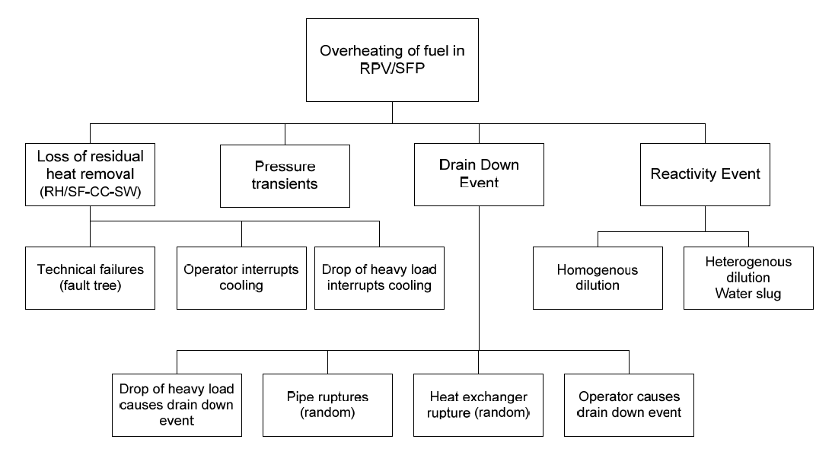

**Figure 9.3.1 General Master Logic Diagram for Overheating of Fuel [45]**

The level 2 PSA sequences begin with the end states as defined in Level 1. Any end state having the potential to release the fission products from the fuel in the core or SFP are transferred to Level 2. The L2 PSA assesses the amount, probability and timing of a release of radioactive substances leaking from the nuclear power plant during severe accidents.

**Table 9.3.1 Plant Operating States (POS) for SPSA [45]**

| ID | Description | Hours |
| --- | --- | --- |
| POS4:1 | FW is disconnected, AF is started, RC temperature 175 ºC, One RH train in operation, RC is filled | 4 |
| POS4:2 | PRZ is full, 2 RH trains in operation (second train started at temperature 120 ºC) | 2 |
| POS5:1 | RC temperature 93 ºC, The operability requirements - less restrictive, The phase covers the lowering of RC level up to DT5\*. | 30 |
| POS5\*:1 | Starts when first SRV is dismantled, The RC is now open, The RPV head is dismantled, The reactor cavity is filled. | 25 |
| POS6:1 | The reactor cavity is filled, Fuel is transported to the fuel pool | 45 |
| POS7 | The RPV does not contain any fuel, The SGs may be drained | 24 / 96 / 240\* |
| POS6:2 | Re-loading, The reactor cavity is filled, Draining the RC level to RPV flange | 60 |
| POS5\*:2 | The RPV head is mounted, Diesel tests are performed (i.e. in next phase all diesels are available), SI logic and full flow test are performed directly before filling of the RCS *Note that two different situations exist namely with or without water in the SGs (primary side)* | 40 |
| POS5\*:3 | The RCS is filled, The diesels are available, The SI is fully available | 8 |
| POS5:2 | The RCS is filled, All SRVs are mounted, Warming up | 30 |
| POS4:3 | RC temperature above 93 ºC, Continued warming, Bubble in PRZ | 12 |

\* The different times indicated for POS7 are due to different types of refuelling outages.

**Table 9.3.2 Shutdown PSA Level 2 – Example of outage period for a BWR in terms of residual heat**



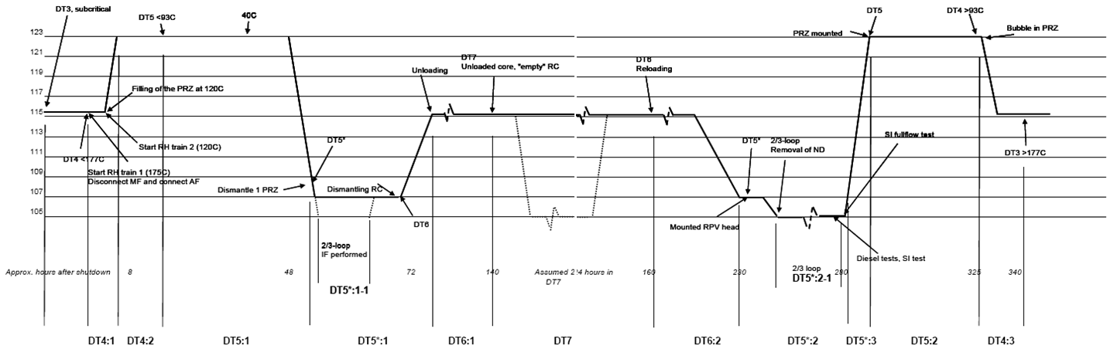

**Figure 9.3.2 SPSA Level 2 a Swedish NPP example (POS definitions)**

**Shutdown PSA Level 2 – Source terms**

Usual definition of source terms is based on:

* Noble gases;
* Volatile fission products CsI and CsOH;
* Non-volatile fission products BaO and MoO2;
* Rutenium;
  + During power operation conditions no large quantities of Ruthenium can be expected due to the **high vaporization** temperature of the metal.
  + If however heating of the core occurs in air, oxidation will occur and **Ruthenium oxides vaporize at much lower temperature**. Ruthenium is considered a volatile nuclide.
  + A prerequisite for significant amount of Ruthenium oxides to form is that enough **air is available**. It is most likely that it is necessary with double openings in RC in order for the air to flow through the core.

It is however very **difficult to calculate** the amount of Ruthenium and there is no model in MAAP that takes this into account.

**MAAP analysis**

For Shutdown L2 PSA a number of MAAP analysis cases have been run [34]. The purpose of MAAP analysis cases are:

* Calculate released amount of fission products during shutdown conditions depending on containment spray availability.
* Analyze importance of lower residual heat and different water level in RC during shutdown compared to power operating conditions.
* Verify the assumption that release category calculations for power operating conditions can be used also for shutdown conditions.

### An example from Swiss NPP’s (CCA)

**Example of POSs definitions for BWR Shutdown states [110]**.

The example given here is for a BWR4 NPP, which is scheduled to end operations within two years. It must be noted that the model of the phases (POSs) at shutdown is very much dependent on plant design, plant’s systems, and scheduling of operations during and before the shutdown period, therefore what is described here does not apply in detail to any other plant in operation. Nevertheless some of the considerations shown here apply in general to all NPPs.

NOTE:

The contribution would be more descriptive with added figures for each phase, but these are proprietary.

Shutdown operation is different from the full power operation because of the following reasons:

1. During power ramp-down and ramp-up reactor power level is lower comparing with full power level, but at the very beginning and at the very end of the shutdown period it may be close to the power operation
2. During power ramp-down and ramp-up reactor coolant pressure and temperature conditions are lower than at power, but at the very beginning and very end again close to full power status
3. In all phases of the shutdown period systems status is completely different since some systems during shutdown are

* not working,
* not available – disconnected,
* not available due to maintenance,
* not needed,
* not possible to use due to the pressure/temperature conditions.

Because of the above mentioned reasons it is necessary to define

1. interface point conditions between power operation and shutdown/low power operation as the starting/ending point for L1 PSA shutdown,
2. major changes in equipment configuration during the shutdown period,
3. major equipment relevant to the shutdown period.

Unlike the full power operation, the plant configuration changes with time during shutdown. The fuel is not restricted to the reactor vessel. Technical specifications for some important systems and equipment are relaxed to allow for maintenance that is not possible during power operation. These factors all must be considered in developing the shutdown analysis boundary. Functions such as decay heat removal and inventory control are still necessary. Other functions such as reactivity control are not applicable for shutdown. Because of these reasons also other criteria must be used to define properly particular phases of the shutdown period.

It is necessary to identify major system function and location (BWR) including signals significant to the operation modes:

* FWS - Fire water system
* ACWS system - Auxiliary Cooling Water System
* CNFW system - Condensate and Feedwater system
* FPCS system - Fuel Pool Cooling System
* STCS system - Shutdown and Torus Cooling System
* CIS system - Containment Isolation System (signals for steam tunnel operation, radiation in steam tunnel, reactor building radiation, signals for RPV level, limits for alarm signals etc.).

Monitoring signals from Technical Specifications for Operational Modes:

* measurement of radiation,
* measurement of the Sump Level,
* measurement of the Water Level in RPV and availability of signals in operational Modes.

The interface point between power operation and shutdown for the purpose of developing the shutdown PSA model is based on the definition of Plant Operational Modes. At the plant five reactor operating modes are defined:

* Mode 1 Normal Power operation
* Mode 2 Startup
* Mode 3 Hot Shutdown (where initially the turbine bypass is used for cooldown, RCS temperature reaches 150 oC, STCS starts, then after 3-4 hours reactor water temperature reaches < 100 oC , at this point “cold shutdown” is achieved).
* Mode 4 Cold shutdown (RPV opening, reactor well flooding the fuel pool dam between fuel pool and reactor well.
* Mode 5 Refuelling (starts at reactor head removal).

The status of front line systems to carry out the safety functions is also an important parameter for defining the interface.

Plant shutdown configuration significantly changes during shutdown operation. The plant shutdown documentation identifies several distinct phases of the shutdown process, representing so called shutdown POSs. These phases represent different plant configurations (including different success criteria or availability of critical systems) during the shutdown period.

The most fundamental characteristics involve the condition of reactor coolant system and of the reactor refuelling well. Throughout the outage, the requirement for, and the availability of, frontline and support systems varies, as the outage evolves. Similarly, the equipment that is in service changes to meet demands of specific configurations and to meet the need to perform maintenance on alternate trains or systems.

The shutdown phase configurations and phase durations (fraction of outage duration) were based on the outages in the period 1998 through 2008. The refuelling shutdown work plan is executed in three phases and shutdown analysis is consistent with these phases as follows:

* Phase 1: The boundary of shutdown analysis starts at the phase 1 of the shutdown work plan commencing about 4 hours before the end of Mode 3, when within the first hour the STCS is started at an RCS temperature of about 150 oC. This phase lasts until fuel pool dam removal.
* Phase 2: Corresponds to Mode 5.
* Phase 3: Corresponds to Mode 4 following Mode 5 after refuelling. Reactor well is drained and vessel closure is carried out. This phase lasts until initial withdrawal of control rods.

In contrast to full power operation, plant configurations and conditions significantly change during low power and shutdown operation. There are also different types of outages experienced by NPPs such as regular refuelling and maintenance outages and unplanned outages which follow a disturbance in normal operation. In the technical specifications, low power and shutdown operation is usually divided into several operational modes, each having its own operational requirements. Plant conditions, configurations, timing and transitions between operational modes also depend on the type of outage. The current practice for modelling this changing plant operational environment during low power and shutdown in the Shutdown PSA is to define a number of POSs which are used to describe the operational stages during the outages.

It is necessary to follow plant shutdown documentation with regard to the shutdown process which may involve several different phases or the so called shutdown POSs. These phases as mentioned earlier represent different plant configurations with different success criteria and availabilities of critical systems.

The shutdown phase or POS identification provides the primary assumptions regarding the shutdown analysis. POS are generally characterized by some or all of the following:

* reactor criticality (and/or shutdown margin),
* decay heat level,
* reactor coolant system temperature and pressure,
* primary system water level,
* status of RCS loops,
* location of the fuel,
* availability of safety and support systems,
* system alignments,
* status of the RPV head and containment.

The most fundamental characteristics involve the condition of the reactor coolant system and of the reactor refuelling well. The location of the reactor head, whether on or off the reactor vessel, greatly impacts the capability of frontline systems to provide makeup and decay heat removal. Also, the amount of water in the reactor or in the reactor’s refuelling well and decay heat level impact the available time for recovery following a loss of shutdown cooling systems.

Considering all these inputs, a review of the shutdown procedures and timeline should be conducted to identify the characteristics and unique configurations associated with the shutdown phases to be modelled. The outage types should be reviewed from plant outage history. The **phase configurations and phase durations** (fraction of outage duration) are then identified based on previous outages, which represent current practice at the plant. Outage durations and experience are thus based on real data being consistent **with plant-specific data for initiating events** included in the PSA for power operation.

There are basically three different types of outages:

* refuelling outages,
* planned maintenance outages and
* unplanned outages.

Based on the definition of the interface point between the full power and shutdown modes as described previously, it may be noted that the reactor outages that are relevant to shutdown PSA are those that lead to cold shutdown state.

**Important Shutdown Characteristics:**

**Table 9.3.3 Important shutdown characteristics**

| **Shutdown Characteristic** | **Options** |
| --- | --- |
| Status of reactor vessel head | Installed or removed |
| Status of reactor well | Not flooded or flooded |
| RCS pressure and temperature | Vary as the shutdown proceeds |
| Core cooling | STCS or (STCS and FPCS) |
| Location of fuel | Reactor vessel and/or fuel pool |
| Availability of SUSAN | Two trains, one train, or partial train |
| Availability of other safety and support systems | Status of PRVs/SRVs, TCS, CRDS, ACWS, TBICWS, Control Air and electrical support systems. |

**Time split fractions for Full Power and Shutdown Operation**

It should be noted that the **Full Power and Shutdown operation should be consistent** - taking into account the same data used as far as statistics on shutdowns and operation. The total length of the shutdown has an impact on the time frames used for calculation of maintenance unavailability values in full power model and in general on the total time frame used for duration of full power operation and shutdown operation and related frequencies of initiators. If the time fractions are distributed incorrectly, the contribution of some phases/components might be over- or under- evaluated, and does not provide a best estimate reflection of the shutdown phase contribution to the total risk corresponding to the full power model.

The three phases mentioned above were further divided into 6 sub-phases:

1A, 1B, 2A, 2B, 3A, 3C with corresponding time split fractions based on above given Shutdown Characteristics in **Table 9.3.3**.

**Phase 1**

During phase 1, the status of the RPV head changes from being installed to being removed. This is the major factor in dividing phase 1 into two sub-phases. With the head removed towards the end of the second sub-phase, a loss of decay heat removal will not result in an increase in system pressure. Therefore, a vent path through the pressure relief valves (PRVs) is not required to maintain the pressure below the shutoff head of low-pressure makeup systems: ALPS, CSS and firewater. In addition to being able to provide firewater through the permanently installed RPV firewater injection line, as directed in accident management procedures, removal of the RPV head allows for use of a fire hose on the 29.4 m elevation to provide firewater as an alternative makeup water source. Shortly following the removal of the RPV head, the main steam lines are plugged to allow maintenance on safety relief valves (SRVs) and PRVs.

With the line plugged, the normal vent path to the torus is no longer available. No other vent paths are considered in the procedures, although alternative vent paths may be established through the STCS. Therefore, with no return path to the torus credited, the use of SUSAN torus cooling system (TCS) as a backup means of removing decay heat is not credited in the analysis after RPV head removal, although the system is available in phase 1.

**Phase 1A**

Phase 1 of the shutdown plan begins in mode 3 with removal of reactor pool shield and start of one STCS train in shutdown cooling mode at RCS temperature is around 150 oC (STCS train aligned to the reactor recirculation loop). This train of STCS also provides head spray to cool the RPV head. When the RCS temperature reaches 100 oC, marking the beginning of mode 4, the second train of STCS is started and aligned directly through the **condensate clean up** system and feed water system. When STCS train B is connected directly to the KRA or clean-up filter, in the condensate & feed water cycle, the loop is called direct clean-up cycle. The fuel pool overflow line is connected to this STCS train and RPV level is increased. RPV level control is done as required by opening a drain valve to KAKO (condensate tank for makeup to the CRDs - Control Rod Drive Pumps). The increase in RPV water level in the initial phase is to provide shielding to personnel working on RPV head.

**Phase 1B**

Drywell head is removed followed by RPV head removal. Reactor internals (like steam dryer and moisture separator) are removed and placed in the reactor internals pool. **Reactor well flooding** process is accomplished by maintaining level in a condenser with the condensate storage tank (KAKO), connecting STCS train B to hotwell and pumping the inventory with a condensate pump through the condensate clean-up system and the feed water system to the reactor vessel STCS second train, usually train B is said to have been connected in indirect clean-up cycle connected as it is connected to the KRA or clean-up filters via hot well and in this case the STCS pump is kept working along with one condensate pump in minimum flow to flood the reactor vessel well. To flood the reactor well, STCS train B takes suction either from torus or the suction side is connected to RCS with the discharge connected to hot well and KAKO is used to make up the hot well and in turn to flood the reactor well. After the reactor well is flooded fuel pool dam is removed, the fuel pool and reactor well get joined marking the end of phase 1.

**Phase 2**

The transition from phase 1 to phase 2 is primarily marked by the flooding of the reactor well and removal of the fuel pool dam. The time between the reactor vessel well being fully flooded and removal of the fuel pool dam is a short duration, so that creating a unique analysis sub-phase for the condition with the reactor well flooded and the fuel pool dam in place does not provide additional insights into risk. Additionally, the availability required for alternate cooling systems is reduced following flooding of the reactor vessel well.

Phase 2 begins just after fuel pool dam replacement. Phase 2 involves mainly the fuel movement and lasts up to just before fuel pool dam installation.

During phase 2, two systems are used for fuel cooling, STCS and FPCS. Normal practice is to keep one train of the STCS in operation during all of phase 2. The FPCS provides secondary cooling, and is not capable of cooling both the fuel pool and the reactor core. During phase 2, fuel is moved from the reactor vessel to the spent fuel pool, and then is returned to the reactor vessel. These fuel shifts are a significant change in plant configuration and represent the major factor in dividing phase 2 into sub-phases.

Phase 2A

Phase 2 begins just **after the fuel pool dam removal**. FPCS provides cooling to fuel pool initially**. Fuel unloading** **from RPV** begins in phase 2. About half way through the fuel unloading, STCS discharge is extended also to fuel pool and that of FPCS is aligned to reactor well. **STCS train A is thus connected both to shutdown cooling loop and fuel pool**.

In case of phase 2 and phase 2 sub-phase definitions, some changes have been made in the 2009 model. As per the trend of refuelling in 2004-2008 and latest shutdown practices, it was observed that after about 50% of fuel offload from RPV to spent fuel pool, the STCS train A discharge is extended from RPV to spent fuel pool. It is also observed that the STCS train A is not disconnected from RPV when it is connected to fuel pool. STCS provides cooling to both RPV & fuel pool. Most of the planned maintenance on STCS is being carried out during Rx operation from 2005 onwards and thus STCS train B is also operable for most of the time in phase 2.

Thus there are no major changes taking place in system configuration within phase 2 except that the STCS A & B discharge is extended to fuel pool after about 50% of fuel offloading. The disconnection of STCS from fuel pool takes place in the beginning of phase 3 after fuel pool dam placement and thus phase 2 is divided only into two sub phases 2A & 2B (Throughout phases 1, 2, 3 STCS train A is generally connected to RPV and not disconnected unless there is a need for some small maintenance activities).

In present refuelling practice, there is just one change of configuration of STCS taking place in phase 2 at about completion of 50% fuel offloading (STCS discharge connected to both fuel pool and RPV) as explained above and the disconnection of STCS from fuel pool takes place after phase 2 in the beginning of phase 3. The human intervention for disconnecting of STCS from fuel pool is covered in phase 3A in the present model.

Phase 2B

Fuel unloading & **reloading** are carried out. Phase 2 ends just before installation of fuel pool dam.

From the refuelling shutdown experience it is seen that when STCS train A discharge is extended to RPV, STCS train B is also connected to STCS A discharge. **Thus, STCS train A and B provide cooling to both RPV and fuel pool after 50% fuel is transferred to fuel pool**. The requirement for cooling is however availability of only one train of STCS. STCS train B is stopped towards the end of phase 2B and STCS train A is disconnected from fuel pool after fuel pool dam is placed back i.e., in the beginning of phase 3A.

**Phase 3**

After refuelling activities are completed and the fuel is reloaded, **phase 3 starts with installation of the fuel pool dam** which is followed shortly by reactor vessel well drainage. Phase 3 is essentially the reverse of phase 1, except **that one train of the STCS is generally operating instead of two trains** except during the reactor well drainage or if condensate clean-up is in operation, which would require the second train of the STCS to operate.

Flooding the reactor vessel well provides a large quantity of water above the fuel that significantly increases the time available to recover from any potential event. It also is used as an indicator that certain equipment can be taken off line.

SUSAN systems provide a backup for fuel cooling for some shutdown states. The plant practice is to maintain two trains of SUSAN systems available until the reactor vessel well is flooded. When the reactor well is full, at least one train of SUSAN normally remains partially available from the normal offsite power supply. During years when the torus is drained for inspection, only the CWS system would potentially remain available.

**Phase 3A**

Phase 3 begins with **fuel pool dam installation**. STCS train A is disconnected from reactor well, remains connected only in shutdown cooling loop and FPCS discharge is connected back to fuel pool. In phase 3A**, prior to draining the reactor vessel well, at least one complete train of SUSAN systems is restored to available status. Reactor well is drained to KAKO** (with STCS B in direct clean-up cycle.

**Phase 3B**

Reactor internals are installed back, **RPV head and drywell head are installed**, all the system tests are carried out before initial withdrawal of control rods which marks the end of phase 3. The **second SUSAN train is restored prior to setting the head back** on the RPV.

The two Figures below summarize the discussion provided above and show the main characteristics of plant status during the shutdown phases.

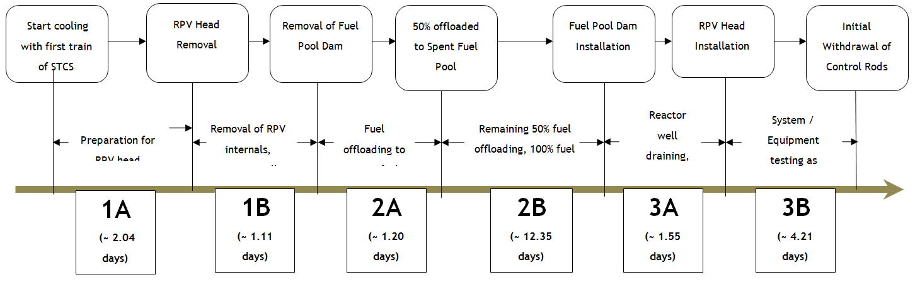

**Figure 9.3.3 Representation of Shutdown Phases (Total Fuel Offloading Scheme)**

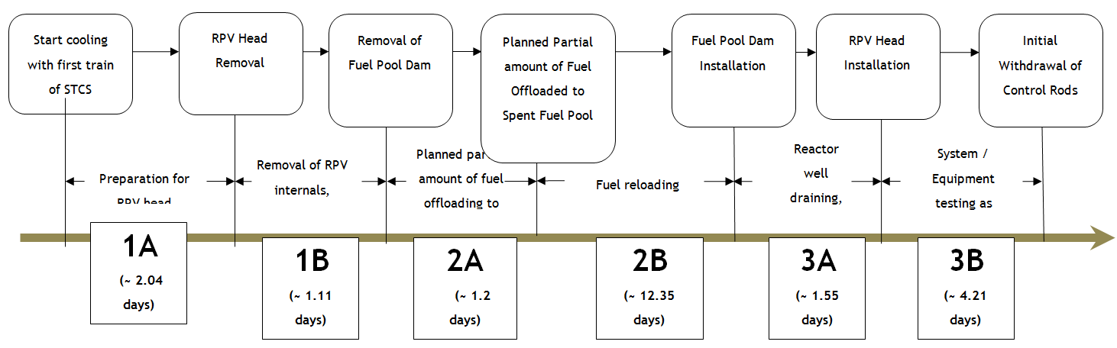

**Figure 9.3.4 Representation of Shutdown Phases (Partial Fuel Offloading Scheme)**

### An example from Ukrainian VVER’s (SSTC)

Ukrainian regulations currently in place require that full scope Level 1 and Level 2 PSA covering all operational states and full spectrum of initiating events (including internal initiators, internal and external hazards) potentially resulting in nuclear fuel damage in the reactor core as well as in the spent fuel pool is developed for all operating units. To satisfy this requirement the pilot studies for all unit types operating in Ukraine (namely, VVER‑440, VVER‑1000 "small series", VVER‑1000/V‑320) are performed and are being adapted to other (non-pilot) units. The general methodology used in pilot PSA studies is essentially the same, but there are plant-specific differences that were accounted in PSA as well as some differences in modelling assumptions applied by PSA developer teams. The description below represents typical approach applied while implementation in particular PSA study may have some specifics which are not reflected.

**Table 9.3.4** below provides typical list of VVER‑1000 plant operation states accounted in PSA for Ukrainian NPPs with VVER‑1000.

**Table 9.3.4 – Definition of POS for Ukrainian NPPs with VVER‑1000**

| No. | Plant operation state | POS duration for calculation of IE frequencies, hours |
| --- | --- | --- |
| 1 | POS1 "Decrease of reactor power from 50% down to minimal controlled level and transfer to a subcritical state" | 19 |
| 2 | POS2 "Hot standby " | 10 |
| 3 | POS3 "RCS cooling down to 200 °С" | 15 |
| 4 | POS4 "RCS cooling from 200 °С down to 150 °C" | 9 |
| 5 | POS5 "RCS cooling from 150 °С down to 140 °C" | 2 |
| 6 | POS6 "RCS cooling from 140 °С down to 80 °C" | 16 |
| 7 | POS7 "Cold shutdown with sealed RCS" | 105 |
| 8 | POS8 "RCS draining" | 515 |
| 9 | POS9 "Reactor core unloading (refuelling)" | 293 |
| 10 | POS10 "Reactor core unloaded" | 117 |
| 11 | POS11 "Cold shutdown after the repair or refuelling" | 160 |
| 12 | POS12 "RCS hydraulic repressurization tests (for tightness and for integrity)" | 38 |
| 13 | POS13 "RCS heat-up to 150 °C" | 97 |
| 14 | POS14 "RCS heat-up to 260 °C, hot stand-by prior to power increase" | 88 |
| 15 | POS15 "Transfer to critical state and power increase up to 40% of nominal" | 94 |

In the table above POS8–POS10 corresponds to the states with RPV open, and POS5–POS11 is characterized by open containment state. Description of POS with open RPV and containment, which are identified for Level 2 Low power and shutdown states PSA is provided in **Table 9.3.5**. In these states RCS temperature is less than 70 °C and RCS pressure is atmospheric.

**Table 9.3.5 – POS with open RPV and containment**

| POS # | POS title | RCS level | Main systems (equipment) in operation or "hot stand-by" state | Main systems (equipment) out of operation |
| --- | --- | --- | --- | --- |
| 8 | RCS draining | 200-300 mm below the main reactor seal | Heat removal is provided by 1/3 LPIS trains TQ12(22,32) in cold leg recirculation mode  Reactor is in subcritical state. All control rods are inserted into the reactor core.  Н3ВО3 concentration in RCS coolant and in pressuriser is 16–20 g/dm3.  At least two ECCS hydro accumulators are with nominal borated water inventory. Gas treatment and SFP ventilation systems are operable.  One of SFP cooling trains is in operation, the other one is in hot standby.  Other systems in hot standby:  - 1/3 LPIS trains TQ12(22,32);  - 1/3 trains of essential service water system QF11(21,31);  - 2/3 HPIS trains ТQ13, 23(33). | One of safety and support systems trains can be in maintenance.  SGs and secondary circuit systems may be out for repairing |
| 9 | Reactor core unloading (refuelling) | above 34.7 m | Heat removal of reactor core and SFP is provided by 1/3 LPIS trains TQ12 (22, 32) and by one of SFP cooling system trains, respectively.  Core unloading or refuelling is in progress.  Н3ВО3 concentration in RCS coolant and in pressuriser is 16–20 g/dm3.  Ventilation systems TL21, TL41, TL49 are in operation.  At least two trains of AOVs compressed air supply system (UT10, 20, 30) are in operation.  Other systems in hot standby:  - 1/3 LPIS trains TQ12(22,32);  - 1/3 trains of essential service water system QF11(21,31);  - 2/3 HPIS trains ТQ13,23(33);  - one of SFP cooling system trains. | One of safety and support systems trains can be in maintenance.  SGs and secondary circuit systems may be out for repairing |

It shall be noted that specific conditions of low power and shutdown modes (including the states with RCS and/or containment open) are accounted mainly at the plant damage states analysis and grouping stage. Therefore, PDS identification, grouping and selection of scenarios for detailed deterministic analyses are performed separately for POS with open containment and with isolated containment.

The containment vulnerability and response analysis performed in the framework Level 2 low power and shutdown states PSA involved evaluation of the main processes and phenomena associated with severe accidents for VVER‑1000. The analysis results indicate that:

* accidents occurred in POS with open RCS could not lead to an increase of RCS pressure; therefore phenomena associated with fuel degradation and melting at high pressure can be excluded;
* for POS with open RCS the reactor coolant boils off at temperatures which are not sufficient for self-sustained steam-zirconium reaction; therefore this process can be neglected at the early stages of severe accident progression; however for other low power and shut-down states this phenomenon still needs to be accounted, and hydrogen generation, deflagration and detonation conditions shall be evaluated and included in containment event trees;
* steam explosions were excluded both for nominal power Level 2 PSA and for low power and shut-down modes considering low probability of this event due to an absence of water in reactor cavity;
* such phenomena as high pressure melt ejection (HPME) and direct containment heating (DCH) are associated with event sequences with high RCS pressure. Correspondent conditions may exist either initially at the beginning of the accident or occur in the course of accident progression. However for operation states with open RCS any significant pressure increase is not possible, therefore for these POS the HPME and DCH phenomena can be excluded. For other low power and shutdown states the same assumptions as for nominal power operation are applicable;
* interaction of the molten core-with reactor cavity concrete begins after RPV failure. Since decay heat at LPSD states is much lower comparing to the nominal power operation state, greater time is required for base slab or cavity side walls melt through. To estimate time of containment failure associated with MCCI the analyses with MELCOR code need to be performed;
* static containment pressure increase depends on geometric characteristics of the containment. The analysis confirmed that containment structures failure due to pressure increase shall be accounted only for POS with isolated containment.

To evaluate accidents progression specifics and timing a number of MELCOR analyses were performed in the framework of Level 2 PSA for low power and shut-down states. The initial states with closed RCS as well as with open RCS were evaluated. POS8 (see **Table 9.3.5**) was selected as more representative one to evaluate scenarios for open RCS.

An example MELCOR analyses results for station blackout scenario in POS8 (RCS and containment are open) with dependent loss of decay heat removal are provided below. ECCS hydro accumulators are assumed to be unavailable. The cases evaluated include:

* no operation recovery case;
* recovery of one spray system train before RPV failure (at 55000 s);
* recovery of one spray system train after RPV failure (at 57000 s).

The objective of the analyses is to evaluate if hydrogen deflagration and detonation conditions can be reached in open containment state with PARs installed. Analyses results demonstrate that:

* for case without spray recovery the hydrogen deflagration conditions are not reached;
* containment spray restart results in steam condensation, an increase of hydrogen relative fraction and suction of air into the containment thus increasing the potential for hydrogen deflagration and detonation. Maximal hydrogen concentration reached depends on hydrogen concentration at the spray restart time and reaches 6.2% and 13% for spray restart before RPV failure and after RPV failure, respectively. Thus deflagration conditions are reached for the first of spray restart cases. Late containment spray restoration (after MCCI initiation) results in reaching the flame acceleration conditions;
* restart of containment spray at RPV failure time in open containment state does not have significant influence on radioactive release estimates.

Considering the above it can be concluded that overall hydrogen recombiners productivity is not sufficient for spray recovery at the ex-vessel SA phase. Since no significant effect on radioactive release is expected, late containment spray recovery is not recommended.

|  |  |
| --- | --- |
| Thot  **Figure 9.3.5 – Temperature of water and steam above core** | Reac_lev  **Figure 9.3.6 – Level of coolant in the reactor** |
| H2_mass  **Figure 9.3.7 – Mass of H2 generated in the core and in the reactor cavity (w/o containment spray restart)** | H2_mass_wSpray  **Figure 9.3.8 – Mass of H2 generated in the core and in the reactor cavity (with containment spray restart)** |
| Dome_Hydrogen_Molar_Fraction  **Figure 9.3.9 – Molar fraction of hydrogen in the containment** | Dome_Oxigen_Molar_Fraction  **Figure 9.3.10 – Molar fraction of oxygen in the containment** |
| Dome_Steam_Molar_Fraction  **Figure 9.3.11 – Molar fraction of steam in the containment** | Power  **Figure 9.3.12 – Decay heat in the core and the reactor cavity** |
| CsI_mass_ENV  **Figure 9.3.13 – Radioactive products class 16 (CsI) mass release to the environment** | |

The main conclusion from Level 2 PSA for POS with open RCS is that states resulting in containment isolation success and prevention of radioactive release outside the containment represent only 14% of the overall plant damage states frequency at low power and shutdown modes. This result is the consequence of large contribution of PDS with open containment. It shall be noted that in the base model of containment event trees the operator actions on containment closure and sealing are not accounted. Therefore, POS with open/non-isolated containment make a dominant contribution to the range/group of radioactive releases through leakages of the containment.

### EXAMPLE FROM BULGARIA (INRNE)

**(Based on KNPP information)** **Study of accident progression in unsealed VVER-1000/V320 reactor during repairing**

##### INTRODUCTION

This example presents a thermo hydraulic analysis of RHR system failure due to loss of low pressure pump (LPP) connected in RHR mode.

For analysis purposes is selected an operating condition of the KNPP, which unites all stable states in cold conditions where the primary circuit is opened by removing the MCP head. The selected plant state requires draining of the primary circuit coolant to the level of upper part of the MCP vessel.

The purpose of the analysis is to define the timing for reaching the following stages during the development of processes in the reactor system:

* Loss of sub cooling (ΔTSI<10 °C) in the core outlet;
* Beginning of reactor core uncovery;
* Beginning uncovery of primary circuit cold legs;
* Beginning core outlet temperature increase;
* The fuel cladding temperature beyond 923.15 K;
* Estimation of time for operators’ intervention.

The selected plant operating state is repair work with unsealed primary circuit by removing the MCP head during. The need of such analyses is determined by requirements for validation of EOP at shutdown and low power.

The reactor is at shutdown and cold condition before outage. The primary circuit is opened by removing MCP heads for performing some repairment actions. Because of that primary circuit water level is reduced to the upper part of MCP vessel. All control rods are inside the reactor core. Boron concentration is at 16g/kg. One channel of Low-Pressure Safety Injection System (LPSIS) is on standby. All other characteristics are selected as boundary conditions.

**Specific assumptions**

All systems for normal operation is consider to be unavailable after the initiating event. According to [A10], it is assumed that the operator switches on an LPSIS 30 min after the beginning of the initiating event.

In investigating conditions the safety systems are in following modes:

* one channel of LPSIS is in cooling mode;
* the second channel of LPSIS is connected by emergency make-up tank;
* the third channel of LPSIS is considered to be under repair.

Primary make-up system is conservatively excluded in the model.

The scenarios were discussed with KNPP experts as the most reasonable from an engineering point of view. In this way it can be stated that the scenarios are prepared based on the engineering judgment and experience in analysis of plant events.

The purpose of the analysis is to determine the development of the accident and to evaluate the time the operators from main control room (MCR) have before taking the necessary actions to prevent core damage in cases where this time is under 30 minutes.

##### DESCRIPTION OF THE KOZLODUY NPP AND RELAP5 MODEL

The reference power plant for this analysis is Unit 6 at Kozloduy NPP site. Systems and equipment of the KNPP, Unit 6 operate according to the design requirements for the corresponding level of reactor power [A1].

The RELAP code is designed to predict the behavior of reactor systems during normal and accident conditions [A2]. The analysis of the nuclear power plant’s behavior with thermo-hydraulic code is carried out for its safety justification in case of design disturbances during the processes and malfunctions or failures of the equipment. Several studies related to the VVER-1000 nuclear power plant accident, have been modelled with RELAP5/MOD3.2 [A3], [A4], [A5], [A6], [A7], [A8]. Usually most of the publications present accident analyses in the full power operation of the plant. Nowadays nuclear safety regulations require the shutdown state to be more systematically analyzed. In the present study a transient in shutdown state of the plant is analysed. For the purpose of the study RELAP5/MOD3.2 computer code has been used to simulate the VVER-1000/V320 NPP model [A9]. The model has been developed at INRNE-BAS for the analyses of operational occurrences, abnormal events, and design basis scenarios. The RELAP5 nodalization schemes of the plant used in the analysis are presented in Figures **9.3.14**-**9.3.17**.In modifying of the RELAP5 input data describing the model of the reactor VVER-1000 the shutdown and cold conditions and the modifications after the modernization program are taken into account. The actual four-loop system has been modelled by four single loops for primary and secondary sides. The model provides a significant analytical capability for the specialists working in the field of NPP safety. In the RELAP5 model for VVER-1000/V320 NPP are included: reactor vessel; core region represented by three channels; pressurizer system including heaters, spray and relief valves; safety system - low pressure injection pumps. In the model is also presented a make-up/drain system, including a connection (control) with the pressurizer. Secondary side is developed too and is presented by eight SG Safety valves, four BRU-A valves, BRU-K valves, steam pipe lines (including main steam header) and turbine, including a regulating valve in front of the turbine. The horizontal steam generator (SG) has been modelled. A separator model and the perforated sheet have been modelled in the SG model too. The main cooling pump (MCP) has been developed using homologous curves of real pumps.

##### BASE CASE SCENARIO

**Without operator actions -** the main goal of the analysis is to determine the progress of the accident and to assess the time which operators from MCR have before taking the necessary action to prevent core damage, where this time is less than 30 min [A9].

The expected accident scenario:

1. Initiating event – LPSIS failure in 0.0 s;
2. Simulation of failure of protection signal YZ which was actuated due to ΔTSI<10 °C. Because of that all channels of LPSIS will failed. YZ signal controls safety system;
3. Core uncover;
4. The fuel cladding temperature beyond 923.15 K.

##### OPERATOR ACTIONS SCENARIO

The main objective of the analysis is to demonstrate the effectiveness of the operator's action, in which the acceptance criteria "non-uncovering reactor core" has been successfully implemented.

The expected accident scenario:

1. Initiating event – LPSIS failure in 0.0 s;
2. Simulation of failure of protection signal YZ which was actuated due to ΔTSI<10 °C. Because of that all channels of LPSIS will failed. YZ signal controls safety system;
3. The operator starts one LPP after ΔTSI<10 °C and 30 min after the beginning of initiating event. Switching scheme is:

Safety injection tank (sump) – LPSIS emergency tank – LPP – Primary circuit – Containment - Safety injection tank (sump).

##### RESULTS

Comparisons of the most important parameters’ behaviour for the two scenarios are shown in Figures 9.3.18-9.3.23. The calculations are performed up to 15,500 s into transient time for the base case and up to 6,000 s for the operator action scenario.

Until the accident the reactor is cold, depressurized, the pressure is atmospheric. It is assumed LPSIS failure that leads residual heat from the core at outage cooldown mode.

Loop cooling in maintenance cooldown is: Primary circuit cold leg#4 before MCP - ECCS heat exchanger – LPP

- Primary circuit hot leg#1.

As a result of the LPP failure the water temperature starts to increase, leading to an increase in the coolant volume due to a change in the density of water, and after about 396 s is observed filling volume which simulates the upper part top of the unsealed MCP and there is significant loss of coolant, which stops at 1400 s as a result of evaporation of water, which boils at 390 s. Thus the loss of coolant up to 1400 s is as the leakage at initial moment (due to coolant expansion), and the evaporation of coolant through unsealed MCP. Loss of sub cooling (boiling of the coolant) in the core outlet is shown in **Figure 9.3.18**.

The behavior of the water level in the reactor core for the both scenarios is shown in **Figure 9.3.19**. After discontinue of the decay heat from the reactor core through an LPP it starts coolant reheating and therefore small water over the core, it quickly reaches boiling point. This is supported by both the increase of the temperature for the first 390 s (reaches 100 °C) and the rapid loss of the water level above the core, which for this type of accident is below the level of the primary circuit hot legs. One of the characteristics of this accident is that the reactor coolant level is 0.20÷0.35 m under upper part of the MCP vessel. Although the residual heat is less (11.5 MW), by **Figure 9.3.19** shows how fast (after 723 seconds) the core begins to uncover. Uncovering the core is the result of boiling water at the core outlet. Thus for base case, after about 3503 s, when the primary circuit cold legs uncover, the reactor core is cooling only by the water which is in the reactor vessel and has already begun the uncovering of the upper end of the core. Due to the boiling of the coolant at a pressure close to atmospheric, with slight changes, the low decay heat, for a long time no rise in temperature of the fluid is observed, i.e. no core heating is observed, which eventually occurs after significant core uncovery at 5,951 s. At 8,243 s fuel cladding temperature of the core outlet reaches 650 °C, which is a condition for leaving SB EOP and transition to SAMG.

Fluid heat up over the reactor core is shown in **Figure 9.3.20**, using the steam temperature because in RELAP5 the liquid temperature reaches only a saturation temperature, which depends only on pressure - i.e. steam is overheated. For base case after 5,951 s begins core reheating and there is overheated steam over the reactor core (**Figure 9.3.19**).

For the scenario with operator action it is assumed those 30 minutes after the beginning of the accident, the operator actuates one LPP. As a result of operator actions is prevented overheating of reactor core and coolant.

The fuel cladding temperatures are presented on **Figure 9.3.21**. For base case the fuel cladding temperatures have increased with the beginning of the core uncovery and at 8,243 s have reached the boundary value – 923.15 K of transition between EOPs and SAMG. For operator action scenario the fuel cladding temperatures do not reach this boundary value.

The behavior of the primary pressure is shown in **Figure 9.3.22**. Initially the pressure is about atmospheric, and slightly increases up to about less than 2 atmospheres due to boil water in the core and in the presence of hydro-lock in primary circuit cold leg, which do not allow free movement of the steam to the point of the primary circuit depressurization – upper part of the MCP#2. The PRZ level is presented in **Figure 9.3.23**. LPSIP flow rate is presented in **Figure 9.3.24**. **Figure 9.3.25** illustrated leakage flow rate through unsealed MCP to containment.

##### CONCLUSIONS

In this section is discussed the thermal-hydraulic calculation of loss of RHR system at shut down plant state and unsealed primary circuit for VVER-1000/V320 units at KNPP. As a result of the thermo-hydraulic analysis the following general conclusions are formulated:

The operator has a short time to avoid a partial core uncovery. The reason is the minimum coolant volume in the primary circuit. The partial core uncovery, which is observed in the first 10-30 minutes, does not lead to the core heating up.

Simultaneously, it should be noted that due to the characteristic of the initial state, namely atmospheric pressure and an inlet temperature of the core 70 °C and minimum residual heat, beginning of reactor core heat up occurs after 5951 s, the fuel cladding temperature reached the 923.15 K (boundary value of transition between EOPs and SAMG) at 8243 s. This shows that even if there is an insignificant core uncovery, the operator will have enough time before reactor core heat up occurs.

##### References:

1. Groudev, P.P., Pavlova M.P., Demerdjiev P.A., Data Base for VVER-1000/V320. SACI of KNPP, BOA 278065-A-R4, INRNE-BAS, Sofia, 1999.
2. Allison, C.M., Hohorst, J.K., Role of Relap/SCDAPSIM in nuclear safety, Science and Technology of Nuclear Installations, Article number 425658, 2010.
3. Pavlova M., Andreeva M., Groudev. P., Steam Line Break investigation at full power reactor for VVER-1000/V320, [Nuclear Engineering and Design](http://www.researchgate.net/journal/0029-5493_Nuclear_Engineering_and_Design), Vol. 285, pp.65-74, 2015.
4. Pavlova M., Andreeva M., Groudev. P., RELAP5/MOD3.2 blackout investigation for validation of EOPs for KNPP VVER-1000/V320, [Progress in Nuclear Energy](http://www.scopus.com/source/sourceInfo.url?sourceId=13182&origin=recordpage), Vol. 49 (5), pp. 409-427, 2007.
5. Andreeva M., Groudev P., Pavlova M., “Analytical validation of operator actions in case of primary to secondary leakage for VVER-1000/V320, Nuclear Engineering and Design 295 (2015), 479-488.
6. Andreeva M., Pavlova M., Groudev. P., Investigation of critical safety function "Heat sink" at low power and cold condition for Kozloduy Nuclear Power Plant WWER-1000/V320, [Annals of Nuclear Energy](http://www.scopus.com/source/sourceInfo.url?sourceId=29363&origin=recordpage), Vol. 40, pp. 221-228, 2012.
7. Groudev. P., Andreeva M., Pavlova M., Investigation of Nuclear Power Plant Behaviour at Low Power and Cold Conditions During an Overpressurization in Primary Circuit, [Annals of Nuclear Energy](http://www.scopus.com/source/sourceInfo.url?sourceId=29363&origin=recordpage), Vol. 62, pp. 231-241, 2013.
8. Groudev. P., Andreeva M., Pavlova M., Investigation of main coolant pump trip problem in case of SB LOCA for Kozloduy Nuclear Power Plant, WWER-440/V230, [Nuclear Engineering and Design](http://www.researchgate.net/journal/0029-5493_Nuclear_Engineering_and_Design), Vol. 76, pp. 137-145, 2015.
9. Groudev, P.P., Pavlova M.P., Demerdjiev P.A, Engineering Handbook. SACI of KNPP, BOA 278065-A-R4, INRNE-BAS, Sofia, 1999.
10. BNRA – Bulgarian Nuclear Regulatory Agency, “Statute book on the Safe Use of Nuclear Energy, vol. 1, Sofia, 2004.

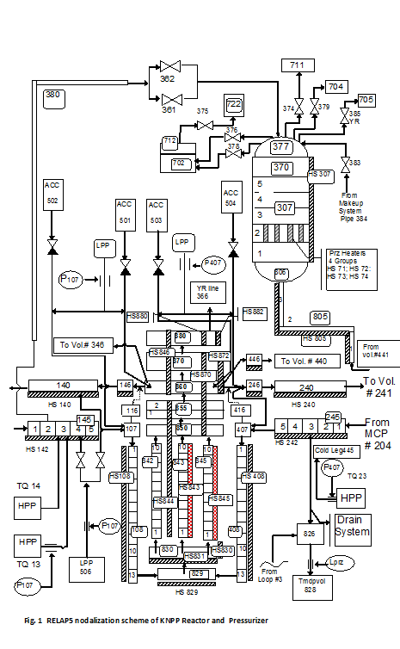

**Figure** **9.3.14 RELAP5 nodalization scheme of KNPP Reactor and Pressurizer**

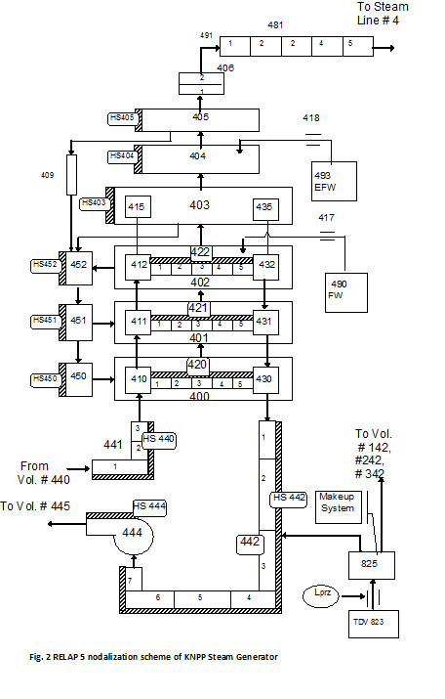

**Figure 9.3.15 RELAP5 nodalization scheme of KNPP Steam Generator**

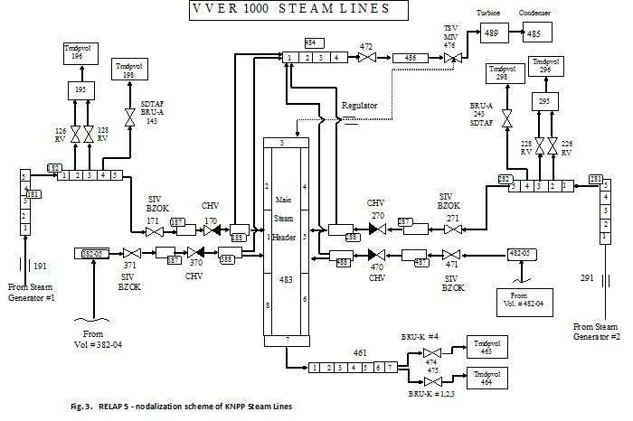

**Figure 9.3.16 RELAP5 – nodalization scheme of KNPP Steam Lines**

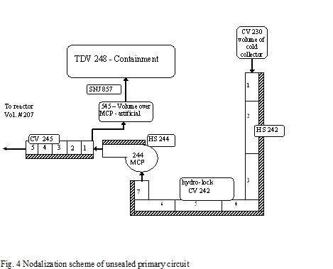

**Figure** **9.3.17 Nodalization scheme of unsealed primary circuit**

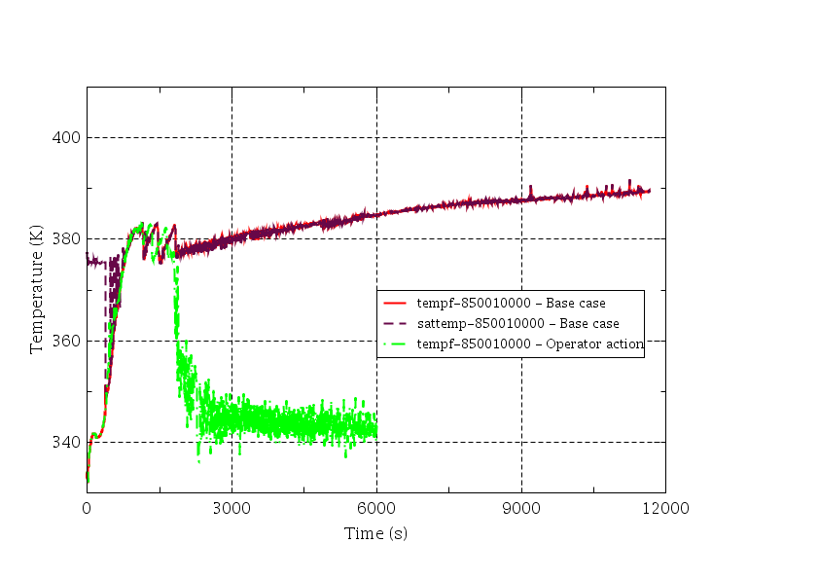

**Figure** **9.3.18 Core outlet temperatures**

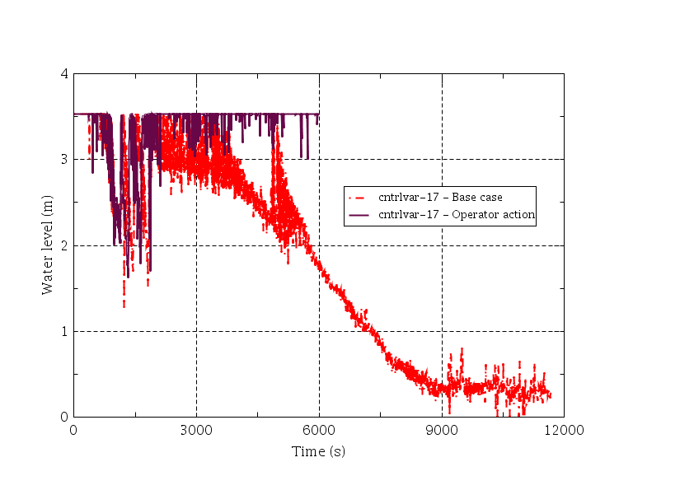

**Figure 9.3.19 Water level in the reactor core**

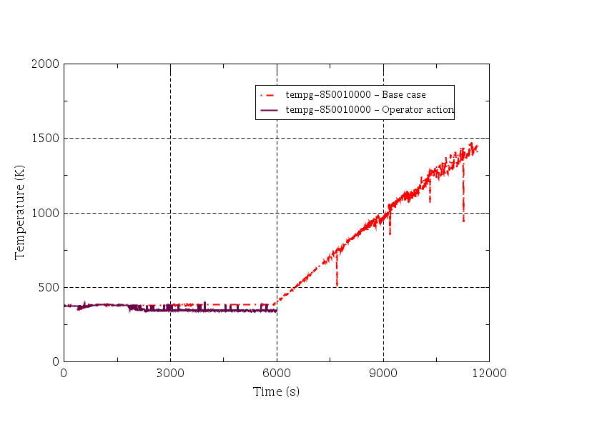

**Figure 9.3.20 Gas coolant temperature in the core outlet**

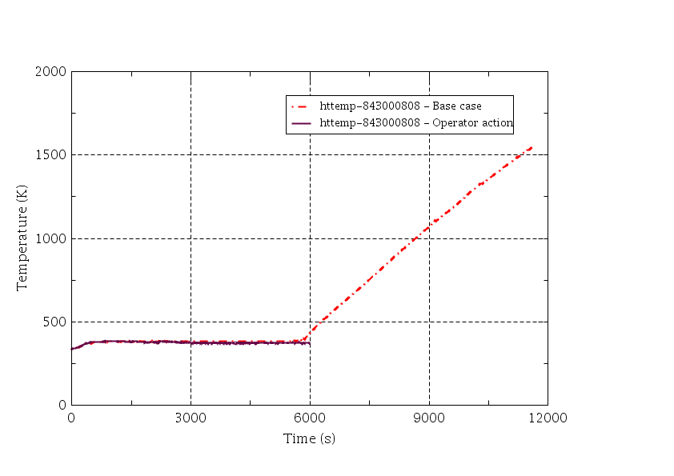

**Figure 9.3.21 Fuel cladding temperature in the core**

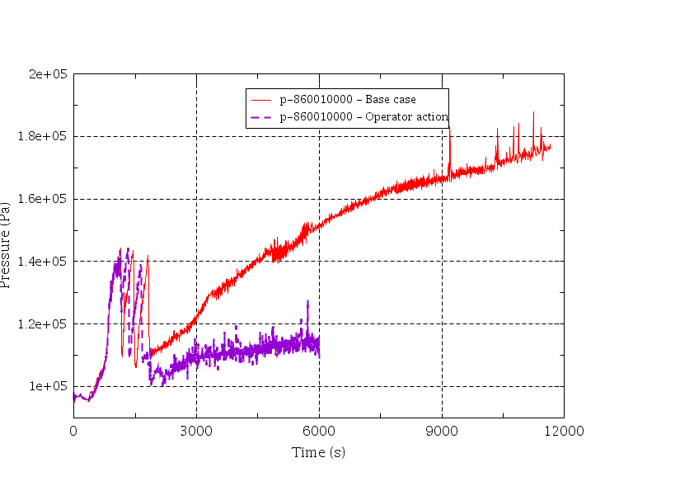

**Figure 9.3.22 Primary pressure**

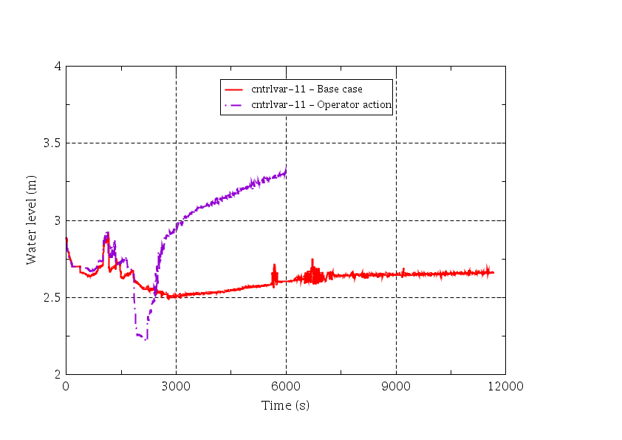

**Figure** **9.3.23 PRZ level**

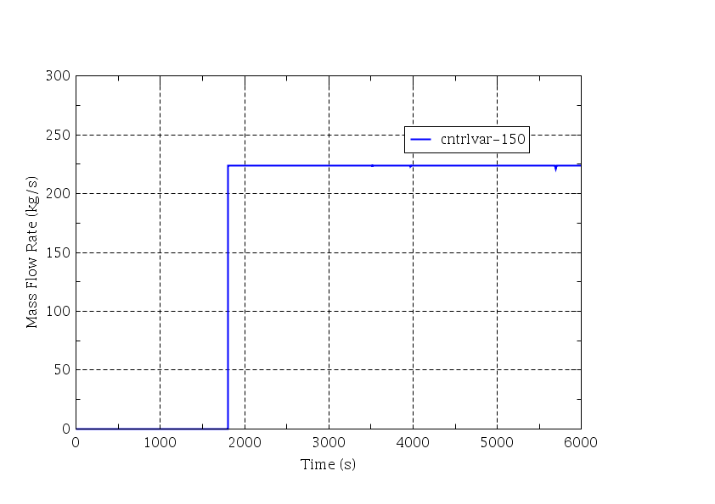

**Figure 9.3.24 LPP flow rate to primary circuit– Operator action**

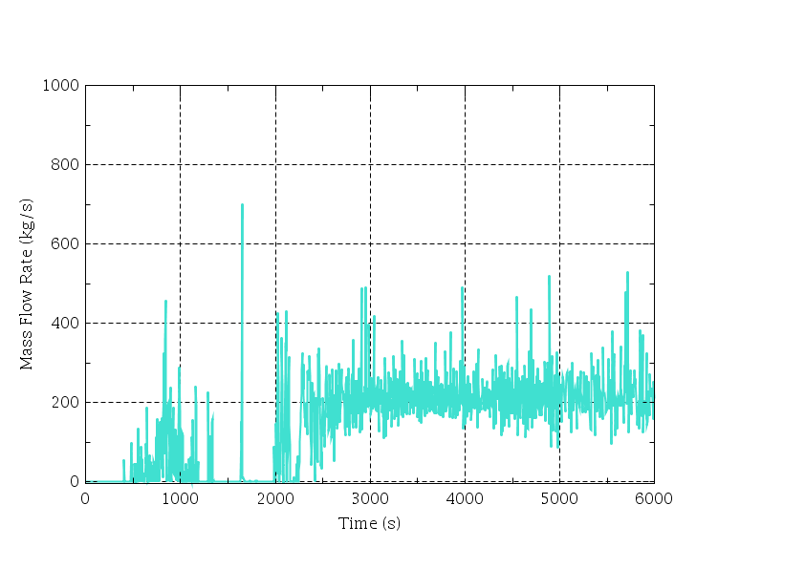

**Figure 9.3.25 Leakage flow rate through unsealed MCP to containment– Operator action**

Example for low power and shutdown plant state conditions, including unsealed states for VVER 1000 reactor, based on KNPP information.

**Table 9.3.6 List of plant operating states for low power and shutdown probabilistic safety analysis**

| POS | RCS  Average  temperature  (°C) | RCS  pressure  (bar) | RCS status  (closed, partially  open, open) | Containment  status (closed,  open) | RCS level (full,  mid-loop, level,...) | Residual heat removal  when the core is in the  reactor | Additional characteristics (criticality, decay heat, plant configuration [status of rod, reactor coolant pump,...], location of the fuel, availability of safety and support system, status of automatic protection) |
| --- | --- | --- | --- | --- | --- | --- | --- |
| POS1 | 280 | 160 | Closed | Closed | Full, steam in pressurizer. | Secondary system (4 SGs are fed by one main feed water pump or by 2 auxiliary feed water pumps and steam removed through turbine bypass [BRU-K]). | Reactor is at low power conditions before outage. Decrease of the unit from 40% to shut down. Shutdown of main feed water pump at the end of this POS.  Availability of all safety systems and of all automatic protections.  At the end of this POS, all control rods are dropped and Boron concentration increases to maximum 16g/kg. |
| POS2 | From 280 to 230 | From 160 to 70 | Closed | Closed | Full, steam in pressurizer. | Secondary system (4 SGs are fed by 2 auxiliary feed water pumps and steam removed through BRU-K). | Reactor is at hot shutdown before outage with availability of all safety systems and of their automatic protections.  All control rods are inside the core. Boron concentration is at 16g/kg.  Operation of one TK makeup pump.  3 or 4 MCPs in operation. |
| POS3 | From 230 to about 160 | From 70 to 20 | Closed | Closed | Full, steam in pressurizer. | Secondary system (4 SGs are fed by 2 auxiliary feed water pumps and steam removed through BRU-K). | Reactor is at hot shutdown before outage with unavailability of hydro accumulators and of some automatic protections (interlock for At, >75°C ,automatic closing of MSIV  Protection. Hydro-press" of MCP).  All control rods are inside the core. Boron concentration is at 16g/kg.  Operation of one TK makeup pump.  3 MCPs in operation. |
| POS4 | From about 160 to 90 | Between 40 and 15 | Closed | Closed or open | Full, N2 in  pressurizer. | Secondary system (4 SGs fed by 2 auxiliary feed water pumps and steam removed through BRU-K). | Reactor is at intermediate shutdown before outage.  All control rods are inside the core. Boron concentration is at 16g/kg.  3 MCPs in operation.  Operation of one TK makeup pump.  Availability of two LPIS trains in RHR. And one train in safety injection.  Switching off of pumps of TQn3, TQn4, TQn1 and TX at 150 °C.  Availability of new COP system. |
| POS5 | From 90 to 7Z | From 18-12 to above 5  (in case of maintenance outage without core  refuelling)  or to atm  (in case of outage with core refuelling) | Closed | Closed or open | Full, N2 in  pressurizer. | Operation of one train of TQn2 /RHRS. | Reactor is at cold shutdown before outage. All control rods are inside the core. Boron concentration is at 16g/kg.  Availability of one LPIS train in safety injection configuration and one LPIS train in RHR configuration.  Shutdown of all MCPs.  Operation of one makeup pump.  Unavailability of TQn3.  Availability of new COP system. |
| POS6 | Below 70 | From 18-12 to about 5 | Closed | Closed or open | Full, N2 in  pressurizer or  Water solid RCS | Operation of one train of TQn2 /RHRS. | Reactor is at cold shutdown for outage (except RCS and refuelling outages). All control rods are inside the core. Boron concentration is at 16g/kg. Preventive maintenance of one train of safety system, of one train of support system and of one power grid. Availability of one LPIS train in safety injection configuration. Availability of SGs and of systems from secondary side. Unavailability of TQ n3. Automatic protection:   * Availability of new COP system; * Availability of automatic protection in case of LOOP; * In all other cases operator actions are required for actuation of LPIS. |
| POS7 | Below 70 | Atm | Partly open (3 unsealed central control rod drives to prevent H2 bubble formation under top of RCS). The equivalent diameter is 240 mm. | Closed or open | Reactor flange level | Operation of one train of TQn2 /RHRS | Reactor is at cold shutdown before outage. All control rods are inside the core. Boron concentration is at 16g/kg.  Preventive maintenance of one train of safety systems, of one train of support systems and of one power grid.  Availability of one LPIS train in safety injection configuration. Unavailability of TQ n3.  Automatic protection:   * Availability of new COP system; * Availability of automatic protection in case of LOOP; * In all other cases operator actions are requires for actuation of LPIS. |
| POS8 | Below 70 | Atm | Open (vessel head off) | open | Reactor flange level | Operation of one train of TQn2 /RHRS. | Reactor is at cold shutdown before outage. All control rods are inside the core. Boron concentration is at 16g/kg.  Preventive maintenance of one train of safety systems, of one train of support systems and of one power grid.  Availability of one LPIS train in safety injection configuration.  Availability of two trains of TQn3. |
| POS9 | Below 70 | Atm | Open | Open | Refuelling level | Operation of one train of TQn2 /RHRS | Refuelling, core unloading.  Boron concentration is at 16g/kg.  Preventive maintenance of one train of safety systems, of one train of support systems and of one power grid.  Availability of one LPIS train in safety injection configuration.  Availability of two trains of TQn3. |
| POS10 | Below 70 | Atm | Open | Open | RCS may be drained | Nothing | Core empty.  Preventive maintenance of one train of safety systems, of one train of support systems and of one power grid |
| POS11 | Below 70 | Atm | Open | Open | Refuelling level | Operation of one train of TQn2 /RHRS. | Core loading.  Boron concentration is at 16g/kg.  Preventive maintenance of one train of safety systems, of one train of support systems and of one power grid.  Availability of one LPIS train in safety injection configuration.  Availability of two trains of TQn3. |
| POS12 | Below 70 | Atm | Closed | Open | Reactor flange level | Operation of one train of TQn2 /RHRS. | Reactor is at cold shutdown after outage. All control rods are inside the core. Boron concentration is at 16g/kg.  Preventive maintenance of one train of safety systems, of one train of support systems and of one power grid.  Availability of one LPIS train in safety injection configuration.  Availability of two trains of TQn3. |
| POS13 | Below 70 | Atm | Closed | Open | Reactor flange level | Operation of one train of TQn2 /RHRS. | Reactor is at cold shutdown after outage. All control rods are inside the core. Boron concentration is at 16g/kg.  Availability of one LPIS train in safety injection configuration and one LPIS train in RIR configuration. |
| POS14 | Below 70 | From atm to 5-18 | Closed | Open | Full, N2 in pressurizer.  water-solid  RCS. | Operation of one train of TQn2 /RHRS. | Reactor is at cold shutdown after outage. All control rods are inside the core. Boron concentration is at 16g/kg.  Availability of one LPIS train in safety injection configuration and one LPIS train in RHR configuration.  Operation of one TK makeup pump Unavailability of TQn3.  Availability of new COP system. |
| POS15 | From below 70 to 160 | Between 18 and 25 | Closed | Closed | Full, N2 in  pressurizer  Or water-solid  RCS. | Nothing | Reactor is at intermediate shutdown after outage. All control rods are inside the core. Boron concentration is at 16g/kg.  Safety systems TQn2, TQn3, TQn4, TQn1 and DC are disconnected.  Pressure tests of RCS and SGs are performed  3 MCPs in operation.  Operation of one TK makeup pump. Unavailability of TQn3 when primary temperature is lower than 150 °C. Availability of new COP system. |
| POS16 | From 160 to 230 | From 18-25 to 70 | Closed | Closed | Full, steam in pressurizer | Nothing | Reactor is at hot shutdown after outage with unavailability of hydro accumulators and of some automatic protections (interlock for At >75°C, automatic closing of MSIV,  Protection "Hydro-press" of MCP up to 200°C in the primal)/ circuit).  All control rods are inside the core. Boron concentration is at 16g/kg.  Availability of other safety systems (TQn1, TQn2, TQn3, TQn4) and their automatic protections.  Operation of one TK makeup pump.  3 MCPs in operation up to 200°C in the primary circuit. |
| POS17 | From 230 to 280 | From 70 to 160 | Closed | Closed | Full, steam in pressurizer. | Secondary system (4 SGs are fed by 2 one auxiliary feed water pumps and steam removed through BRU-K). | Reactor is at hot shutdown after outage with availability of all safety systems and of their automatic protections.  All control rods are inside the core. Boron concentration is at 16g/kg.  Operation of one TK makeup pump.  4 MCPs in operation. |
| POS18 | 280 | 160 | Closed | Closed | Full, steam in pressurizer. | Secondary system (4 SGs are fed by 2 auxiliary feed water pumps and steam removed through BRU-K). | Reactor is at low power conditions after outage. Increase of the unit to 40% NP.  Start-up of main feed water pumps.  Availability of all safety systems and of all automatic protections.  All control rods are at the top of the reactor. |

# 

# Examples of ACCIDENT PROGRESSION in spent fuel pool

## Example from GRS for Spent fuel pool accident in a PWR

GRS has been working on a research project financially supported by the German Federal Ministry of Economics and Technology (BMWi) regarding the extension of probabilistic analyses for SFP. Supporting deterministic analyses of the accident progression inside the SFP were a main part of the project. The accident progression has been analysed for both PWR and BWR pools by using the integral code MELCOR 1.8.6. Objective of the research project was the development of a basic approach for consideration of SFP within Level 2 PSA, the quantification of event trees, and the identification of possible mitigative accident measures. The work has been kindly supported by the utilities of the two reference plants by providing plant data.

General boundary conditions of the MELCOR analyses are:

* the modelling includes spent fuel pool, reactor circuit, containment/reactor building (closed) and relevant compartments of adjacent buildings,
* passive autocatalytic recombiners (PARs) are considered as realized in the plants, other SAM measures have not be considered,
* different loadings of the pools:
  + standard loading during normal power operation (shortly after finishing in-service inspection 🢣 highest decay heat for that operating mode),
  + partial loading during in-service inspection (one third of the core has been moved into SFP; connection with filled flooding compartment and reactor pressure vessel),
  + full loading: inclusion of the whole core from RPV into SFP; pool connected to filled flooding compartment and RPV, and
  + full loading: inclusion of the whole core from RPV into SFP; pool separated from flooding compartment (worst case regarding the timing of severe accident sequence).
* Postulated initiating event: long lasting station black out (Leaks in the lower part of the SFP are considered as practically eliminated for German NPPs due to the design of the pool (pipe connections only in the upper part of SFP, at least 6 m above the top edge of racks; design against earthquakes between VI and VIII on the EMS/MSK scale).

A schematic picture of a SFP inside a German PWR is given in **Figure 10.1.1**.

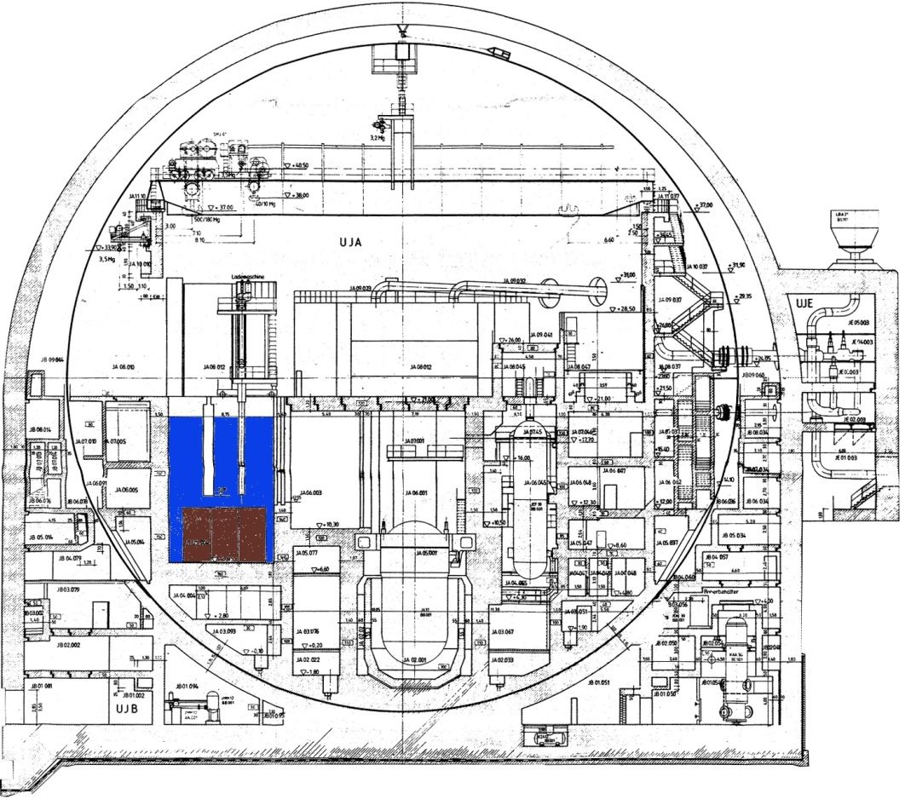

**Figure 10.1.1 Schematic arrangement of SFP in a German PWR with potential containment failure modus**

Detailed modelling of the containment and reactor building annulus was applied. 58 passive autocatalytic recombiners (PARs) distributed on 37 control volumes have been considered. Depletion of hydrogen and carbon monoxide is calculated by the PAR model.

**Table 10.1.1** provides summary results for four calculated sequences.

**Table 10.1.1 Summary results of PWR SFD analyses**

|  | Standard Loading  (hh:mm:ss) | Partial Loading (hh:mm:ss) | Full Loading, Flooding Compartment filled (hh:mm:ss) | Full Loading, Pool separated\*\*\*  (hh:mm:ss) |
| --- | --- | --- | --- | --- |
| Initiating event | 00:00:00 | 00:00:00 | 00:00:00 | 00:00:00 |
| Water Level at top edge of racks | 342:08:20 | 105:41:40 | 112:58:20 | 50:28:30 |
| Failure Fuel Assemblies | - | 538:34:30 | 165:42:00 | 65:29:44 |
| Water Level at lower support plate of racks | 677:38:20 | 239:04:00\* | 174:02:54 | 99:03:20 |
| Start of significant relocation | - | 538:50:30 | 166:01:40\* | 82:26:40\* |
| Water completely evaporated | - | 284:51:40\* | 180:31:40 | 108:50:00 |
| Failure of steel liner | - | 538:53:40 | 185:22.31 | 109:25:00 |
| Start of MCCI | - | - | 366:15:50 | 121:20:03 |
| Failure of concrete of the bottom of SFP | - | - | 413:36:40 | 132:06:14 |
| Relocation in compartments below SFP | - | - | 413:36:40 | 132:06:14 |
| Relocation into sump | - | - | -\*\* | 134:23:20 |
| Start first venting | - | - | 477:48:20 | - |
| Stop first venting | - | - | 483:38:20 | - |
| End of calculation | 694:26:40 | 694:26:40 | 497:28:20 | 694:26:40 |

\* Calculated point in time cannot be depicted in the right chronological order

\*\* No 4th cavity (sump) has been used

\*\*\* Calculation with four cavities

For the sequence “Full Loading, Flooding Compartment filled” the containment pressure (**Figure 10.1.2**) and the hydrogen masses (**Figure 10.1.3**) are shown.

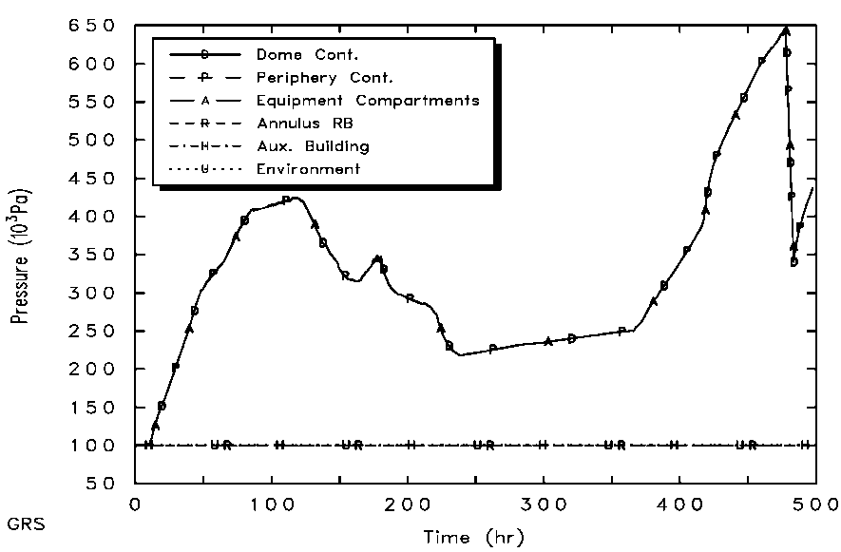

MCCI SFP

End Venting

Start Venting

**Figure 10.1.2 Containment pressure for sequence SFP Full Loading, Flooding Compartment filled**

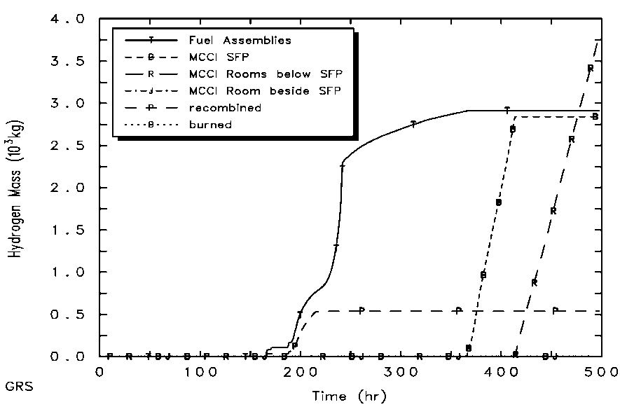

Oxygen consumed

**Figure 10.1.3 Hydrogen masses for sequence SPP Full Loading, Flooding Compartment filled**

The following general conclusions can be drawn:

* MELCOR is, in principle, able to calculate SFP melt scenarios. However, several adjustments have to be made to the input, so that the results need careful interpretation.
* Evaporation extends over several days 🢣 steam concentrations inside SFP and containment are high 🢣 impact of air oxidation is small, hydrogen is generated by Zr-Steam and MCCI chemical reactions.
* Only for low decay heat inside SFP, where uncovering of the fuel assemblies is terminated before their heat-up, air oxidation can occur after steam concentration has been depleted.
* Heat transfer by thermal radiation has an impact on the containment (calculated by a simple control function model) 🢣 strong heat-up of the containment above SFP beyond design temperature.
* It might be helpful to initiate filtered containment venting earlier in case of SA inside SFP in order to prevent high containment loads and high venting temperatures later.
* It is very likely that SA sequences inside SFP run into filtered containment venting.
* During fuel degradation in the SFP (before MCCI begins) the temperatures are lower than in RPV accidents during normal operation 🡪 less release of radionuclides from fuel. After MCCI has started, the release fractions from fuel reach levels which are known from accidents in the RPV.
* With full loading of the SFP, the fuel melt layer (including material of the racks) at the bottom of the SFP is in the order of 1 m. Such a thick melt layer would probably develop heat transfer mechanisms (convection, steel layer on top) which enhance lateral erosion. Depending on the NPP design, this may lead to different sequences than vertical erosion. In case of the German design, radial melt-through of the containment may be possible. If, on the other hand, corium penetrates through the bottom of the SFP into the sump region, MCCI could be stopped because of the large amount of water in the sump, and because the melt spreads on bigger areas.
* For normal loading of the SFP (i.e. in normal operation with RPV fully loaded) the accident evolution in the SFP is much slower than in the RPV.

Based on these MELCOR analyses a simple and rough event tree analysis has been performed for SFP accidents. The event tree analysis indicates that there is more than 90% probability for successful containment venting. Late containment failure has approx. 5% probability (e.g. due to venting inoperability, thermal containment failure, containment melt-through). All other failure modes (e.g. open containment, damage due to hydrogen combustion) are insignificant.

## ASETC Calculations OF SFP ACCIDENTS IN L2 PSA (IRSN)

### CONTEXT IN FRANCE

The French operating PWRs (Gen II) includes SFP which are located outside the reactor building. An additional common SFP is planned to be created in near future to limit the quantity of fuel assemblies in existing SFPs.

The safety of SFP is based on design features that allow prevention of fuel melt accident. Accident situations initiated by a long term total loss of cooling would be managed thanks to additional water make-up. These additional water make up are reinforced by EDF after the Fukushima. Accidents situations initiated by SFP draining have to be excluded thanks to specific features like siphon breakers, pipe elevations, system design (isolation), quality of the SFP steel liner, etc. SFP L1 PSAs were developed by EDF for operating NPPs and lead to improvement of the SFP circuits and transfer channel from reactor. These improvements by EDF are implemented during PSR.

Concerning “criticality”, the safety demonstration is provided by the geometry of the SFP (minimal distance between the assemblies) for the 900 MWe PWR series, by the geometry of SFP and the presence of neutron absorber plates between the assemblies (high density racks) for the 1300 and 1450 MWe PWRs.

In PSAs fuel melt accidents in a SFP are always associated to “large release” accidents. No mitigation measures are credited, until now, because the SFP buildings are not designed for that purpose.

### 900 AND 1300 MWE PWR SFP CONFIGURATIONS STUDIED WITH ASTEC

To prepare a future extension of IRSN L1-L2 PSA to SFP accidents, ASTEC simulations have been performed for the 900 and 1300 MWe PWRs. Such simulations need number of data like:

* geometric or material data: for the fuel bundles, racks, SFP, fuel building
* data on the source of radioactivity: assembly number stored in the fuel, residual power;
* data on the reactor and SFP operating states and fuel management (charge/discharge) process: power states of reactor, working shutdown, refuelling shutdown, and reactor fully discharged.

The reactor building is separated from the fuel building and to enable the transfer of the fuel, a transfer tube links the reactor and the fuel pools. The pools in reactor and fuel buildings are divided in two and three compartments. Each compartment is separated from another by a gate. The Fuel Pool Cooling System is connected to the Reactor Heat Removal System and to the Reactor Water Safety Tank. So, in addition to the cooling of the spent fuel, this system may be used to back up the reactor cooling system or to fill and to drain the pools.

All the possible states of spent fuel pool have been studied

* Reactor core fully discharged in the SFP (RP-API in Figure 10.2.1): the IRSN calculations consider that the SFP accident occurs at the beginning (point 2 of the Figure 10.2.1) and at the end (point 3 of the Figure 10.2.1) of this SFP state. At this moment, the whole reactor assemblies have been discharged in the pool, therefore the residual power is maximal,
* Reactor core fully charged (APR in Figure 10.2.1): the SFP state is defined by the end of refuelling (point 4 of the Figure 10.2.1) and the beginning of the unloading (point 5 of the Figure 10.2.1). The time of that SFP state is generally very long because the reactor produces electricity during this period. The assemblies stored in the pool are cooled and have lost most of their residual power. This is the reason why the assessment distinguishes the point 4 and point 5.
* Refuelling shutdown (APR in Figure 10.2.1): the IRSN assessment considers that an accident occurs during handling of an assembly. During this operation, the water height above handling assembly is minimal. The variation of residual power contained in the pool can be important: at the beginning of the refuelling shutdown, only “cold” assemblies are in the pool but at the end of refuelling shutdown, reactor assemblies are in the pool.

Two types of initiating events are addressed in the ASTEC calculations: the total loss of cooling and the rapid drainage accidents. This is a parametric study and realism of such situation has not been considered. A loss of SFP cooling accident could occur if the cooling system of the pool is failed and if the water injections in the pool are not available. A draindown flow rate could be induced by a little leak of the pool but an error on circuit configurations (that would not be detected and stopped by automatism).

For each state of spent fuel pool except refuelling shutdown, IRSN has studied with ASTEC:

* the uncovering of fuel assemblies stored in the pool due to a loss of cooling
* the uncovering of fuel assemblies stored in the pool due to a rapid draindown.

For the particular case of refuelling shutdown, IRSN has assessed with ASTEC:

* the uncovering of a fuel assembly during handling due to a loss of cooling
* the uncovering of a fuel assembly during handling due to a rapid draindown.

Sensibility assessments have been performed on the residual power, the draindown flow rate (3000 and 6000 m3/h) and the initial pressure in the gap of assemblies.

The gap defines the volume between the fuel and its cladding. During fuel irradiation, gaseous fission products are created which brings an increase of the pressure in the gap. The cladding rupture time is shorter as the gap pressure is high and the irradiation period is important. IRSN has tried to study the behavior of “hot” and “cold” fuel bundles.

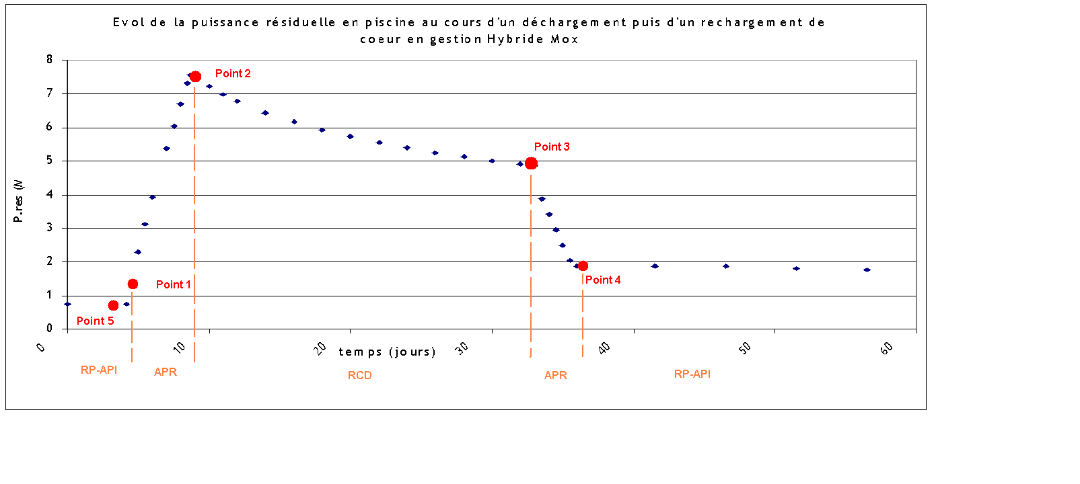

Time (day)

Residual power (MW)

**Figure 10.2.1 – Example of residual power evolution in a 900 MWe PWR SFP**

### PHYSICAL PHENOMENA

A loss of cooling accident in a pool can be divided into several phases:

* Phase 1: heat-up of the SFP to the saturation conditions: no radiological danger for the operators and the population near the plant.
* Phase 2: vaporization of water until it reaches the top of the fuel assemblies: the progressive loss of coolant above the stored assemblies generates a radiological danger for the operators of the plant that could limit the interventions in the fuel building.
* Phase 3: uncovering/degradation of fuel assemblies contained in the SFP: the temperature of the assemblies increases when uncovering. Rupture cladding occurs when the temperature reaches 1000 K. Cladding oxidation appears at 1200 K with air and 1400 K with steam. The air oxidation is much more exothermic than the steam oxidation.
* Phase 4: after progressive fuel melt, MCCI can occur at the bottom of the SFP.

After the cladding rupture, the volatile fission products that have accumulated are released. The release continues with the release of other fission products presented in the fuel, because the temperature of release mechanisms is reached.

In the case of a slow uncovering due to a loss of cooling, the predominant phenomenon is rather steam oxidation, although a mixed atmosphere could be present above the uncovering front. This atmosphere influences the degradation and the H2 production.

Once uncovering, the top of the racks undergoes degradation (at 1700 K). Shortly after, when the melting point of zircaloy is reached (2500 K), the top of fuel rods melts. Because of racks design, the molten metals relocate just below. The degradation process is defined by the successive relocation of molten mixture.

### SUMMARY OF ASTEC RESULTS AND LIMITATIONS OF THE CODE

The main outcomes are listed below and the Figure 10.2.2 presents the synthesis of degradation calculations performed with ASTEC.

These calculations provide first order of magnitude results with rather pessimistic assumptions (e.g. no thermal loss by pool walls or atmosphere of the building). Some conclusions are proposed here:

* concerning loss of cooling situations,
  + the top fuel rod dewatering starts between 53 and 841 hours, the cladding rupture time of fuel assemblies stored in the pool occurs when the water level in the SFP is below 2 or 3 meters of the top of stored assemblies: clad ruptures occur between 18 and 184 hours after top fuel rod dewatering,
  + times are shorter during fuel handling (dewatering can start after 36 hours),
  + there is an important hydrogen production (650 to 1140 kg) but the steam released from the SFP may inert the SFP building atmosphere. One concern for late accident management (to avoid explosion) would be to control air ingress …
* concerning loss of coolant situations,
  + the delay before uncovering of course depends on the drain down flow rate, then the delay before cladding rupture depends on the “hot assemblies” power (roughly from 1 h to 10 h),
  + there is limited steam in the SFP building so the building could not be inerted.

Concerning the impact of gap pressure and the respective behavior of “hot” fuel assemblies on “cold” fuel assemblies, the following conclusions are obtained from these ASTEC calculations (limitations are explained below):

* the degradation of “cold assemblies” begins immediately after “hot assemblies” when “cold assemblies” are close to “hot assemblies”;
* if “cold assemblies” are completely isolated from “hot assemblies”, the time before cladding rupture is not significantly impacted;
* the impact of the gap pressure is not significant.

**Limitations of the code**

The geometrical modelling (axisymmetric assumption, suitable for core modelling) of fuel bundles in ASTEC is not appropriate to SFP geometry and approximations have to be done. Nevertheless, the most important parameter is the cooling capacity of fluid channels, therefore the fluid sections in the model. These approximations create uncertainties on the calculated cladding rupture time. Sensitivity studies have shown that it seems to be limited in comparison with the time between top fuel uncovering and the cladding rupture.

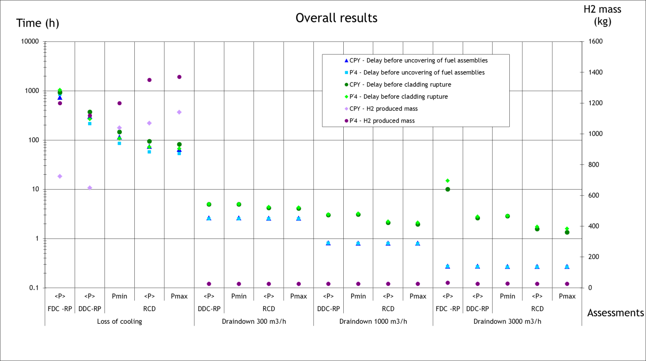

**Figure 10.2.2 – Synthesis of ASTEC fuel degradation results**

### CONCLUSIONS

This type of ASTEC calculations provides preliminary insights on the accident progression in case of SFP accident. They (of course) confirm that such accidents must be associated to very large release accidents in L2 PSA.

For the future, there is still some open area for research to identify some mitigation strategies:

* effect of cooling by natural convection with air, by spray …
* limitation of heat transfer from hot bundles to cold bundles if this can preserve the cold ones from melting,
* feasibility to inert the fuel building against hydrogen explosion,
* radioactive release filtration, …
* controlling the criticality even if the geometry is modified.

## Example Spent fuel pool in Sweden (LRC)

The Swedish national report [30] on stress tests described the impact of external events causing the severe accidents involving core meltdown or fuel damage in the SFP. In Sweden SFP is located inside the containment in BWR design and outside the containment in PWR design. The L1 PSA, SFP draining events are modelled [35], however it is not extended to L2 PSA. Also in some Swedish PSA studies, SFP is not considered, neither for shutdown (outage) nor for other operating modes, however, SFPs are considered in the yearly outage planning PSAs before each outage, but there is no methodology report describing this.

After Fukushima Dai-chi accident, stress test has been performed on all operating reactors in Sweden. Regarding SFP, the ENSREG report [31] identified some weaknesses in its instrumentation and control systems. It also indicated the need of diversity in SFP cooling e.g. installation of pipelines to feed firewater into the pools and mobile equipment.

In Sweden on May 13, 2013, there was an event at Forsmarks (unit 3- BWR design) NPP related to loss of SFP cooling, when the emergency diesel generators failed to start after undetected loss of two phases on 400 kV incoming off-site supply resulting in loss of SFP cooling [27]. This event leaded to loss of SFP cooling capability with no increase in SFP temperature. At Forsmarks in this configuration, the water heat-up rate is approx. 0.7°C per hour. The temperature was around 35°C. If manual action had not been implemented, it would have taken around 30 hours before water had started to boil [32].

The Swedish national reports [30], [33] concluded the followings extracted actions required from the licensees for the ‘at reactor SFPs’:

* Reassess the integrity of the SFP: Integrity and robustness of the SFP during prolonged extreme situations at the site shall be further evaluated and reassessed;
* Seismic analyses: a return frequency of 10-5/year shall be used as a basis for reviews/back fitting of the fuel pools’ structural integrity.
* Consider improvements of the capability to cool the SFP: Prolonged extreme situations should be the basis for technical and administrative measures to ensure the capabilities for spent fuel pool cooling during prolonged extreme situations, including alternative means of cooling and residual heat removal of the spent fuel pool.
* Investigate the instrumentation of the SFP: Instrumentation for measurement of necessary parameters in the spent fuel storage (water level, temperature) in the event of severe accidents as well as the resistance of the equipment to harmful environment conditions shall be investigated.
* Loss of electrical power, different situations and the impact on the NPPs’ spent fuel pools due to loss of electrical power.

The above actions are now being implemented or ongoing by the licensees.

## Example Spent fuel pool in France (EDF)

In EDF PWR, spent fuel pool is outside the containment. As no credit can be assumed for mitigating a core melt accident in the spent fuel pool, it is supposed that any core melt accident that would happen would lead to large releases. Then PSA for spent fuel pool is essentially a level 1 PSA analysis and core melt sequences are directly associated with unacceptable Level 2 PSA releases.

## Example Spent fuel pool IN JAPAN (jansi)

In Fukushima-Daiichi NPP Unit 1 water leak was observed during the earthquake. Based on the results of site investigation and analysis, the NRA (Nuclear Regulation Authority, Japan) estimated that the water leak on the 4th floor of Unit 1 occurred by water that jetted out through gaps in the panel joints of the overflow chamber caused by the pressure of water overflowing into the overflow chamber due to sloshing in the SFP.

As the water sloshing might have been occurred in the SFP, the NRA conducted the analysis related to the water flood in the duct from the SFP due to the water sloshing. From the analysis sloshing wave height of the SFP, amount of water are estimated [118].

Models of the spent fuel pool were as follows.

Modeling range：surrounding floors, air-conditioning ducts, and overflow chamber

Model scale：approx. 170,000 elements

Load conditions：Apply the seismic response waves simultaneously in three directions.

Analysis method：Volume-of-Fluid method

From the analysis sloshing wave height of the SFP, amount of water are estimated.

During Niigataken-Chuetsu-Oki (NCO) Earthquake SFP water of Kashiwazaki-Kariwa (K-K) NPP overflew due to sloshing. In KARISMA project of IAEA [119], benchmark exercises were conducted for SSCs of K-K NPP during NCO earthquake. Sloshing analysis of the SFP was included in the benchmarking. Twenty-one organizations from 14 countries, participated in the benchmarking exercises.

Different approaches were taken to model the geometry of the pool: 2D vertical cross-sectional shape, model with equivalent 3D rectangular shape, 3D models reflecting main dimensions of the pool without details, detailed geometry of the pool including the pit and scaled model of the pool used for experiment. For these models dynamic time history response analyses were conducted.

Participants’ results show good agreement for those parameters that could be predicted analytically: sloshing frequency (COV = 0.08) and total wave height (COV = 0.2).

However, spilled water results have a big variation: from 66 tons to 376 tons. Recorded movie during the earthquake provided by TEPCO showed quite complex free surface wave form and results of some teams confirmed that tendency.

There is another example of three dimensional FEM time history response analysis using VOF (Volume of Fluid) techniques in which three dimensional wave height and overflow pattern of the water as well as the amount is evaluated [120].

## EXAMPLE SPENT FUEL POOL IN HUNGARY (NUBIKI)

This appendix contains a concise description of the probabilistic safety assessment for the spent fuel pool of the Paks NPP, Hungary. Level 1 and level 2 aspects are both covered. Consolidated results are available for the level 1 PSA, i.e. for the frequency of fuel damage, after a recent major upgrade of the initial analysis. An upgrade of the level 2 PSA is currently ongoing to refine the definition of release categories for the spent fuel pool and determine the associated release magnitudes and release frequencies more realistically in comparison to the initial study. Thus the level 2 PSA part focuses on some preliminary insights yielded from the analyses completed so far.

**Level 1 PSA**

A level 1 PSA model for the SFP is available for the Paks Nuclear Power Plant in Hungary since 2002. Initially, the assessment was limited to internal events and hazards as well as to unit 1 assigned as the representative unit of all the 4 units of the plant. In 2006 the assessment for internal events and hazards was extended to all units, i.e. unit specific, stand-alone level 1 PSA models and results are now available for the four spent fuel pools of the VVER-440/213 type units of the Paks NPP. Several model updates have been performed since 2002 to reduce uncertainties, remove some conservatism assumed in the initial assessment and reflect safety impacts from plant modifications. Motivated by the implementation of symptom-oriented EOPs for spent fuel pool accidents, a thorough review of the accident sequence models was performed in 2015 to identify the need for model modifications. These modifications and several other model upgrades reflecting findings from deterministic safety analyses, PSA model upgrades for the reactor, detailed system analyses, as well as the update of input reliability data were subsequently performed. This reassessment led to a significant change in the results of the spent fuel pool PSA with respect to the annual fuel damage probability as well as to the contributions of the different POSs and initiating events to the overall risk. The updated results show only a small difference among the different units. Moreover, the risk significance of fire induced events is found lower and the importance of loss of cooling accidents is larger than prior to the revision.

Six distinct POSs were defined for the spent fuel pool in the PSA. On one hand, the POS definitions and characteristics were based on the different pool states addressed in the relevant EOPs. On the other hand, the amount of the water in the spent fuel pool, as well as the residual heat of the fuel assemblies were also taken into consideration in the definition and characterization of the different POSs. The 6 POSs were described by the number of fuel rods and the associated heat production (decay heat) in the SFP, volume of water above the fuel rods, volume of water in the spent fuel pool and yearly mean POS duration.

With respect to internal initiating events, the following events were selected and analysed in detail in each POS:

* loss of SFP heat removal system (taking into account the failure of the heat removal train in operation as well as the standby heat removal train),
* loss of coolant accidents due to pipe ruptures in the heat removal system of the SFP (separate assessments were performed for isolable and for non-isolable pipe sections),
* loss of off-site power – LOOP (this event is identical to the corresponding event analysed in the reactor PSA).

Concerning internal hazards, the detailed probabilistic analysis was limited to fire and flooding events, since previously all other internal hazards had been screened out from further analysis.

Event sequence analysis, as well as event tree construction was based on supporting thermohydraulic analyses and on the definitions of required interventions as in the EOPs. Each event tree starts with one of the initiating events listed above and then it branches off for the different mitigation systems as well as human recovery actions modelled as event tree headers. Fault trees are constructed to adequately describe the logical combinations of equipment failures and human errors leading to the failure of safety systems to fulfil their intended functions. A stand-alone fault tree was built for the loss of heat removal system initiating event, to determine the initiating event frequency and to correctly model failure events along the accident sequences.

Pre-initiator (type A), initiator (type B) as well as post-initiator (type C) operator actions and failure events were taken into consideration in human reliability assessment (HRA). The scope of type C human failure events was primarily limited to proceduralized actions. Post-initiator operator actions were determined on the basis of symptom-oriented EOPs relevant to SFP accidents. A further sub-group within the modelled type C human failure events is composed of those actions that are aimed at recovering failed systems or equipment, as well as other, usually non-proceduralized, long term actions to find and use additional means of accident mitigation. The PSA model for the SFP of the Paks NPP includes recoveries from LOOP, failure of heat removal system as well as pipeline breaks (only if the location is accessible).

The quantification of event sequences was performed by using the RiskSpectrum PSA Professional software applied generally to model development and quantification in the Paks PSA. For risk characterization, the point estimates of fuel damage frequency and the annual fuel damage probability were determined for the different initiating events in each plant operational state. By summing up the fuel damage probabilities for the various initiating events and plant operational states, we calculated the cumulative risk (annual fuel damage probability) for the SFP of the Paks NPP. We used qualitative analysis to identify and interpret the minimal cutsets that were found dominant contributors to the cumulative SFP risk. Importance, sensitivity and uncertainty assessment was also performed in accordance with widely used, internationally accepted methods.

Level 1 PSA for some natural external events that can affect risk was completed for a selected spent fuel pool of the Paks NPP in 2013 and the seismic PSA of the SFP was developed in 2014. The analysis followed the commonly known steps: selection and screening of external hazards, hazard assessment for screened-in external events, analysis of plant response and fragility, PSA model development, and risk quantification and interpretation of results. As a result of event selection and screening, the following external hazards were subject to detailed analysis: earthquake, extreme wind, extreme rainfall (precipitation), extreme snow, extremely high and extremely low temperatures, lightning, frost and ice formation. During the screening process it was found that available hazard analyses did not enable to decide if tornados and blockage of the water intake filters could be screened out or not. Additional hazard assessment has been proposed to clarify these questions.

The risk of fuel damage induced by natural external hazards was quantified to the extent seen feasible. In addition to risk quantification, unresolved issues and necessary follow-on analyses were identified and proposed. The fuel damage risk has been assessed quantitatively for seismic, wind, snow and frost hazards. Detailed importance, sensitivity and uncertainty analyses were conducted. Moreover, the main risk contributors induced by these external events were also identified. Additional follow-on analyses were proposed to enable improved risk quantification by means of reducing uncertainties, establishing a better technical basis for the applied analytical assumptions or decreasing unnecessarily high conservatism.

Based on the findings of hazard assessment and plant response analysis, the fuel damage risk induced by extreme rainfall and lightning was found to be insignificant. However, some follow-on analyses were proposed and safety enhancement measures were conceptualised to fully underpin this conclusion. Due to lack of appropriate data and supporting analysis on the capacity of spent fuel pool systems and components no PSA model has been developed yet for extreme temperatures. Follow-on analyses necessary for quantifying the risk of fuel damage induced by extreme temperatures have been proposed.

A plan of follow-on actions has been set up based on the analysis findings. Follow-on analyses have been started in accordance with this action plan. For more details on PSA for external events other than earthquakes, see [121].

**Insights into Level 2 PSA**

The VVER\_440/213 spent fuel pool is located in the reactor hall (**Figure 10.6.1**) which is a huge non-hermetic building. This building can play an important role in level 2 PSA through affecting the fission product transport and release into the environment.

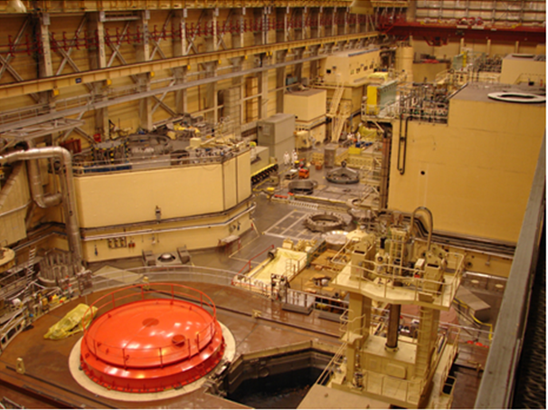

SFP

**Figure 10.6.1 Reactor Hall of VVER-440/213 Plants**

Over and above the characteristics of POSs and accident sequences determined for the SFP in the level 1 PSA, for level 2 PSA all this is information is complemented by the status of the reactor hall ventilation systems and of the SFP lid (SFP covered or open).

In the level 2 PSA the accident progression was analysed by using the integral code MELCOR 1.8.6. The code models the severe accident phenomena, the heat up and melting of the fuel rods in the SFP. Representative accident sequences of the SFP in each of the 6 POSs were modelled, the timing of the main phenomena and the fission product release rates were calculated.

It was found that the release of materials (hydrogen, steam, fission products) from the spent fuel pool into the reactor hall and from there to the environment is strongly influenced by the ventilation systems. There is a recirculation ventilation system (TL16) which blows air in the SPF, above the nominal water level. There are two sucking ventilation systems (TN01, TN13) which also communicate with the atmosphere of the spent fuel pool. Two other ventilation systems (UH05, TN14) are used for exchanging air in the reactor hall. The connections of the ventilation systems can be seen in **Figure 10.6.2**. The different operating configurations of the ventilation systems modify the flow pattern above the spent fuel pool and in the reactor hall. The flow pattern impacts on the transport of radioactive materials in the reactor hall and on the subsequent release into the environment. The MELCOR code cannot calculate these special 3D flow patterns. Therefore three-dimensional calculations were performed by the GASFLOW code. The results of 3D calculations were used for the nodalization of the MELCOR code.

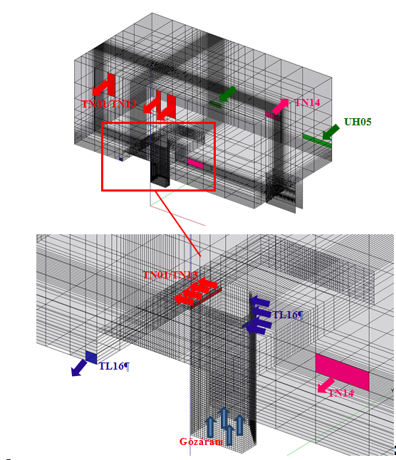

**Figure 10.6.2 Gas flow Nodalisation for Flow Pattern above SFP**

There are no dedicated accident management strategies and guidelines in place yet for the SFP, therefore the fuel damage frequency together with the probability of the different possible configurations of the ventilation systems and with the SFP lid position (SFP covered or open) determine the probability of the release categories. The probabilities of the ventilation system configurations have been determined in an accident sequence specific manner for each POS of the SFP. The MELCOR calculations are ongoing to enable the definition of release categories and the calculation of release frequencies.

We have preliminary results for the release rates which will determine the release categories. The results show that filtered ventilation can decrease the release from the pool into the environment by about an order of magnitude (see Figures **10.6.3** and **10.6.4**, respectively).

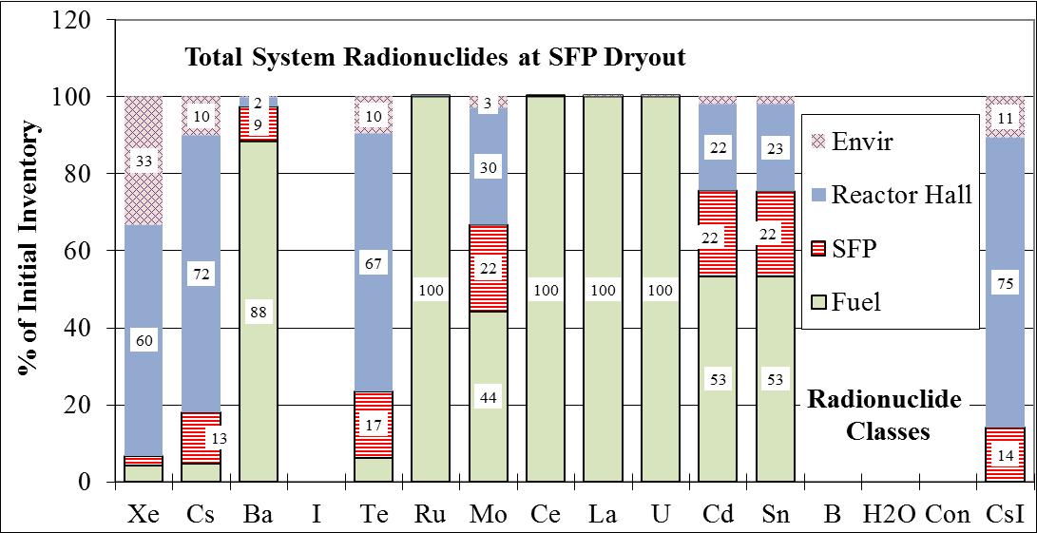

**Figure** **10.6.3 Release after Refuelling, SFP Covered SFP, Ventilation Systems out of Operation**

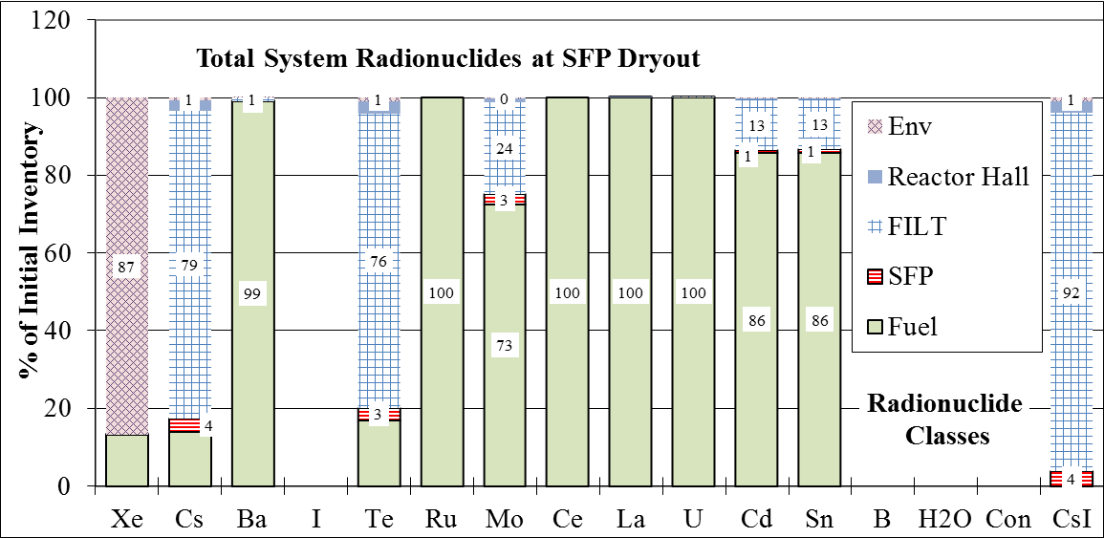

**Figure** **10.6.4 Release after Refuelling, SFP Covered SFP, TN01 Ventilation System in Operation**

## Example Spent fuel pool in Ukraine (SSTC)

Initial analyses of severe accidents in SFP were performed using MELCOR 1.8.3 code. The code was developed for analysis of severe accidents in the reactor core; therefore its application for evaluation of SA in SFP requires to utilize special modelling techniques and assumptions. This may influence correctness of predictions made by the code thus number of case studies with different modelling options applied was performed to get consistent results.

As an example, the main results of total station blackout severe accident analyses for VVER‑1000/V‑320 SFP are provided below. To evaluate SA progression in SFP and estimate the consequences of SFP injection recovery (2 kg/s injection rate) at various SA stages the following total station blackout cases were evaluated:

* no operation recovery case;
* SFP injection recovery at a decrease of SFP level down to 3.4 m (approx.30% of fuel height is uncovered);
* SFP injection recovery at fuel cladding temperature 1200 °C;
* SFP injection recovery at the moment of fuel collapse down to SFP bottom;
* SFP injection recovery at MCCI start.

The results of analyses indicate that:

* early SFP injection restoration (at SFP level of 3.4 m) allows to avoid fuel damage and to restore successful spent fuel assemblies cooling;
* when fuel cladding temperature of 1200 °C is reached, SFP injection terminates further fuel assemblies’ damage. About 50% of FA height remains undamaged. Total hydrogen production is 2.5 times lower than in no-actions case;
* start of SFP injection after FA collapse allows to terminate further debris heat-up (due to relatively low initial debris temperature and its porosity), to establish its long term cooling and to prevent SFP liner melt-through. Total hydrogen production is 15% lower than in no-actions case;
* MCCI cannot be terminated by late SFP injection; however concrete melt-through occurs for 1.5‑2 times slower than in no-actions case.

Correspondent analysis plots are provided on Figures 10.7.1–10.7.5.

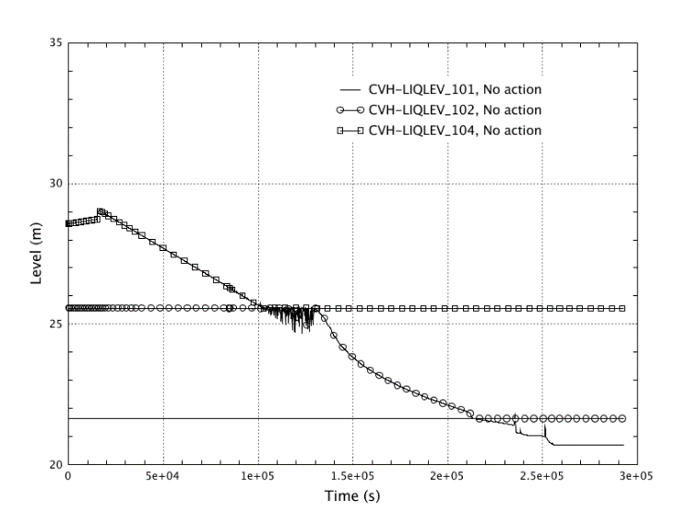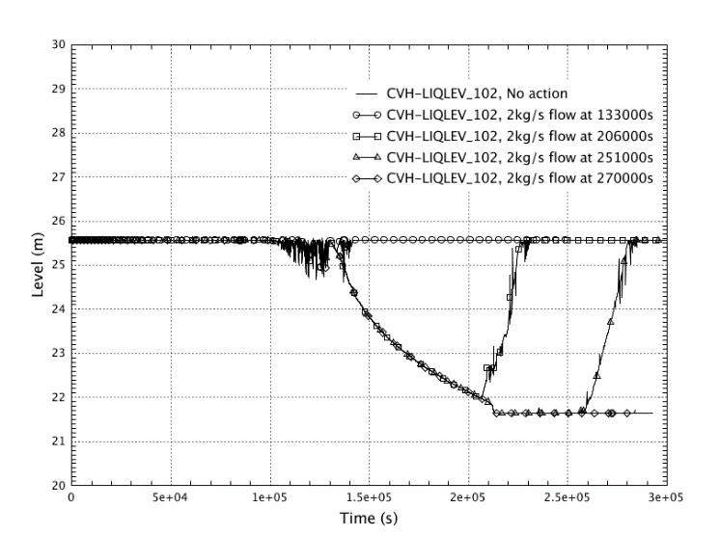

**Figure** **10.7.1 – Water level in SFP (without operator actions – left, with operator actions – right)**

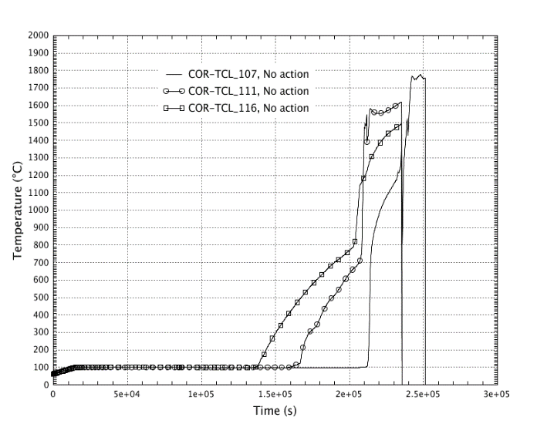 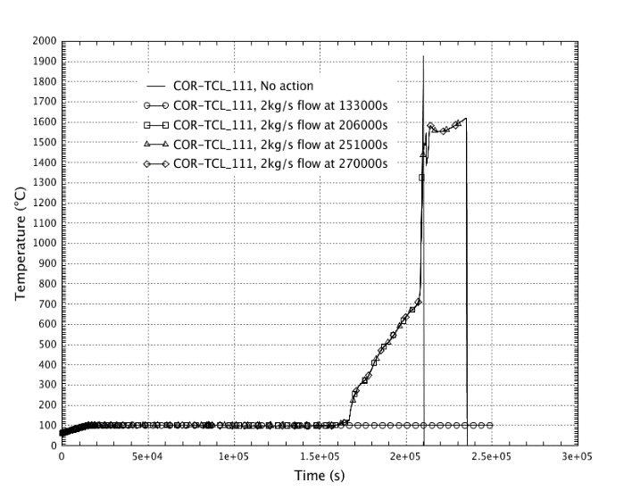

**Figure 10.7.2 – Claddings temperature in SFP (without operator actions – left, with operator actions – right)**

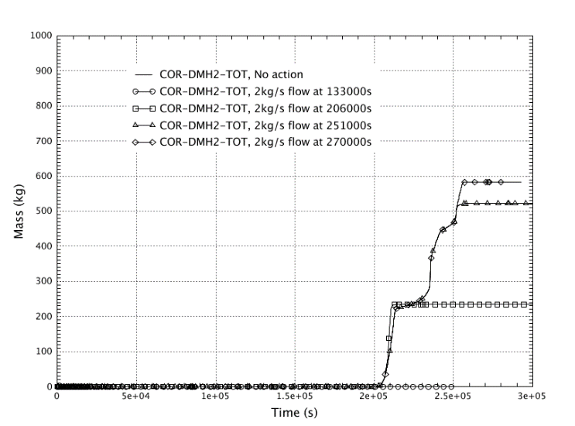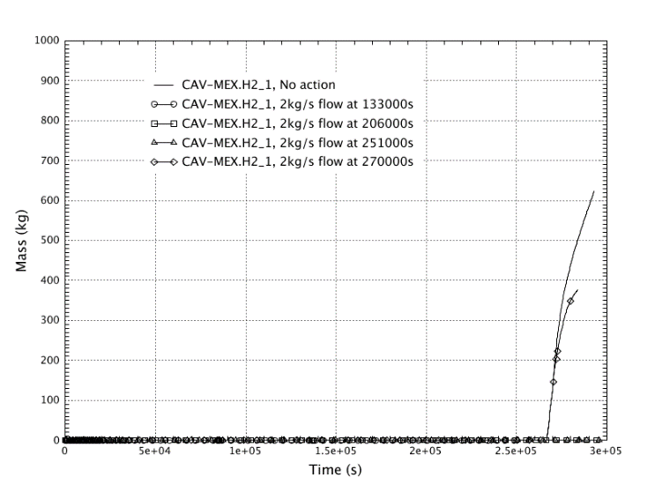

**Figure 10.7.3 – Cumulative hydrogen production from fuel assemblies and racks (left) and in the cavity (right)**

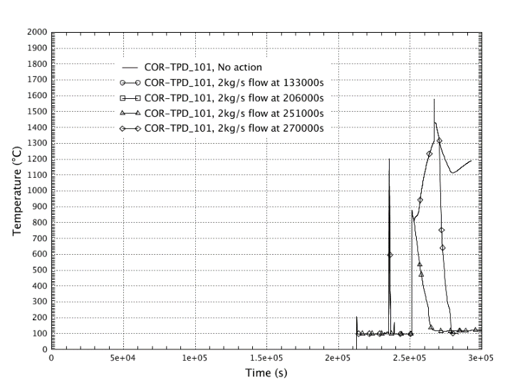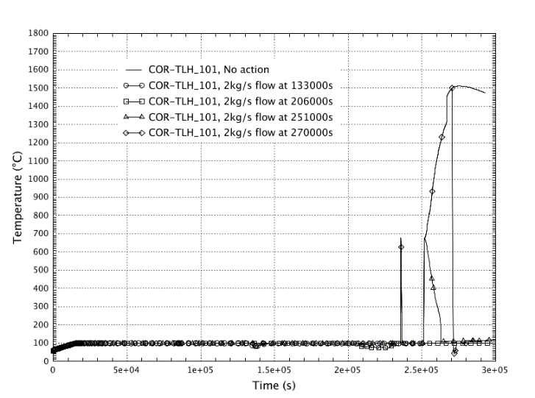

**Figure 10.7.4 – Debris and lower head temperature in SFP**

**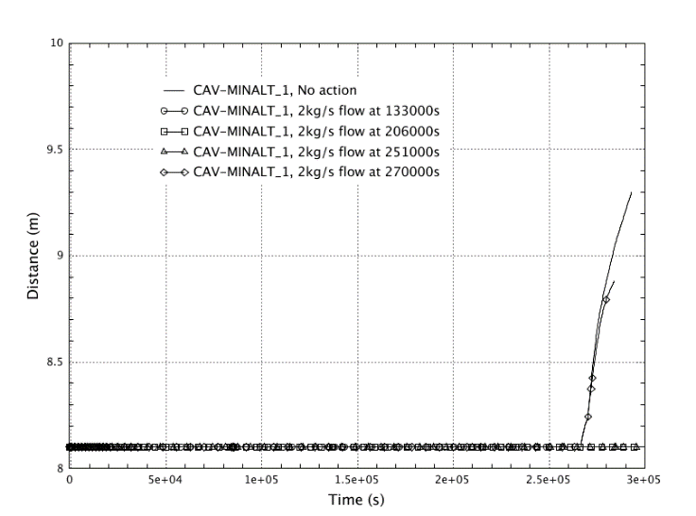**

**Figure** **10.7.5 – Damaged concrete level**

Based on the analysis results it can be concluded that SFP injection restoration at various SA stages contributes to a decrease of radioactive releases, hydrogen generation and concrete structures melting speed.

Considering the limitations of code version used these results and conclusions shall not be treated as the final ones. More recent code version model with more precisely defined assumptions (including the ones on SFP fuel decay heat) is now under development to evaluate SFP SA termination possibility at the late SA stages. It shall also be noted that some of the uncertainties associated with SFP SA progression (e.g., potential criticality evaluation) are selected for further in-depth analysis to be performed in the framework SA phenomena evaluation program initiated by the Utility.

## EXAMPLE FROM BULGARIA (INRNE)

(It has been used Risk Engineering and the INRNE work in this field)

In Bulgaria, presently only two VVER-1000/V320 reactors (Units 5 and 6, respectively) at the Kozloduy NPP are in operation. In order, to evaluate their safety, especially with respect to the risks associated with accidents occurring in the SFP, some analyses have been carried out. These analyses have been performed by Risk Engineering ltd. by using the version 2.1 of the MELCOR code [115], [116].

The SFP is situated in the containment and are used for storing of the spent fuel (until the residual heat of the spent fuel is reduced to the admissible levels) and also for temporary storage of control rod absorbers and dummy fuel assemblies [117].

The MELCOR 2.1 model that was used for the analysis consists of the following parts [116]:

* Containment model – the same of for the reactor SA analyses with slight modifications;
* SFP pools model (TG21B01-TG21B06, including drainages and wet refuelling shaft);
* Primary side model (reactor without internals and 4 loops which are lumped into a single loop).
* The study is limited only to the SFP into containment, closed to the reactor pit.

It is developed specific guidance for fuel behavior in SFP during severe accident conditions and they are under review.

1. This might be true for ‘spontaneous pipe breaks’ due to lower pressure in primary system. However other human induced ‘drain down’ events need to be considered. [↑](#footnote-ref-2)
2. Structural failures may not only lead to loss of coolant inventory, it can also lead to loss of cooling depending on what structure fails. [↑](#footnote-ref-3)
3. Failure of emergency power supplies - the failure of a mitigation system (i.e. emergency power supply system) shall be modelled separately from the Initiating event. In this case the IE for the reactor PSA as well as for the SFP PSA shall be LOOP, and the availability of the emergency power supply system shall be taken into consideration as a mitigation system in the event tree. [↑](#footnote-ref-4)
4. k-eff (or k-effective) is the effective neutron multiplication factor (ratio between neutron production and neutron loss in a system containing fissile material). This factor represents the possibility for a system to undergo a sustainable fission chain reaction, in which case k-eff ≥ 1 [↑](#footnote-ref-5)
5. The objective is also to be able to predict FP releases for new fuel types in the reactor core. [↑](#footnote-ref-6)
6. Mo is of special importance due to the formation of CsMoO4 which prevents the formation of CsI and favors the formation of gaseous iodine. [↑](#footnote-ref-7)
7. See public documents at https://gforge.irsn.fr/gf/project/passam/ [↑](#footnote-ref-8)
8. http://cordis.europa.eu/project/rcn/198668\_en.html [↑](#footnote-ref-9)
9. The first entrance criterion is a thermocouple temperature at the core outlet above 650°C. The second criterion postulates the opening of the SAMGs one hour after loss of shutdown cooling when the thermocouples are not available. The entrance to SAMGs in this study conservatively assumes that both criteria are requested while in real accidental situation only one of these two criteria is sufficient to open the SAMGs. [↑](#footnote-ref-10)